Register Page: Where user register with their mobile number. And a given number sent to them.

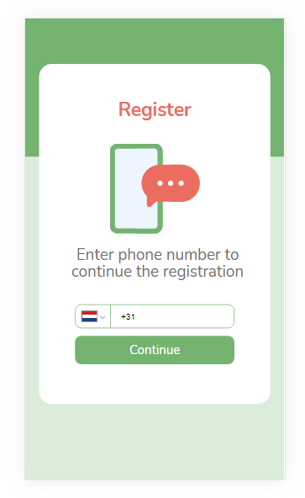

Verification Page:

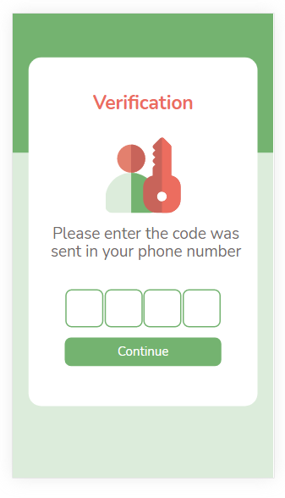

Here they have to verify that code number.

Set Password: After verify they must have to set their new Password.

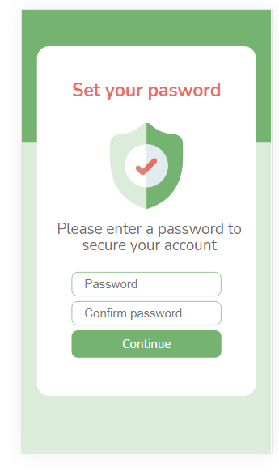

Set First name and Last name: After create an account they must have to give their First name and Last name.

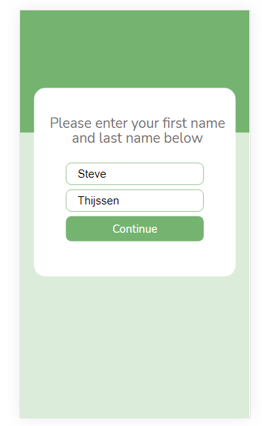

Welcome: After the register completion it will redirect to welcome page with Start button. That mean’s account is created now it comes to donation part.

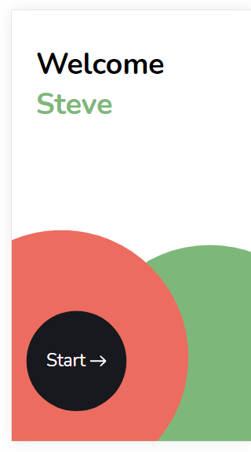

Donation:

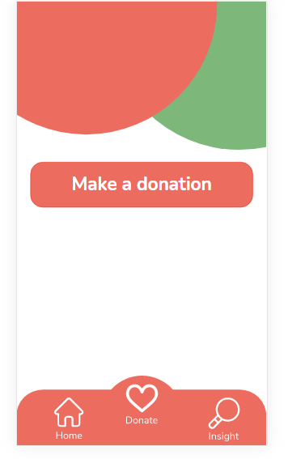

After click on that donation button it will show two methods.

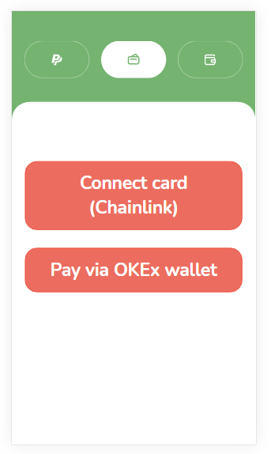

1. Connect card (chainlink)
   * For this, we are using Chainlink to create smart contract and connecting OEC to Real world/Application using it. Because we cannot connect to Blockchain world directly without chainlink. So after we use it we can provide the debit/credit card informations.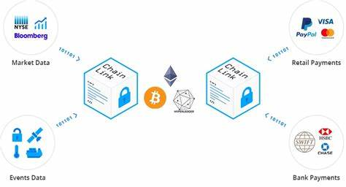

And also using USDT. For converting we are taking chainlink help. Because Blockchain world cannot understand our real world price directly or neither Debit card or Credit card . So, we will be using chainlink and before the donation we are getting the card details.

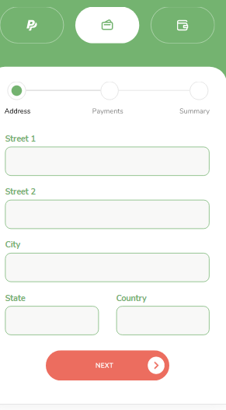

After add the card details we can donate with chainlink and OEC.

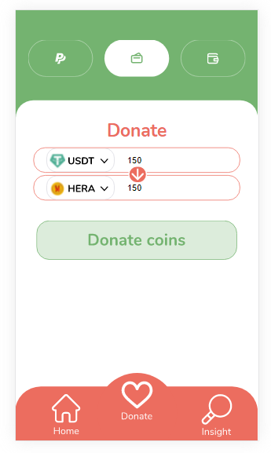

Here we are providing 1 USDT = 1. In the code we are first creating an smart contract using solidity language. And we are using etherjs to connect this chainlink to OEC Blockchain. And doing transaction. After Every donation as well as with direct account payment system in lottery tickects page being added 1 ticket number. Then redirecting to Insights page. Where he can see the all the helped stories or the added lottery numbers page. Pay via OKEx wallet (OEC).

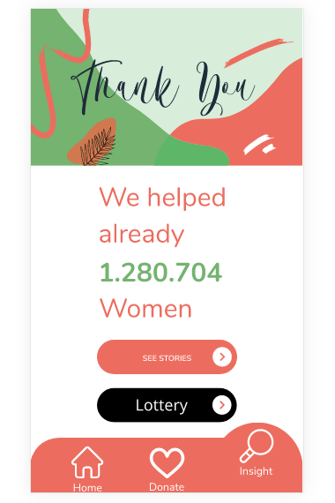

Insight page.

1. Pay via OKEx wallet:

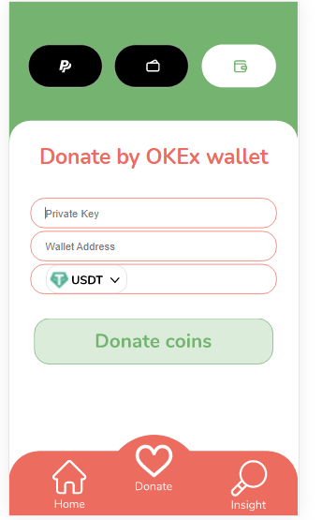

Here

* + For the direct paying the person has to have an OKEx account in order to do it. They will have to provide their Api key + their Wellet address. For this method we are converting manually USDT to ETH and then sending to us from their account. And also for the receiving we are using our wallet.

For the lottery part. There has the count down from the current date to Friday.

When Friday comes then the tickets will randomly generate a number from server side. Because we can't let the users to wait until the NGO or others person to generate. If that number is matching with his any ticket numbers then he will won. After every Friday the lottery tickets will be expired.

Why chainlink?

The smart contract concept was first introduced by Ethereum; however, their smart contracts can only manage data on the blockchain. They miss a bridge to real-world businesses. ChainLink aims to help in decentralizing the internet to create a link between blockchain and their real-world applications. Also we needed it for the transacting with the credit/debit card.

Are we using GameFi ?

Yes. We are using this system on lottery ticket page.