System and Software Architecture Description (SSAD)

<Project Name>
基于Spark的跨平台成绩分析&课程推荐系统

<Team number>
Team Members
纪鸿旭
许云峰
刘航舟
张培

<Team members and roles>
纪鸿旭：产品经理/算法工程师
许云峰：项目经理/系统架构师/前端工程师
张 培：视觉设计师/数据分析师
刘航舟：后端工程师/测试工程师

3/26/17

Version History
Date | Author | Version | Changes made | Rationale
03/19/17 | 许云峰 | 0.9 | - 需求分析、系统分析、添加介绍 | - 建立框架
03/26/17 | 许云峰 | 1.0 | - 开发客户端原型、搭建服务端环境 | - 开发环境搭建完成

Table of Contents
System and Software Architecture Description (SSAD) i
Version History ii
Table of Contents iii
Table of Tables iv
Table of Figures v
1. Introduction 1
1.1 Purpose of the SSAD 1
1.2 Status of the SSAD 1
2. System Analysis 2
2.1 System Analysis Overview 2
3. NDI/NCS Interoperability Analysis 7
3.1 Introduction 7
3.2 System Structure 7
3.3 Evaluation Summary 8
4. Architectural Styles, Patterns and Frameworks 10

Table of Tables
Table 1: Actors Summary 2
Table 2: Artifacts and Information Summary 3
Table 3: Process Description 4
Table 4: Typical Course of Action 4
Table 5: Alternate Course of Action 4
Table 6: Exceptional Course of Action 4
Table 7: NDI Products Listing 5
Table 8: NDI Evaluation 6

Table of Figures
Figure 1: System Context Diagram 2
Figure 2: Artifacts and Information Diagram 3
Figure 3: Process Diagram 4

Introduction

Purpose of the SSAD

<<Identify the objectives of this document. >>
本文档的目的是展示系统架构，包括项目所涉及到软件和硬件部分的细节。

Status of the SSAD

<<Briefly describe about status of this document, key differences from previous version.>>

0.9版本 初步介绍
1.0版本 客户端用户用例图

System Analysis

System Analysis Overview
<< This section should include a short description of the purpose of the system being developed
The following is an example from the CSC Volunteer Tracking project:
The primary purpose of the Volunteer Tracking System is to track the performance of volunteers working at the California Science Center. The Volunteer Tracking System keeps track of the number of hours that each volunteer has completed and of communications and job requests between and among volunteers, supervisors, and the volunteer coordinator. The system generates reports and certificates based on the needs and preferences of the volunteer coordinator and the CSC's managers. Notifications are sent to the volunteer coordinator once volunteers' working hours meet certain levels required for special recognition. >>
此成绩分析&课程推荐系统的主要目的是方便在校大学生对于自己成绩的分析以及参考我们的推荐选课。
用户有三种功能可供选择：
- 输入自己的学号和urp密码，进行个人成绩分析。
- 搜索某一老师或某一课程，进行教学班成绩分析。
- 输入学号或者课程，进行课程推荐。

System Context
<< This section should contain the system's context, in the form of a UML Class Diagram showing the actors and their relations to the system. More information and example can be found in ICM EPG> Task: Analyze the Proposed System >>
<<System Context Diagram>>
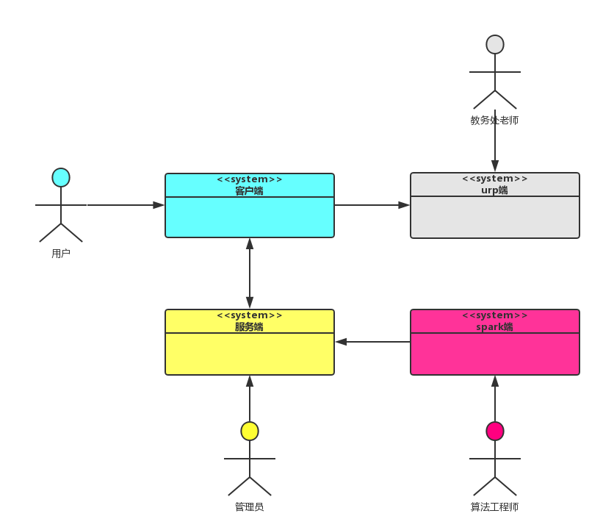
Figure 1: System Context Diagram

<< For each actor shown in the UML Class Diagram:
- The (role) name of the actor
- A description of the actor's relation to the system being developed
- A list of the actor's responsibilities with respect to the design, implementation, installation, and use of the system being developed. >>
Table 1: Actors Summary
Actor | Description | Responsibilities
用户 | APP的使用者 | 查看成绩分析结果和推荐的课程
管理员 | 服务器的管理者 | 控制系统的数据I/O，管理维护系统
算法工程师 | 研究、实现算法的人 | 用算法处理庞大的成绩相关数据
教务处老师 | Urp系统的管理者 | 录入、审核urp系统成绩

Artifacts & Information
<< This section of the document describes the artifacts and information created by the system. These artifacts can either be used by the end user or reused by the system to produce further artifacts.
This section should contain:
- a UML class diagram showing the artifacts that the system being developed will inspect, manipulate, and/or produce
- and for each artifact shown in the UML class diagram, the artifact's name and its purpose.

More information and example can be found in ICM EPG> Task: Analyze the Proposed System. >>

信息架构图
<<Artifacts and Information Diagram>>
Figure 2: Artifacts and Information Diagram
Table 2: Artifacts and Information Summary
Artifact | Purpose
用户 | 包含学号、urp密码等学生个人信息
成绩 | 包括教学班、教师、学生、分数等信息
教学班 | 包括教师、上课学生、教室等信息
教师 | 包括教师姓名、拥有教学班等信息
推荐算法 | 包括基于课程的聚类算法和基于项目的协同过滤推荐算法

Behavior
<< This section should contain:
- One or more UML Use-Case Diagrams showing the processes whereby actors and the system interact in order to accomplish a goal that benefits at least one of the actors.
- For each use case shown in the UML use case diagram(s):
- The assigned identifier (name) of the use case
- The purpose of the use case
- The requirement(s) listed in the SSRD that are (completely or partially) covered by the use case.
- The risks associated with developing/implementing the use case.
- The pre-conditions for invoking the use case
- The post-conditions that exist after the use case has been completed
- English descriptions of the use case's standard (sunny day) course of action and its alternate (rainy day) course(s) of action.
More information and example can be found in ICM EPG> Task: Analyze the Proposed System. >>
用户用例图

<<Use-Case Diagram>>
Figure 3: Process Diagram

Capability x

Process y
Table 3: Process Description
Identifier
Purpose
Requirements
Development Risks
Pre-conditions
Post-conditions

Table 4: Typical Course of Action
Seq# | Actor’s Action | System’s Response
1 | 交互描述
2
…
n
Table 5: Alternate Course of Action
Seq# | Actor’s Action | System’s Response
1
2
…
n
Table 6: Exceptional Course of Action
Seq# | Actor’s Action | System’s Response
1
2
…
n

NDI/NCS Interoperability Analysis

Introduction
<< Identify the Non-Developmental Item (NDI) and Net-Centric Services (NCS) including open source software or libraries that you are using/ plan to use in your project and analyze their interoperability by using iStudio tool>>
这一节详细介绍了系统的体系结构，包括客户端、服务器端的。

COTS / GOTS / ROTS / Open Source / NCS
<< Identify all candidate commercial off-the-shelf, government-off-the-shelf, research-off-the-shelf, open source software, libraries, and net-centric services component that you are using/ plan to use. Also identify the purpose of each component. >>
Table 7: NDI Products Listing
NDI/NCS Products | Purposes

Connectors
<< Identify the connector, for example
- “In this project, we use PHP/MySQL Connector to enable the PHP web application to retrieve and query data from the database”. >>

Legacy System
<< Identify the connector, for example
- “In this project, the development system has to be able to interoperate and works well with “BusinessWorks” version 5.2, which is a software system that the client is currently using.” >>

System Structure
<< Using iStudio to analyze your component interoperability and post the resulting system structure diagram here. >>
Figure 6: Software Component Class Diagram
涉及客户端、服务端、数据库、spark端

Table 68: Software Component Description
前端所有架构（包括设计、类图、状态描述）
Table 69: Server Framework Component Description
后端所有架构
Table 70: Spark Framework Component Description
Spark端所有架构

Evaluation Summary
<< Summarize the final selection of your interoperable NDI/NCS, its usage and its comment. Example can be found in ICM EPG> Task: Provide Architecture Feasibility Evidence.>>

Table 8: NDI Evaluation
NDI | Usages | Comments

Architectural Styles, Patterns and Frameworks
如下表，你能看到我们架构的风格、设计模式和框架。
Table 70: Architectural Styles, Patterns, and Frameworks

Name | Description | Benefits, Costs, and Limitations
C/S | 两层体系结构：客户端和服务器端  客户端负责呈现和展示功能。  服务器端负责管理数据。 | 客户端/服务器端是将用户和系统的耦合关系降低的，这样我们在更改某一功能的时候可以不影响其他部分。每个部分都是独立的职责。
MVVM | 包括模型、视图、视图模型。 | 1. 低耦合。视图可以独立于模型变化和修改，一个视图模型可以绑定到不同的视图上，当视图变化的时候模型可以不变，当模型变化的时候视图也可以不变。  2. 可重用性。一些视图逻辑可以放在一个视图模型里面，让很多视图重用这段视图逻辑。  3. 独立开发。开发人员可以专注于业务逻辑和数据的开发，设计人员可以专注于页面设计。  4. 可测试。界面素来是比较难于测试的，而现在测试可以针对视图模型来写。
Ionic2+  Angular2+ cordova框 架 | 一个大而全的Web app开发框架，包含了各种UI库、解决办法。 | 它有助于我们的MVVM模式，可以把各个不同职责的代码放在不同的地方运行。
NodeJS+express+koa框架 | 一套基于js的轻量级服务器端框架，对于I/O处理是非常快速且便捷的。 | 它使用事件驱动，非阻塞I/O 模型而得以轻量和高效，非常适合在分布式设备上运行数据密集型的实时应用。

