Object Modeling Technique (OMT)
Summary

by

David S Burris

Ph.D. in Computing Science

Certified Computer Programmer

Certified Systems Professional

Certified Computing Professional

csc_dsb@shsu.edu

Permission is granted to students in my classes to use any or all of the material in this document for their personnel educational in conjunction with the course textbooks. All other rights reserved. Materials may not be transmitted to individuals not registered in my classes.

UML: Unified Modeling Language

James Rumbaugh at General Electric
– OMT Object Modeling Technique 1991

Grady Booch at Rational Inc. (1994 – real time)

Ivar Jacobson 1997

Rational Machines was founded by Paul Levy and Mike Devlin in 1981 to provide CASE tools to expand the use of modern software engineering practices, particularly explicit modular architecture and iterative development. Rational was sold for US$2.1 billion to IBM on February 20, 2003.

First Released in 1985, the Rational Environment was an integrated development environment for the Ada programming language, which provided good support for abstraction through strong typing. Its goal was to provide the productivity benefits associated with academic single-user programming environments to teams of developers developing mission-critical applications that could execute on a range of computing platforms.

In 1994, Rational merged with Verdix, a public company that produced a wide array of Ada compilers targeted to many architecture/OS combinations. The resulting entity was named "Rational Software", and promptly integrated the Rational Ada and C++ environments with the code generators and runtimes developed by Verdix.
In 1995, James Rumbaugh joined the company, and Rational acquired Ivar Jacobson's firm Objectory AB from Ericsson. With Grady Booch already aboard, this brought within one company three of the leading object-oriented software methodologists. These three experts attempted to unify their work. To eliminate the method fragmentation that they concluded was impeding commercial adoption of modeling tools, they developed Unified Modeling Language (UML), which provided a level playing field for all tool vendors. At its 1.0 release, the Unified Modeling Language was contributed to the Object Management Group, which has managed its subsequent development.

UML – ISO Standard 1997

Not wide acceptance, e.g., use of Peter Coad by Military

Simula 67 (1967) is considered the first Object Oriented Language!

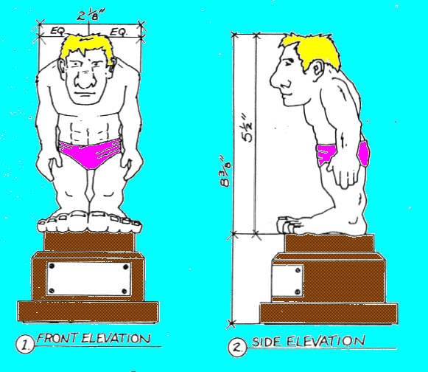


One view of an object is frequently insufficient to grasp its totality. This true of most projects in which object orient methods are used.

Based on "Controlling Software Projects, Management, Measurement, & Estimation," by Tom DeMarco, Yourdon Press, 1982, ISBN 0-13-171711-1 025, page 63.

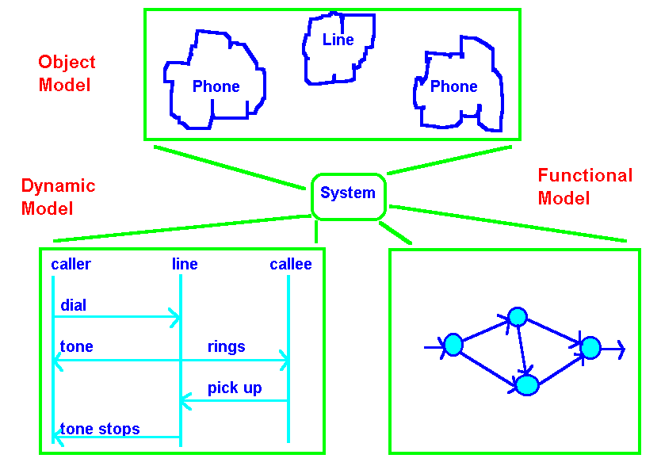

OBJECT MODEL: The object model describes a system in terms of the objects of which it is constructed - it shows their identity, their relationship to other objects, their attributes and operations. The object model provides an essential framework for understanding the dynamic and functional models.

DYNAMIC MODEL: The dynamic model describes those aspects of a system related to time and the sequencing of operations - events that mark changes, states that define the context for events, and the organization of events and states.

FUNCTIONAL MODEL: The functional model describes those aspects of a system concerned with transformations of values function mappings, constraints, and functional dependencies. This model captures what a system does without regard for how or when it is done.

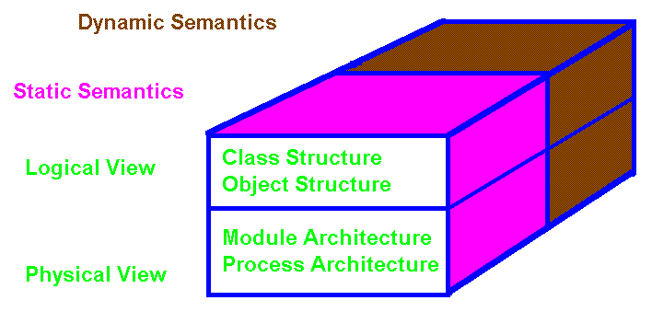

Booch Models for Object Oriented Design

LOGICAL VERSUS PHYSICAL MODELS:

What classes exist and how are those classes related? Class Diagram.

What mechanisms are used to regulate how objects collaborate? Object Diagrams.

Where should each class and object be declared? Module Diagrams.

To what processor should a process be allocated, and for a given processor, how should its multiple processes be scheduled? Process Diagram.

STATIC VERSUS DYNAMIC SEMANTICS:
It is difficult to describe a dynamic event in a static medium. In object oriented solutions we attempt to express dynamic semantics through: state transition diagrams, and timing diagrams.

ANALYSIS

USING THE

OBJECT MODELING

TECHNIQUE

(OMT)

"Object-Oriented Modeling and Design" by James Rumbaugh, Michael Blaha, William Premerlani, Frederick Eddy, and William Lorenson, published by Prentice Hall, 1991, ISBN 0-13-629841-9.

OBJECT MODELS

OBJECT MODEL: The object model describes a system in terms of the objects of which it is constructed - it shows their identity, their relationship to other objects, their attributes and operations. The object model provides an essential framework for understanding the dynamic and functional models.

DYNAMIC MODEL: The dynamic model describes those aspects of a system related to time and the sequencing of operations - events that mark changes, sequences of events, states that define the context for events, and the organization of events and states.

FUNCTIONAL MODEL: The functional model describes those aspects of a system concerned with transformations of values, functions mappings, constraints, and functional dependencies. This model captures what a system does without regard for how or when it is done.

Compare: Static vs Dynamic dataflow with control flow
Objects

Objects have:

- Attributes

- Operations and Methods

- Links and Associations

- Exhibit Multiplicity

5) Link Attributes

Object Modeling Technique Notation ( OMT )

Notation for Object Classes:

Class Name
attribute-name-1: data-type-1 = default-value-1
attribute-name-2: data-type-2 = default-value-2
* * *

operation-name-1(argument-list): result-type-1
operation-name-2(argument-list): result-type-2
* * *

A class diagram is a pattern or template that describes all possible instances of data and methods that an object of the class might have.

An object or instance diagram describes a particular object.
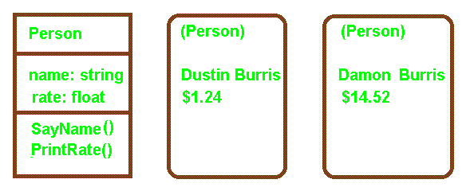
Class Definition Objects with values

Explicit object identifiers are not needed. Each object has its own unique identity. Two "people" (objects) with the same name and pay rate would still be unique and the systems could differentiate between them. You may invoke methods on the objects Dustin and Damon to Pay them or to ask them to say their name (SayName).
// in file shuttle2.cpp
#include <iostream.h>
#include <stdio.h>
#include <string.h>

class Shuttle{
private:
char shuttle_name[20];
char shuttle_destination[20];
int course;
public:
Shuttle(char *name, char *destination, int course_in); //constructor

void identify( );
void set_course( int new_course);
};

Shuttle::Shuttle(char *name, char *destination, int course_in){
strcpy(shuttle_name, name); strcpy(shuttle_destination, destination);
course = course_in;}

void Shuttle::identify(){cout << "Shuttle named " << shuttle_name <<
" bound for " << shuttle_destination << " course " <<
course << ".\n\n";}

void Shuttle::set_course( int new_course) { course = new_course;}
How many shuttles would you like? 3
Shuttle named ShuttleA bound for Freedom course 45.

Shuttle named ShuttleAA bound for Freedom course 45.

Shuttle named ShuttleAAA bound for Freedom course 45.

ShuttleAA change course to 38.
Shuttle named ShuttleAA bound for Freedom course 38.
void main()
{
char ch[2] = "A";
char name[20] = "Shuttle";
int m;

Shuttle* fleet[26];
cout << "How many shuttles would you like? ";
cin >> m; cout << "\n";

//Dynamic allocation of shuttles.
for(int i = 0; i < m; I++){ strcat(name, ch);
fleet[i] = new Shuttle(name, "Freedom", 45); }

for(i = 0; i < m; i++) fleet[i] -> identify();

cout << "\nShuttleAA change course to 38.\n";
fleet[1] -> set_course(38);
fleet[1] -> identify();
}
LINKS AND ASSOCIATIONS

A link is a physical or conceptual association between objects. A link is an instance of an association. A group of links with common structure and semantics is called an association. Associations are inherently bi-directional and frequently appear as verbs in a problem description.

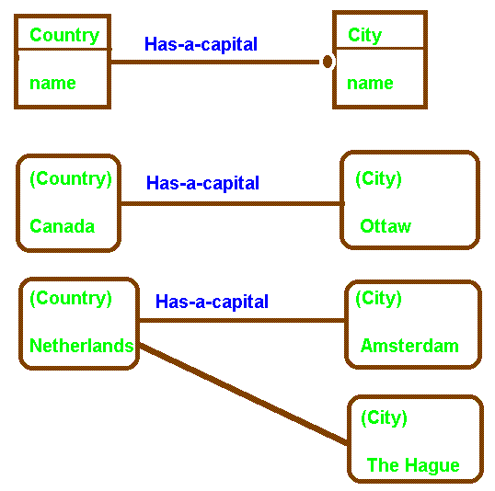
Cultural/Political capitals

One-to-Many Association and Links (1 : M)

"Object-Oriented Modeling and Design," by James Rumbaugh, Michael Blaha, William Premerlani, Frederick Eddy, William Lorensen, Prentice Hall, 1991, ISBN 0-13-629841-9.

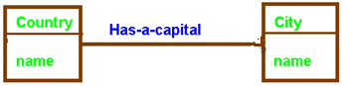
One-to-One (1 : 1)
Entity Relationships Expressed

Using Entity-Relationship (ER) Database Diagrams

 | Car |  | Driver
 |  | 1:1
 | Manager |  | Employee
 |  | 1:M
 | Manager |  | Employee
 |  | M:1
 | Rental Car |  | Customer
 |  | M:N

Flat files emphasize the storage of data. Programmers produce relationships between data items. Relational databases emphasize storage of data and relationships. Object oriented databases emphasize storage of data, user relationships, inheritance, and most importantly object behavior. In developing a relational definition for a database, the DBA (team) must:
- determine what datum must be retained,

- which datum exist only in the presence of other datum (records), and

- how collections of datum (records, tuples, etcetera) are related.

How collections of records are related is the most difficult thing to determine and potentially the most crucial to the long-term health of the database. The ability of users to manipulate data to produce information is directly related to how well the DBA has provided users the ability to utilize linkages.

These linkages or “relations” are a part of the way an organization conducts business. Only a person intimately involved with the operation of the enterprise will be likely to determine all such relationships. Relationships not anticipated at the time the database is defined may be hard or impossible to add latter.

Most business relationships are not ad hoc. A good designer should have no trouble anticipating 95% or more of the relationships a business utilizes and the frequency the relationship is required. These same principles apply to the development of object orient systems.
Object Oriented Database

 |  |  | Class Tire
Data Structures
--
Methods:
M1( ) { -- }
M2( ) { -- }
Balance( ) { -- }
 | Class Armored |  |  |  | Class Jet
 | Data Structures  -- |  |  |  | Data Structures:  --
 | Methods:  M3( ) { -- } |  |  |  | Methods:  M4( ) { -- }
 |  |  | Class Commercial |  | Class Military
 |  |  | Data Structures:  -- |  | Data Structures:  --
 |  |  | Methods:  -- |  | Methods:  --  Balance( ) { -- }
Tire aTire;
Armored armoredTire;
Commercial commercialTire
Military militaryTire;

Tire-Point: access all Tire; // Pointer variable to parent & children.

aTire.Balance( ); // Compile time bind.
armoredTire.Balance( ); // Compile time bind inherited.
commercialTire.Balance( ); // Compile time bind inherited.
militaryTire.Balance( ); // Compile time bind overridden.

Tire-Point = (AddressOf)commercialTire; //Point to grandchild.
Tire-Point.Balance( ); // Polymorphism, runtime bind

Tire-Point = (AddressOf)militaryTire;
Tire-Point.Balance( ); // Polymorphism, runtime bind

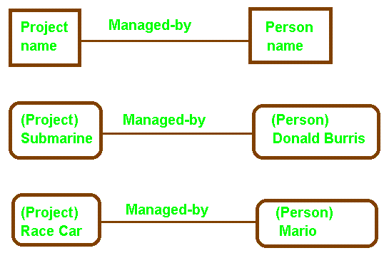
One-to-One Association and Links for Objects

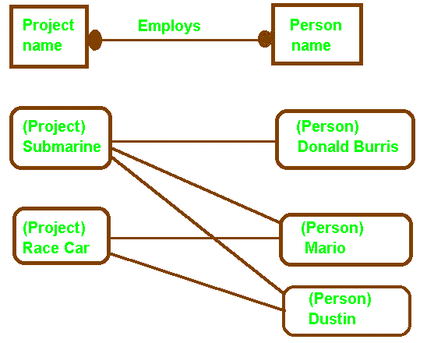
Many-to-Many Association and Links

Many-to-many relationships frequently occur in CAD/CAM applications, networks, or any other application that can be represented by a graph. As in database, the M:N relationship is typically implemented using a bridge relation. During specification the relationship is defined. The implementation bridge is created during design.
Many-To-Many Implementation Solution
Is Use of a Bridge Relation in Database Design

*
 | Course |  | Student
** An M:N relationships may be reduced to two 1:M relationships via the bridge!

 | Course | Has-Enrolled | Grade | Enrolled-In | Student
 |  | 1:M |  | M:1

 |  |  | History |  | English |  | Spanish |  | Math |  | Com Sci
 | Mary |  |  |  |  |  | B |  | D
 | Jim
 | Joe |  | B |  | B |  | C
 | Sam |  |  |  |  |  | B |  | A |  | B

Each “grade” in the bridge relation has exactly two pointers. One to represent its membership in the “Has-Enrolled” relation and one to represent its membership in the “Enrolled-In” relation.
Grade Record Format | Grade | Course Point | Student Point
Typically a bridge composite key consists of the key for each one side of each 1:M relationship.
Relational Database with “bridge” relation:

 | COURSE
 | Course | Room | Other
 | CS | LDB 418
 | Mth | LDB 216 |  |  | Key
 | Eng | EVN 212 |  |  | Course
 |  | 1:M
 | GRADE
 | Course | Grade | Name |  | Key
 | CS | A | Joe |  | Course+Name
 | CS | B | Betty
 | CS | C | Tom
 | Mth | A | Sara |  | Foreign Key:
 | Mth | C | Mary |  | Course -> Course
 | Eng | C | Mary
 | Eng | B | Betty |  | Grade -> Student
 | Eng | C | Sara
 |  | 1:N
 | Student
 | Name | Phone | Other |  | Key
 | Joe |  |  |  | Name
 | Betty
 | Tom
 | Sara
 | Mary

The key for the “bridge” relation is the combination of the keys on the “one” side of the one-to-many relationship. The key components in the bridge relation represent “foreign Keys” pointing to the relations being joined.

Course |  | Grade |  | Student
 | Course |  | Student

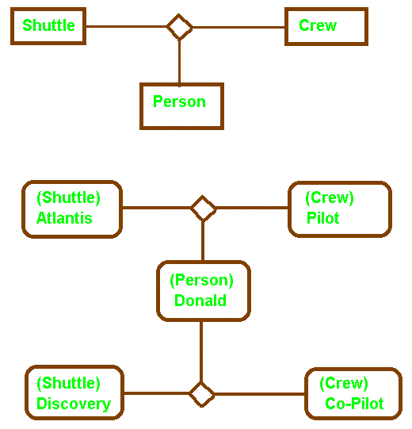
Ternary Association and Links

Most associations are binary, or a special restricted form of ternary called qualified. While high order relations are possible, they are more complicated to implement and should be avoided when possible.

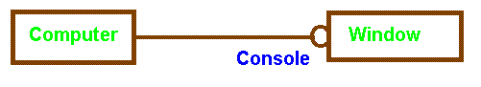
Zero-or-One Multiplicity

A computer may have one or none of its windows designated as a console for controlling a network and receiving network message. Console is a role name in this example.

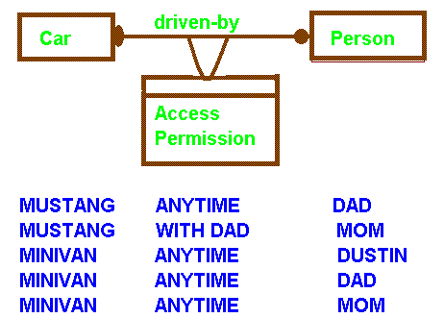

Link attribute for a many-to-many association

A link attribute is a property of the links in an association. Permission to drive is a property of the link, a joint property of both classes. Attachment to objects of either class would result in loss of information.

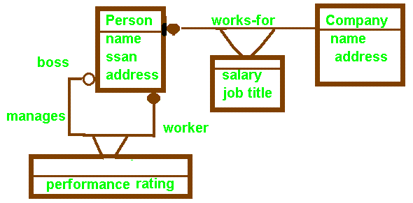
Many persons are employed (works-for) by the same company. As a result of the employment, each person has a salary and job title. People may work unsupervised or several people may be managed by a boss. The boss is responsible for performance ratings.
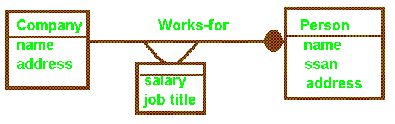
One-to-Many: Works.

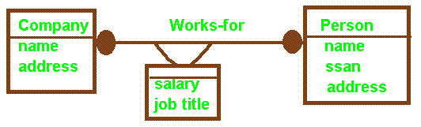
Many-to-Many: Works.

Example: Sam works for SHSU as a PGMR-1 and TDC as a MGR-3
Avoid folding link attributes into one of the classes.

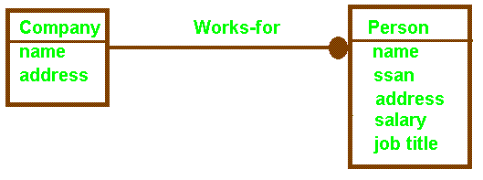
One-to-Many: Works.

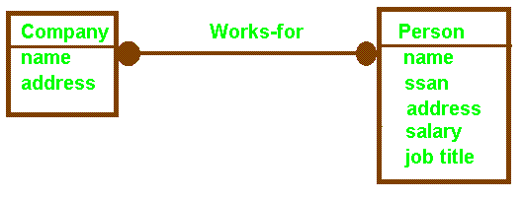
Many-to-Many: Fails without link attributes. Limits future use.

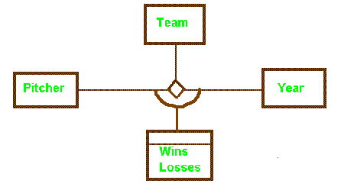

Harry Eisenstat Cleveland Indians 1939 6 7
Harry Eisenstat Detroit Tigers 1939 2 2
Willis Hudsin Cleveland Indians 1939 9 10
Willis Hudsin Cleveland Indians 1940 2 1
Willis Hudsin Washington Senators 1940 1 2
Willis Hudsin St. Louis Browns 1940 0 1

Link attributes in a ternary association

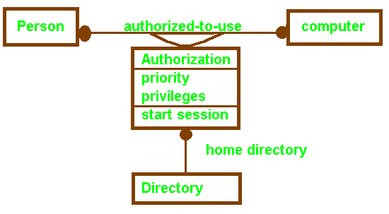
Modeling an Association as a Class

When links can participate in associations with other objects or when links are subject to operations, it is useful to model the association as a class.
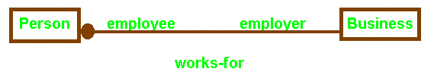
Role names for an association
Role names frequently improve the understanding of relationships.

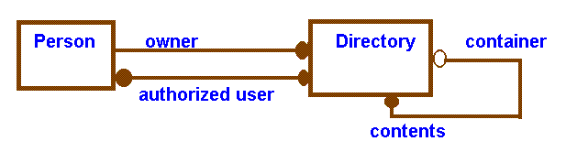
Role names help to distinguish multiple associations between the same pair of classes. They are required to distinguish associations between two objects of the same class, e.g. boss and worker in the manages association using class person.

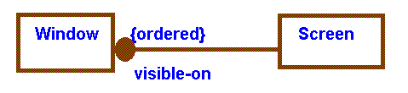
Windows on a screen are usually ordered. Only the topmost window is directly accessible.

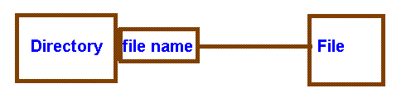
Qualification reduces a binary relationship to a lower level association. The Directory + file name identifies a unique file in DOS.
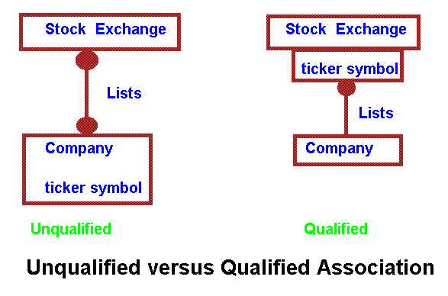
In the unqualified association, knowing a company's ticker symbol does not identify the stock exchange. In the qualified association, knowledge of the ticker symbol associates the company with a particular stock exchange.

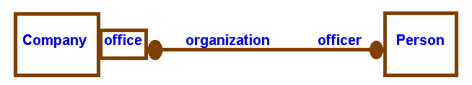
Many-to-Many Qualified Association

Cryogenics President David Burris
Cryogenics Treasurer Darlene Burris
Cryogenics Board of Directors Damon Burris
Cryogenics Board of Directors Dustin Burris
Cryogenics Board of Directors Donald Burris
NASA President Good Person
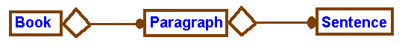
Aggregation

Aggregation should be used if the parts do not have a meaningful role separate from the whole.

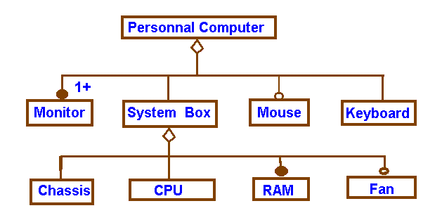
Multilevel Aggregation

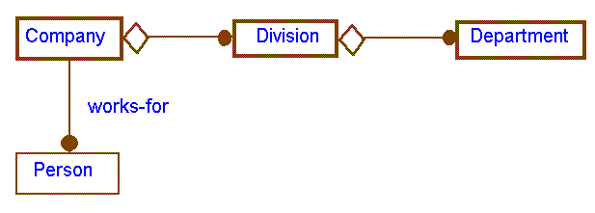
Aggregation and Association

If two objects are tightly bound by a part-whole relationship, use aggregation. If they exist separately, use association.

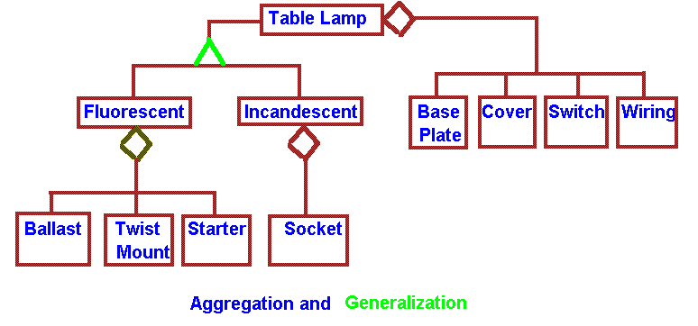

Aggregation relates instances, two distinct objects are involved where one is part of the other. Generalization relates classes. Generalization (inheritance) is a way of structuring the description of a single object.

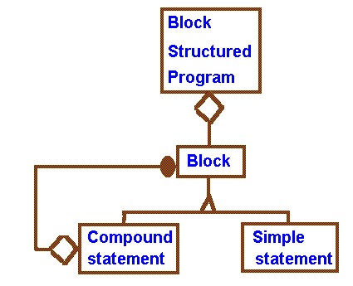
Recursive Aggregate

The OMT notation may be used in conjunction with meta languages like BNF to improve readability. Note “Block” is recursively defined.

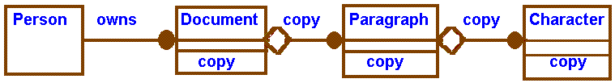
Propagation (Triggering) of Operations

To copy a document implies you copy paragraphs, which in turn implies you copy characters.

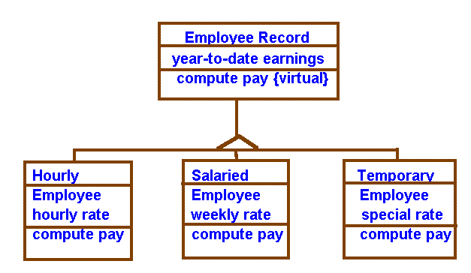
Virtual Class and Virtual Method

A virtual class (meta-class) has no direct (concrete) instances. A concrete class has distinct instances. Virtual classes help describe and aid development through inheritance. Virtual methods indicate a need for "over loading" or polymorphic methods.

Timing Diagrams and Scenarios

1) caller lifts phone  2) hears dial tone  3) caller dials digits (1)  4) dial tone stops  5) caller dials digit (2)  6) caller dials digit (3)  7) caller dials digit (4)  8) caller dials digit (5)  9) caller dials digit (6)  10) caller dials digit (7) | 11) called phone rings  12) called phone starts to ring  13) ring appears in calling phone  14) called phone picked up  15) ring stops in called phone  16) ring stops in calling phone  17) phones connected  18) caller hangs up  19) phones disconnected  20) called party hangs up
Scenarios: Completed call, line busy, trunk lines down, collect call, operator assisted, etcetera.

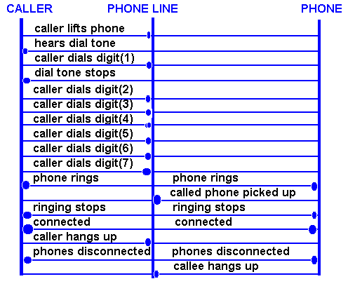
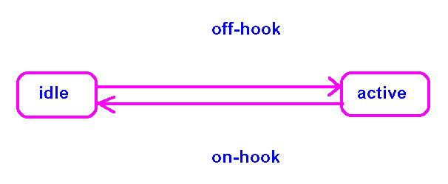
PHONE

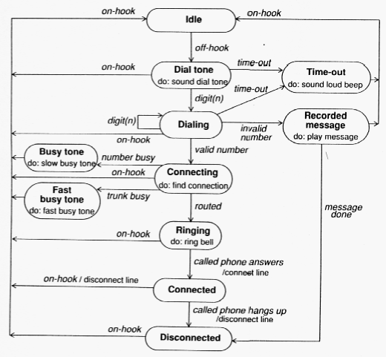

State diagram based on "Object-Oriented Modeling an Design" by James Rumbaugh, Michael Blaha, William Premerlani, Fredrick Eddy, and William Lorenson, published by Prentice Hall, ISBN 0-13-629841-9, page 94.
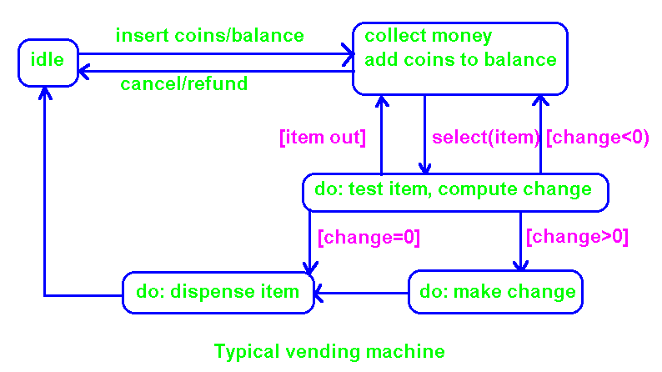

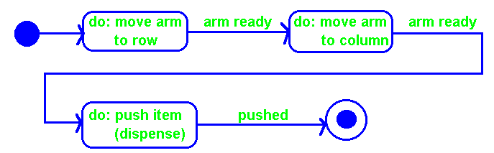
Dispense item action of vending machine.

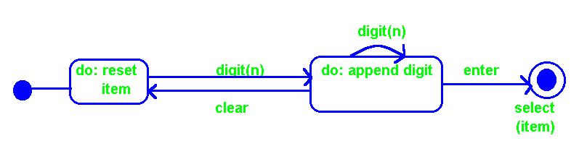
Select item activity of vending machine.
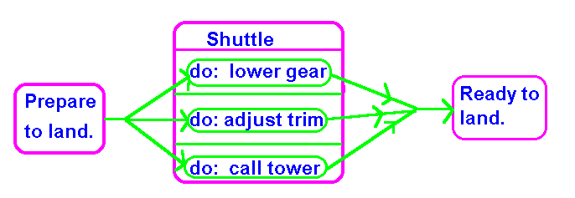

Synchronization of Concurrent Activities

Assume the shuttle is about to land and that there is an object that prepares it for landing. The internal activities do not have to be synchronized but all activities must be completed before proceeding to the actual landing. This is an example of dividing control into concurrent activities and then latter merging control.

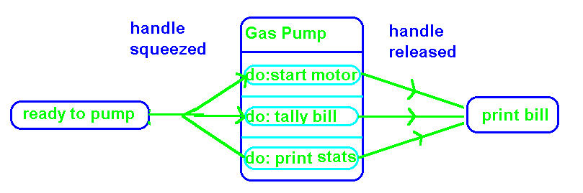
Automatic gas pump.

Implementing Link Attributes in Relational Databases

REPRESENTING M TO N RELATIONSHIPS

STUDENTS | <<---------------->> | COURSE
M to N

A student may enroll in many courses (but only one section), and a course may have many students enrolled in it.

STUDENT TABLE (key: Student, Course)
STUDENT COURSE SEX EYE COLOR
Joe | English | Male | Blue
Joe | History | Male | Blue
Joe | Computers | Male | Blue
Mary | Computers | Female | Green
Mary | English | Female | Green
Dustin | Computers | Male | Blue

COURSE TABLE (key: Course, Student)
COURSE ROOM TEACHER STUDENT
Computers | LDB-418 | Burris | Joe
Computers | LDB-418 | Burris | Mary
Computers | LDB-418 | Burris | Dustin
English | AB-1 | Luther | Mary
English | AB-1 | Luther | Joe
History | AB-1 | King | Joe

Note the high degree of qualifier and key field duplication. There is a very high chance for errors in consistency with respect to field contents. Since this solution is not 3rd Normal, it is subject to insertion, deletion, and update anomalies (ex: add Math to “Course” – need dummy entry for student).
REPRESENTING M TO N RELATIONSHIPS

The solution is to use an intermediary table (bridge relation) replacing the direct MANY-TO-MANY with two ONE-TO-MANY relations.

COURSE | <-------->> | ENROLL | <<------> | STUDENT
1 to M M to 1

COURSE TABLE (Key: Course)
COURSE ROOM TEACHER
Computers | LDB-418 | Burris
English | AB-1 | Luther
History | AB-1 | King

ENROLL TABLE (Key: Course, Student – composite of primary keys on “1” side of the two 1:M relationships)
COURSE STUDENT Grade
Computers | Dustin
Computers | Joe
Computers | Mary
English | Joe
English | Mary
History | Joe

STUDENT TABLE (Key: Student)
STUDENT SEX EYE COLOR
Dustin | Male | Blue
Joe | Male | Blue
Mary | Female | Green

Keys are duplicated in the "joining" table, but duplication of qualifier fields is greatly reduced. Most insertion, deletion, and update anomalies are eliminated in 3rd Normal Form (ex: adding Math to “Course” – does not require dummy values.

Implementing Link Attributes in Ada

Desire a Many to Many Relationship
 | Business |  |  |  | Person
 | Data Structures |  |  |  | Data Structures
 | Methods |  |  |  | Methods

Design to Implement using a Link Attribute
 | Business |  |  |  | Person
 | Data Structures |  |  |  | Data Structures
 | Methods |  | U |  | Methods
 |  |  | Hire Data
Title
Wages
 |  |  | Methods

Implement Business to Person for Illustration with code.
 | Business |  |  |  | Person
 | Name  City  Emp_Pt |  |  |  | Name  City
 | Get_Name( )  Get_City( )  Put( )  Hire( )  Put_Employee( ) |  | U |  | Get_Name( )  Get_City( )  Put( )
  Hire Data
  Title
  Wages
  aPerson: in out Person_Pointer;
  aHire: in out Hire_Data_Pointer;

Assume the system business and persons. We decide a business may hire at most one person. A person may work for at most one business. When hired, a person receives both a title and wage. Business and Persons may exist independent of each other. Assume employees will only be accessed via the employer.

Hint: To allow a business to employ more than one person, consider placing the hire data pointers in an array within the business. A similar array (or queue) within Person would allow a person to work for more than one business.

-- file Link_IO.ads
with Ada.Text_IO;
package Link_IO is
procedure put(Item: Character) renames Ada.Text_IO.put;
procedure put(Item: String) renames Ada.Text_IO.put;
procedure new_line(Spacing: Ada.Text_IO.Positive_Count:=1)
renames Ada.Text_IO.new_line;

type Person_Name_Type is (Darlene, Damon, Dustin, Donald, David);
package Name_IO is new Ada.Text_IO.Enumeration_IO(Person_Name_Type);
procedure put(Item: Person_Name_Type;
Width: in Ada.Text_IO.Field
:= Name_IO.Default_Width;
Set: in Ada.Text_IO.Type_Set
:= Name_IO.Default_Setting)
renames Name_IO.put;

type City_Name_Type is (Huntsville, Livingston, Houston, Cut_Shoot);
package City_IO is new Ada.Text_IO.Enumeration_IO(City_Name_Type);
procedure put(Item: City_Name_Type;
Width: in Ada.Text_IO.Field
:= City_IO.Default_Width;
Set: in Ada.Text_IO.Type_Set
:= City_IO.Default_Setting)
renames City_IO.put;

type Business_Name_Type is (ACME, SHSU, TDC, Disney_Land);
package Business_IO is new Ada.Text_IO.Enumeration_IO(Business_Name_Type);
procedure put(Item: Business_Name_Type;
Width: in Ada.Text_IO.Field
:= Business_IO.Default_Width;
Set: in Ada.Text_IO.Type_Set
:= Business_IO.Default_Setting)
renames Business_IO.put;

type Job_Title_Type is (Manager, Sales, Analysist, Grunt);
package Job_IO is new Ada.Text_IO.Enumeration_IO(Job_Title_Type);
procedure put(Item: Job_Title_Type;
Width: in Ada.Text_IO.Field
:= Job_IO.Default_Width;
Set: in Ada.Text_IO.Type_Set
:= Job_IO.Default_Setting)
renames Job_IO.put;

type Money is delta 0.01 range 0.00..100.00;
package Money_IO is new Ada.Text_IO.Fixed_IO(Money);
procedure put(Item: in Money;
Default_Fore: Ada.Text_IO.Field := 4;
Default_Aft: Ada.Text_IO.Field := 2;
Default_Exp: Ada.Text_IO.Field :=0)
renames Money_IO.put;

end Link_IO;
--file LinkAt.ads
with Link_IO; use Link_IO;
package LinkAt is

type Person_Type(N: Person_Name_Type; C: City_Name_Type) is tagged record
Name: Person_Name_Type := N;
City: City_Name_Type := C;
end record;

type Person_Pointer is access all Person_Type'Class;
function Get_Name(aPerson: Person_Pointer) return Person_Name_Type;
function Get_City(aPerson: Person_Pointer) return City_Name_Type;
procedure put(aPerson: Person_Pointer);

type Hire_Data_Type is record
Title: Job_Title_Type:= Grunt;
Wage: Money := 0.0;
Employee: Person_Pointer;
end record;

type Hire_Data_Pointer is access Hire_Data_Type;

type Business_Type(N: Business_Name_Type; C: City_Name_Type) is tagged record
Name: Business_Name_Type := N;
City: City_Name_Type := C;
Emp_Pt: Hire_Data_Pointer;
end record;

type Business_Pointer is access all Business_Type'Class;
function Get_Name(aBusiness: Business_Pointer) return Business_Name_Type;
function Get_City(aBusiness: Business_Pointer) return City_Name_Type;
procedure put(aBusiness: Business_Pointer);

procedure Hire(aBusiness: in out Business_Pointer;
aPerson: in out Person_Pointer;
aHire: in out Hire_Data_Pointer;
aTitle: in Job_Title_Type := Grunt;
aWage: Money := 0.00);
procedure Put_Employee(aBusiness: Business_Pointer);
end LinkAt;

--file LinkAt.adb
with Link_IO; use Link_IO;
package body LinkAt is

function Get_Name(aPerson: Person_Pointer) return Person_Name_Type is
begin return aPerson.Name; end;

function Get_City(aPerson: Person_Pointer) return City_Name_Type is
begin return aPerson.City; end;

procedure put(aPerson: Person_Pointer) is
begin put(aPerson.Name); put(" "); put(aPerson.City); new_line; end;

function Get_Name(aBusiness: Business_Pointer) return Business_Name_Type is
begin return aBusiness.Name; end;

function Get_City(aBusiness: Business_Pointer) return City_Name_Type is
begin return aBusiness.City; end;

procedure put(aBusiness: Business_Pointer) is
begin put(aBusiness.Name); put(" "); put(aBusiness.City); new_line; end;

procedure Hire(aBusiness: in out Business_Pointer;
aPerson: in out Person_Pointer;
aHire: in out Hire_Data_Pointer;
aTitle: in Job_Title_Type := Grunt;
aWage: Money := 0.00
) is
Hire_Data_Pt: Hire_Data_Pointer;
begin
Hire_Data_Pt := new Hire_Data_Type;
aBusiness.Emp_Pt := Hire_Data_Pt;
Hire_Data_Pt.Employee := aPerson;
Hire_Data_Pt.Title := aTitle;
Hire_Data_Pt.Wage := aWage;
end;

procedure put(aHire: Hire_Data_Pointer) is
begin
put(aHire.Title); new_line;
put(" Wage = "); put(aHire.Wage,6,2); new_line;
end;

procedure Put_Employee(aBusiness: Business_Pointer)is
begin
put("Print employera and employee data: "); new_line;
put(aBusiness);
put(aBusiness.Emp_Pt);
put( aBusiness.Emp_Pt.Employee);
end;
end LinkAt;
--file UseLnAt.adb
with Link_IO, LinkAt; use Link_IO, LinkAt;
procedure UseLnkAt is
P1, P2, P3: Person_Pointer;
B1, B2, B3: Business_Pointer;
D1, D2, D3: Hire_Data_Pointer;
begin
P1 := new Person_Type(Donald, Huntsville);
put(P1); new_line;
B1 := new Business_Type(SHSU, Huntsville);
put(B1); new_line;
Hire(B1, P1, D1, Analysist, 18.27);
new_line;
Put_Employee(B1);
new_line;

P2 := new Person_Type(Darlene, Livingston);
B2 := new Business_Type(SHSU, Huntsville);
Hire(B2, P2, D2, Sales);
new_line;
Put_Employee(B2);

end UseLnkAt;

