Software Engineering

(TestPlanning.doc)

by

David S Burris

Ph.D. in Computing Science

Certified Computer Programmer

Certified Systems Professional

Certified Computing Professional

csc_dsb@shsu.edu

Permission is granted to students in my classes to use any or all of the material in this document for their personnel educational in conjunction with course textbooks. All other rights reserved. Materials may not be transmitted to individuals not registered in my classes.
Validation and Verification

Validation:

Making sure that we are "building the right product." The main method is by checking the current form of the product, and particularly the final form of the product with the requirements. The customer must be consulted to make sure there are no misunderstandings. This is the desired product!

Verification:

Making sure that we are "building the product right." This is accomplished by comparing each work product with its predecessor to make sure that each part grows correctly from its prior form.

We also verify the process by making sure that we comply with established organizational standards, conduct technical reviews, prototyping, and generally assure the quality of the product.

Dijkstra: “Testing can not be used to demonstrate program correctness.” Testing only demonstrates the program produces the desired result for a specific set of inputs and circumstances.
Common View of Testing:

A successful test in one in which no errors are found.

Glen Meyers, "The Art of Software Testing," Wiley 1979.

1) Testing is a process of executing a program with the intent of finding an error.

2) A good test case is one that has a high probability of finding an as yet undiscovered error.

3) A successful test is one that uncovers an as yet undiscovered error.

4) A good test reduces by a count greater than one, the number of additional tests cases that must be designed to achieve reasonable testing.

5) A good test tells us something about the presence or absence of a class of errors rather than an error associated only with the specific test at hand.

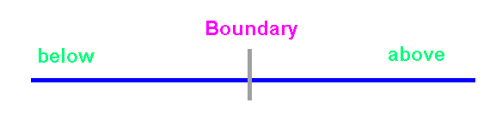
Data should include one datum below the boundary, one datum above the boundary, , crossing the boundary, and the boundary itself. Example FICA tax with tax rate and limit.

Our objective is to design tests that systematically uncover different classes of errors with a minimum amount of time and effort.
Test Information Sources

Sources for Test Input:

1) Software Requirements Specification
(e.g., list of features and interactions)

2) Design Specification
(e.g., coverage unit and work in combination, test all abstractions required to meet user requirements, e.g., bridge relations.)

3) Source Code

These sources should be used to develop

1) Test Plan and Procedure
(start prior to coding)

2) Test Cases

3) Expected results

4) Regression Testing

Software Quality Assurance (SQA)
and Software Reviews

Industry studies at TRW, Nippon Electric, Mitre Corp and others indicate that design activities introduce between 50% and 65% of all errors (defects) during the development phase of software projects. Formal review techniques have been shown to be up to 75% effective in uncovering design flaws.

Reviews should be conducted to:
• Point out improvements in the product of a single person or team.

• Confirm those parts of a product in which improvement is either not needed or desired.

• Help to achieve a more uniform, predictable level of quality than can be achieved without reviews.

Reviews are desirable after:

• System specification to get client approval.

• Design.

• Coding.

• Development of test cases.

T. C. Jones, "Programming Productivity," McGraw-Hill, 1986.

"Implementing Software Inspections," course notes, IBM Systems Sciences Institute, IBM Corporation, 1981.

M. Fagan, "Design and Code Inspections, and Process Control in the Development of Programs," IBM Technical Report 21.572, December 1974.
Daniel P. Freedman and Gerald Weinberg, "Walkthroughs, Inspections, and Technical Reviews Evaluating Programs, Projects, and Products," 3rd edition, 1982, Little Brown and Company, ISBN 0-316-292826.
Formal Technical Reviews or
Structured Walk Throughs

Walk-throughs are most productive when:

• The material to be discussed is distributed to the attendees for review two or three days before the walk through. Management must support the position that all attendees do their home work prior to the walk-through to avoid wasting the groups time.

• The number of attendees is limited to four or five and the session to about one hour. The project manager may be barred from the walk-through if they are not technically competent or it is felt their presence may inhibit the frank and open exchange of ideas. Education of junior members is a goal of the review process.

• In some cases, it may be necessary to include an impartial mediator to resolve disputes. Raise issues, don't resolve them. Watch your language, be humble, avoid critical negative phrasing. Stick to the issues. There is always some danger an overly aggressive group will be detrimental to a designer or programmer who is not very sure of their work. On the other hand, an overly aggressive individual may overwhelm the suggestions or criticisms of the group.

• Technical reviews should specifically "avoid" redesigning systems or programs. The purpose of the meeting is to verify the specification/design/code accomplishes the desired purpose and identify problems. Spontaneous group designs almost always end in failure.

• Formal notes should be taken and the individual or group that is the subject of the inspection should be expected to respond to the groups suggestions in a reasonable time.

• The entire "group" is responsible for any flaws or bugs in the final product.
To illustrate, assume

• the cost of a error uncovered during design cost 1.0 monetary units to correct.
• The same error uncovered just before testing commences will cost 6.5 units (relatively speaking).
• During testing, 15 units.
• If not found until after release, 60 to 100 units.

Then the development cost comparison:

Errors Found | Number | Cost Unit | Total
 | Reviews | Conducted
During design | 22 | 1.5 | 33
Before test | 36 | 6.5 | 234
During test | 15 | 15 | 315
After release | 3 | 67 | 201
 |  |  | 783
 | No Review | Conducted
Before test | 22 | 6.5 | 143
During test | 82 | 15 | 1230
After release | 12 | 67 | 804
 |  |  | 2177

Relative cost comparison base on actual data collected for large software projects in "Implementing Software Inspections," course notes, IBM Systems Sciences Institute, IBM Corporation, 1981. This material is summarized in "Software Engineering A Practitioner's Approach," 3rd edition, by Roger Pressman, McGraw-Hill, 1982, pp 558-562, ISBN 0-07-050814-3.

M. Fagan in "Design and Code Inspections, and Process Control in the Development of Programs," IBM Technical Report 21.572, December 1974 found that code inspections after design and coding save about one programming month per 1000 non comment source statements.
Test Case Design Methods

1) White/Glass Box Test:
Knowing the internal workings of a product, tests can be conducted to be sure that all paths are exercised. Exhaustive testing is seldom feasible (compiler – infinite number of legal/illegal; license plates – large upper bound).

White box testing typically discovers from 50% to 70% of software errors.

Most popular form of traditional testing.

2) Black Box Testing:

Knowing the specified function that a product was designed to perform, tests are conducted to demonstrate that all functions (individually and as a group) are fully operational.

In black box testing there is little or no interest in the internal structure of the software. Black box testing finds the "blind spots" in a design. It also locates areas that work well under normal circumstances yet result in errors whenever data happens to be somewhat unusual.

Alan Eliason, "Systems Development Analysis Design & Implementation," Little Brown, p 495, ISBN 0-316-23256-4.

3) Regression Testing:
Save test and results for future use.
White Box Testing

Ideally all datum should be tested exhaustively but this is seldom feasible. For example, assume a license plate consisting of letters and digits in the form LLL-DDD. The number of combinations of data is 26*26*26*10*10*10 = 17,576,000 possibilities.

A language translator must accept an infinite number of correct programs and reject an infinite number bad programs.

We compromise by:
• guarantee that all independent paths within a module have been exercised at least once
• exercise all logical decisions on their TRUE and FALSE sides
• execute all loops at their boundaries and within their operational bounds
• exercise all internal data structures to assure their validity

A) Logic errors and incorrect assumptions are inversely proportional to the probability that a program path will be executed.

B) We often believe that a logical path is not likely to be executed when, in fact, it may be executed on a regular basis.

C) Typographical errors are random.

D) Errors are seldom uniformly distributed.

"Bugs lurk in corners and congregate at boundaries." White box testing is far more likely to uncover them.

B. Beizer, "Software Testing Techniques," 2nd ed., Van Nostrand Reinhold, 1990.
Black Box Testing

Most popular forms include:
• Stress tests to determine capacity and response limitations.
• If a minimum amount of data is required for accurate results, test with the exact amount as well as too little.
• Normal Path Test - verify valid data leads to valid results.
• Error Path Test - verify invalid data leads to proper error processing. Normal Path Testing combined with Error Path Testing is also know as "Equivalence Partitioning."

•Black box testing should be heuristically directed at all command interfaces:
♦ Specify commands with incorrect syntax; use subtle and blatant variations of the correct form.
♦ Provide syntactically correct input that is out of sequence or specified at the wrong time. Enter data above, below, and not in the valid range.
♦ Type a partially correct command then terminate the command entry.
♦ Omit all commands, just hit return.
♦ Generate a system interrupt immediately after a command is entered.

• Check for incorrect or missing functions, functional validity.

• Look for interface errors.

• Check for errors in data structures or external database access.

• Check for initialization / termination errors.

• Is the systems sensitive to certain inputs or ranges.
Since errors cluster at boundaries rather than at the center of an input domain, tests should be developed:

1) For an input with a range bounded by values A and B, test cases should be designed with values equal to A and B, just above and just below A and B respectively.

2) If an input specifies a number of discrete values, test cases should be developed that exercise the minimum and maximum numbers. Test cases should also be tried that are just above and below the extremes.

3) Guidelines 1 and 2 should be applied to output conditions. For example if a table of shuttle re-entry parameters is to be generated, test cases should be generated to produce the minimum and maximum size table.

4) Be sure to test all internal data structures at their boundaries. Programmers do not like to do this.

Fact:
♦ The cost of finding and repairing defects increases exponentially the latter they are found in the process.
♦ As a result, preventing defects is generally less expensive than finding errors, even early in the process.
♦ Testing can never be expected to locate all the problems in software.
♦ Most organizations do not generate uniformly distributed random errors, rather the errors they generate fall into repetitive classes. It doesn't make sense to uniformly spend time and money attempting to improve quality, rather resources should be concentrated in the error prone areas.
♦ Programming changes are highly error-prone, all changes should be view as potential sources of error injection.

As a result World Class Software Organizations collect defect statistics on both the Upstream (specification and design) as well as Down-stream process (coding and testing).

Statistical Quality Assurance implies:
1) Information about software defects is collected and categorized.
2) An attempt is made to trace each defect to its underlying cause (e.g., specification, design, violation of standards, poor communications with the customer).
3) The Pareto principle (80% of the defects can be traced to 20% of all possible causes) is used to isolate the 20% of major error types.
4) Once the vital few categories have been identified, the majority of available resources are committed to correct the problems that have caused these defects.

Practitioners should spend their time and money on things that really matter. The purpose of Statistical Quality Assurance (SQA) is to determine what really matters!
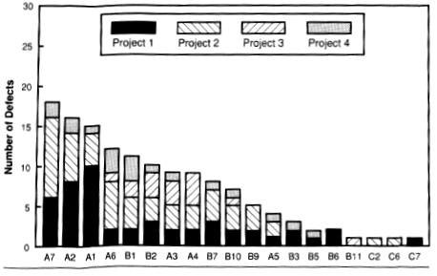
This Pareto distribution, a ranking of the number of defects by cause starting with the most prevalent on the left, is from "Software Metrics; Establishing a Company Wide Program" by Robert B. Grady and Deborah L. Caswell, 1987, p125, Englewood Cliffs, NJ: Prentice-Hall. See also "Measuring and managing software maintenance," IEEE Software, September 1987. Using this data from four programs, Hewlett-Packard was able to establish that over one third of the defects were constrained to only three categories. By focusing their process improvement in these areas they reported significant quality improvements.

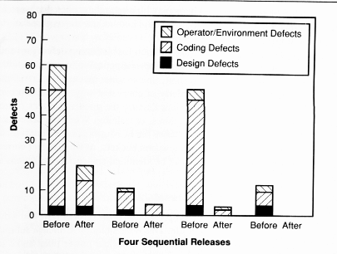
According to Grady more than a third of the errors were due to poor understanding of the user's interface requirements. By establishing an extensive prototyping and design review program, the number of defects for four successive releases dropped from 25% of the total for the first two releases to less than 10 percent for the third release, and to zero in the forth release. This process is called Cause Analysis.

At least one company using defect prevention methods reports a 50% reduction in defects found during development and a 78% reduction in errors shipped.

Typical error categories include:
• Incomplete or erroneous specifications (IES).
• Misinterpretation of customer communications (MCC).
• Intentional deviation from standards (IDS).
• Violation of programming standards (VPS).
• Error in data definition or representation (EDR).
• Inconsistent module interface (IMI).
• Error in design logic (EDL).
• Inaccurate or erroneous testing (IET).
• Inaccurate or incomplete documentation (IID).
• Error in programming language translation of design (PLT).
• Ambiguous or inconsistent human-computer interface (HCI).
• Miscellaneous (MIS).

Watts S. Humphrey, "Managing the Software Process," reprint 1990, Addison-Wesley, pp. 350 - 387, ISBN 0-201-18095-2.

Roger S. Pressman, "Software Engineering A Practitioner's Approach," 3rd ed., 1992, pp. 578 - 581, ISBN 0-07-050814-3.

Robert Grady and Deborah Caswell, "Software Metrics: Establishing a Company Wide Program," Englewood Cliffs, NJ: Prentice-Hall, 1988, *****required reading ***.

Edward Yourdon, "Decline & Fall of the American Programmer, Yourdon Press, Prentice-Hall, 1992, ISBN 0-13-203670-3.
The best testing is done by a separate test team.

♦ A separate team attempts to show the software has errors, not that its correct. Their ego is not attached to the quality of the product as they did not write it.

♦ By concentrating on testing, they get practice and develop techniques regular programmers have neither the time or inclination to develop.

♦ The team should be judged solely on how well they "test."

♦ To prevent interference from management, the team should report to a different manager than the management responsible for developing the software.

♦ The team should not be allowed to work directly on the software.

IBM “Black Team”

Tom DeMarco, "Controlling Software Projects Management Measurement & Estimation," 1982, Yourdon Press: Prentice-Hall, ISBN 0-13-171711-1.

Tom DeMarco and Timothy Lister, "Peopleware Productive Projects and Teams," Dorset House, 1987, ISBN 0-932633-05-6.
A natural tendency for new programmers is to mix idea, e.g., mix code for state tax and federal taxes in an attempt to reduce the total code written. Another natural tendency is to write one monolithic program. As requirements increase, the existing code just gets larger to accommodate the requirements.

By the late 1960’s, a movement to emphasize “maintenance of functional domain” (one or very limited number of ideas per module) was being lead by individuals such as Edsgar Dijkstra [“Programming Considered as a Human Activity,” in Proc. 1965 IFIP Congress, North-Holland Publishing Co., 1965]. Dijkstra emphasized structured programming, attempting to write code that could be read like a book without undisciplined branching. All functional modules should have a single entry point and single exit point. Psychologist have shown that limiting the ideas in a function and limiting control constructs contributes to human understanding. The process is called “chunking.”

Niklaus Wirth emphasized “top-down iterative refinement” and designed the language Pascal to support this design principle [“Program Development by Stepwise Refinement,” CACM, Vol. 14, No. 4, 1971, pp. 221-227].

In 1966, C. Bohm and G. Jacopini [“Flow Diagrams, Turing Machines, and Languages with Only Two Formation Rules,” Communications of the ACM, Vol. 9, No. 5, May 1966, pp. 336-371] demonstrated that any idea that may be expressed on a digital computer never requires more than three control constructs. In fact, a program may be constructed in principle that can be read from top to bottom like a book when properly written utilizing these three control structures. The work of psychologist and others has suggested that the human mind is more productive when the set of control constructs is minimal or near minimal.

This minimal set of control structures according to Bohm and Jacopini includes:
- Simple sequence (most languages execute statements sequentially in the order encountered).
- Simple choice (selection) with a compound statement for both true and false.
- A simple loop mechanism. The test may be at the top or bottom. Testing at the top of the loop is frequently more convenient.

Sequential | Wake |  | Choice |  | Wake |  | Loop |  | Wake
 |  |  |  |  | Eat
 | Eat |  |  |  |  |  |  |  | Eat
 |  |  |  | No |  | Yes
 |  |  |  |  | Weekend?
 | Work |  |  |  |  |  |  |  | Work
 |  |  |  | Work |  | Play
 |  |  |  |  |  |  |  | Yes
 | Rest |  |  |  | Rest |  |  |  | Live?
 |  |  |  |  |  |  |  | No

McCabe’s Cyclomatic Complexity Measure and Basis Path Testing

Flow graphs depict logical control flow. Any procedural design representation can be translated into a flow graph.
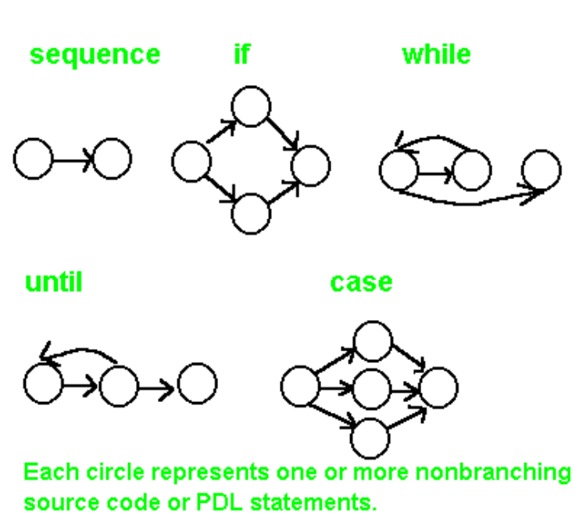

Cyclomatic Complexity, V(G), is the number of regions in a planar graph. Count all bounded regions and the unbounded area outside the graph. Empirical evidence suggests that modules where V(G) >= 10 are highly prone to errors and extremely difficult to adequately test. There appears to be a distinct relationship between McCabe’s metric, the number of errors existing in the code, and the time required to find and correct such errors.
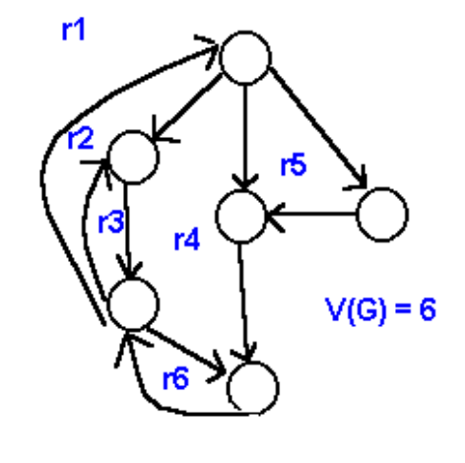

Quantitative Measure of Difficulty: based on decisions – control flow!
Basis Path Testing

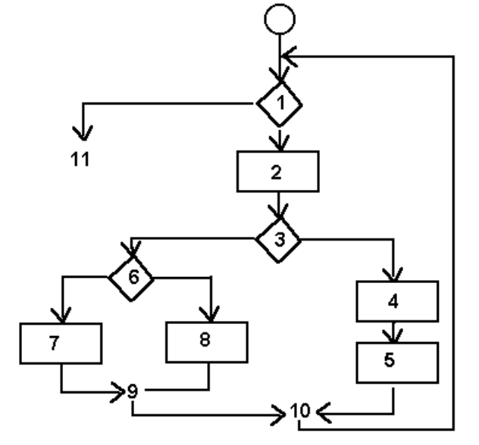
Procedural (flow chart)
Design showing program control structure.

A node may contain one or more procedural statements. A set of procedural statements and a decision may map into the same node. Nodes are connected by edges. A node containing a condition is termed a predicate node.

Corresponding flow graph assuming no compound conditions are contained in the decision diamonds.
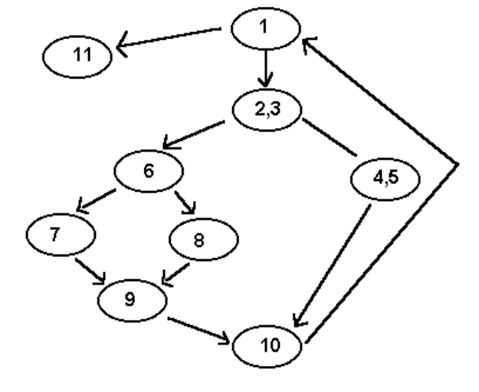

Cyclomatic Complexity is the number of independent paths in the basis set and provides an upper bound on the number of independent tests that must be conducted to ensure every instruction is executed at least once. To be independent, a path must introduce at least one new set of processing statements or conditions.

Paths (there are only four):
1) 1 - 11
2) 1 - 2 - 3 - 4 - 5 - 10 - 1 - 11
3) 1 - 2 - 3 - 6 - 8 - 9 - 10 - 1 - 11
4) 1 - 2 - 3 - 6 - 7 - 9 - 10 - 1 – 11
Cyclomatic Complexity
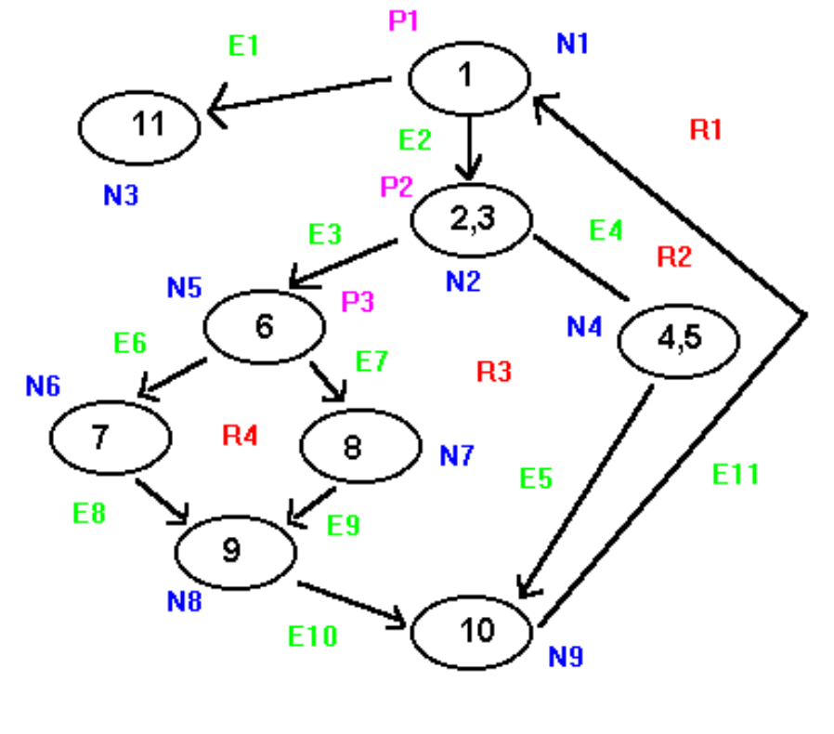
Cyclomatic Complexity may be computed in one of three ways to determine the basis set.

1) The number of regions of the flow graph correspond to the Cyclomatic Complexity.

2) V(G) for a flow graph, G, is defined as V(G) = E - N + 2 where E is the number of flow graph edges and N is the number of flow graph nodes.

3) Cyclomatic Complexity, V(G), for a flow graph G is also defined as V(G) = P + 1 where P is the number of predicate nodes contained in the flow graph G.

Example:
1) The flow graph has 4 regions.
2) V(G) = 11 edges - 9 nodes + 2 = 4.
3) V(G) = 3 predicate nodes + 1 = 4.
V(G) provides an upper bound on the number of independent paths that comprise the basis set, and by implication, an upper bound on the number of tests that must be designed and executed to guarantee coverage of all program statements.

PDL
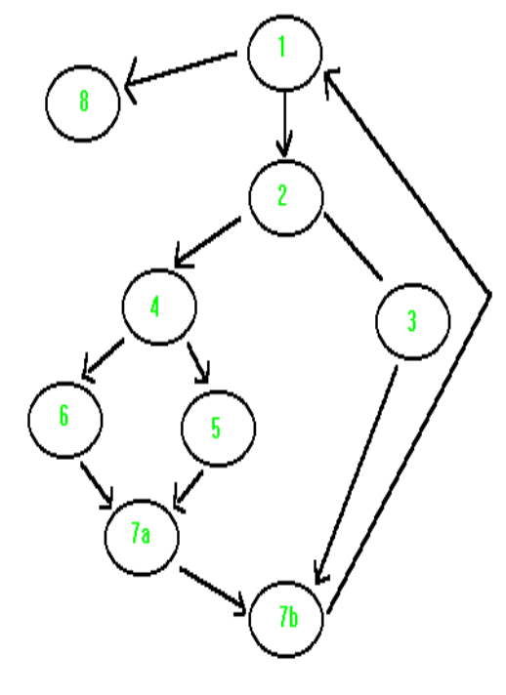
Procedure SORT
1: do while records remain
read record;
2: if record field 1 = 0
3: then process record;
store in buffer;
increment counter;
4: elsif record field 2 = 0
5: then reset counter;
6: else process record;
store in file;
7a: end if
endif
7b: end do
8: end procedure

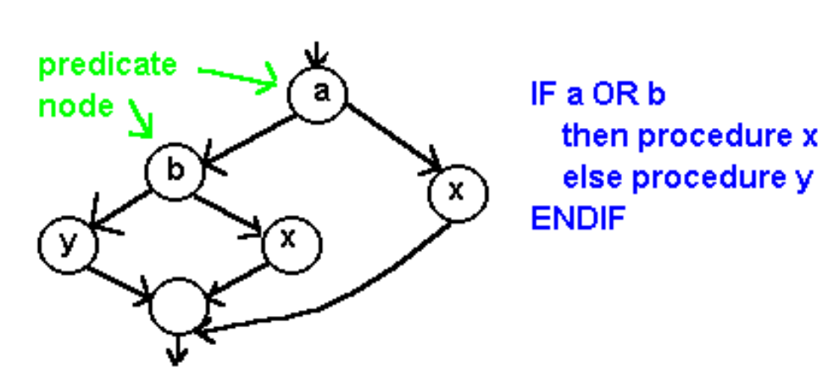
“Software Engineering A Practitioner’s Approach” by Roger S. Pressman, 3rd Edition, McGraw Hill, ISBN 0-07-050814-3, p 575-576, 601- 605.
System Changeover

- Direct Method: Complete one-time conversion from the old system to the new system. A “big bang” if it fails!

- Pilot Method: Bring up the entire system for a single user group, but not all users at the same time. This is a “little bang” if it fails.

- Phased (modular) Method: Seeks to divide a system into pieces and install a piece at a time. Minimal shock to user community.

- Parallel: Often preferred in conjunction with the phased approach. Both the old and the new system are run in parallel until the new system operation is verified and the users are ready for the change. Expensive but frequently the safest approach in critical situations. This requires that every transaction be captured and processed on both systems.

Alpha Testing – user with developer
Beta Testing – user by self
Automated Testing Tools

Categories:
- Static Analyzer: Supports proving static allegations of correctness on structure / format.

- Code Auditor: Filter to check coding standards.

- Assertion Processor: Proff of correctness aid.

- TestFile Generators: Create typical inputs.

- Test Data Generators: Automated analysis system to help user select data to make a program behave in a prescribed manner.

- Test Verifer: Measures internal test coverage, loops, etceteras.

- Test Harness: Aid to a) install a candidate program in a test environment, b) feed it input data, c) simulate by stubs the behavior of subordinate (subsiderary) modules.

- Output Comparator: Automatic comparison of sets of outputs for differences or similarities.

- Symbolic Execution System: Testing using algebraic input rather than numeric data.

- Environemnt Simulators: Enables modeling the external environment of real-time software.

- Data Flow Analyzer: Tracks the flow of data to find undefined data references, incorrect indexing, and other data related errors.

Critical Applications

When failure results in loss of life or unacceptable loss of property.

1) Air Traffic Control

2) Air Defense

3) Cardiac Monitor System

4) Rail and Subway Systems

5) Critical Communications Systems

Hardware Reliability

1) Statistical Reliability Theory

2) Redundant Circuits

3) Self Checking (Parity, Cyclic
Redundancy Checks)

4) Majority Voting Logic

5) Duplicated Systems

6) Fall-Back and Switchover

Reliable Software

1) SOFTWARE REDUNDANCY

a) Dual computations achieved through non-identical components.
Area Triangle = ½ base times * height.
Area triangle with sides A, B, and C = sqrt((S*(S-A)*(S-B)*(S-C)) where S = (A+B+C)/2
b) Triple redundancy or higher allows voting.

2) SELF CHECKING PROCEDURES

a) Checksums.

b) Checkdigits.

c) Hash (SHA, MD5)

3) REVERSIBLE COMPUTATIONS

Assume A1 and B1 as inputs to a function, FNC1(A1,B1), that computes results R1, R2. Now use the results as inputs to a function, FNC2(R1, R2), that reverses the computations producing results A1' and B1' in an attempt to approximate the original inputs. The computations are accepted as correct if A1, B1 and A1', B2' are acceptably close.

4) APPROXIMATION & REASONABLENESS CHECKS

Check Digit (credit card numbers etceteras)
Properly done, more than 95% accurate in catching transposition and substitution errors committed by carbon based life forms.

Ex: for 43726
4 + 3 + 7 + 2 = 16 then 16 modulo 10 = 6

Ex: given 43926 in error:
4 + 3 + 9 + 2 = 18 then 18 modulo 10 = 8

Ex: given 43276 in error
4 + 3 + 2 + 7 = 16 then 16 modulo 10 = 6 – error missed

Using positional weights modulo 11 for 4372:
4 * 1 + 3 * 2 + 7 * 3 + 2 * 4 = 39 then 11 – (39 modulo 11) = 5

Implies: 43725

Ex: 43275
4 * 1 + 3 * 2 + 2 * 3 + 7 * 4 = 44 then 11 – (44 modulo 11) = 11 fails!

Certification

Institute for the Certification of Computing Professionals (ICCP)

IEEE Computer Society
