Book of Projects
“The only source of knowledge is experience”, Albert Einstein
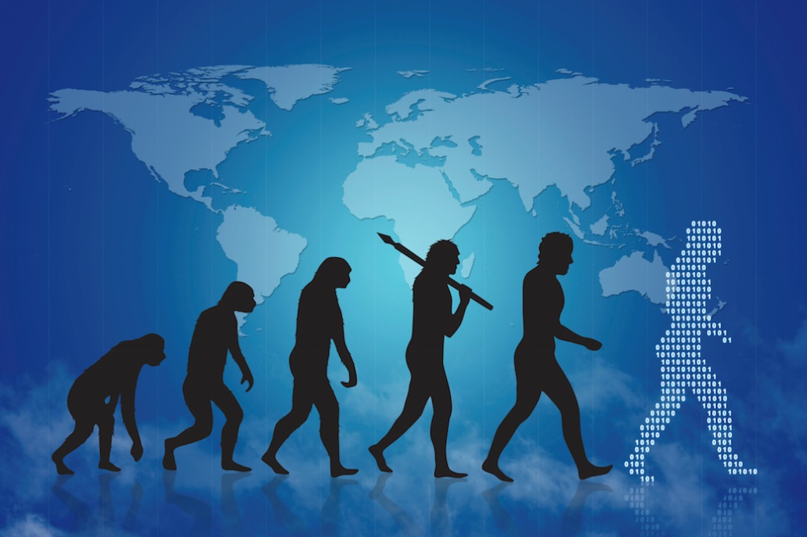

Summary

Tracer 1
Autonomous Robot Car 2
Freescale Cup 3
Leds Controller via Android 4
Video Game (Battleship) 5

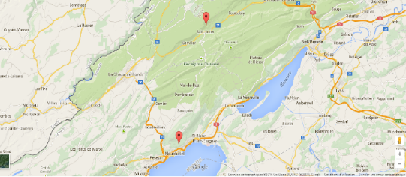
Figure 1 Map with the localization of the two embedded boards

Figure 2 Wapsmote board
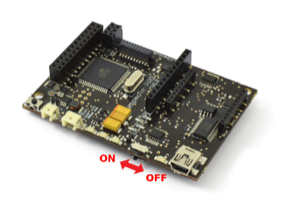

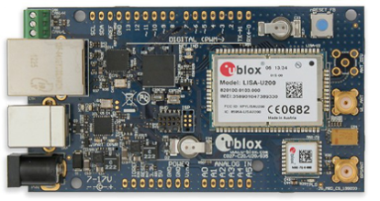
Figure 3 Ublox board
Goal
To know the placement of a parcel in real time through embedded systems

Team
2 Students in Bachelor of Informatics specialized in embedded system (third year)

Programming Software
MBED platform, Waspmote platform

Material used
Ublox C027 and Wapsmote embedded board

Programming language
C, C++

Time of work
50 hours (February 2015 – April 2015)
Methods
The user enters the arrived coordinates and his phone number in a text file. The text file is saved in a webserver. The embedded system receives his GPS coordinates every 5 minutes through a GPS module and sends it to the server. The server compares the received coordinate with the saved coordinate. If the coordinates correspond, the server sends a message with the user's phone number to the embedded system. The embedded system sends at this time a SMS to the user to inform him that his parcel is arrived.

Final Result
Each embedded system receives its GPS coordinates and sent them to the server. A SMS is sent to the user when the parcel is arrived

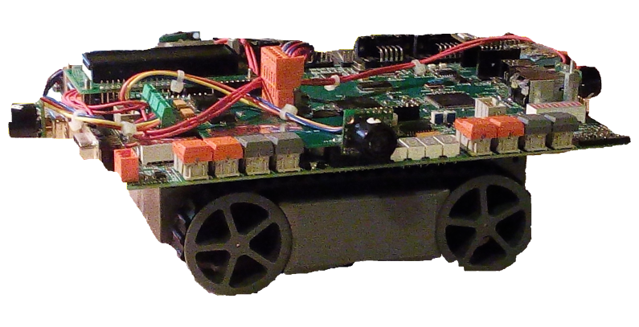
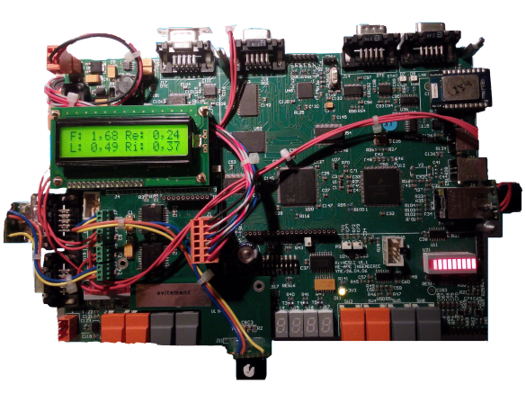
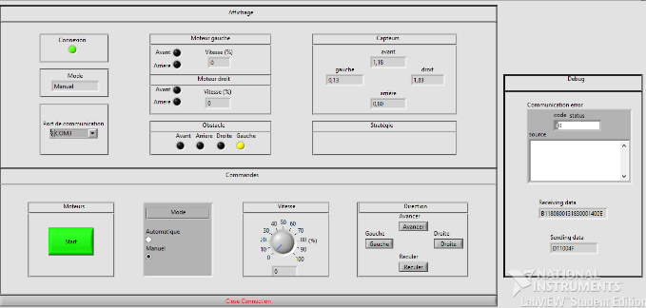
Figure 4 Robot car (left view)
Figure 5 Robot car (top view)
Figure 6 Monitoring with Labview

Goal
The robot may move in an unknown environment and avoid the obstacles. The robot may be guided through a software interface.

Team
Alone in Bachelor of Informatics specialized in embedded system (third year)

Programming software
Codewarrior, LabVIEW

Programming Language
C

Time of work
150 hours (February 2015 - May 2015)

Method
Ultrasonic sensors are used to determine the distances on each side of the robot. This one move automatically without touching any obstacle. Through the software interface, the robot can be guided by a user through the software interface or move freely. On the software interface each distance of each sensor, between the robot and an eventual obstacle, can be visualized.

Final Result
The robot moves automatically and can be guided through the software interface. On the software interface can the speed, the start and stop of the robot and the automatic and manual mode chosen.

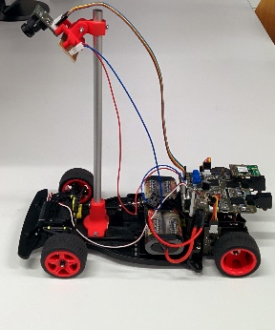
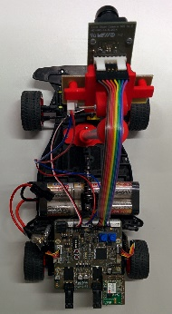
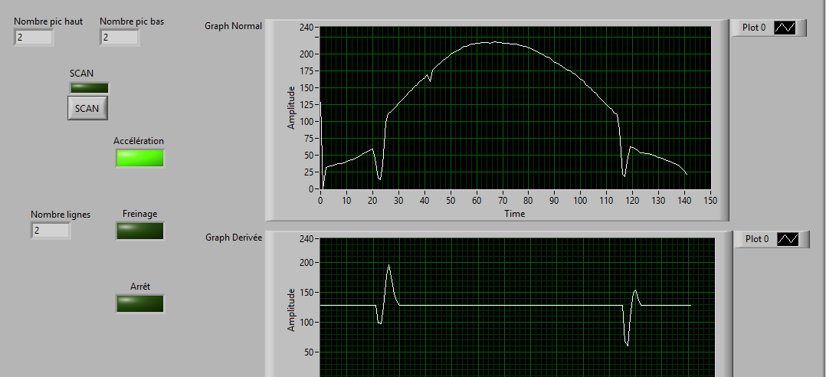
Figure 7 Freescale Cup's car (left view)
Figure 8 Freescale Cup's car
Figure 9 Monitoring Labview

Goal
The robot may move as speed as possible on a white circuit, with two lines on each part, without going out of it.

Team
Two students in Bachelor of Informatics specialized in embedded system (third year).

Programming Software
Codewarrior, LabVIEW

Programming language
C

Time of work
200 hours (September 2014 - February 2015)

Method
The robot has a camera on the top of a stand, which is on the front of the robot and allow the visualization of the circuit. The result coming from the visualization of the camera is processed and, depending on the result, its differently interpreted on the engines (acceleration, braking, turn right or left, etc.). The result of the processed image could be visualized on a software interface.

Final Result
The robot can drive without going out of the circuit. The processed image can be visualized on a software interface with the state of the robot (acceleration, breaking, stopped) and the average speed.

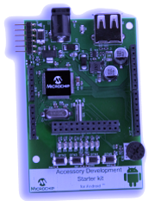
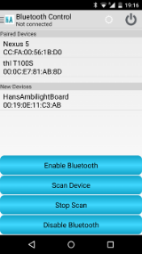
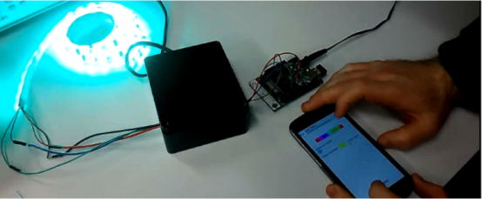
Figure 10 PIC24F (from Microchip)
Figure 11 One of the page of the Android application
Figure 12 complete assembly with PIC24F board, the transistors (black box) to put the PWM color from the board to the leds
Goal

Creation of an android application which allows the change of led's color long-distance.

Team
Two students in Bachelor of Informatics specialized in embedded system (third year).

Programming Software
Eclipse (programming of the Android application), MPLAB X IDE (programming of the embedded board)

Time of work
200 hours (September 2014 – February 2015)

Programming Language
C (for the embedded board) and Java Android (for the Android application)

Time of work
200 hours (September 2014 – February 2015)

Method
The color is sent through the Bluetooth from a phone to an embedded board (where the leds are connected). This board receives the frame with the value of the colors and adapts them to send it, as a Pulse Width Modulation (PWM) signal, to four transistors. This four transistors are used to convert this PWM signal to a power signal and have the corresponded color on a led’s band.

Final Result
The color changes in four methods (phone rotation, movement of shake and through a slider).

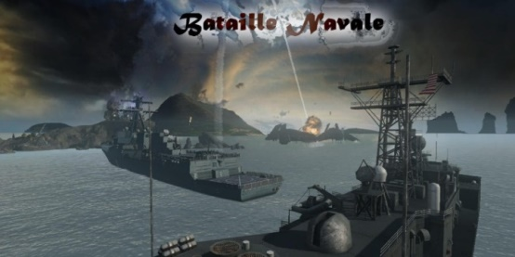
Figure 13 First page of the video game
Goal
Creation of a video game which may allow a player to plays against a computer.

Team
2 Students in Bachelor of Informatics specialized in embedded system (first year)

Programming Software
Eclipse, SQL Library
Programming Language
C

Time of work
200 hours (February 2013 - June 2013)

Method
The player places his ships on a predefined grill. The placement of the computer’s ships is done randomly on another grill. The player and the computer play each in turn.

Final Result
Each ship can be placed on the grill without going beyond the grill. Ships are randomly placed without being visible to the player. Each one plays in turn till one player has no ship anymore.

