Quantitative assessment method for domain name system isolated management risk
SiYu Liang¹, ZhuoRan Wang²
GuangZhou University, GuangZhou, China
Abstract. DNS(domain name system) is an important infrastructure of the Internet, providing domain name resolution services for a large number of internet applications and users. However, the DNS is managed by various countries. When the Internet of various countries are isolated from each other, the DNS of various countries may not run by themselves, noted as Isolation Management Risk. To lower the risk, some country has set up a domestic root server instance so that reliance on overseas domain name servers for root zone resolution is relieved. However, the normal domain name resolution in a country which deployed root server instance, to a certain distant, is still confronted with the Isolation Management Risk. Currently, there is no effective way to quantify the Isolation Management Risk of DNS. In order to quantify DNS Isolate Management Risk, this paper proposed an effective approach to assess DNS Isolate Management Risk within a specific of time and areas.
Keywords: Domain Name System.
- Introduction
The domain name system(DNS)[7] plays a crucial role in the operation of Internet. DNS helps us using Internet easier by acting as a distributed database and mapping domains and their corresponding IPs. Almost all activities on the Internet rely on DNS, including web application, email, etc.
The recursive server requires a multiple levels of domain name servers including root servers, top level domain name servers and authoritative domain name servers to iteration resolute domain name. In the process of iteration domain name resolution. First, the recursive server requests the TLD zone information from root domain servers. Then, it queries the TLD servers to obtain the authoritative name server data which includes the domain name server's IP. Finally, the recursive server could fetch the domain name resolution result from its domain name server.
The iteration domain name resolution requires the stable of network connections between each domain name server. However, the DNS is managed by various countries. In some extreme situations, the Internet of various countries could be isolated from each other by the organizations that have the ability to block their export routers. Therefore, this can lead to abnormal behaviors of the network access and failure of the DNS service. We call this isolate management risk. A capable organization can invalidate a country's DNS by isolate attacking.
In order to protect DNS services against this risk, departments from various countries deployed root server instances[9] which provide root domain resolution services in the domestic. The root server instances can clone the root zone configure files from the root servers, so that the recursive servers could access the root server instances by anycast technology and resolve the root domain name when they face some isolated attacks. Deploying the root server instances reduces the damage of isolate management risk.
But isolated attack can still affect DNS resolution. The root server instances could not provide the authoritative domain resolution. Under isolated attack, recursive servers have no ability to access the authoritative servers if they were not deployed in a same isolated area. Anyway, the recursive servers could not resist one hundred percent of the isolate management risk.
To measure the extent of isolated management risk, this paper provide a method to quantitatively assess this risk, making the process of observing DNS defenses clearer.
This method provides an indicator, POSD(proportion of overseas server dependency) to define the degree of the damage to the Isolation Management Risk. Isolated attack makes individual countries unable to access the name servers which from other areas. If an overseas domain name server is needed for domain name resolution, we will refer to this domain name as an OSD (Overseas Server Dependency) domain. So that, in a specific area, the higher proportion of OSD in the user domain name resolution requirements, the greater the harm caused by the isolated attack.
- Related work
It is proposed that the centralization structure of DNS root server contains power abuse risk[1].
Disappearance risk: There may have an organization which have power to delete a top-level domain record from the root zone files, people calls it as disappearance risk[1]. When an organization make a ccTLD(country code top level domain[8]) disappear from the root zone, every domain name under that top level domain would not be able resolved by any recursive server.
Blindness risk: If the root server could be controlled by an organization and has able to refuses providing services for recursive servers within a specific area, people calls it as blindness risk. Users could not access the Internet, who rely on a recursive server which has been blinded and could not provides resolution services.
The risk of root power abuse seriously jeopardizes the openness and equality of the Internet. This paper proposes a method to quantitatively analyze the risks to ensure the security[13] of the Internet.
Namecoin[4], based on Bitcoin’s[10][11] blockchain[12] technology, implements a distributed key-value pair database, which is currently used for ".bit" domain name registration. Namecoin realizes the decentralization of domain name registration and distribution. However, such a system which completely not authoritative leads to some problems. Namecoin facing trouble that domain name squatting and the lack of dispute resolution mechanism, and how to integrate with the current DNS system is still unclear.
decentralized distributed domain name resolution system[5] has become a research focus. Its design concept mainly includes two core components:
Country root: The country root coexists with 13 existing root servers. It can provide root zone resolution and interact data with other country roots.
Root alliance: A large number of country roots compose to root alliance. Country roots from root alliance interact with each others based on peer-to-peer protocol. Members of the alliance voluntarily exchange DNS zone files according to the content of the agreement, so as to realize an open and equal governance structure of the Internet.
The country root coexists with the existing DNS root servers, and the recursive servers could choose the country roots or the existing root servers as the hint zone.
Beyond that, there are some common threats to DNS:
DDOS attack[15]: DDOS attack is the most effective and simplest attack against DNS. When a domain name server is attacked by DDOS, the resources of the server are exhausted.
cache poison attack[19]: It is the creation of DNS server packets that refer domain names to incorrect IP addresses.

- Problem statement
DNS as an critical Internet infrastructure that most of our behavior on the Internet depends on. The process of DNS resolution is not complex, but it relies on the name servers from different country. This situation carries risks.

  - DNS vulnerabilities
There are some defects from the DNS resolution process.
In a normal DNS resolution process, the client sends a domain name resolution request to a recursive server, then the recursive server would performs iterative resolution after it receives the DNS packet.
First, the recursive server requests the root servers for getting the information of TLDs(top level domains). Then, it queries the TLD servers to obtain the domain's name servers data. After that, the recursive server could fetching the resolution result by requesting the domain name authoritative server.
During this process, the recursive server plays a key role, it has to communicate with other domain name servers. It means that, blocking the communication link between recursive servers an

  - Isolation management risk
In reality, it is likely that the export route of a certain country is blocked for some reason, causing shut down of communication. And such risk is Isolation management risk(IMR). Isolated attack makes it only possible for the domestic communication but impossible for any data transferred abroad through the export route. In certain circumstances, some organizations in this world own the technology and power to lsolate certain country from the Internet.
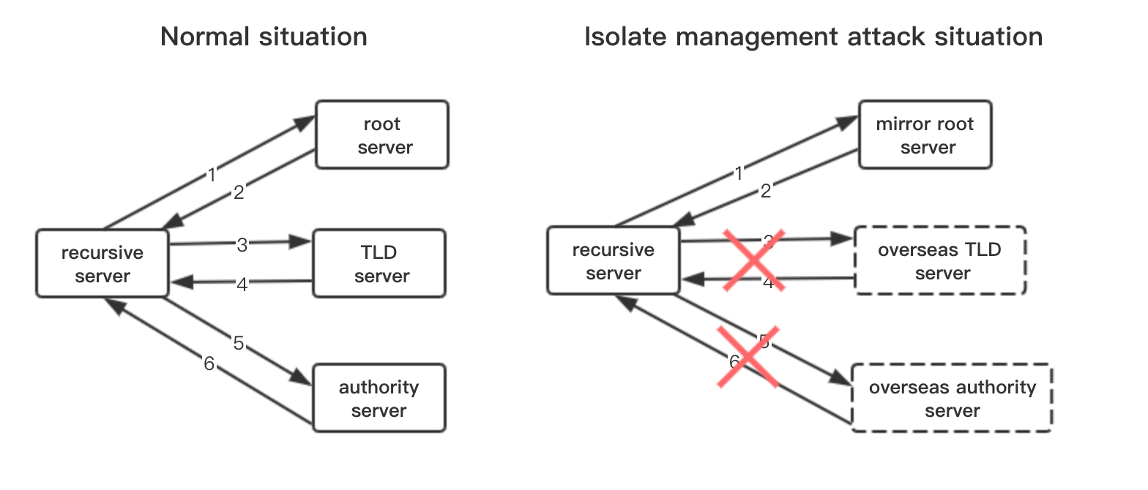
Fig. 1. Isolate attack.

  - Damage
The isolated attack could damage the Internet of an area. The biggest effect is that large number of DNS resolutions are failed. It seems like the domain name system totally down in this area. In this case, many web applications may not work at all and the users of this area have no access to the Internet. If the area cover a country, would cause bigger problem.

  - Preventive measures
Now, here are some measures to prevent DNS isolated management risk. For instance, some organizations deploy root server instances domestic to provide the root domain resolution. The root server instances make it possible for recursive servers to resolve the root domain without relying on the root domain servers from other countries. It could reduces the damage of their country's Internet under isolated attack.
- Method for assessment isolation management risk
However, the current precautions they proposed could not totally eliminate the isolated management risk. This paper provide a approach for quantitative assessment the risk. With this method, user could evaluates how damaging the isolate management risk is in specific area.

  - Proportion of overseas server dependency
We propose an indicator, POSD(Proportion of overseas server dependency), to measure the degree of damage to isolated attack. POSD is the proportion of user DNS resolution demands that depend on overseas servers.
In the process of domain name iterative resolution, recursive server has to access other domain name servers. Once in a while, some of those domain name servers are deployed at other area. When an area including a recursive server is being isolation attacked, the recursive server has no ability to access domain name servers which deployed at other area. If the domain name server what we need in a domain name resolution process has be blocked, the DNS request would failed.
In order to know how degree of damage to isolated attack, we could calculate the proportion of failed DNS requests to all user requests. That's why we propose the POSD indicator.
For example, there are great demands of oversea domain name resolutions in user DNS requests of China. Most of these domain name resolutions rely on oversea servers. When China being isolated attack, the degree of the damage would be large. However, there are not much domain name demands like that in the United States. For example, they don't often need to resolve the domain name like ".cn". So the dependence on oversea domain name servers will be relatively small in United States, and they receives relatively little damage under isolated attack.
First, we collect all the user DNS resolution logs. By extracting this log files, we could obtain a DNS requests list of users, named RDL(request domain list). It represents all domain resolution requirements in this area.
Then, we filter domain names that must rely on overseas domain name servers from RDL. We call these domain names as OSD(overseas server dependency).
This paper define POSD as the proportion of OSD in RDL, which could represent the degree of DNS isolated management risk.
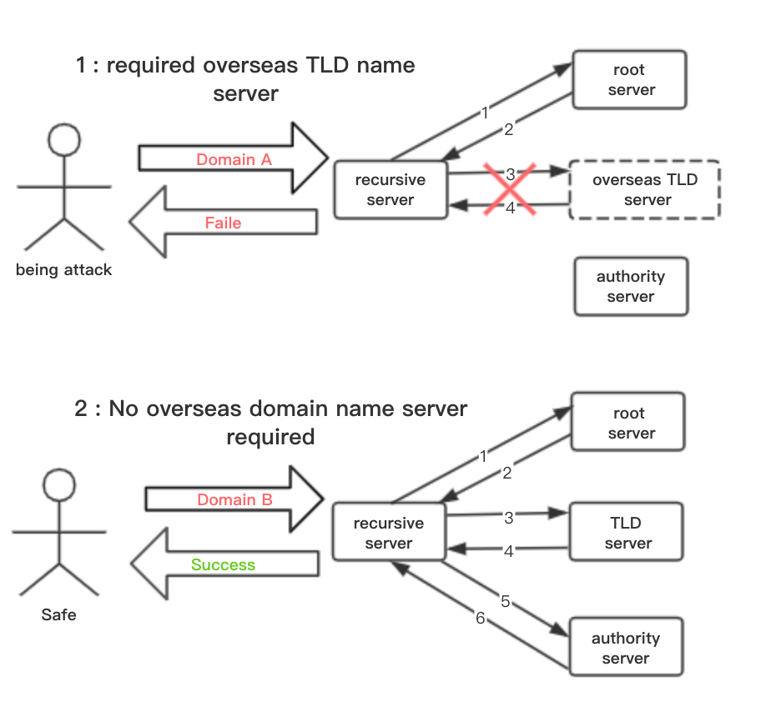
Fig. 2. Effects of isolated attacks.

  - Measurement process
1、DNS request data collection
First, we collect the user DNS resolution logs. By randomly collecting the user DNS requests from the legitimate channels, such as telecom operators and network administrators, to estimate the overall user resolution requirements. Then filter the RDL from these log files.
To make the results more realistic, the purity of the logs is very important. So that, it's necessary to avoid the bad data when collecting user DNS request logs, such as web crawler data, net attacking packets, etc.

2、Track domain resolution
After fetching RDL, we should extract the OSD domain names from the domain name list. Here we comes out a method to make the classification work.
First, we split each zones of each domain names in RDL, then resolve them by recursive server to fetch their name servers' IPs. For instance, "www.abc.com", we divide it into three sections: "com.", "baidu.com.", "www.baidu.com." and resolve them one by one. We could determine these IPs by publicly available IP geolocation databases[6] whether they are deployed abroad or not. We could define each domain names in this process as OSD or not, then save the OSDs.
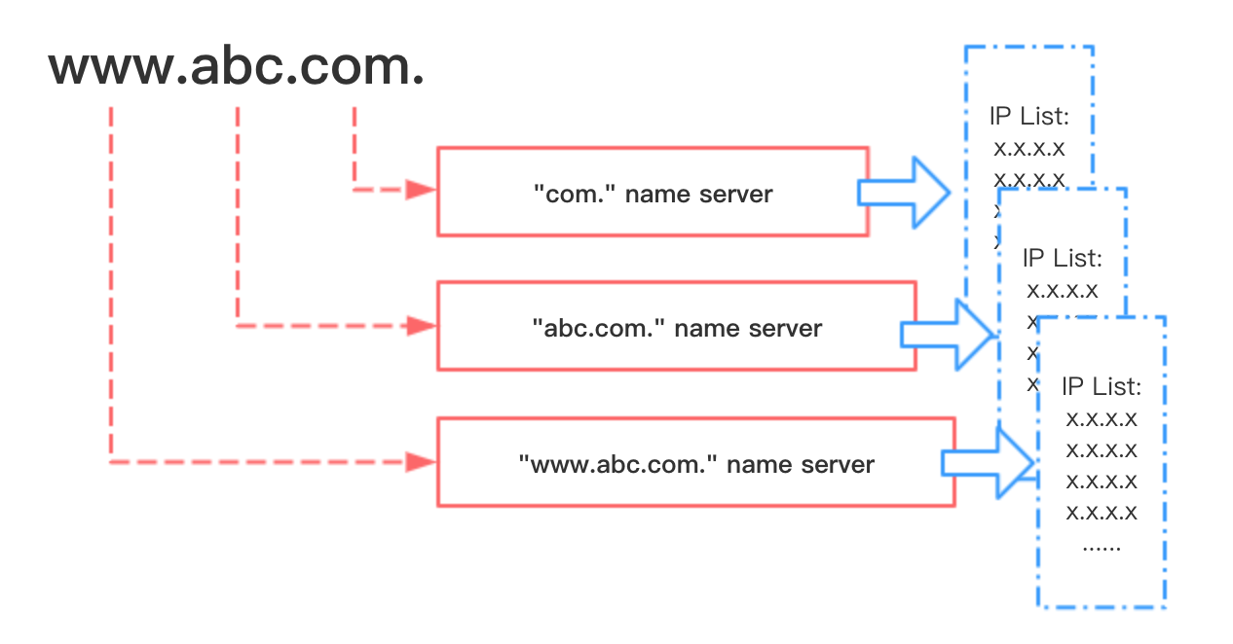
Fig. 3. Running example of tracking domain name server.

3、Statistical
We could calculate the POSD after fetching RDL and OSD. It is likely that when isolated management risk occurs, the more affected DNS resolution requests the network have, the more damage the network is.

POSD = OSD / RDL

POSD is numerically the proportion of OSD in RDL. We define this as the degree of damage to isolated management risk.

  - Running example
Here is an running example to demo how we could use this method.
China and the United States have deployed their DNS with root servers, authoritative servers, recursive servers and a certain number of user clients. In particular, we assume that China has deployed the stable root server instances. In this case, all recursive servers would not cache any DNS requests.
We suppose that there are 100 users in China, and each client makes a randomly DNS requests every 1 second. Then we collect the users' DNS request logs and analyze them. With the analysis result, we found that about 7/10 of the domain name demands belonged to OSD. So the degree of the damage to isolated management risk is 70%. We assume that their are the same scenario in the US, but they have only 1/10 of their users domain name demands belonged to OSD. Because most of the major name servers are deployed at US, so that their users could finish a large number of domain name resolutions domestic. Therefore, the degree of damage to isolated management risk are different between China an US.
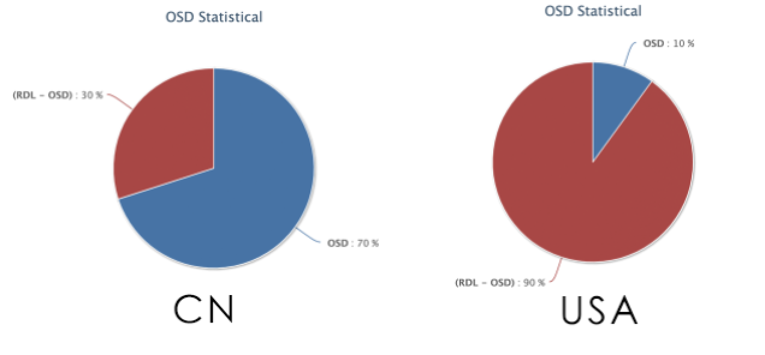
Fig. 4. Running example data compare.

- Conclusion
This paper propose a method and indicator, POSD, which can quantitatively evaluate isolated risks in a certain area. With this method, the isolation management risk could be discovered in time. To objective analysis the security of the Internet.

References
- B.X. Fang, "Country Autonomous Root Domain Name Resolution Architecture from the Perfective of Country Cyber Sovereignty", Information Security and Communication Privacy, no. 12, pp. 35-38(in Chinese), 2014.
- B.X. Fang, "United National root DNS system A blockchain based solution", https://itforum.admhmao.ru/upload/iblock/e68/binxing-fang.pdf, last accessed 2019/11/8
- Verisign Homepage, https://www.verisign.com/, last accessed 2019/11/8.
- "Namecoin", http://namecoin.info, last accessed 2019/11/8.
- ZHANG Yu, XIA Zhongda, FANG Binxing, ZHANG Hongli, "An Autonomous Open Root Resolution Architecture for Domain Name System in the Internet", Journal of Cyber Security October, Vol. 2 No. 4, 2017.
- Ip-geographical tools, https://ipip.net, last accessed 2019/11/8
- Domain name system, https://en.wikipedia.org/wiki/Domain_Name_System, 2019
- ccTLD, https://en.wikipedia.org/wiki/Country_code_top-level_domain, last accessed 2019/11/8
- Root server instance, https://www.icann.org/icann-acronyms-and-terms/zh/G0287, last accessed 2019/11/8
- Bitcoin Sourcecode [Online], available: https://github.com/ bitcoin/bitcoin/, last accessed 2019/11/8
- Nakamoto S. Bitcoin: a peer-to-peer electronic cash system [Online], available: https://bitcoin.org/bitcoin.pdf, last accessed 2019/11/8
- Swan M. Blockchain thinking: the brain as a decentralized autonomous corporation. IEEE Technology and Society Magazine, ACTA AUTOMATICA SINICA, 2016, 42(4): 481−494
- LIU Yul，YUE Min92，TANG Jin-huai’，MIAO Lin4, "Security Analysis of Internet Domain Names System", 10.39690.issn.1671-1122.2010.12.005
- DNS cache pollution, https://en.wikipedia.org/wiki/DNS_spoofing, last accessed 2019/11/8
- DDOS, https://en.wikipedia.org/wiki/Denial-of-service_attack, last accessed 2019/11/8

