

**Diane Harris**



**Your**

**Leadership**

**Assessment**

**Results**

## Dear Diane,

Thank you for completing the Leadership Assessment. We hope that it will help in your personal journey to keep improving your leadership style.

## Assessment Overview

## Overall Score

|  |  |  |
| --- | --- | --- |
| |  | | --- | |  | | **Your overall score is** **3.3**  While you have some very strong areas, there is still opportunity for growth. Hopefully this report will be a useful resource to help you identify these and start on the road to self improvement! |

This graph depicts your percentage alignment with behaviors aligned to each assessment measure

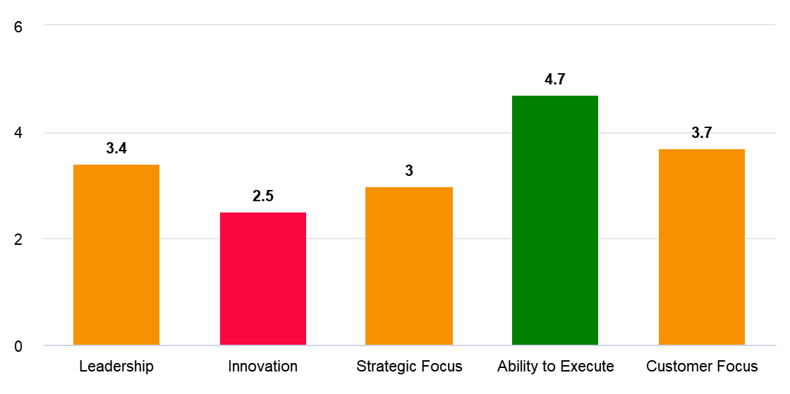

## How You Compare

See how you compare with our database of previous respondents, and other respondents in the Executive role.

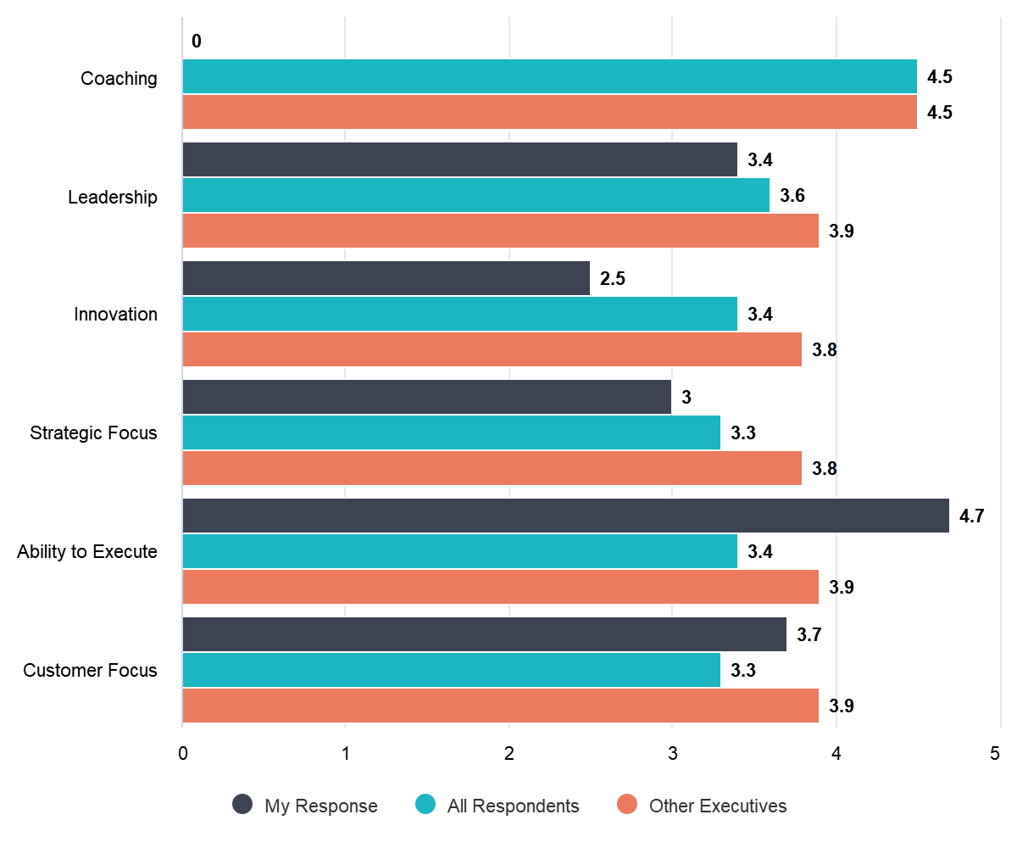



## Assessment Detail

|  |  |
| --- | --- |
|  | Leadership |

|  |
| --- |
|  |

|  |  |
| --- | --- |
|  | Innovation |

|  |
| --- |
|  |

Leadership Style

Your results indicate that you have a moderate leadership style. This is important in that studies show that if your team feel you have a good leadership style they will feel more secure and engaged in their role. Understanding the strengths and weaknesses of your leadership style will help you communicate better with your staff. This is even more effective when you share your leadership style with your staff. When both sides understand, they have a greater understanding of your perspective and how to work effectively with you. This knowledge also points out which personalities may not receive your style well.

* You only occasionally set clear goals. In one study, 63 percent of employees reported that they wasted time at work because they weren't aware of what work was a priority, and what wasn't. As a leader, it's your job to work with the members of your team to set clear goals. And once you do that, make sure everyone knows exactly what those goals are, what their relative priority is, and what the team's role is in reaching them.

**Developing Your People**

Your results indicate that you are good at developing people, well done. The importance of developing others is based on strong research findings and insight from practice that leaders of sustained improvement build the capabilities of others. The evidence shows that successful change relies on a critical mass of people with know-how and energy being committed to the change initiative. Identifying, building and retaining 'the right staff with the right stuff' is a fundamental quality of leaders of change, without which organizational improvement is doomed to fail.

**Embracing Diversity**

Your results indicate that you embracing diversity is not your strong suit. Our culture influences the way in which we see the world. A variety of viewpoints along with the wide-ranging personal and professional experience of an international team can offer new perspectives that inspire colleagues to see the workplace—and the world—differently. Diversity of thought has been shown to breed creativity and drive innovation, helping to solve problems and meet customer needs in new and exciting ways. For example, cosmetic giant L’Oréal attributes much if its impressive success in emerging markets to its multicultural product development teams. Multiple voices, perspectives, and personalities bouncing off one another can give rise to out-of-the-box thinking. By offering a platform for the open exchange of ideas, businesses can reap the biggest benefits of diversity in the workplace. A recent study from Forbes echoed this notion, concluding that “the best way to ensure the development of new ideas is through a diverse and inclusive workforce.”

* The range of experience, expertise, and working methods that a diverse workplace offers can boost problem-solving capacity and lead to greater productivity. In fact, studies have shown organizations with a culture of diversity and inclusion are both happier and more productive.
* You occasionally seek out diverse opinions. Diverse teams are more likely to constantly reexamine facts and remain objective. They may also encourage greater scrutiny of each member’s actions, keeping their joint cognitive resources sharp and vigilant. By breaking up workplace homogeneity, you can allow your employees to become more aware of their own potential biases — entrenched ways of thinking that can otherwise blind them to key information and even lead them to make errors in decision-making processes.

**Promoting Company Culture**

Your results indicate that you promote a moderately good company culture. Company culture is important to employees because workers are more likely to enjoy their time in the workplace when they fit in with the company culture. Employees tend to enjoy work when their needs and values are consistent with those in the workplace.

* You only sometime promote a make it happen culture. Too many leaders have ample conversations but never make decisions. Ask yourself this question every time you’re in a meeting: what will be different when we walk out of this room? If you can’t answer that question, you just wasted everyone’s time.
* We all make mistakes. It's part of being human. The key is to learn valuable lessons from those mistakes so we don't make them again. When members of your team make honest mistakes, don't punish them--instead, encourage them to try again.

|  |  |
| --- | --- |
|  | Strategic Focus |

|  |
| --- |
|  |

**Be Entrepreneurial**

Your results indicate that you are moderately entrepreneurial. Entrepreneurs and intrapreneurs find ways to tap new markets. Consider the person or group that develops a new market in an emerging economy. In this kind of economy, thousands or millions of people can become customers if the company emerges to meet their needs. When the new business venture grows, employment increases and other businesses crop up to provide services to workers of that business venture. Therefore, the emergence of a new market provides fuel for overall growth.

* Monitoring your business’s market for changes can be vital to continued success. Unless you keep abreast of how your market is evolving, you could find your business left behind as your product or service offerings become outdated, your target market moves on to a new trend or business, and your competitors eat your lunch.
* Customer feedback is an insight into what is working well about your product or service and what should be done to make experience better. You might have the best expertise in the industry in which your company operates, but your professional knowledge will never be more valuable to business performance than customer insights. Their opinions help you ensure that the end product will actually meet their expectations, solve their problems and fulfill their needs.

**Lead Change and Innovation**

Your results indicate that leading change and innovation is not your strong suit. Innovation has become a core driver of growth, performance, and valuation. Research bears out this point. More than 70 percent of the senior executives in a recent survey say that innovation will be at least one of the top three drivers of growth for their companies in the next three to five years.  
  
  
Other executives see innovation as the most important way for companies to accelerate the pace of change in today's global business environment. Leading strategic thinkers are moving beyond a focus on traditional product and service categories to pioneer innovations in business processes, distribution, value chains, business models, and even the functions of management.  
  
  
You can take explicit steps to foster an innovation culture based on trust among employees. In such a culture, people understand that their ideas are valued, trust that it is safe to express those ideas, and oversee risk collectively, together with their managers. Such an environment can be more effective than monetary incentives in sustaining innovation.

* You can take explicit steps to foster an innovation culture based on trust among employees. In such a culture, people understand that their ideas are valued, trust that it is safe to express those ideas, and oversee risk collectively, together with their managers. Such an environment can be more effective than monetary incentives in sustaining innovation.

|  |  |
| --- | --- |
|  | Ability to Execute |

|  |
| --- |
|  |

**Strategic Focus**

Your results indicate that you have a moderate strategic focus. Strategic management is the continuous planning, monitoring, analysis and assessment of all that is necessary for an organization to meet its goals and objectives. Fast-paced innovation, emerging technologies and customer expectations force organizations to think and make decisions strategically to remain successful. The strategic management process helps company leaders assess their company's present situation, chalk out strategies, deploy them and analyze the effectiveness of the implemented strategies.

* A resourcing strategy identifies future staffing needs and works out how to meet those needs: by external recruitment or developing existing employees; working with the whole organisation to understand its current and future needs, addressing resourcing not only in terms of filling vacancies but also the wider needs and expectations of candidates.
* You occasionally terminate offerings that are no longer in keeping with the strategy of the business. There is always a cost to continuing to offer products or services that are not for the long term. It is sometimes tempting because a portion of the market (known as laggards) still want to buy them. But sometimes you just have to walk away from these "opportunities" because the long term cost will not justify the short term gain.

|  |  |
| --- | --- |
|  | Customer Focus |

|  |
| --- |
|  |

**Decision Making**

Your results indicate you are a good decision maker, well done. This is important in that studies show that if your team feel you make consistent, predictable decisions they will feel more secure and engaged in their role.

|  |  |
| --- | --- |
|  | People vs Task Orientation |

|  |  |
| --- | --- |
|  | **People is your strongest Orientation but you are balanced.**  People-oriented workplaces are prone to benefit from new and inspired ideas from people whose experiences are different to the traditional decision makers in an organization. A task-oriented workplace is less conducive to this. |

People oriented leaders are focused on supporting, motivating, and developing the people on their teams and the relationships within. This style of leadership encourages good teamwork and collaboration, through fostering positive relationships and good communication. People oriented leaders prioritize the welfare of everyone in the group and will place time and effort in meeting the individual needs of everyone involved. This may involve offering incentives like bonuses, providing mediation to deal with workplace or classroom conflicts, having more casual interactions with team members to learn about their strengths and weaknesses, creating a non-competitive and transparent work environment, or just leading in a personable or encouraging manner.

The benefit of people oriented leadership is that team members are in a setting where the leader cares about their well-being. Relationship-oriented leaders understand that building positive productivity requires a positive environment where individuals feel driven. Personal conflicts, dissatisfaction with a job, resentment, and even boredom can severely drive down productivity, so these types of leaders put people first to ensure that such problems stay at a minimum. Additionally, team members may be more willing to take risks, because they know that the leader will provide the support if needed.