**Lab 5A: Crossbar.io**

### Install Docker on a Raspberry Pi

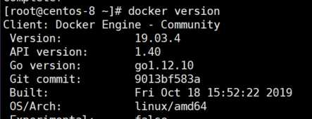

### Build and run new image from Dockerfile

