**Lab 7A: ThingSpeak**

Sign up and log in [ThingSpeak](https://thingspeak.com/)

Create new channel cpu_loop with field1 cpu_pc and field2 mem_avail_mb

Copy the Write API Key from [channels](https://thingspeak.com/channels)

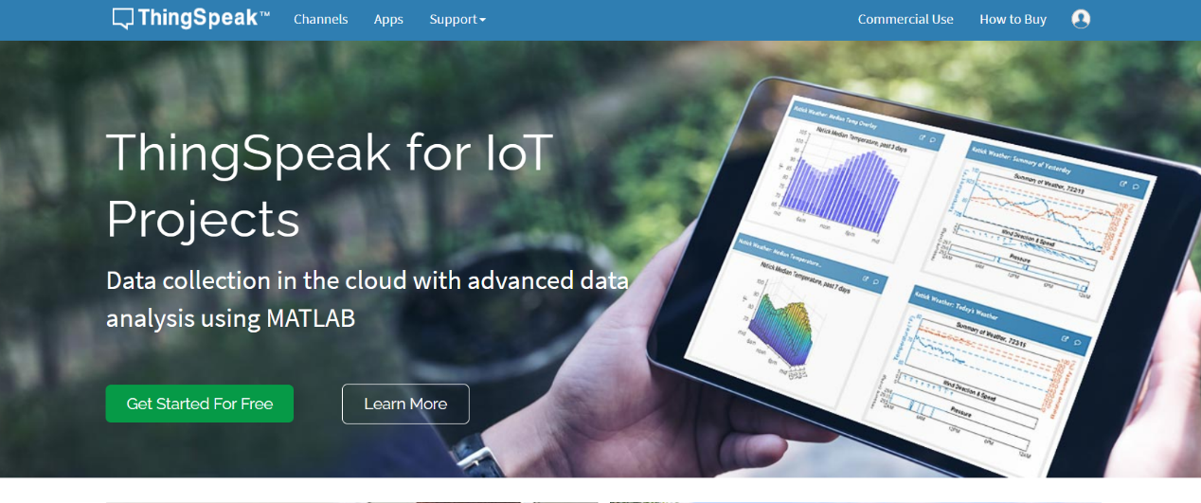

Review and run thingspeak_feed.py