**Lab 8A: Examples**

On Windows, open Git Bash and install Python packages as follows

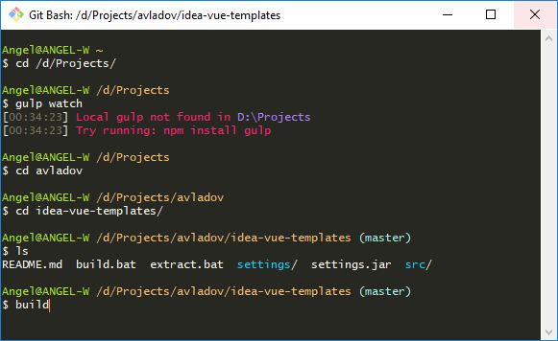

## Lab 8B: Data Analysis

## 