**Lab 9A: YANG (**[**Yet Another**](https://en.wikipedia.org/wiki/Yet_another)**Next Generation)**

Install and run [pyang](https://github.com/mbj4668/pyang) on a Raspberry Pi

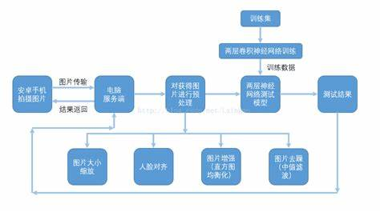

Install and run GIMP and Pinta to display a PNG file via VNC Viewer

