

Frankfurt University of Applied Sciences

**OOP Java**

**User documentation**

***Proffessor: Students:***

Dr. M. Kamlage Stefan SchneiderTiana Dabovic

Contents

Menu 3

Four Wins 4

Gobang 4

Five Wins 5

Sources and tools 6

# Menu

The menu is the first screen the users see. It provides various options for the players, the game mode and the game board.

First, the two players have to put in their names and choose a shape and color for their coins. A name may only contain letters, hyphens (-) and blanks and a capital letter must be at the beginning of each word, and cannot be the same.

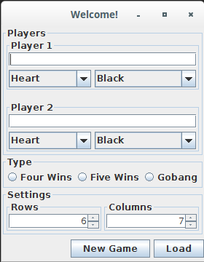

Every player has her/his own text field to enter the name and two select menus, one for the shape and one for the color of their coins.

NOTE: Both players CANNOT choose the same color

After that is done, the game type must be selected. The options provided are “*Four Wins*”, “*Five Wins*” and “*Gobang*”.

When selecting *Five Wins* or *Gobang*, the board must have as many rows as columns.

After all, entering a false input is not critical, dialog window will tell you what went wrong.

If you want to continue playing a saved game (you will see below how to save a game), just the game type must be specified.

A click on “*Load*” will open a new window, where the suitable file must be selected.

The Picture below shows a valid input:

In this example, the players are called Alice and Bob. Alice plays with red heart shaped coins and Bob take the black stars. The game is Gobang and they play on a squared board with 7 columns and rows.

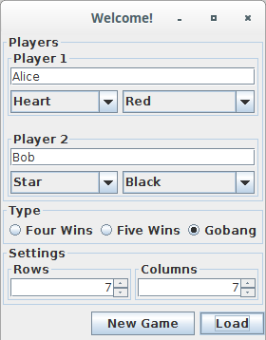

# Four Wins

After the player write their names , chose shape and colour of coins and size of the playing board they can start playing the game.

With the click on top first row, players put in their coin which covers lowest free position in the column. Winner is the player, who achieves four coins in board right up diagonally, left up diagonally, verticaly or horizontaly.

If no one wins, game is draw and players will be able to see this message under the gaming board.

If you would like to save Your game, you can do it with the click on button Save.

*Hint:*

*You are not able to write your prefer name of saved game, application is going to it by itself with the method Curent Time Millies, which returns time in miliseconds from January 1. 1970.*

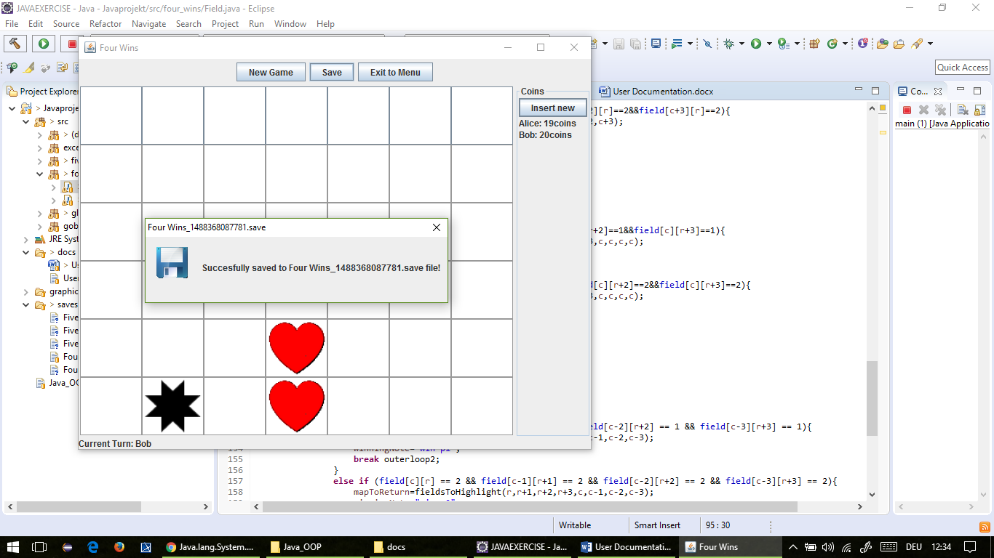

*That means, saved game will have in saved file, on the frist place the name of played game (four in row, five in row or gobang) and after that counted time.*

# Gobang

Very much like Five Wins, the game Gobang is played on a squared horizontal board with comparable rules, even the buttons and status labels are equivalent to Five Wins.

So two players compete against each other and the player with 5 coins in a row (horizontal, vertical or diagonal) wins.

But in Gobang, a player can throw the coins of an opponent, if the following conditions are met:

* Only 2 coins can be thrown
* The 2 enemy coins must be surrounded by your own coins (*picture (a)*)
* The enemy’s 2 coins must already be placed, when you place your last  
  surrounding coin.
* The 4 coins must be in a line (horizontal, vertical or diagonal)

When all these conditions are met, the enemy coins are taken from the board and the 2 coins are added to the enemy’s coin pool (*picture (b)*).

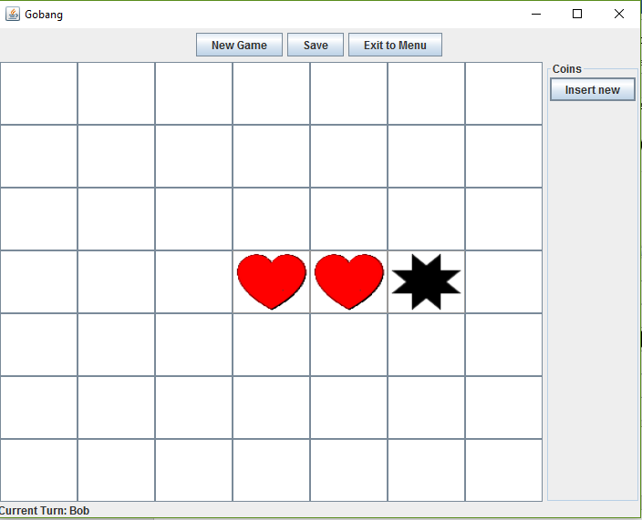

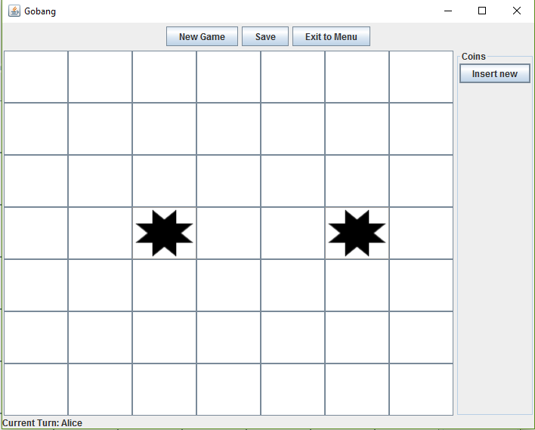

*picture (a) picture (b)*

# Five Wins

If you prefer playing Five Wins, rules are following:

* Playing board also must be squared, as we already mentioned
* Players are allowed to put coins in table in preferred place (*picture(a)*)

Gaming rule is basically similar to Four Wins except the fact that player has to achieve five coins in board right up diagonally, left up diagonally, verticaly or horizontaly (*picture(b)*).

*Neither in Gobang nor in Five Wins you can see you coins status. It is so because first playing board must be sguared. Wenn players chose the number of rows and columns, game multiply those value and become sum of coins for both player. After that it should divide this sum so that the same number of coins would be given to both player. In case that sum of coins is uneven number, division would be with rest (0.5 coins).*

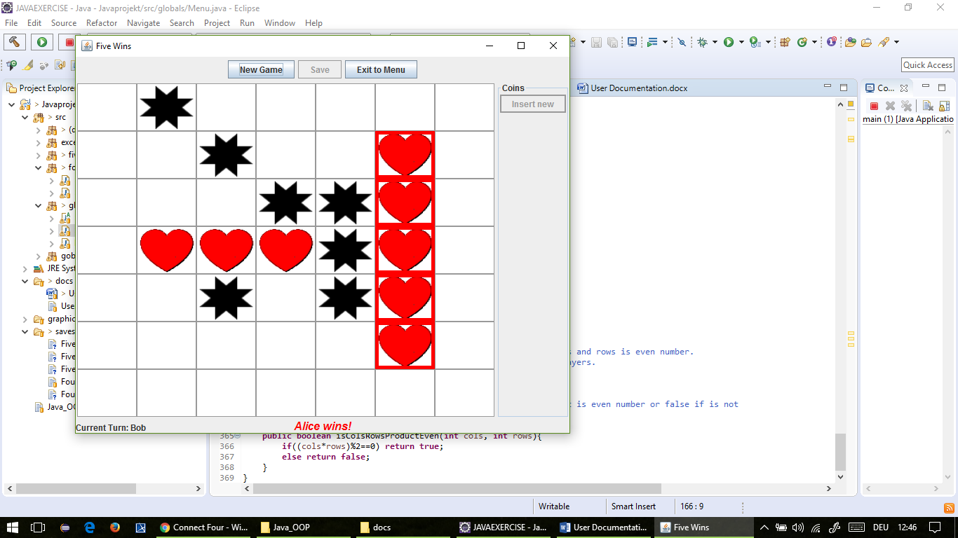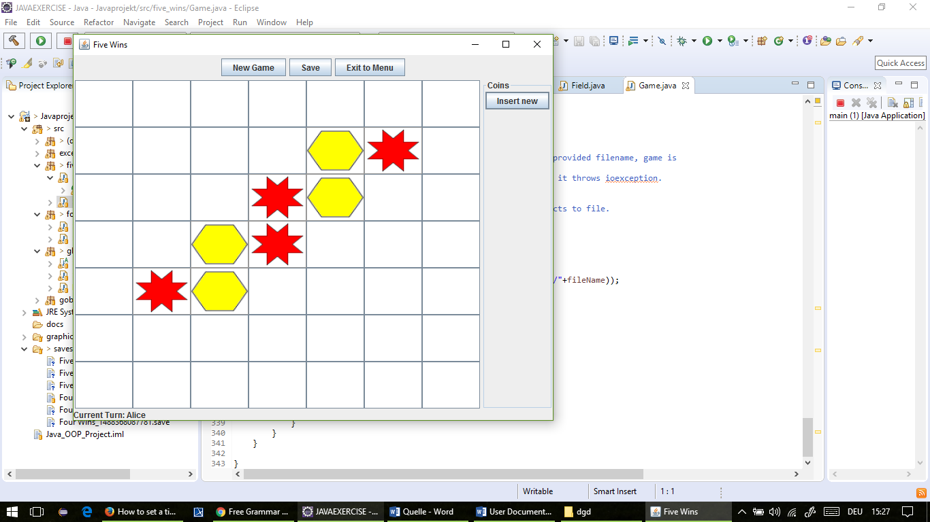

*picture(a) picture(b)*

# Sources and tools

*Stefan Schneider*

*Sources:*

<http://www.dreamincode.net/forums/topic/234693-connect-four-gui/>

*tools: IntelliJ IDEA*

*GitHub*

*Microsoft Word 2016*

*Tiana Dabovic*

*tools:*

*Java Eclipse*

*GitHub*

*Paint*

*Sources:*

<http://stackoverflow.com/questions/20137942/how-to-check-for-horizontal-sets-of-3-in-2d-array>

<http://www.java2s.com/Code/Java/Swing-JFC/BoxLayoutGlueSample.htm>

<http://stackoverflow.com/questions/17549662/what-is-the-difference-between-x-axis-and-line-axis-of-boxlayout-in-java>

<https://docs.oracle.com/javase/tutorial/uiswing/layout/box.html>

http://www.gailer-net.de/tutorials/java/Notes/chap59/ch59_2.html

<http://stackoverflow.com/questions/27255807/jbutton-action-performed>

<https://www.youtube.com/watch?v=rOrJ5TGzyeA>

<https://www.youtube.com/watch?v=1VERDZBsjgE>

<https://www.youtube.com/watch?v=9VrtranTJnc>

<http://docs.oracle.com/javase/7/docs/api/javax/swing/JFileChooser.html>

<http://stackoverflow.com/questions/16239130/java-user-dir-property-what-exactly-does-it-mean>

<http://docs.oracle.com/javase/tutorial/essential/environment/sysprop.html>

<https://docs.oracle.com/javase/7/docs/api/java/io/ObjectOutputStream.html>

<http://stackoverflow.com/questions/7224658/java-try-finally-block-to-close-stream>

<https://www.tutorialspoint.com/java/lang/system_currenttimemillis.htm>

<https://www.youtube.com/watch?v=7KThZb9G7II>

<http://stackoverflow.com/questions/12099843/storing-a-new-object-as-the-value-of-a-hashmap>

<http://www.webopedia.com/TERM/D/dynamic-data-structure.html>

<http://mindprod.com/jgloss/intvsinteger.html>

<http://mindprod.com/jgloss/exception.html>

for allowed characters I used this site(Java: Regular Expressions)

<http://regexr.com/>

https://www.youtube.com/watch?v=s_PfopWcMwI

<http://www.vogella.com/tutorials/JavaRegularExpressions/article.html>

<http://www.mkyong.com/regular-expressions/10-java-regular-expression-examples-you-should-know/>

https://www.youtube.com/watch?v=4XZdpwchIt4

https://www.youtube.com/watch?v=kblbCowBLMc&index=14&list=PLd3UqWTnYXOkvuQb1D4wz2BY0XnKRpEiU

<https://docs.oracle.com/javase/tutorial/essential/exceptions/index.html>

https://docs.oracle.com/javase/tutorial/essential/exceptions/finally.html

<https://www.youtube.com/watch?v=zg4jYJjNEYI&list=PLd3UqWTnYXOnSkaum39zWYI6bPb3i7liz>

<https://www.youtube.com/watch?v=-94XSW55_r8>

<https://www.youtube.com/watch?v=VZif93_F374>

http://stackoverflow.com/questions/6638321/how-to-exit-two-nested-loops

https://www.youtube.com/watch?v=Uh77miF-YMYhttp://docs.oracle.com/javase/tutorial/uiswing/components/spinner.html

https://www.youtube.com/watch?v=Ko9sE4SCeUU

<http://codereview.stackexchange.com/questions/127091/java-connect-four-four-in-a-row-detection-algorithms>

http://stackoverflow.com/questions/1306868/can-i-set-a-timer-on-a-java-swing-jdialog-box-to-close-after-a-number-of-millise

https://docs.oracle.com/javase/7/docs/api/java/util/Timer.html

*for timer given code was used:*

<http://stackoverflow.com/questions/26075366/java-how-to-make-a-popup-window-close-automatically>