Assignment 2 - Report
Gruppe 23 - Florian Werkl, Stefan Schörkmeier

Image(s) showing your successful “first tests” using the OMPL library (for instance, using
Fig. 1-left as obstacle map).
Unfortunately, we have too late read this task. So we only have the 3D case. We hope that’s enough to show our experiments – obviously we first tried out the 2D case as suggested :)
Here we can see an experiment where it comes as close to 2D as it gets. By setting the current and goal postion values of z to 0.5 we only have movement on the x and y axis aka we only move on the 2D plane:
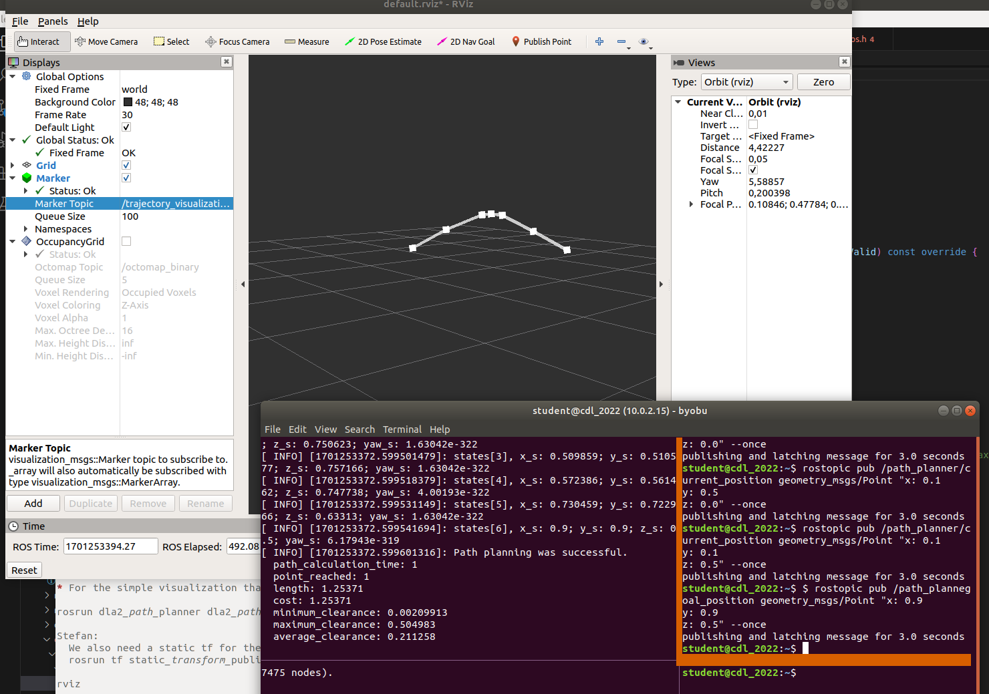
Then we moved in an 3D manner with the default locations of the README in you pathplaner dla file:
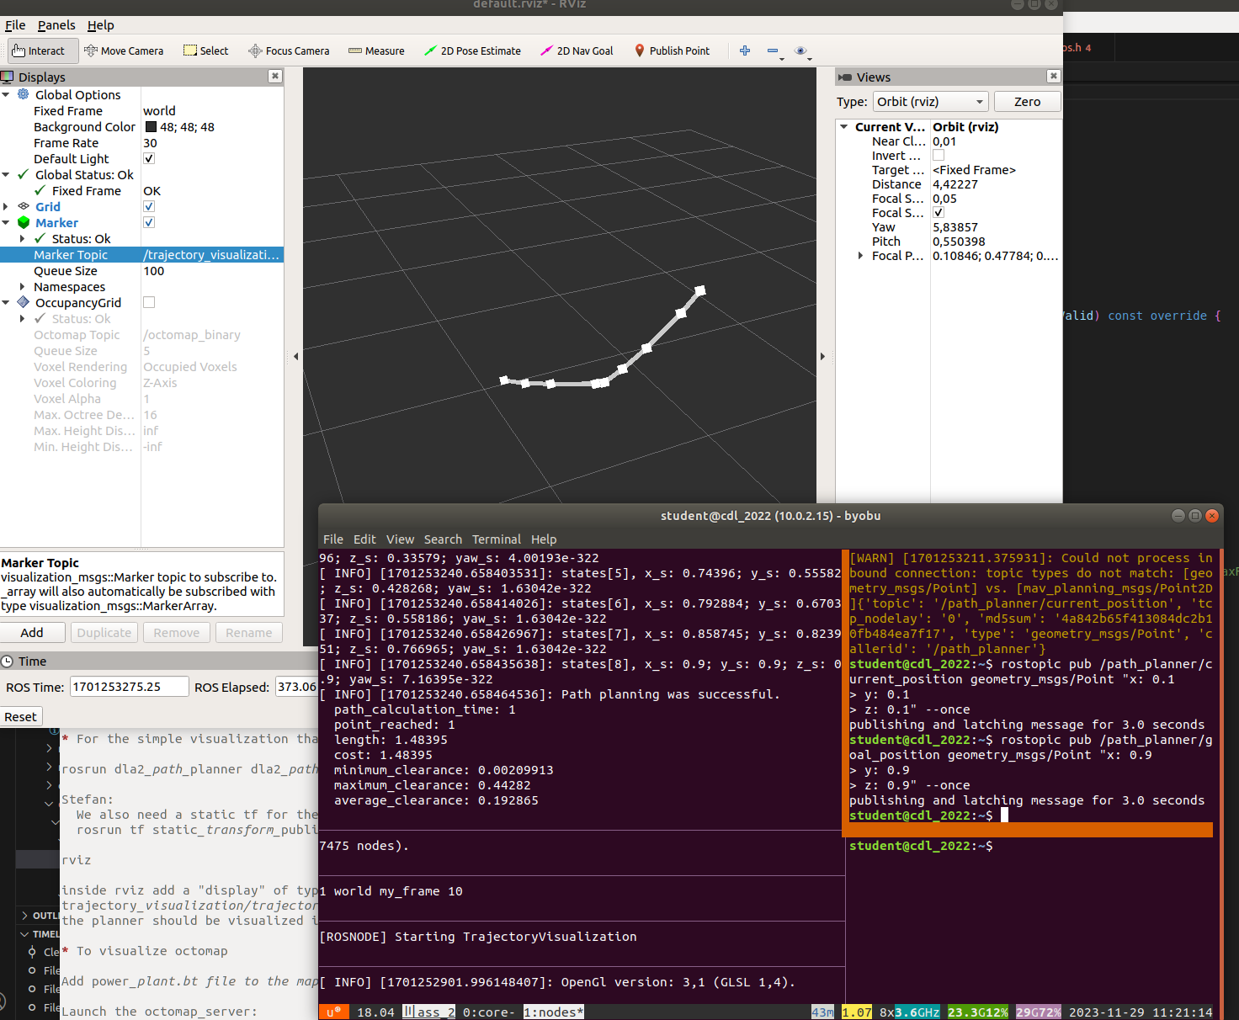
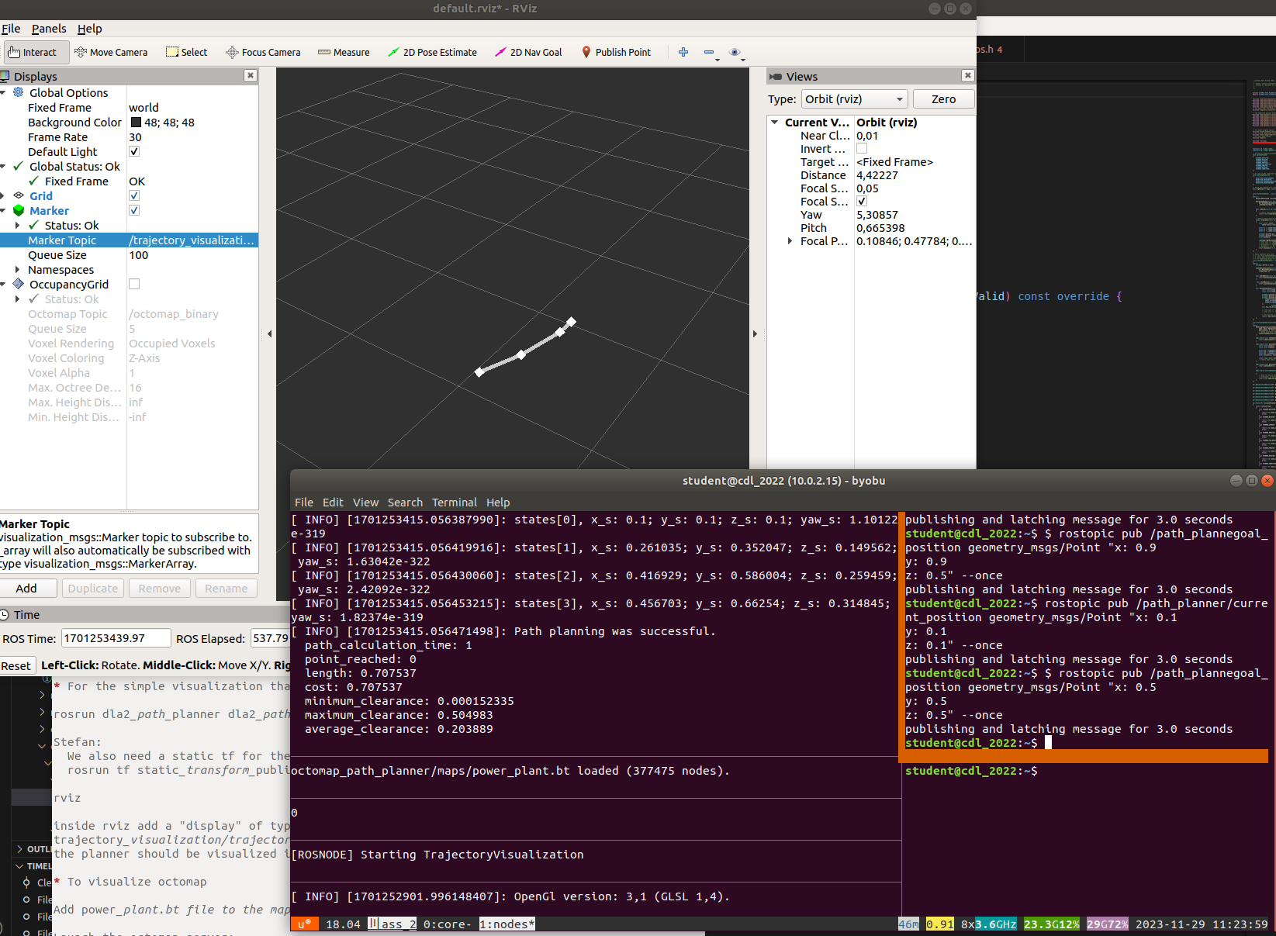
After that we did a little edge case, where we wanted a path right in the middle of the sphere (remember the sphere center is at 0.5, 0.5, 0.5 with an radius of 0.25). Its hard to see in that image, but the path only comes as close to the object as possible, but has not infered with the sphere.

Image(s) of your generated obstacle-free trajectories in the power_plant.bt octomap (Fig. 2).
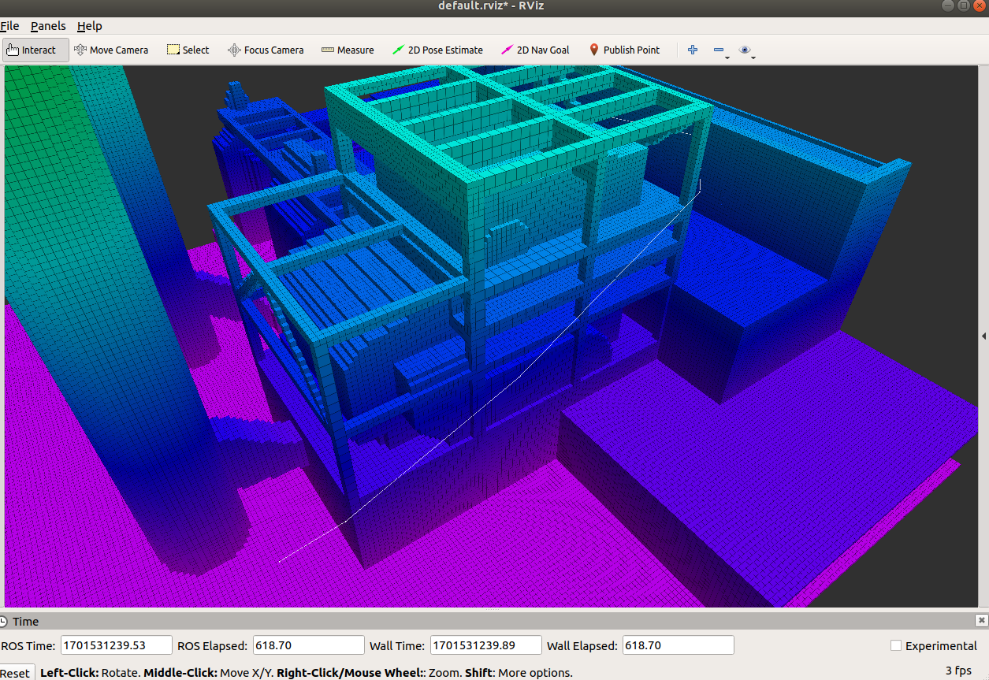
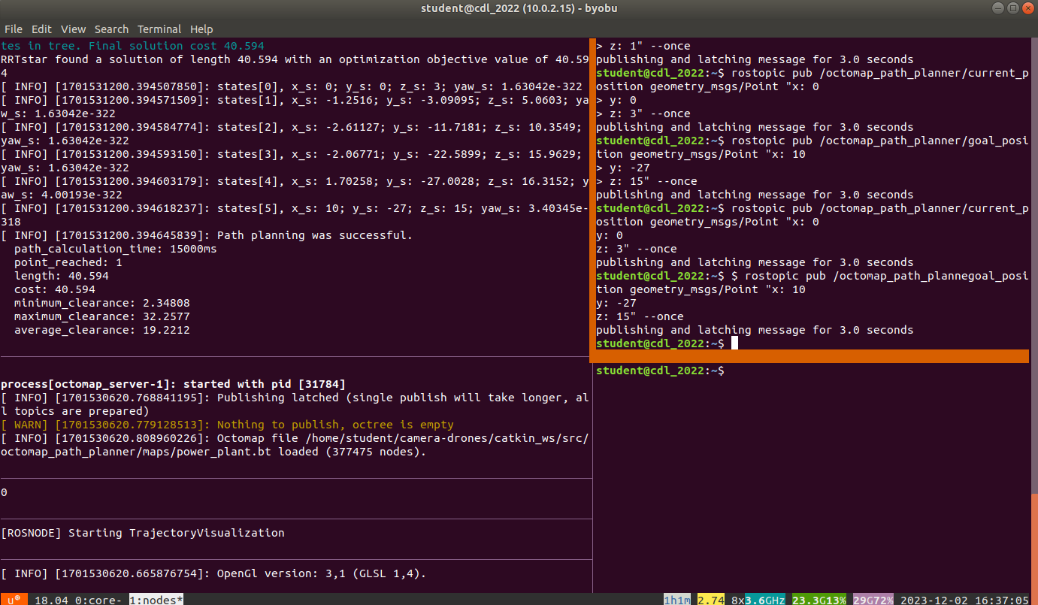
We got following path using the same coordinates as on Fig. 2 (from the point [0, 0, 3] to the point [10, -27, 15] ) with length objective. As we can see the planned path snugs really close to the power plant (Do you believe as well that the drone will crash here? xD)

As we can see in the terminal, the path planning was successful and we ended up on the given point.

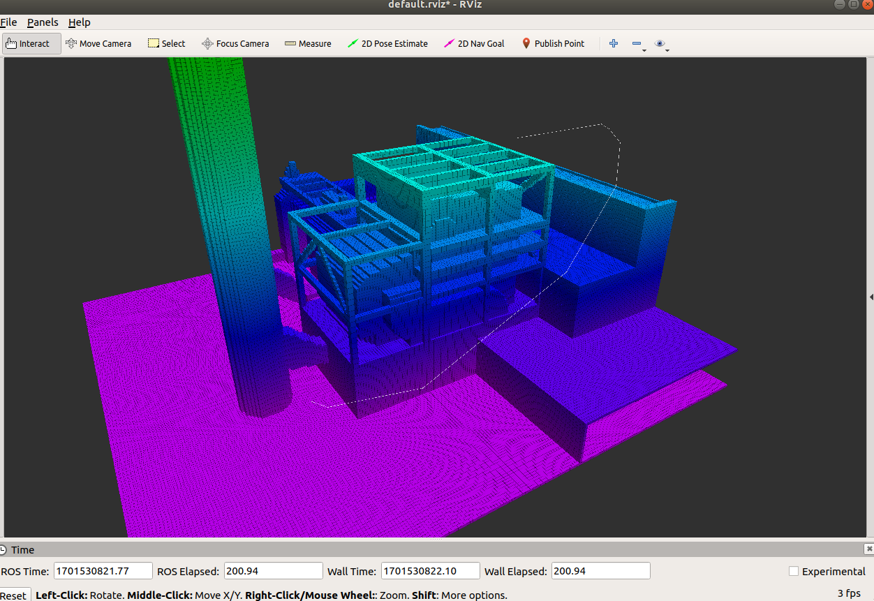
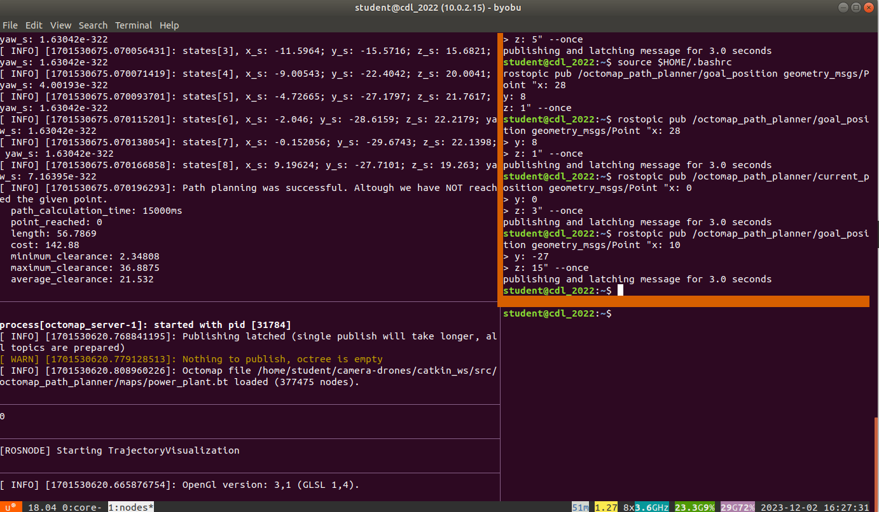
Same as previous, but of trajectories showing good clearance (distance to any obstacles).
We got following path using the same coordinates as on Fig. 2 (from the point [0, 0, 3] to the point [10, -27, 15] ) with clearance and length objective. As we can see in the terminal output the path planner was successful but has not reached the given point. That might be, because our clearance doesn’t allow to get as close to the power plant. QUESTION: should the path look exactly as yours or is it ok this way? :)

Same as previous, but of trajectories that are optimized to avoid unnecessary movement in
the altitude direction, preferring longer horizontal paths instead.
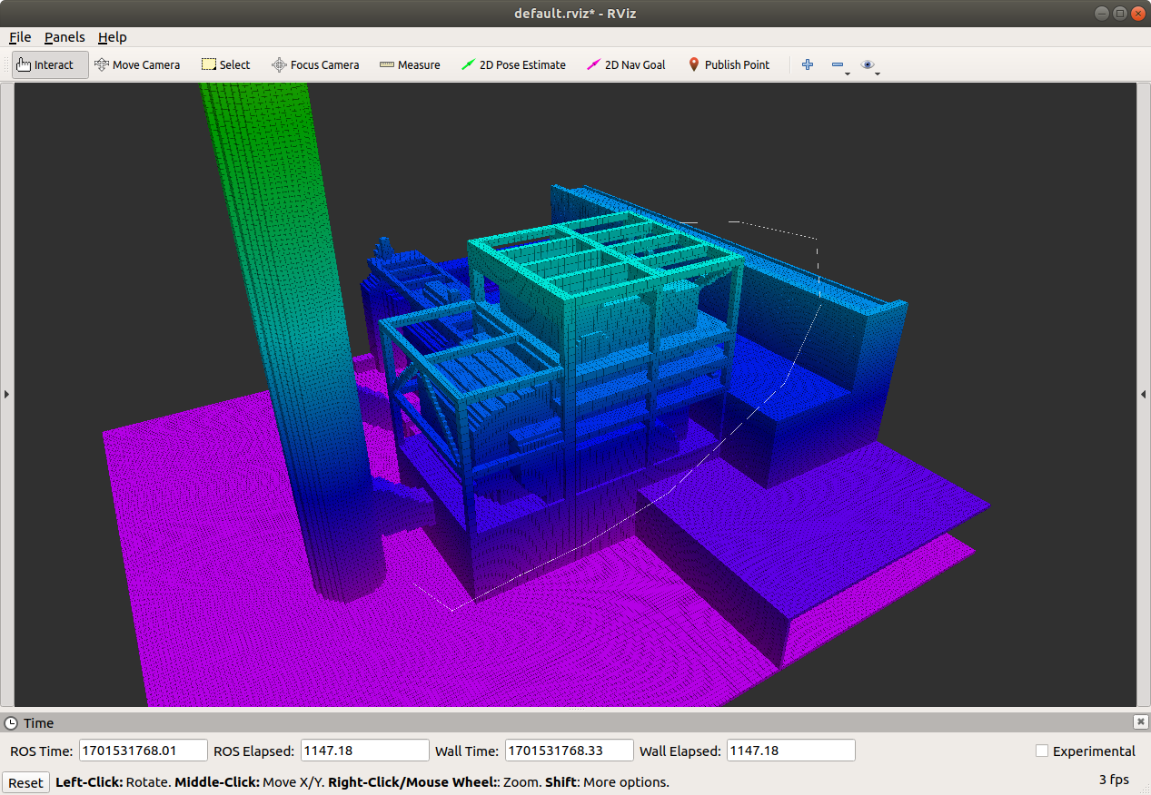
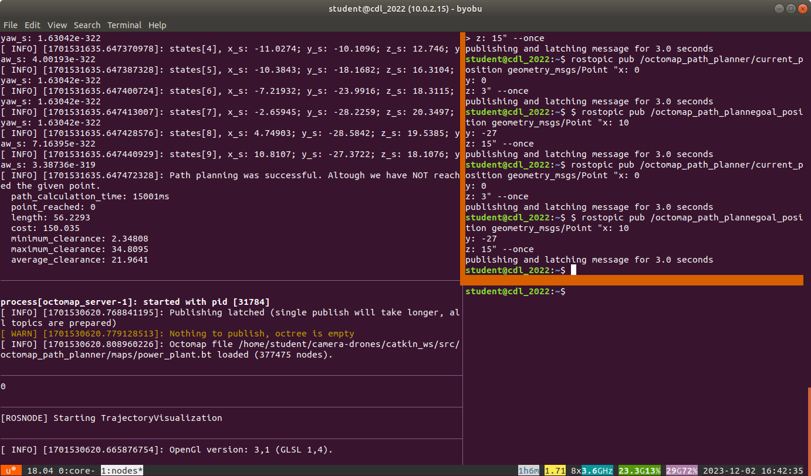
We got following path using the same coordinates as on Fig. 2 (from the point [0, 0, 3] to the point [10, -27, 15] ) with clearance and length objective and an optimization to avoid unnecessary movements in the altitude.
It is quite hard to see on the image, but have an look in the middle (on the purple step) there you can see that it is much more flatter then in the image of the previous part.

Find a test case that causes your trajectory planner to generate a trajectory that goes
through a wall. To avoid this buggy behavior, for instance, define a MotionValidator for your
trajectory planner, which overrides the default implementation and uses the ray-casting
functionality of the Octomap library to determine that a trajectory segment is obstacle-free.
For ease of this task we allowed that z is negative and set a small runtime (0.1)
As we can see in this image with no raycast the first path went directly through the floor plane:
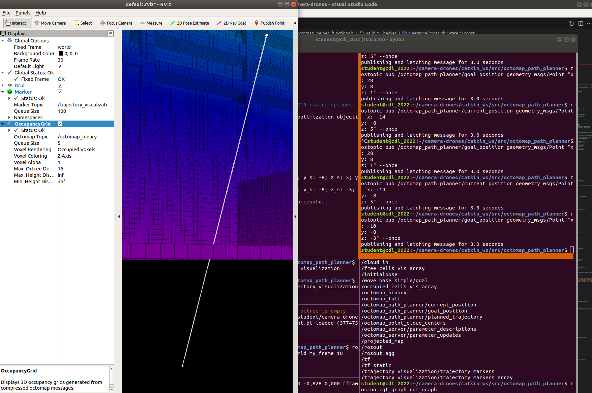

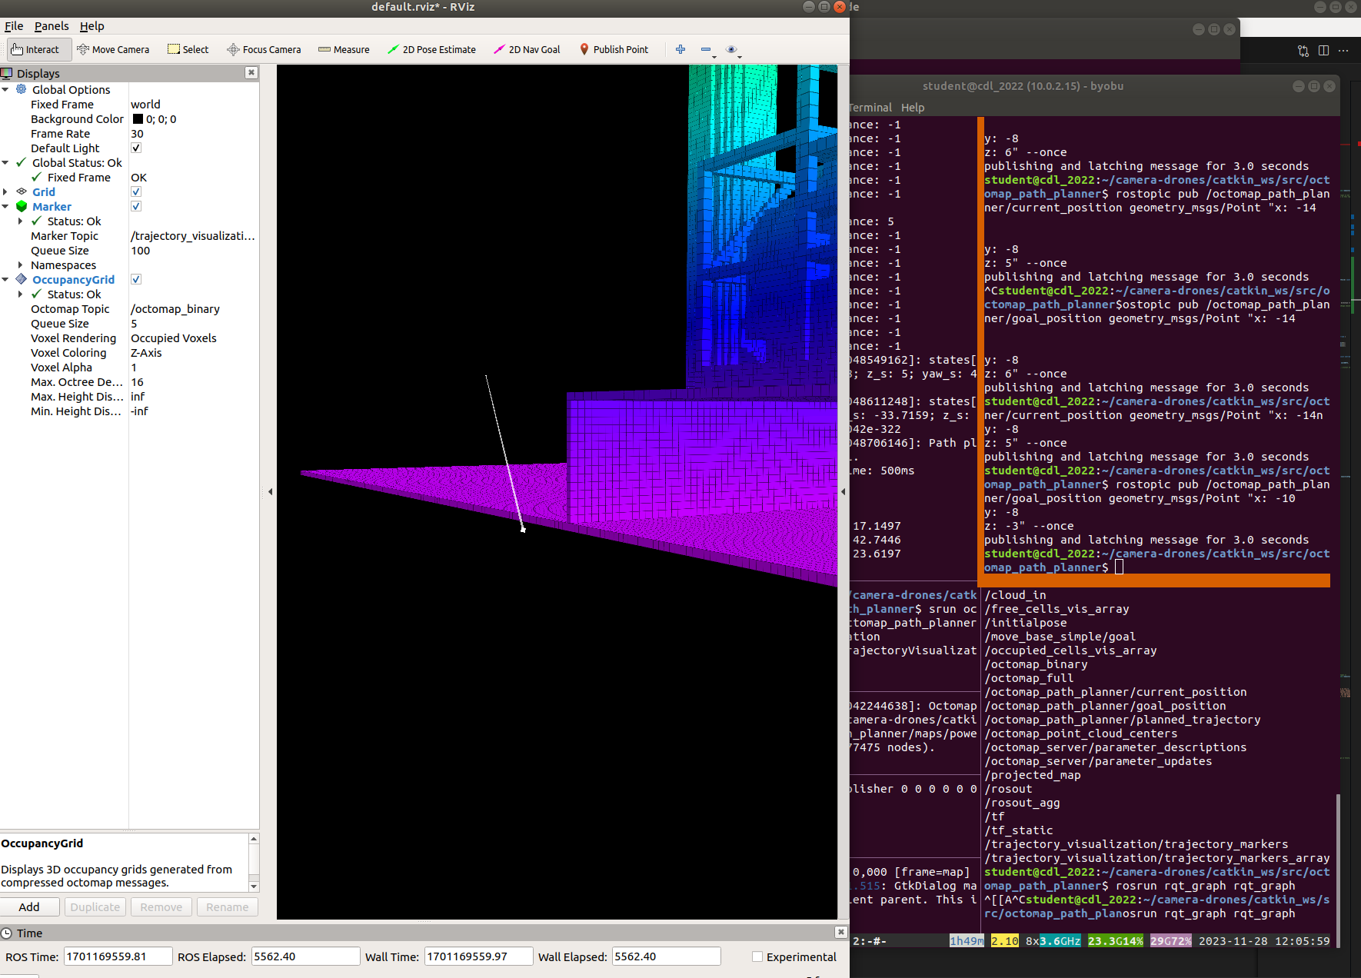
While with an activated raycast we ended up on a random-ish position (but without going through an obstacle)

Find out how to make the OMPL library stop the trajectory search process, other than using
a fixed time allotment for this task. Report on the advantages of your alternate solution.
Here we simply used an max number of iterations:
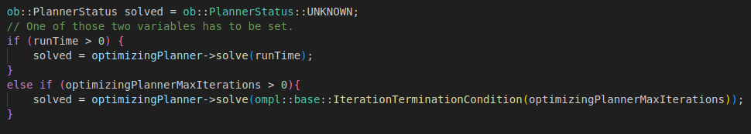
The advantage of using iterations instead of time is, that on the one hand it makes our algorithm independent of the environment/hardware (eg runtime of 10 seconds on a much stronger machine will most liekly lead to a different solution then on a weaker machine) and on the other hand it should be quite predictable. With fixed time we could always have fluctuations (eg different amount of processes running, …)

Points of Feedback:
For the motion-validator, can you test telling the drone to fly from the outside to the inside the powerplant?
(For example, tell the drone to move into the chimeney, or inside a building?
The desired behavior should be that no solution is found. (Maybe this already works)
Yes this has already worked. We still find a path, which is the closest to the point inside the factory it can get (at least we assume so).
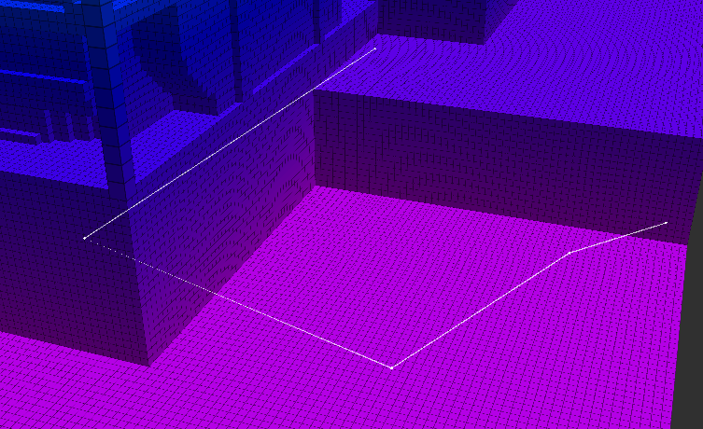

But we can tell that the given point has not be reached with the “point_reached” flag.
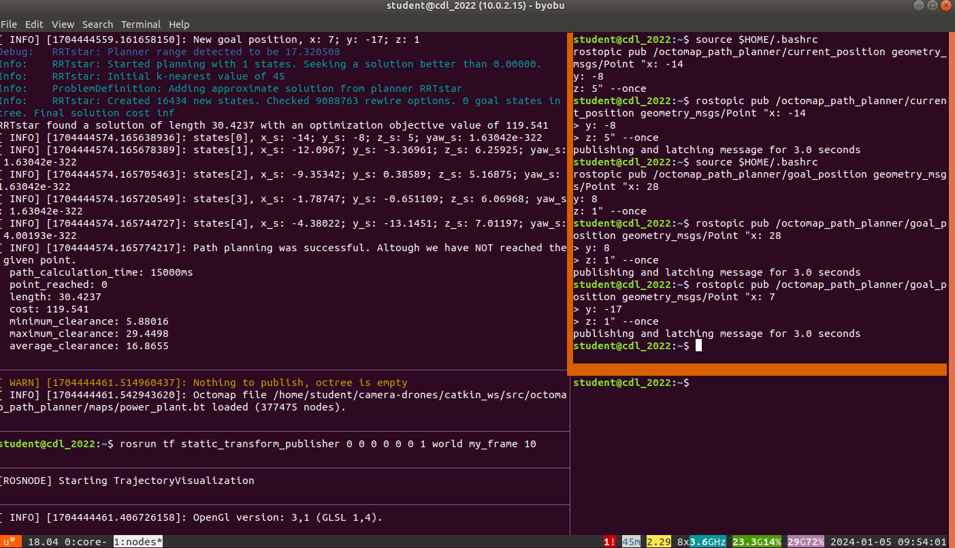

With that we can decide further down the line if we want to take this calculated path or create a new one. At least that was our design intuition.

(I have already graded this as OK, as I like that you take the simplest option) For the termination condition can you test this function?
(From a practical point of view, such function is the best, as it can detect that the planner has converged to a good solution)
Unfortunately we have to little time to test that because we ran into a problem. We were not able to import the header as in the documentation with #include <ompl/base/terminationconditions/CostConvergenceTerminationCondition.h> getting the error message that there is no such a file or directory. After that we tried to simply to insert those 2 files locally, but for some reason it wasn’t able to find those files as well. After trying to fix that for an hour we stopped working on this, because there are other, more pressing features missing and well its January aka exams are coming xD

