Assignment 1 - Report
Gruppe 23 - Florian Werkl, Stefan Schörkmeier

Image(s) showing your obtained Octomap (similar to Fig. 1 above)
In the following images we can see the generated octomap and the byobu window which was created with a script:
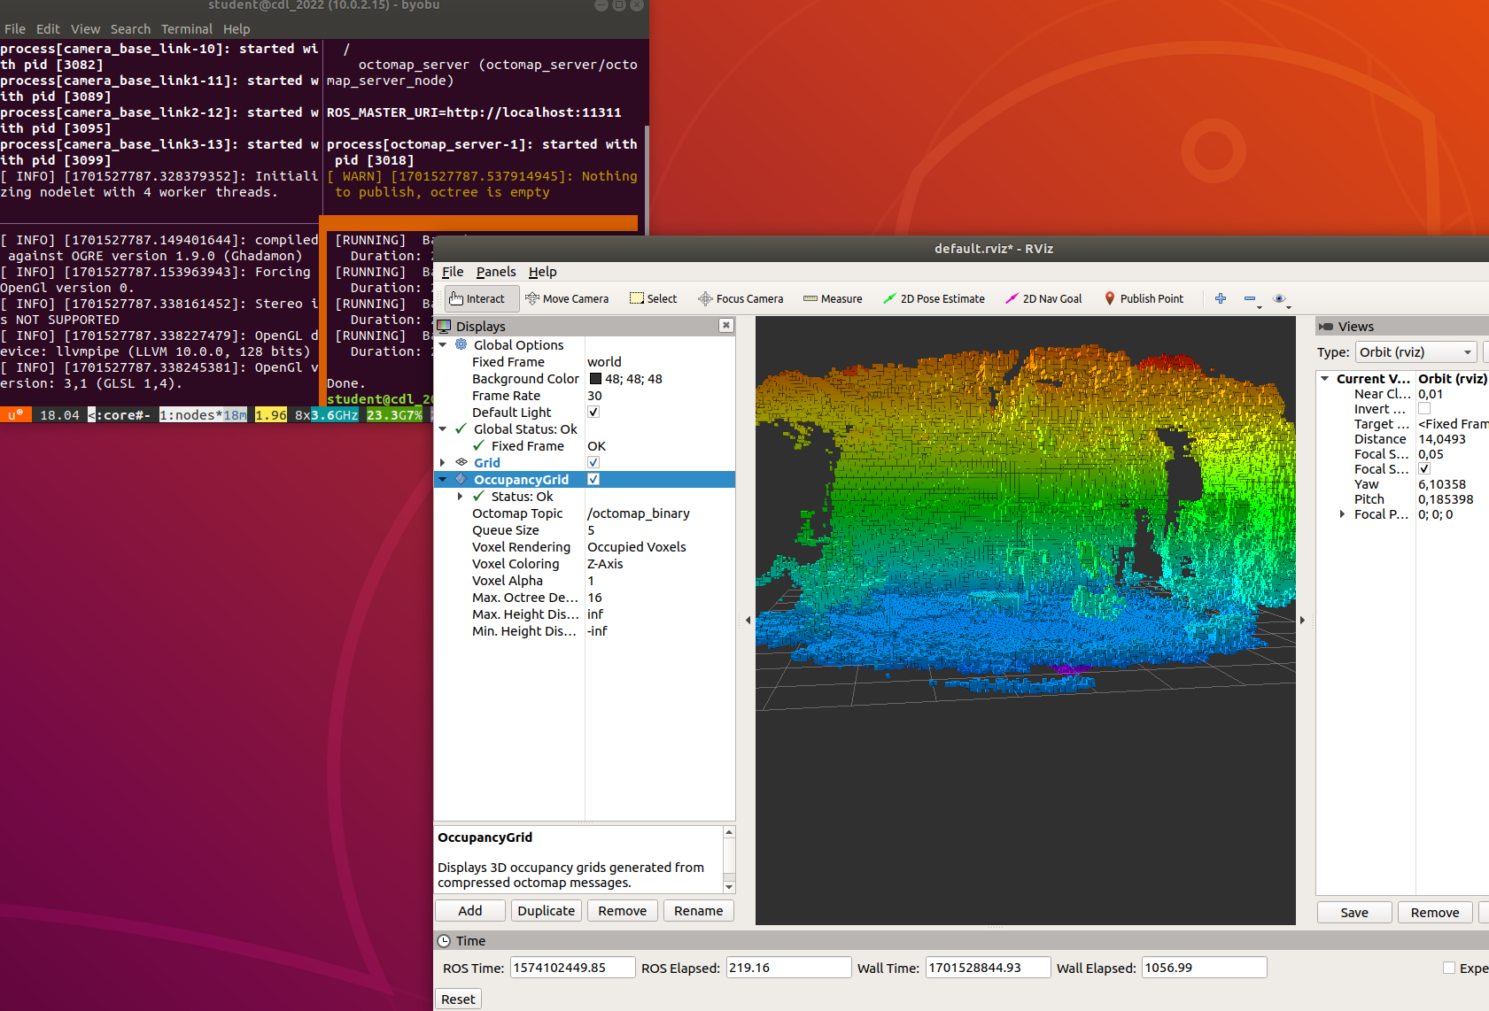
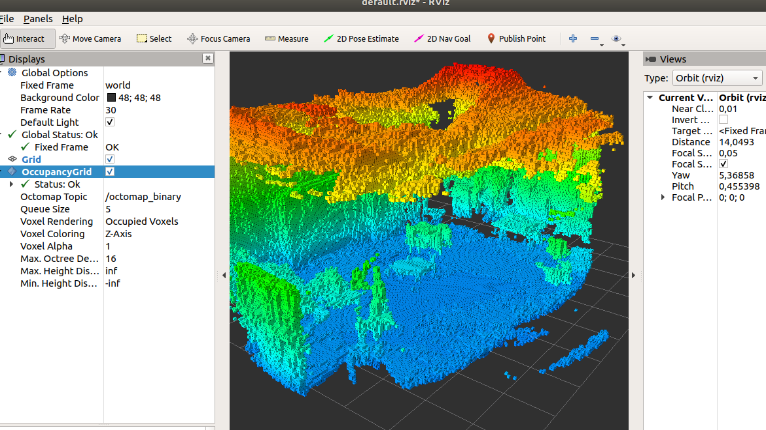
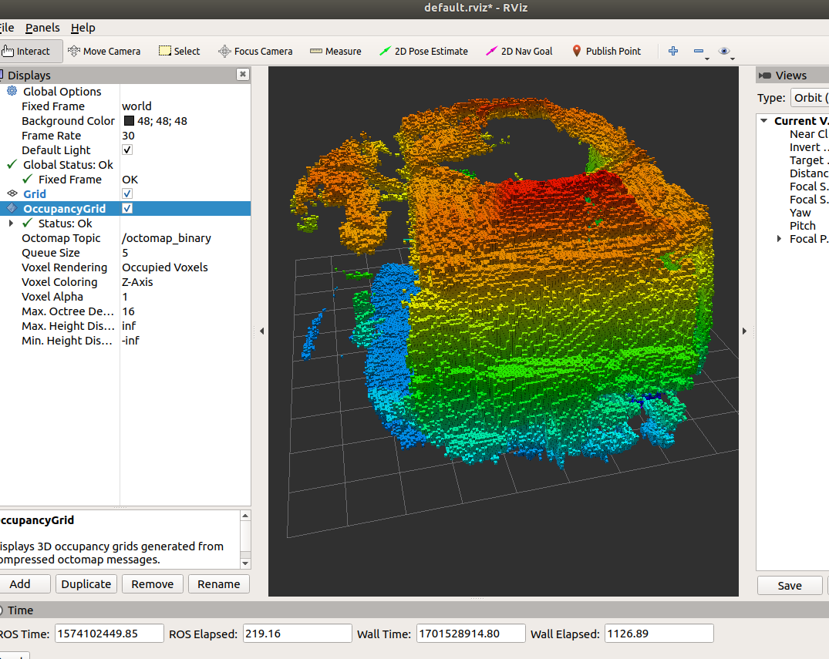
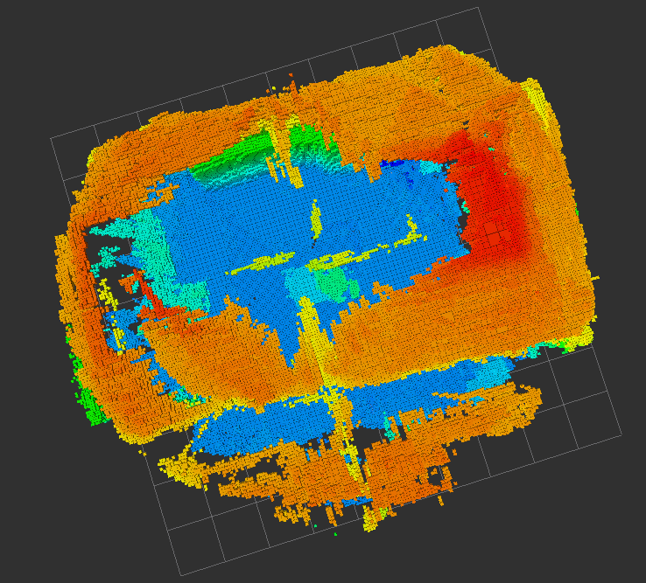

Image of perfect tf-tree (similar to Fig. 2 above)
In the next image we see the tf-tree, which tells us the transform positions of different nodes:

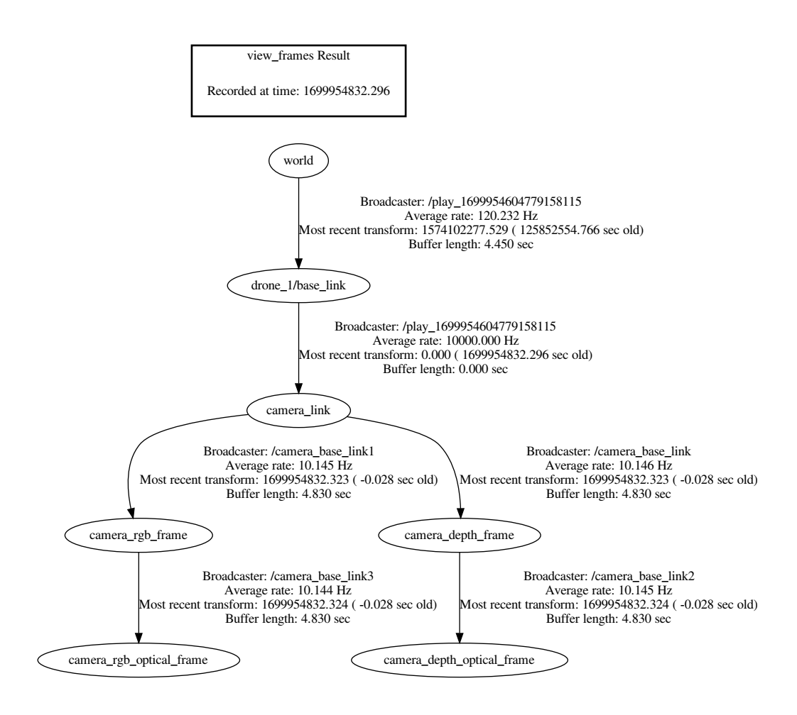

Rosbag inspection (e.g., using rqt-bag or rosbag info in the terminal).
In the following images we did the inspection of the rosbag:
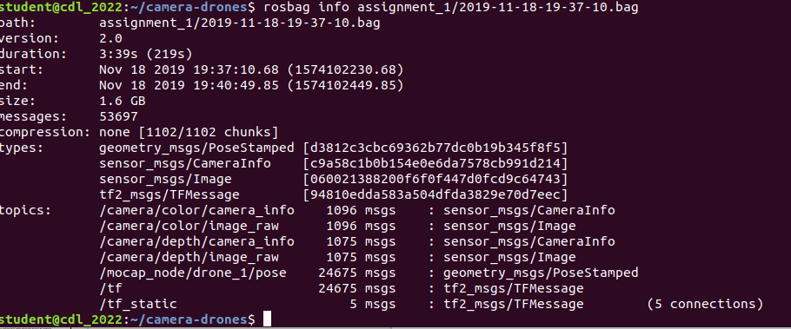
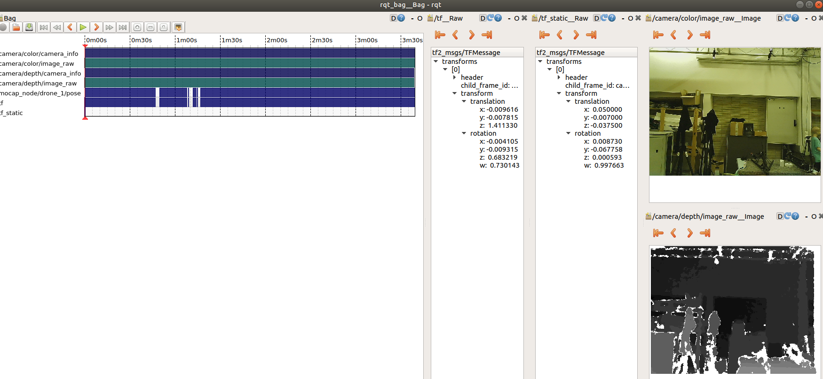
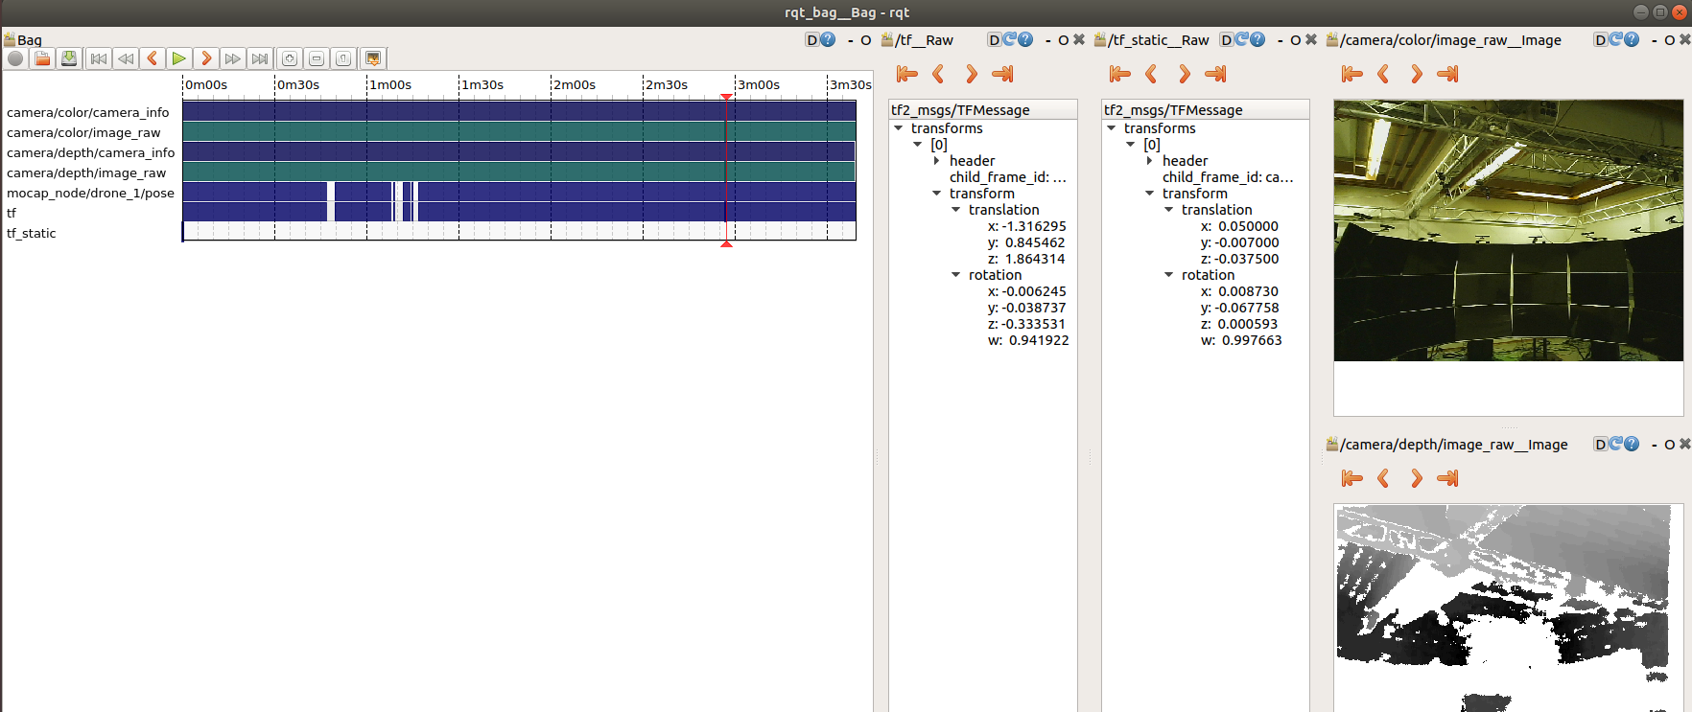
Here we played around with the topics to really understand the data which we were given. Through that it was quiet easy to solve assignment 1, after we have understood what parts were important for this assignment.

Appendix:
A short picture of the first time using RVIZ and playing around with it.

