1. **Introduction - Rye**

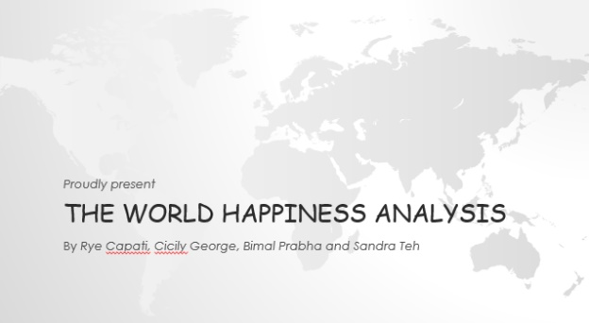

Good evening everyone! We are the Merry Team. We have Bimal, Cicily, Sandra Teh and me myself Rye in the team.

Tonight, we are going to present “The World Happiness Analysis”. First, we would like to talk about our data before we go into analysis.

1. **Jupternote book - Rye**

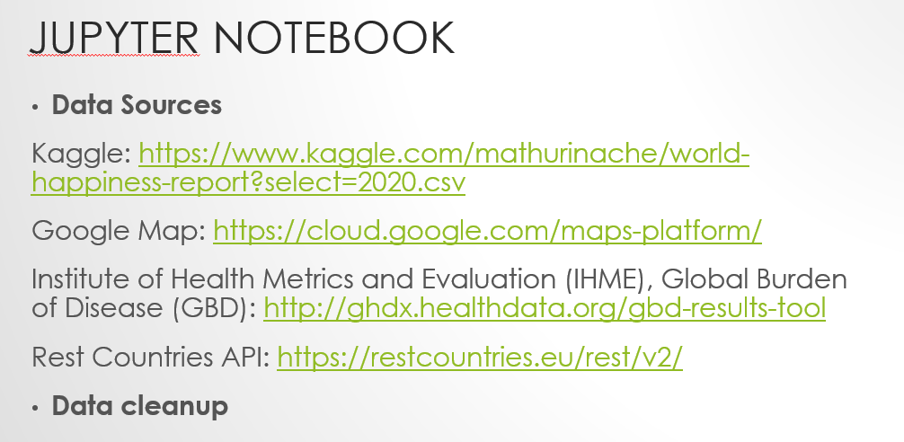

In this slide, you can see that we got our data from Kaggle, Google Map, IHME and Rest Countries API.

Before we get into any analysis, we started with analysing the data and cleaning up the data.

For instance, we go through the column name of the tables to make sure that the column names are consistent across all the tables. If they are not, we renamed the column names. We also make sure those column names are removed if they are not needed. We looked at the data to ensure that if there is NaaN value, we either replace it with something or we remove it completely. Before removing any data, we also make sure that the NaaN value is not going to impact our analysis. Also, we looked at the consistency of the data in all the tables to make sure that those data are related. once we have cleaned up the data, we then merged the data together using concatenate function. The reason why we chose to use the concatenate function instead of merging is because we find that it will be easier to do data visualisation and analysis. We do notice that concatenate function is going take up more memory but given the data size we have; concatenate function was not an issue in our analysis. we mainly use Plotly and Seaborn to do our data visualisation.

1. The world Happiness Analysis **- Rye**



Let’s get into the interesting part now. The world Happiness Analysis.

1. Before we start talking about our analysis, I would like to ask everyone, how happy we are compared to the world?? (Stop for 3 sec) - Rye

Thank you everyone. Let’s see the result.

1. Australia Ranking 2015 to 2019. Rye

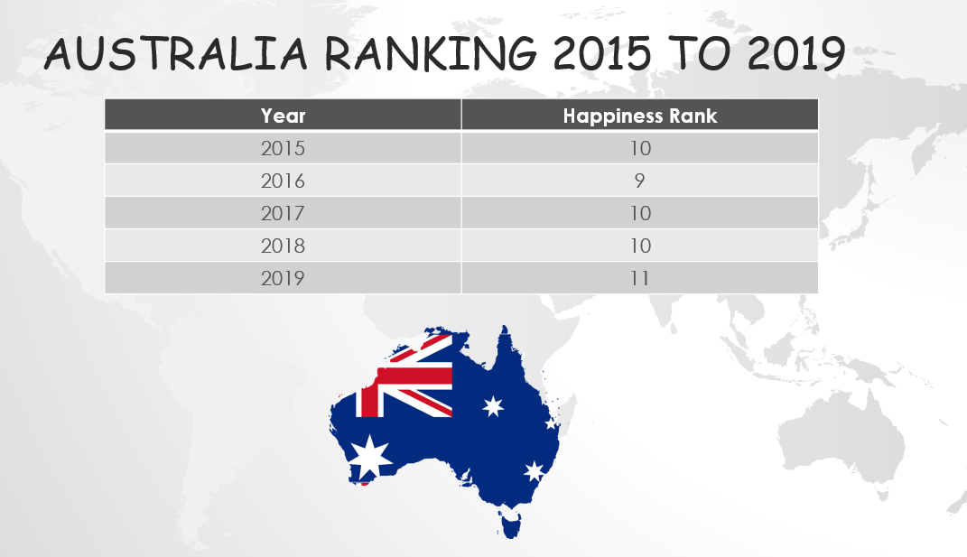

Ta da… As you can see from the slide, Australia rank 10 in 2015, 9 in 2016, 10 in 2017 and 2018 and 11 in 2019. I am sure the result did not surprise everyone; we are indeed living in a happy country.

1. 7 factors that determine the happiness score - Rye

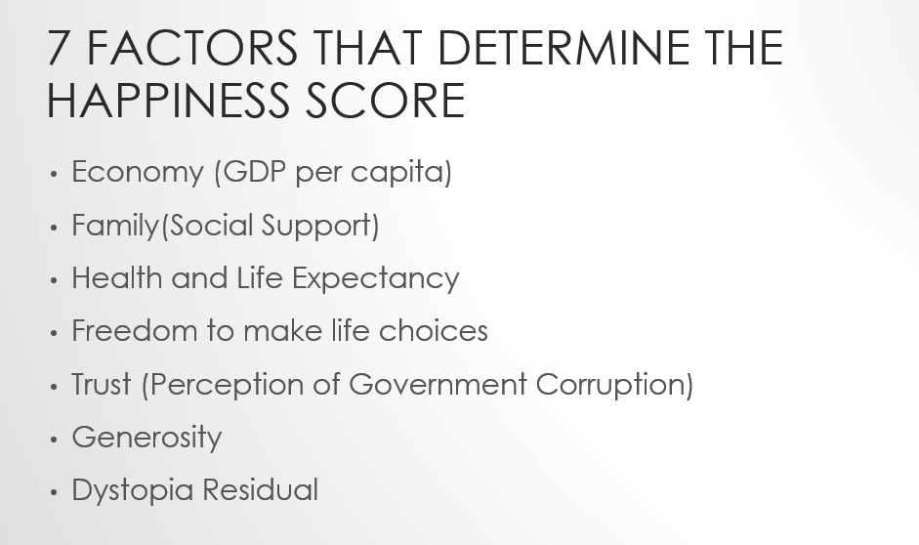

What are the factors that determine the happiness score? As you can see from the slide, these are the 7 factors that determine the happiness score.

**Economy** – this shows the prosperity of a country based on its economic growth.

**Family** – this shows the support each family or person is getting within the country

**Health** – this shows the health wellbeing & life expectancy within the country

**Freedom to make life choices** – this shows the freedom we have in the country

**Trust** – how people perceive their government

**Generosity** – generosity of the people within the country. (eg. Nearly half of all people in Finland give money back to charity regularly and one-third of the Finish population volunteers their time.)

**Dystopia** – is an imaginary country that has the world’s least-happy people. The purpose in establishing Dystopia is to have a benchmark against which all countries can be favourably compared (no country performs more poorly than Dystopia) in terms of each of the six factors.

1. The top 10 countries and the bottom 10 countries. - Bimal



Since we know that Australia is a happy country, we thought that it would be really interesting to see what the top 10 countries and bottom 10 countries are looks like.

1. This is a bar graph that showing the top 10 countries and bottom 10 countries and the score of each factor in Year 2019. The first 10 bars showing the top 10 countries and the bottom 10 bars showing bottom 10 countries. In general, we can see that GDP is usually high in top 10 countries and low bottom 10 countries. What we find that it is interesting is the generosity showing no different between top 10 countries and bottom 10 countries. Also, Even though GDP was par with top country we came to realise what pull down was increase in corruption .
2. These are the bar graphs that showing from year 2015 to 2018. We are going to talk more about the correlation between those factors in the following slide. Now seeing these changes, we tried to dig deeper we wanted to know is there any factors which significantly improved or regressed the score? - bimal
3. Are those factors correlated? - bimal
4. In this heatmap graph, we can see the correlation between each factor. As we all know the higher the value, the better the correlation is. If we look at those value that above 0.7, we can see that GDP per capita are highly correlated to Happiness Score. Following by Family and Health Life Expectancy. If we look at the GDP per capita, we also can see that the correlation between GDP per capital, family and health life expectancy are highly correlated as well. I guess this is kind of make sense to us. As the income is higher, your expectancy of health life will increase as well. Again as previously mention, we can see the generosity is not correlated to GDP per capita as well. Another trend you can observe here, Its easy to identify what lacking the bottom ranked countries but what s interesting even though economic gdp, people haven’t lost hope and family factor is on same par as the top countries - bimal
5. These are the graph then show us the correlation between those factors from 2015 to 2018. - bimal
6. After we analyse the factors, we thought it would be interesting to see whether the top 10 countries stay consistent over the year. From this graph, we notice in Year 2015, the top country is Switzerland but it kind of drop over the year, in Year 2019 Switzerland drop to 6. Another interesting one is Finaland, it was only 6 in Year 2015 but it gone up to number 1 in Year 2018 to 2019. Overall, the top 10 countries stay pretty consistent on top 10 over the year. Looking at where we live, Australia always on the top 10 countries from Year 2015 to 2018. However, it replaced by Austria in Year 2019. Saying that, that doesn’t mean that we are not happy anymore as we are still ranked at 11 in Year 2020. - cicily
7. Another question we think would be very interesting is to see which region has the top 10 countries and bottom 10 countries. If we look at the top 10 countries. The colour bubbles on this map represents the top 10 countries and the colour indicate their happiness score. The top 10 countries happiness score is between 7 to 8. The yellow represents the higher score, the blue represents lower score.

In Year 2019, we can see that the top 10 countries are on the Europe region. If we look at 2015 to 2019. Interestingly, most of the top 10 countries are on the Europe region as well which is consistent over the years.

As we can see from the map, Australia was on the top 10 from year 2015 to year 2018. However, Australia ranking drop to 11 in year 2019. Australia still considered a happy country overall compared to 156 countries. - Sandra

1. Again, the colour bubbles on this map represents the bottom 10 countries and the colour indicate their happiness score. The bottom 10 countries happiness score is between 2 to 4. Again, the yellow represents the higher score, the blue represents lower score.

If we are scrolling from Year 2015 to 2019, we can see most of the bottom 10 countries are on the Africa, Middle East region which is interesting as well. - Sandra

1. Another analysis we thought would be interesting is that we will analyse Australia VS top 1 country.

Sandra

1. Sandra
2. To 20 Rye

21. Throughout our course, we always get the bonus part. Therefore, we would like to add the bonus part here to make it more interesting. Cicily

22. Conclusion – cicily.

23.

**----2nd presentation----- Rye**



We acquired our happy country data from Kaggle for the years 2015 to 2019.

We used Google map API for the country locations.

And we used Plotly to present our visualizations.

**----3rd presentation----- Rye**

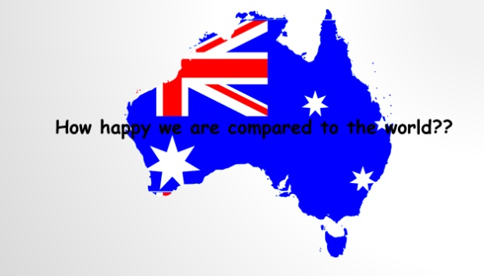

Australia… How happy are we compared to the world?

(Ask the audience) can I see some hands & see what do you think our happy ranking is for the past 5 years? Do you think we are in the top 10?

**----4th presentation----- Rye**

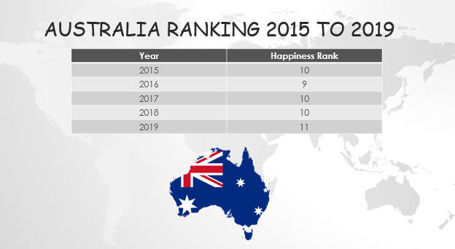

As you can see, we were consistently in the top 10 until last year wherein we drop to the 11th spot.

You will see later by the end of our presentation if we will make it to the top 10 based on our predictions.

For now, let’s talk about what makes a country happy…

**----5th presentation----- Rye**

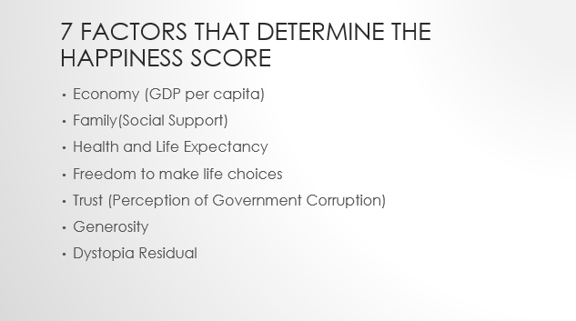

So, what are the factors that contributes to the happiness of a country (based on the data set we gathered)?

**Economy** – this shows the prosperity of a country based on its economic growth.

**Family** – this shows the support each family or person is getting within the country

**Health** – this shows the health wellbeing & life expectancy within the country

**Freedom to make life choices** – this shows the free we are within the country

**Trust** – how people perceive their government

**Generosity** – generosity of the people within the country. (eg. Nearly half of all people in Finland give money back to charity regularly and one-third of the Finish population volunteers their time.)

**Dystopia** – is an imaginary country that has the world’s least-happy people. The purpose in establishing Dystopia is to have a benchmark against which all countries can be favourably compared (no country performs more poorly than Dystopia) in terms of each of the six factors.

I will now pass the mic to Bimal who will provide more information about the top 10 & bottom countries thru the years along with the correlation factors & the data cleaning process which our group conducted.

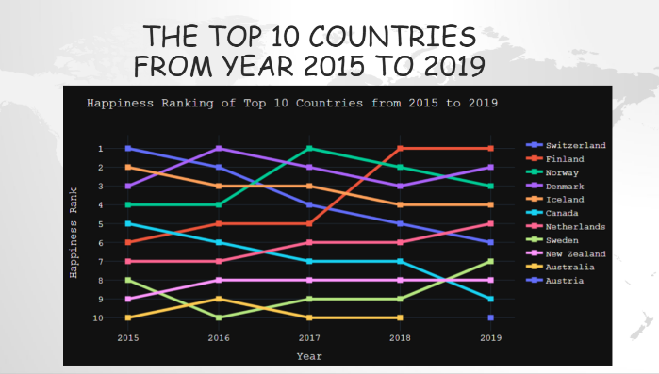

Let's see which are the countries in the Top 10 Ranks from 2015 to 2019.

Switzerland, Denmark Norway and Iceland have consistently been on the top over the period

Austria is only new country which joined top ranks in 2019 pushing Australia down.

Even though GDP was par with top country we came to realise what pull down Australia, was increase in corruption .

Now seeing these changes, we tried to dig deeper we wanted to know is there any factors which significantly improved or regressed the score?

Using the correlation heatmaps we were able to identify two outstanding observations

1. The three major factors contributing to higher rank were GDP, Family, Life expectancy from 2016 to 2019
2. Also, country’s growth influences how long will you live.

Europe has the crowning happiest countries in the world followed by Oceania, that is Australia and New Zealand.

Another trend you can observe here,

Its easy to identify what lacking the bottom ranked countries but what s interesting even though economic gdp, people haven’t lost hope and family factor is on same par as the top countries,

**Near the end of the presentation: Rye**

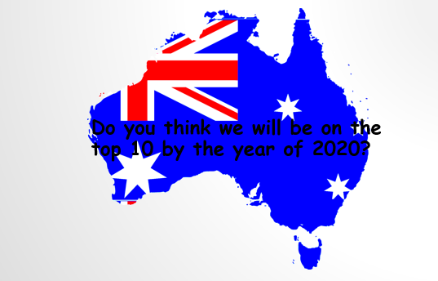

Based on our rankings from the 2015 to 2019, we’ve made some predictions on the happiness score of Australia along with the predicted happiness score of the top 10th country (meaning the minimum score to get into the top 10)

to see if we will make it to the top 10.

Our data is consistent throughout the years for Australia’s ranking so checking the normality of the data was not necessary.

**----Australia prediction presentation----- Rye**

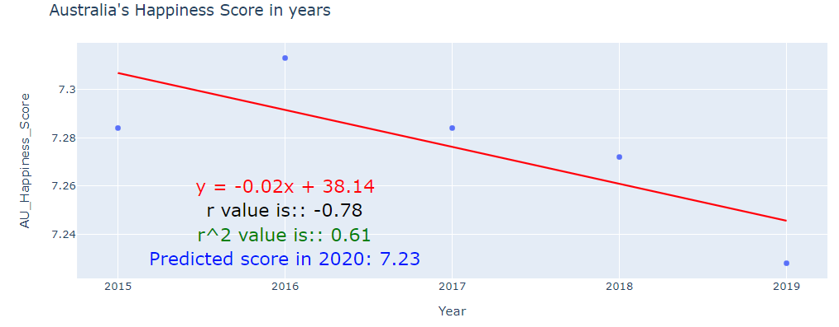

As you can see, we have a negative correlation. Australia’s score goes down as the year progress with a predicted score of 7.23.

**----Top 10th country prediction presentation----- Rye**

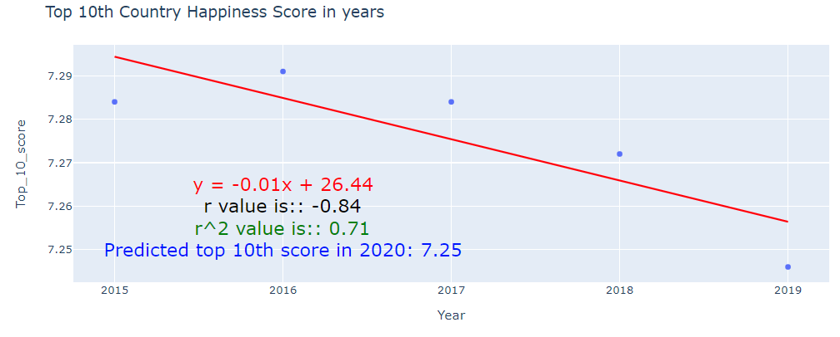

The score of the top 10th country also shows a negative correlation.

But Australia’s score does not meet the minimum score to make it to the top 10 which is 7.25



Which region in the world do you think will have the top 10 countries and bottom 10 countries?

The colour bubbles on this map represents the top 10 countries and the colour indicate their happiness score. The top 10 countries happiness score is between 7 to 8. The yellow represents the higher score, the blue represents lower score.

In Year 2019, we can see that the top 10 countries are on the Europe region. If we look at 2015 to 2019. Interestingly, most of the top 10 countries are on the Europe region as well which is consistent over the years.

As we can see from the map, Australia was on the top 10 from year 2015 to year 2018. However, Australia ranking drop to 11 in year 2019. Australia still considered a happy country overall compared to 156 countries.



Again, the colour bubbles on this map represents the bottom 10 countries and the colour indicate their happiness score. The bottom 10 countries happiness score is between 2 to 4. Again, the yellow represents the higher score, the blue represents lower score.

If we are scrolling from Year 2015 to 2019, we can see most of the bottom 10 countries are on the Africa, Middle East region which is pretty interesting as well.

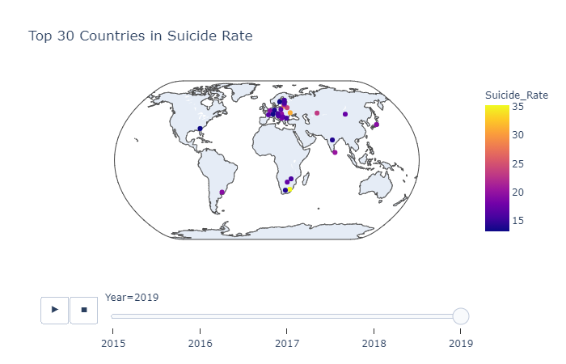

We found something which seems contradicting.

The map here shows the Top 30 Countries in Suicide rate. We have already established that European countries are the happiest countries in the world. Simultaneously they have highest suicide rates among other countries. And Australia is not there, which is good.

But, there is no evidence which shows that the countries with higher happiness score will have high suicide rate.

The lack of any clear relation between suicide and happiness remains unresolved. It is because suicide is hard to explain.

It is silly to think that a single number like “happiness score” could completely explain something as complex as human happiness, but when the score that is meant to be representative of happiness and quality of life strongly correlates with suicide something is very wrong.

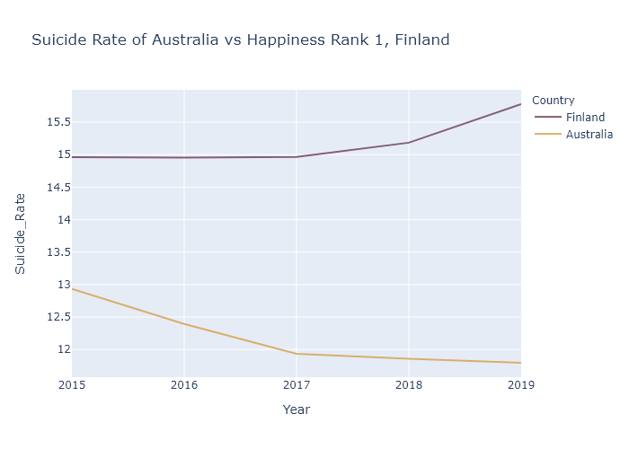

1. **Finland** is an example of a country with a high happiness score and high suicide rate.
2. Australia's suicide rate is lesser than, most of the European nations and the US

Though Australia's **happiness score** is lesser than, most of the European nations, our **generosity** is higher than the top country and **family values** are on par with rank no.1

So give a pat on your back, for being kind. And give a hug to your family.