MASWS Assignment 1 Part 2

Diljá Rudolfsdottir s0966087 & Steven Eardley s0934142

1. Tool Used to Run Queries

To run our SPARQL queries we used a java based tool named twinkle. It's useful because it provides a handy GUI (see Illustration 1) for writing and viewing results, but also support for both SPARQL and the more capable ARQ extended syntax. This allowed us to include functions like COUNT() for more interesting queries.
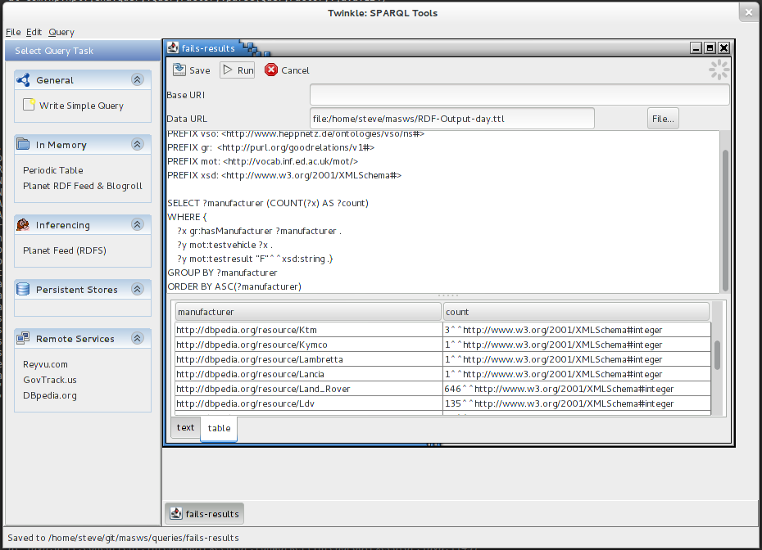Illustration 1: User Interface for Twinkle
One disadvantage was found when using this tool: it was necessary to further decrease our data sample size. Our original data source was one year's worth of MOT test data, from which one month was converted. This required further reduction to just a single day, due to a 'Java heap space' error message shown, causing failed queries (Illustration 2). This corresponds to 128, 775 MOT tests which is translated by our system into 2,833,056 lines of RDF. One day is a tiny portion of the original data set.

2. Changes to Conversion Code
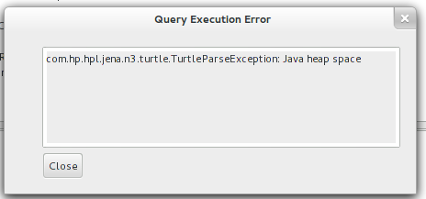Illustration 2: Heap Space Exception

Initially the data failed to parse, requiring modifications to the java code submitted for part 1. The problems arised where vehicle manufacturer names were being translated into dbpedia URIs: while single-word manufacturers like 'RENAULT' were correctly converted to dbpedia:Renault (http://dbpedia.org/resource/Renault) but any manufacturer with more than one word, such as 'LAND ROVER' was converted to dbpedia:Land rover. This has now been changed to produce valid URIs more reliably: changing spaces for underscores and making the first letter of each word upper case, to produce e.g. dbpedia:Land_Rover, which correctly corresponds to http://dbpedia.org/resource/Land_Rover.
3. Query 1
The first query returns the model of each electric vehicle in the data file. This may be useful for people interested in finding out more about electricity as a fuel for transport.

PREFIX dbpedia: <http://dbpedia.org/resource/>
PREFIX vso: <http://www.heppnetz.de/ontologies/vso/ns#>
PREFIX mot: <http://vocab.inf.ed.ac.uk/mot/>

SELECT ?vehiclemodel

WHERE
{ ?x vso:fuelType dbpedia:Electricity .
?x mot:vehiclemodel ?vehiclemodel . }

This produces the following result:
-------------------------------------------------------------------------
| vehiclemodel |
=========================================================================
| "G-WIZ"^^<http://www.w3.org/2001/XMLSchema#string> |
| "PRIUS T SPIRIT VV-I AUTO"^^<http://www.w3.org/2001/XMLSchema#string> |
| "RX400 H SE CVT"^^<http://www.w3.org/2001/XMLSchema#string> |
| "UNCLASSIFIED"^^<http://www.w3.org/2001/XMLSchema#string> |
| "PRIUS T SPIRIT VV-I AUTO"^^<http://www.w3.org/2001/XMLSchema#string> |
| "PRIUS T3 VVT-I AUTO"^^<http://www.w3.org/2001/XMLSchema#string> |
| "CIVIC EXECUTIVE IMA"^^<http://www.w3.org/2001/XMLSchema#string> |
| "INSIGHT"^^<http://www.w3.org/2001/XMLSchema#string> |
| "UNCLASSIFIED"^^<http://www.w3.org/2001/XMLSchema#string> |
| "PRIUS T3 VVT-I AUTO"^^<http://www.w3.org/2001/XMLSchema#string> |
...

4. Query 2
Secondly, we find the top ten vehicles with the highest mileages on the odometer. This shows extracting deeper relations from the data (the float from the mileage object), and performing useful operations such as sorting the values.

PREFIX dbpedia: <http://dbpedia.org/resource/>
PREFIX vso: <http://www.heppnetz.de/ontologies/vso/ns#>
PREFIX gr: <http://purl.org/goodrelations/v1#>
PREFIX mot: <http://vocab.inf.ed.ac.uk/mot/>

SELECT ?manufacturer ?vehiclemodel ?value
WHERE
{ ?x gr:hasManufacturer ?manufacturer .
?x vso:mileageFromOdometer ?mileage .
?x mot:vehiclemodel ?vehiclemodel .
?mileage gr:hasValueFloat ?value }
ORDER BY DESC(?value)
LIMIT 10
-----------------------------------------------------------------------------------
| manufacturer | vehiclemodel | value |
====================================================================================
| <http://dbpedia.org/resource/Renault> | "CLIO 565 DCI" | "999985" |
| <http://dbpedia.org/resource/Volkswagen> | "PASSAT S" | "990317" |
| <http://dbpedia.org/resource/Honda> | "CR-V I-VTEC SE" | "985870" |
| <http://dbpedia.org/resource/Skoda> | "OCTAVIA CLASIC TDI" | "979667" |
| <http://dbpedia.org/resource/Land_Rover> | "DEFENDER 110 COUNTY TD5" | "978140" |
| <http://dbpedia.org/resource/Ford> | "UNCLASSIFIED" | "973313" |
| <http://dbpedia.org/resource/Ford> | "UNCLASSIFIED" | "973313" |
| <http://dbpedia.org/resource/Citroen> | "SAXO VTR" | "960005" |
| <http://dbpedia.org/resource/Renault> | "MASTER LM35 DCI" | "941340" |
| <http://dbpedia.org/resource/Saab> | "9-3 SE TURBO" | "939661" |
-------------------------------------------------------------------------------------
The types (e.g. "999985"^^<http://www.w3.org/2001/XMLSchema#float>) are omitted here for clarity.

5. Query 3
Here we are interested in reliability per manufacturer: producing a list, ordered alphabetically by car company, which shows how many of their vehicles failed MOTs. This demonstrates using variables ?x and ?y to relate tests and vehicles in a query. The use of COUNT requires switching the querying tool from SPARQL to ARQ syntax.

PREFIX dbpedia: <http://dbpedia.org/resource/>
PREFIX gr: <http://purl.org/goodrelations/v1#>
PREFIX mot: <http://vocab.inf.ed.ac.uk/mot/>
PREFIX xsd: <http://www.w3.org/2001/XMLSchema#>

SELECT ?manufacturer (COUNT(?x) AS ?count)
WHERE {
?x gr:hasManufacturer ?manufacturer .
?y mot:testvehicle ?x .
?y mot:testresult "F"^^xsd:string .}
GROUP BY ?manufacturer
ORDER BY ASC(?manufacturer)
-----------------------------------------------------------
| manufacturer | count |
===========================================================
| <http://dbpedia.org/resource/Aixam> | 2 |
| <http://dbpedia.org/resource/Ajs> | 1 |
| <http://dbpedia.org/resource/Alfa_Romeo> | 112 |
| <http://dbpedia.org/resource/Aprilia> | 6 |
| <http://dbpedia.org/resource/Aston_Martin> | 5 |
| <http://dbpedia.org/resource/Audi> | 717 |
| <http://dbpedia.org/resource/Austin> | 17 |
| <http://dbpedia.org/resource/Austin_Morris> | 5 |
| <http://dbpedia.org/resource/Auto-trail> | 3 |
| <http://dbpedia.org/resource/Barossa> | 2 |
...

6. Query 4
The fourth query demonstrates another possible use for our data set – environmental interest. It groups and counts the vehicles by fuel type.

PREFIX dbpedia: <http://dbpedia.org/resource/>
PREFIX vso: <http://www.heppnetz.de/ontologies/vso/ns#>

SELECT ?fuel (COUNT(distinct ?x) AS ?count)
WHERE { ?x vso:fuelType ?fuel .}
GROUP BY ?fuel
ORDER BY ?count
LIMIT 10

------------------------------------------------------------------
| fuel | count |
==================================================================
| <http://dbpedia.org/resource/Liquefied_petroleum_gas> | 120 |
| <http://dbpedia.org/resource/Alternative_fuel_vehicle> | 28 |
| <http://dbpedia.org/resource/Diesel_fuel> | 38598 |
| <http://dbpedia.org/resource/Electricity> | 59 |
| <http://dbpedia.org/resource/Gasoline> | 78985 |
------------------------------------------------------------------
7. Query 5
This query supposes a car club is interested in creating their own data set of Land Rovers with classic car status – older than 1973. Using the CONSTRUCT statement, the data from our set can be gathered using a different ontology: this time using vso: the Vehicle Sales Ontology. The result is a valid RDF data set in XML format.
PREFIX dbpedia: <http://dbpedia.org/resource/>
PREFIX vso: <http://www.heppnetz.de/ontologies/vso/ns#>
PREFIX gr: <http://purl.org/goodrelations/v1#>
PREFIX mot: <http://vocab.inf.ed.ac.uk/mot/>
PREFIX xsd: <http://www.w3.org/2001/XMLSchema#>

CONSTRUCT { ?x a vso:Automobile .
?x mot:vehiclemodel ?vehiclemodel .
?x vso:color ?colour .
?x vso:fuelType ?fueltype .
?x vso:engineDisplacement ?disp .
?x vso:firstRegistration ?regdate}

WHERE
{ ?x mot:vehiclemodel ?vehiclemodel .
?x gr:hasManufacturer dbpedia:Land_Rover .
?x vso:color ?colour .
?x vso:fuelType ?fueltype .
?x vso:engineDisplacement ?disp .
?x vso:firstRegistration ?regdate .
FILTER (?regdate < "1973-01-01"^^xsd:date) }

<rdf:RDF
xmlns:rdf="http://www.w3.org/1999/02/22-rdf-syntax-ns#"
xmlns:vso="http://www.heppnetz.de/ontologies/vso/ns#"
xmlns:gr="http://purl.org/goodrelations/v1#"
xmlns:dbpedia="http://dbpedia.org/resource/"
xmlns:xsd="http://www.w3.org/2001/XMLSchema#"
xmlns:mot="http://vocab.inf.ed.ac.uk/mot/" >
<rdf:Description rdf:nodeID="A0">
<vso:engineDisplacement rdf:nodeID="A1"/>
<vso:color>GREEN</vso:color>
<rdf:type rdf:resource="http://www.heppnetz.de/ontologies/vso/ns#Automobile"/>
<vso:fuelType rdf:resource="http://dbpedia.org/resource/Gasoline"/>
<vso:firstRegistration rdf:datatype="http://www.w3.org/2001/XMLSchema#date">1958-01-01</vso:firstRegistration>
<mot:vehiclemodel rdf:datatype="http://www.w3.org/2001/XMLSchema#string">UNCLASSIFIED</mot:vehiclemodel>
</rdf:Description>
<rdf:Description rdf:nodeID="A2">
<vso:firstRegistration rdf:datatype="http://www.w3.org/2001/XMLSchema#date">1965-09-07</vso:firstRegistration>
<rdf:type rdf:resource="http://www.heppnetz.de/ontologies/vso/ns#Automobile"/>
<mot:vehiclemodel rdf:datatype="http://www.w3.org/2001/XMLSchema#string">88 - 4 CYL</mot:vehiclemodel>
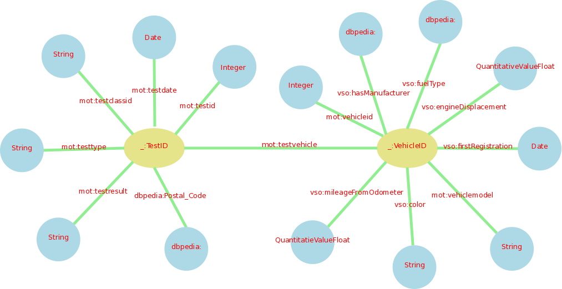
<vso:engineDisplacement rdf:nodeID="A3"/>
<vso:color>BLUE</vso:color>
<vso:fuelType rdf:resource="http://dbpedia.org/resource/Diesel_fuel"/>
</rdf:Description>
...
</rdf:RDF>

7. Your bit!

