TTS Assignment 4 Steven Eardley s0934142

ranker.py first runs part_one(), creating pr.txt, hubs.txt, auth.txt. Then, using this data, part_two() is run, creating part_two_report.txt, a report summarising the activity of the key persons.

Part 1
The ranker first builds a dictionary (named graph_info) of each individual’s emails. While iterating through each line of the file, each person’s outgoing and incoming lists are updated. The dictionary value then contains lists of addresses emailed to and emailed by, with the individual’s email address as the dictionary key. Multiple links (emails) are identified by repeated entries in the list, and emails sent to oneself are ignored.

To implement PageRank, a dictionary of scores is initialised to 1/n, where n is the number of individuals. The graph_info dictionary is iterated through, and its score is updated according to the scores of its incoming email addresses. The sink node (identified if len(outgoing) == 0) score is also totalled and added into the PageRank formula to prevent the total score from ‘bleeding off’ into people who didn’t send emails. This may not have been entirely successful, however, since we can see that klay@enron.com, the email address for Kenneth Lay, CEO, appears top of the list while having not sent any emails, and having received relatively few compared to other key persons. Nonetheless it is pleasing to see Kenneth Lay and Jeffrey Skilling, both prosecuted as guilty parties, as central figures according to the algorithm.

The HITS algorithm runs on the same graph information, with separate dictionaries for the Hub scores and the Authority scores. An individual’s Hub score is updated by the sum of all outgoing links’ Authority scores, their Authority score is updated by the sum of all incoming Hub scores. At each iteration these values are normalised by dividing their score by the square root of the sum of each score squared. Unsurprisingly we find the oddly named broadcast account, pete.davis@enron.com, as a major hub. This makes sense since it will be sending a good many emails. Second in the Hub score we find Bill Williams, a trader according to the New York Times.

Part 2
Using the results from the first section, people of interest are identified by those with the highest PageRank score. These are the nodes constituting the graph. Data flow is found by seeing which of these key players emailed each other.

Another comparison is made to the individuals with the top highest Hub and Authority scores. We actually find that there is little communication between those with top PageRank scores and those with highest HITS results. Perplexing.

Using the above information the following graph is obtained:
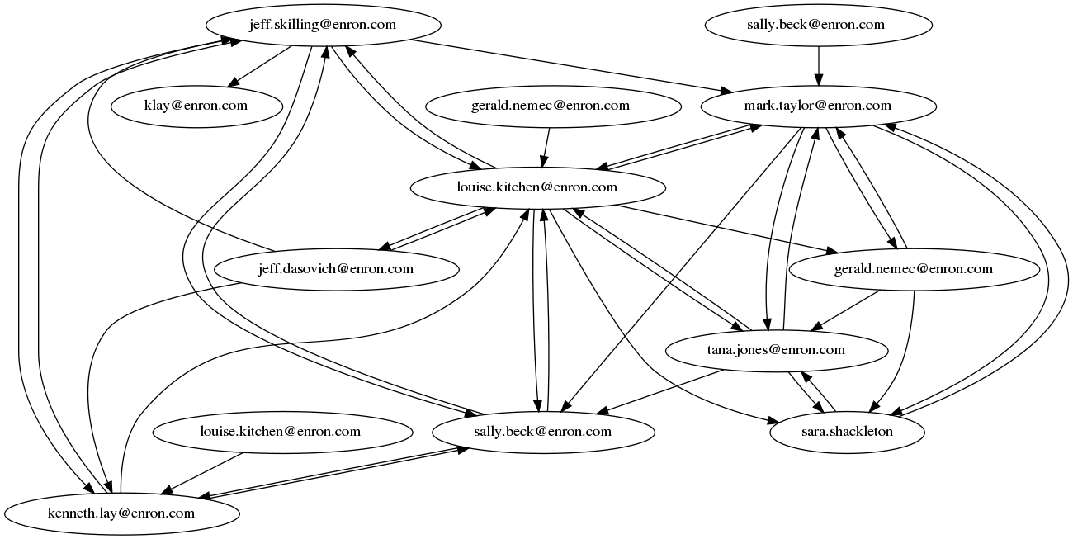

http://www.nytimes.com/2005/02/04/business/worldbusiness/04iht-enron.html

