TTS Coursework 1 Steven Eardley s0934142

The crawler uses the following modules:

re - The standard regular expression module, utilised as detailed below.

urllib2 - An improvement over urllib which detects page errors such as 404s rather than reading the 404 page itself and feeding it into the parser.

robotparser - This module is used to read a robots.txt file and determine if URL access is permitted.

heapq - adds (min) heap functionality to a given list. This is useful as a simple implementation of a priority queue.

time - This is used to implement the request rate, by sleeping the process.

Limitations:
The crawler does not take into account when robots.txt was parsed, so if it were to spend an extended time in one domain, it would fail to pick up changes.

The crawler does not handle navigation through a folder structure. This would require alterations to the baseURL and concatenation of URLs in loadPage(). As such, some links of the form "../page.html" are not properly handled. When browsing it can be seen that these tend to lead to 404 errors anyway.

The crawler does not save the pages as per the algorithm; this is to save disk space since this is not required to parse the pages.

Outline:
Once the crawler access rules and request rate are parsed using the method setUpRobot(), the crawler opens the first page if allowed using urllib2.urlopen(), and reads the input stream as a string. At this stage the URL is added to a 'visited' list, or if denied to a 'denied' list. The content region is identified by selecting the text matching the following regular expression:

'<!-- CONTENT -->.*<!-- /CONTENT -->'

which is a verbose method for matching all characters between the two comments. The text within the content region is checked for URLs using another regular expression:

'(?<=a href=")\S*\.[A-za-z]+'

this takes alphanumeric characters followed by a '.' and a file type such as 'html'. Each URL is then searched for digits (regular expression '\d+') to find the priority. The number is negated and added to the frontier (a min heap using heapq) as a tuple with the url only if it hasn't been found in the visited or denied lists or isn't already in the frontier. Due to the negation, the highest number will produce the minimum and therefore the greatest priority in the queue.

The crawler runs until the frontier is empty, i.e. there are no unexplored pages.

Output:
$ time python crawler.py

Unique URLs found: 856
Pages Visited: 807
Pages Denied: 45
Pages With errors: 4
Pages with no content: 9
External pages detected: 0

real 14m35.839s
user 0m2.452s
sys 0m0.394s

Results:
Due to the delays imposed by the 'Request-rate' field in robots.txt the crawler takes 14.5 minutes to run. During the crawl it finds 856 unique URLs, 45 of which are denied by the robots rules, leaving 811 accessible to the crawler. Of those, 4 pages return 404 errors leaving 807 visited. 9 of these pages have no content section. Inspection of these shows they are CNN 404 pages which were scraped in the original crawl. No links pointing to external domains were encountered by the crawler. Most of these exist outwith the content region.

By logging the size of the frontier at every iteration, a plot was made of the frontier growth:

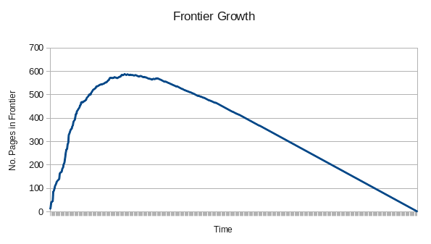
As expected, the crawler encounters a rapidly expanding set of unique pages to consider and then gradually depletes the list. This is because most of these news pages contain numerous URLs to other articles which themselves have similar properties. At the beginning most URLs are novel, then the rate decreases until the maximum frontier length at 588 pages.

