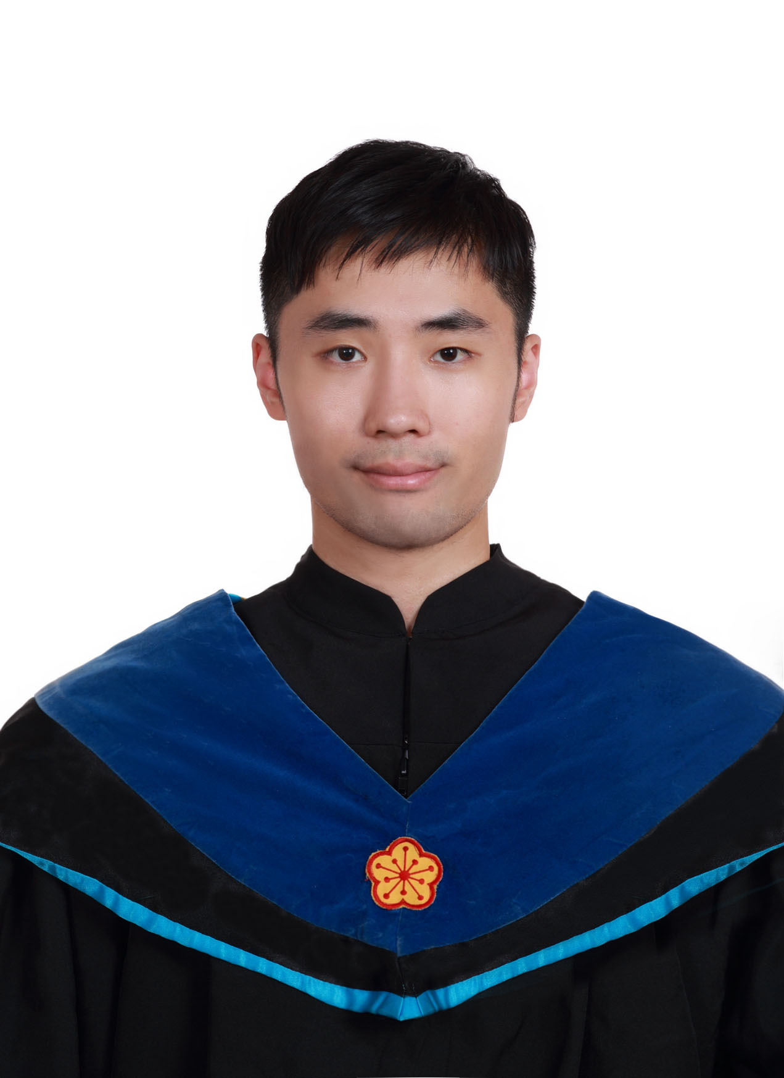

吳錦賢, Kam-In Ng (Steven)

stevenng.kaminng@gmail.com

Macao, China

Intern:

DeepQ, HTC/Deep learning Team

Education:

Bachelor's degree, Physics, National Tsing Hua University, Taiwan

Master's degree, Electrical Engineering, National Taiwan University, Taiwan