A Half-Told Story: How Historical Markers in Ann Arbor, Michigan, Memorialize the Settler-Colonial State and Erase its Indigenous Foundations
If you walk through downtown Ann Arbor, Michigan, you will notice many historical markers and plaques that memorialize significant events, peoples, or places within the city’s history. These markers are largely concentrated in central Ann Arbor, reflecting the city’s earliest establishment by American settlers in the early nineteenth century. Individuals, such as John Allen and Elisha Rumsey, are celebrated on these markers as the first inhabitants of modern-day Ann Arbor; others memorialize major events, such as the construction of the Michigan Central Railroad in 1839, which encouraged the rural settlement to grow as an urban center. While these markers range in scope, they mostly memorialize the city’s “original” inhabitants or its progression as a center of industry through time. But, do they tell a comprehensive story about Ann Arbor’s past, its landscape, and original settlement? What of the Indigenous Anishinaabe peoples who inhabited this region since time immemorial?
To address these questions, we identified 197 historical markers in and around Ann Arbor, Michigan. We recorded each marker’s provenance information, plaque title, and inscription. If applicable, we also recorded when the markers were erected and by whom. Using the marker’s inscription, we then determined which historical narratives (or group heritage) these markers memorialized, and categorized them by primary subjects: colonial/settler, Indigenous, African American/Enslaved/Freed Blacks, foreign nation, and miscellaneous. In some cases, this categorization was not clearly differentiated as these communities had complex relationships with one another, so we created a secondary subject category using the same classifications as outlined above.
Of the 197 historical markers we identified, 95.9 percent were classified as having colonial/settler as the primary subject, followed by Indigenous (1.5 percent), miscellaneous (1.5 percent), and African American/Enslaved/Freed Blacks (1.1 percent) (see Figure 1.). Further review of these marker’s inscriptions also suggests that the histories being memorialized are concerned with the city’s development and progress through time, i.e., the transformation and exploitation of the natural landscape into a regional, urban center during the nineteenth century. The aggregation of this data suggests that Ann Arbor’s historical markers disproportionately memorialize a colonial/settler history, despite Indigenous Anishinaabe peoples occupying this region for thousands of years prior to colonization of North American and later westward expansion by American settlers. Therefore, this bias in memorialization directly displaces Indigenous peoples within the historical record and limits their presence within Ann Arbor’s collective memory.
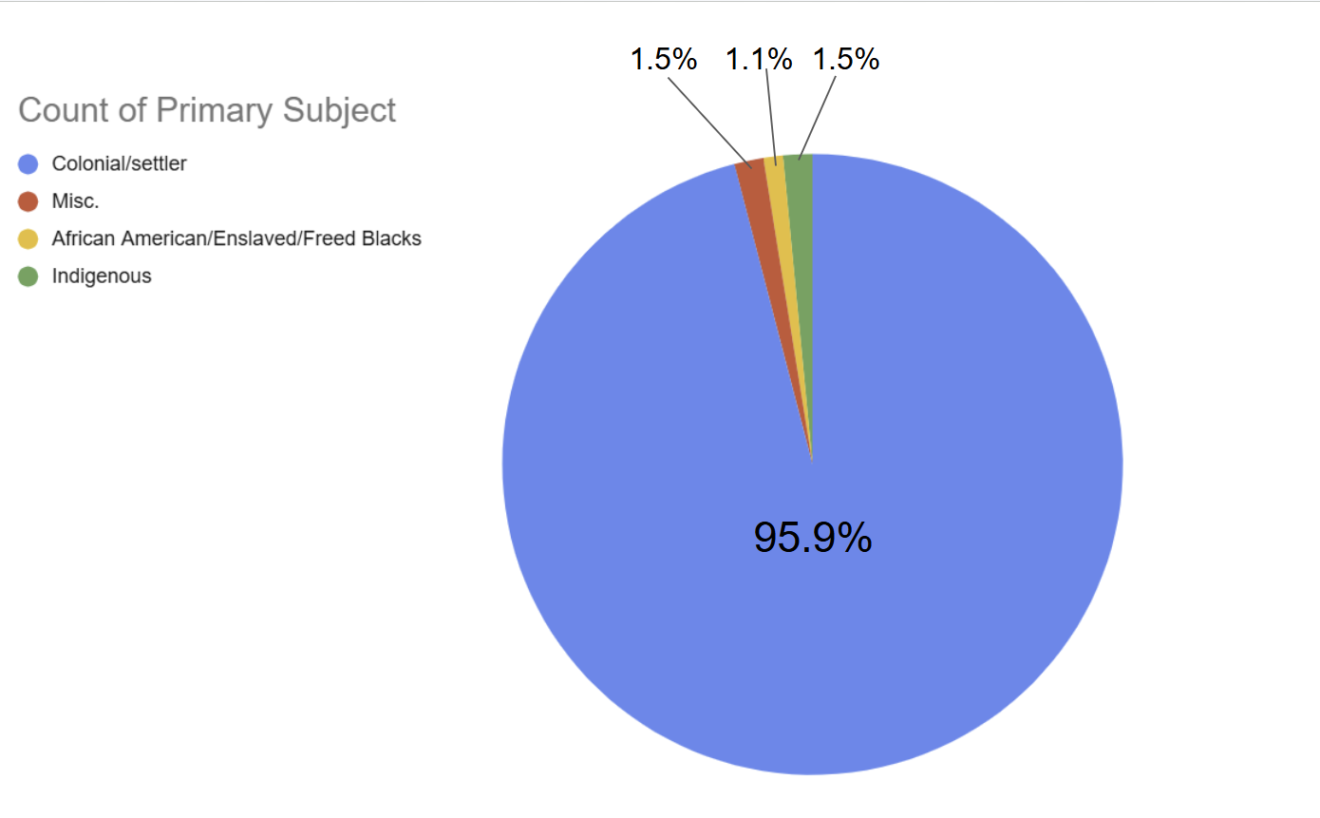
Figure 1. Percentages of Ann Arbor’s historical markers and the primary subjects each monument memorializes.

Furthermore, the few markers that position Indigenous peoples as the primary subject are situated in a colonial context. Of the 197 historical markers we recorded in Ann Arbor, only three were classified as representing primarily Indigenous subjects: 1) Native American Trails, 2) Indian Trails, Roads, and Trains, and 3) Native American Land Gift 1817. While 93.4 percent of all markers did not have a secondary subject identified, every Indigenous marker was classified as having colonial/settler as the secondary subject (see Figure 2.). For example, the inscriptions for the two historical markers about Native American trails in Ann Arbor also describe how American settlers utilized these trails during its early settlement (see Table 1.). Further analysis of one of these markers, i.e., Native American Trails, represents this colonial context clearly, stating:

“Centuries ago, Indian trails crossed the landscape of Washtenaw County. These paths connected Indian villages to fertile hunting and fishing grounds throughout Michigan. When settlers arrived in the County during the 19th century, these same trails were used to link growing communities. Eventually, some of these trails became part of the current road system” (“Native American Trails” 2025).

By positioning these “Indian trails” as being utilized several centuries before settlers arrived in Ann Arbor (and seemingly hinting that they fell out of use sometime before westward expansion), this marker ignores the Anishinaabe communities that continued to occupy this region in the nineteenth century. Additionally, the marker’s juxtaposition of the trails original use by Indigenous peoples, to their later incorporation into the city, further positions how American settlers transformed the landscape from a “primordial state.” This over-looking of remaining Indigenous peoples in the region, constitutes what historian Jean O’Brien, has termed as a firsting-and-lasting of nineteenth century Native Americans (O’Brien 2010). As described by O’Brien, firsting-and-lasting is the process in which the colonial-settler contorts the historical record to:

“[write] Indians out of existence…sometimes through precise declarations that the “last” of them had passed; the colonial regime is constructed as the “first” to bring “civilization” and authentic history to the region” (O’Brien 2010: xii-xv).

While some of these markers appear to highlight Ann Arbor’s Indigenous history, we conclude that they do not provide a comprehensive account of the past, and instead, engage in the firsting-and-lasting of the region’s Anishinaabe population. As provided in the example above, while these markers correctly identify Native Americans as the region’s first inhabitants, they later conclude how the region was “developed” or “urbanized” by nineteenth-century American settlers. Therefore, Ann Arbor’s historical markers perpetuate the colonial state, and memorialize the firsting-and-lasting of its Indigenous populations.
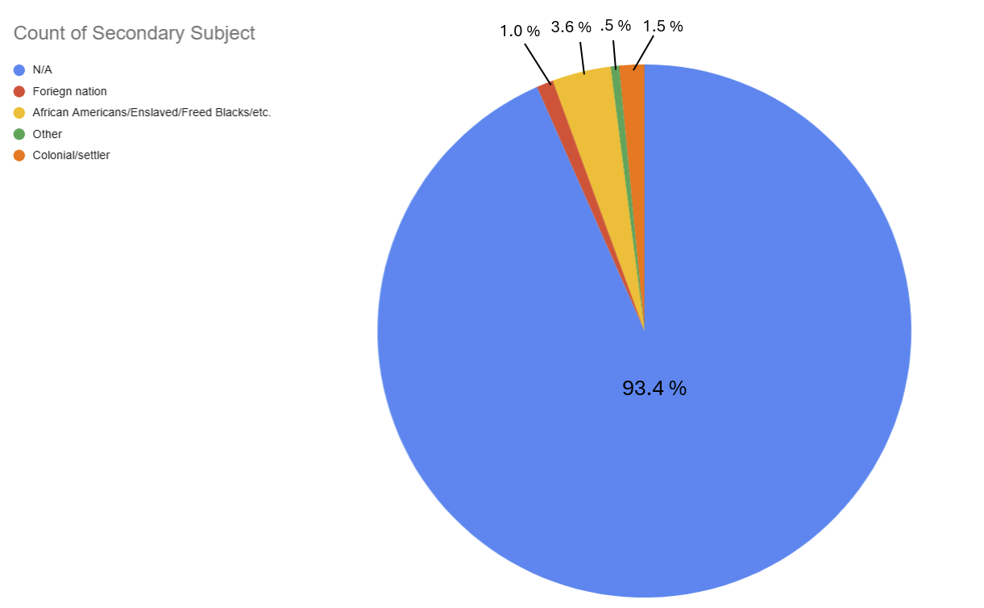
Figure 2. Percentages of Ann Arbor’s historical markers and the secondary subjects each
monument memorializes
Table 1. List of Ann Arbor, Michigan’s Historical Markers having Indigenous Peoples as Primary Subject
Title | Primary Subject | Secondary Subject | Inscription | Location | Date erected | Erected by
Native American Trails | Indigenous | Colonial/  settler | Centuries ago, Indian trails crossed the landscape of Washtenaw County. These paths connected Indian villages to fertile hunting and fishing grounds throughout Michigan. When settlers arrived in the County during the 19th century, these same trails were used to link growing communities. Eventually, some of these trails became part of the current road system.  Parker Mill Park is located along a prehistoric Native American trail that connected the present-day cities of Ann Arbor and Ypsilanti. In the early twentieth century, three earthen mounds were discovered less than one mile from the property. Pottery, copper, slate ornaments, a skeleton of a beaver, and a complete human skeleton were uncovered during excavations. | 42° 16.441′ N, 83° 40.083′ W | N/A | Washtenaw County Historic District Commission
Native American Land Gift 1817 | Indigenous | Colonial/  settler | This plaque commemorates the grant of lands from the Ojibwe (Chippewa), Odawa (Ottawa), and Bodewadimi (Potawatomi), through the Treaty of Fort Meigs, which states that “believing they may wish some of their children hereafter educated , [they] do grant to the rector of the the Catholic church of St. Anne of Detroit … and to the corporation of the college at Detroit, for the use of the said college, to be retained or sold, as the said director and corporation may judge expedient … ” The rector was Gabriel Richard, a founder and first vice president of the corporation of the college, chartered by the territorial legislature as the University of Michigania in 1817. These lands were eventually sold to the benefit of the University of Michigan, which was relocated to Ann Arbor in 1837. | 42°16'41.1"N 83°44'17.8"W | 2002 | History and Traditions Committee, University of Michigan
Indian Trails, Roads, and Trains | Indigenous | Colonial/  settler | Native Americans came from the northeast down the Pontiac Trail from the east down the Broadway hill following a trail that went through what later became Plymouth, and from the southeast up the Huron River along the Potawatomi Trail from what became Ypsilanti. These trails joined at the river, followed along Allen's Creek to the bluffs of what became West Park, and from there along the Potawatomi and other trails to the western part of Michigan.  Anishinaabe includes Potawatomi, Ojibwe, and Odawa tribes who all lived in this region.  Although Ann Arbor was first settled near Main and Huron in 1824, by 1826 Lower Town began attracting settlers. More came after the first wood bridge over the Huron River was built in 1828. | 42° 17.296′ N, 83° 44.087′ W | 2014 | University of Michigan

References
“Native American Trails.” 2025. The Historical Marker Database. https://www.hmdb.org/m.asp?m=104642.

O'Brien, Jean M.. Firsting and Lasting : Writing Indians Out of Existence in New England, University of Minnesota Press, 2010. ProQuest Ebook Central, https://ebookcentral-proquest-com.proxy.lib.umich.edu/lib/umichigan/detail.action?docID=548068.

