Steven Reeves

CST 250

4/2/18

Lab 1 Report

**Introduction:**

The objective of this lab is to get the development tools for this class up and running. Labs will be built off one another and it’s important to start with a solid base. A new project will be tested to make sure the environment is fully functional.

**Part 1:**

This part has us download a copy of the MPLAB X IDE installer and run it on our machine. I downloaded it for Windows as I’ll be working in that OS. <http://www.microchip.com/mplabx-ide-windows-installer>

After downloading the .exe from the above link, I ran the executable (with admin rights) and followed the prompts.

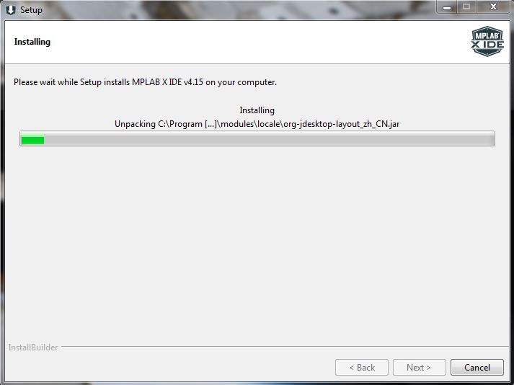

Installation on my laptop found the following error:

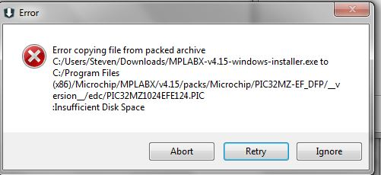

After clearing some space on the laptop, both desktop and laptop installation was successful.

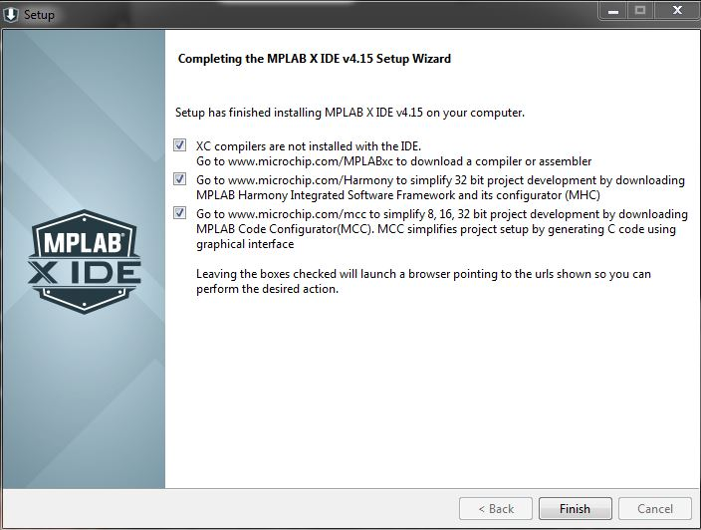

**Part 2:**

This part has us download a copy of the XC32 compiler tools installer and run it on our machine. I downloaded it for Windows as I’ll be working in that OS. http://www.microchip.com/mplabxc32windows

After downloading the .exe from the above link, I ran the executable (with admin rights) and followed the prompts.

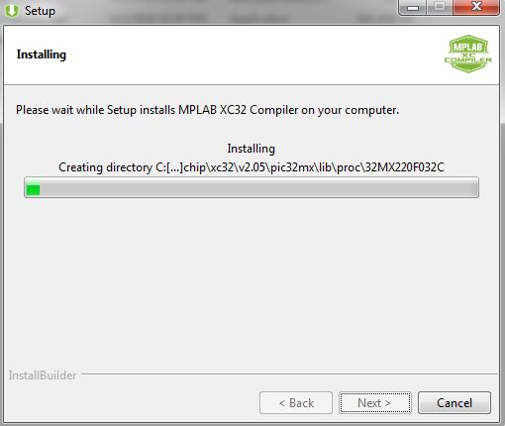

After some time, the installer succeeded.

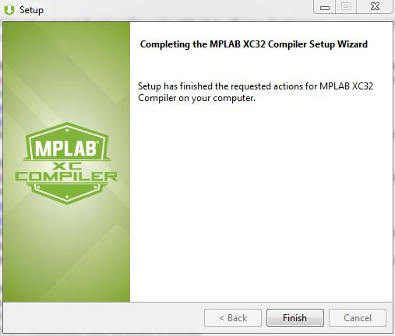

**Part 3:**

This part has us create a new project to make sure everything was installed and setup correctly. After opening the MPLAB X IDE software and starting a new project, I chose Microchip Embedded -> Standalone project. Then after choosing the PIC32MX460F512L device, I chose the Simulator tool under Hardware Tools. The installation of the XC32 compiler was further confirmed after seeing it in the compiler options. After choosing that, I was prompted to enter a project name (Lab1). Here I made sure “Set as main project” was checked as well. After the main project was opened I created a new assembler file under “Source Files”. By default this file (named lab1) had a file extension of .asm. After right-clicking and removing the file from the project, I was able to locate the file on my hard drive and change the file extension to ‘.S’ (note the upper case S).

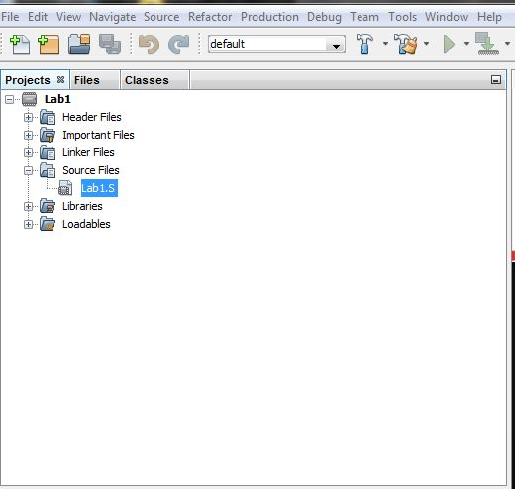

After a quick restart of the application, I copied the contents of ‘Basic_source_template.S’ into lab1.S.

A clean/build command resulted in the following successful screenshot:

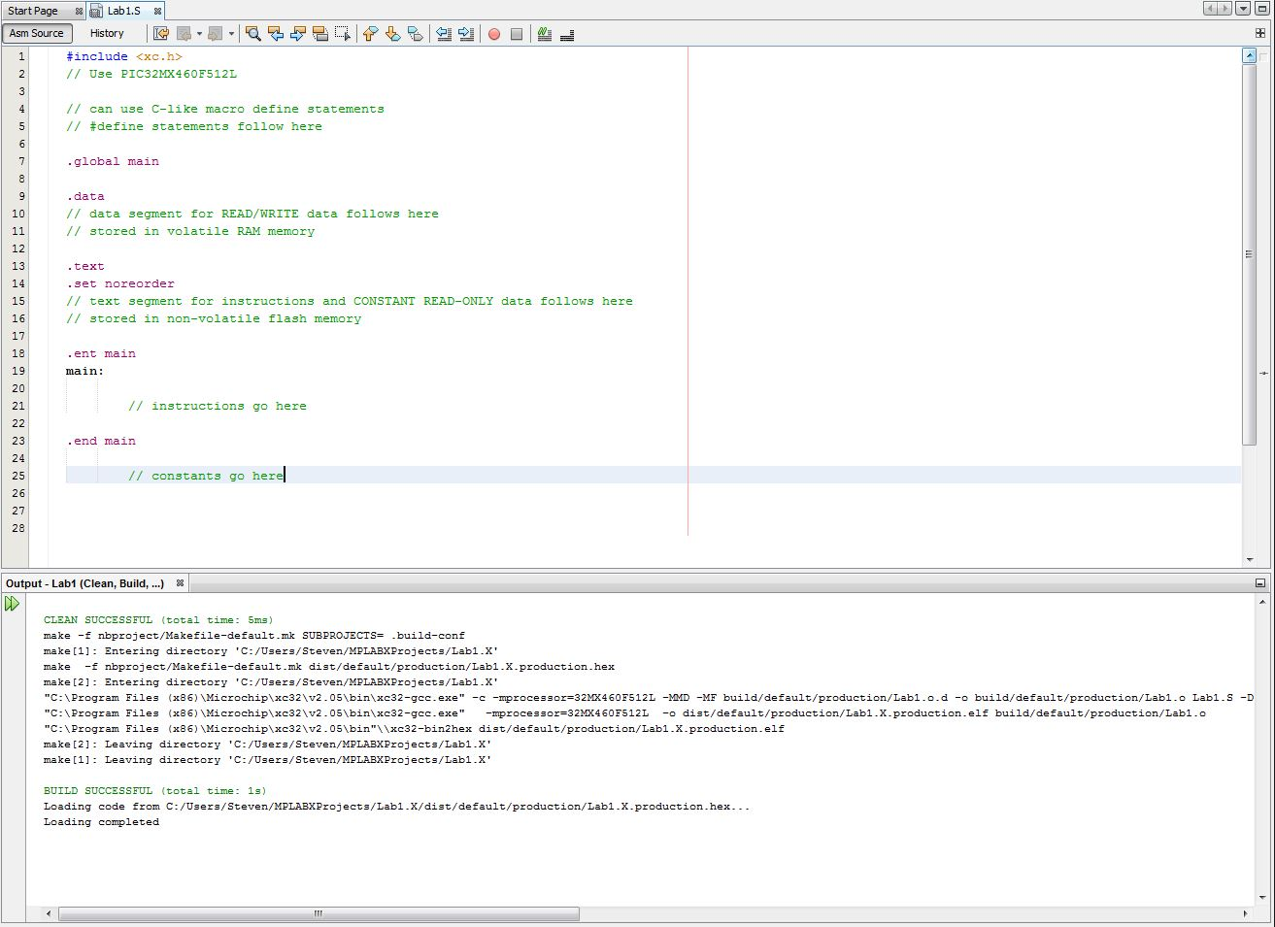

**Conclusion:**

The process of getting the environment wasn’t too difficult. The only problem I really faced was the lack of disk space on my laptop, which was fixed after cleaning some unnecessary programs out. There were also a lot of options that I wasn’t familiar with during installation, but clicking the defaults seemed to work. Setting version control up by having the IDE save the project to my repo worked well too. In summary, I learned to set up yet another IDE and compiler. In this line of work, it’s a good skill to have.