Steven Reeves

CST 250

5/5/18

Lab 4 Report

**Introduction:**

The objective of this lab is to use the disassembly view in the MPLAB X IDE to inspect stack frames as they’re getting used and created.

**Part 1:**

The first part of this lab had me create a new .c project using the same setup we have for previous labs. After dropping a breakpoint at the beginning of the main block, I saw the following:

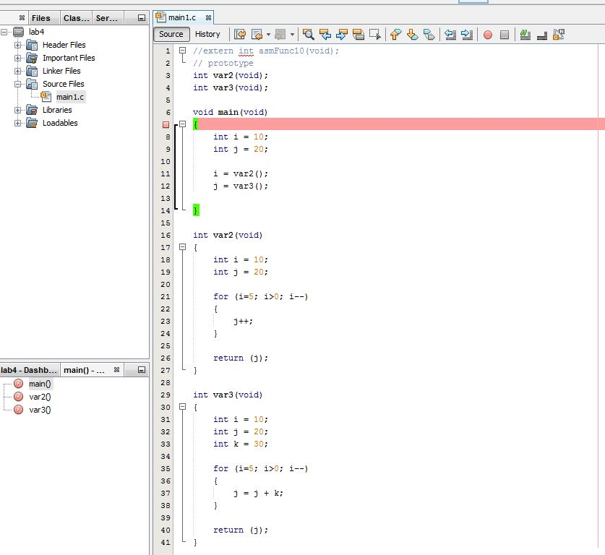

After starting a debugging session, Window->Debugging->Disassembly was used to access the following view:

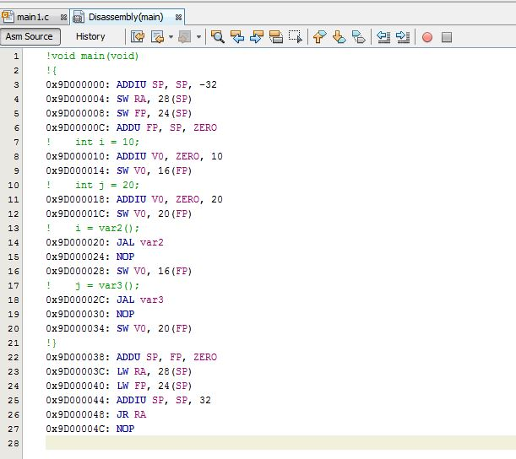

At this point, I was able to tell how the stack frame was constructed, and what was in it. Entering that information into the “Lab 4 Stack Frame Template” is shown below:

Note: “a0-a3” are used as unallocated spots, A0-A4 are used when the function actually sets one of these spots.

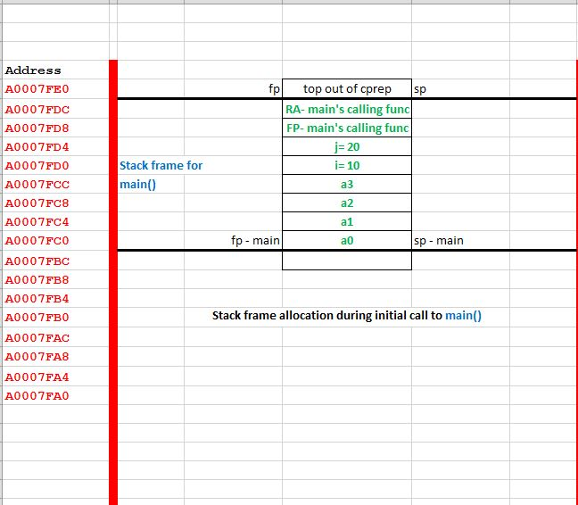

I then deleted my breakpoint from main and added one at the beginning of var2(). The same process of observing the disassembly view was used to obtain the following information:

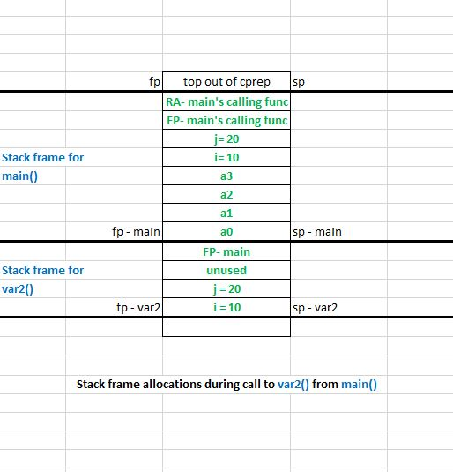

I then deleted my breakpoint from main and added one at the beginning of var3(). The same process of observing the disassembly view was used to obtain the following information:

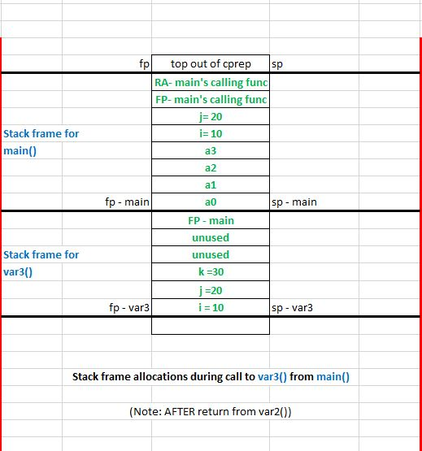

**Part 2:**

This part had me do the same process as above for the remaining main.c projects. Screenshots of the filled out Stack Frame Template are below:

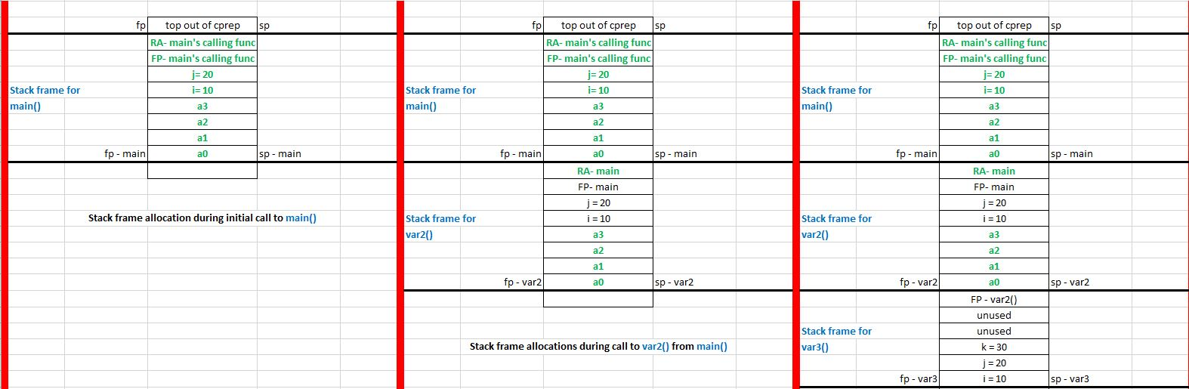main2.c:

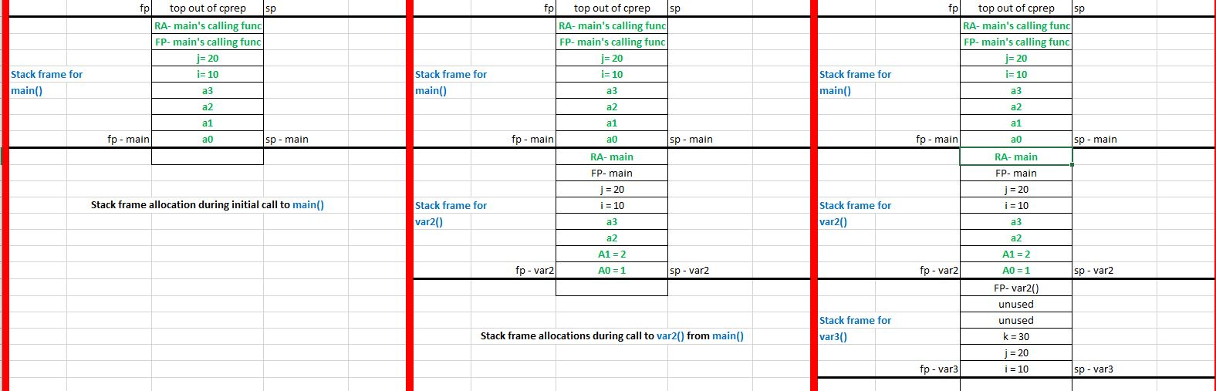main3.c:

main4.c:

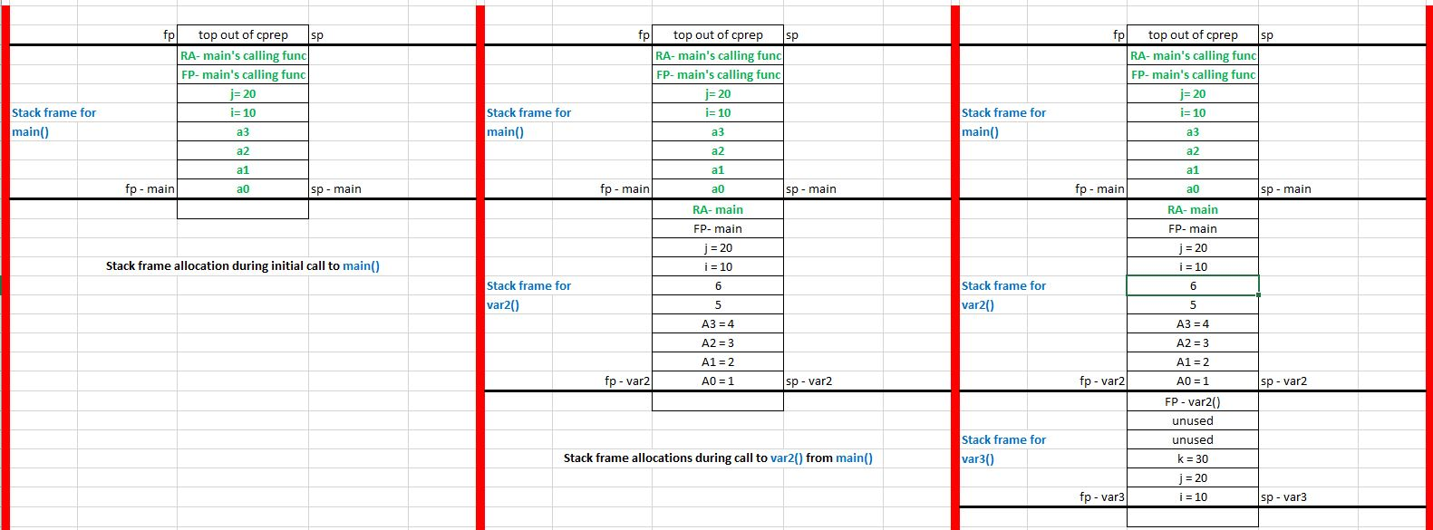

**Conclusion:**

This lab was difficult for me, as I missed the lecture before it. Here are some specific issues I had and how I figured them out.

1) Typo in “Lab 04.docx”: “Fill out the rows for what the memory locations in the stack from is being built to contain…”

- Assumed that “from” should be “frame”

2) Example “Lab 4 Stack Frame Template” posted from missed lecture was blank.

- This just took some time to figure out without an example

3) Having to restart the IDE every time I add the new main.c file

- Didn’t realize I had to do this until a couple of failures to run. Also, removing the breakpoints from previous main.c files helped.

4) Wasn’t sure if I was supposed to step through the code and evaluate variables as they changed

- Seeing that wasn’t mentioned in the lab documentation helped.

5) I was a bit unclear on how a value is returned to a calling function.

- Seeing the stack frame in the template helped here.

6) Not having a working example was the hardest part for me in this.

- PowerPoint presentations helped a lot.

Overall, quite a difficult lab resulted in me just walking through the disassembly code very carefully and realizing how stack frames are used with different functions.