Steven Reeves

CST 250

5/18/18

Lab 5 Report

**Introduction:**

The objective of this lab is to parse a string, evaluate the digits, keep a tally of different digits, and output this total. Creation and manipulation of the stack frame during function calls is another big objective here.

**Part 1:**

Part 1 of this lab had us review a different lab file, “CST250 - Lab 05”. After careful review, I first created a new .S project in the MPLAB IDE. After re-opening the IDE, I built and ran the project to make sure everything was working well.

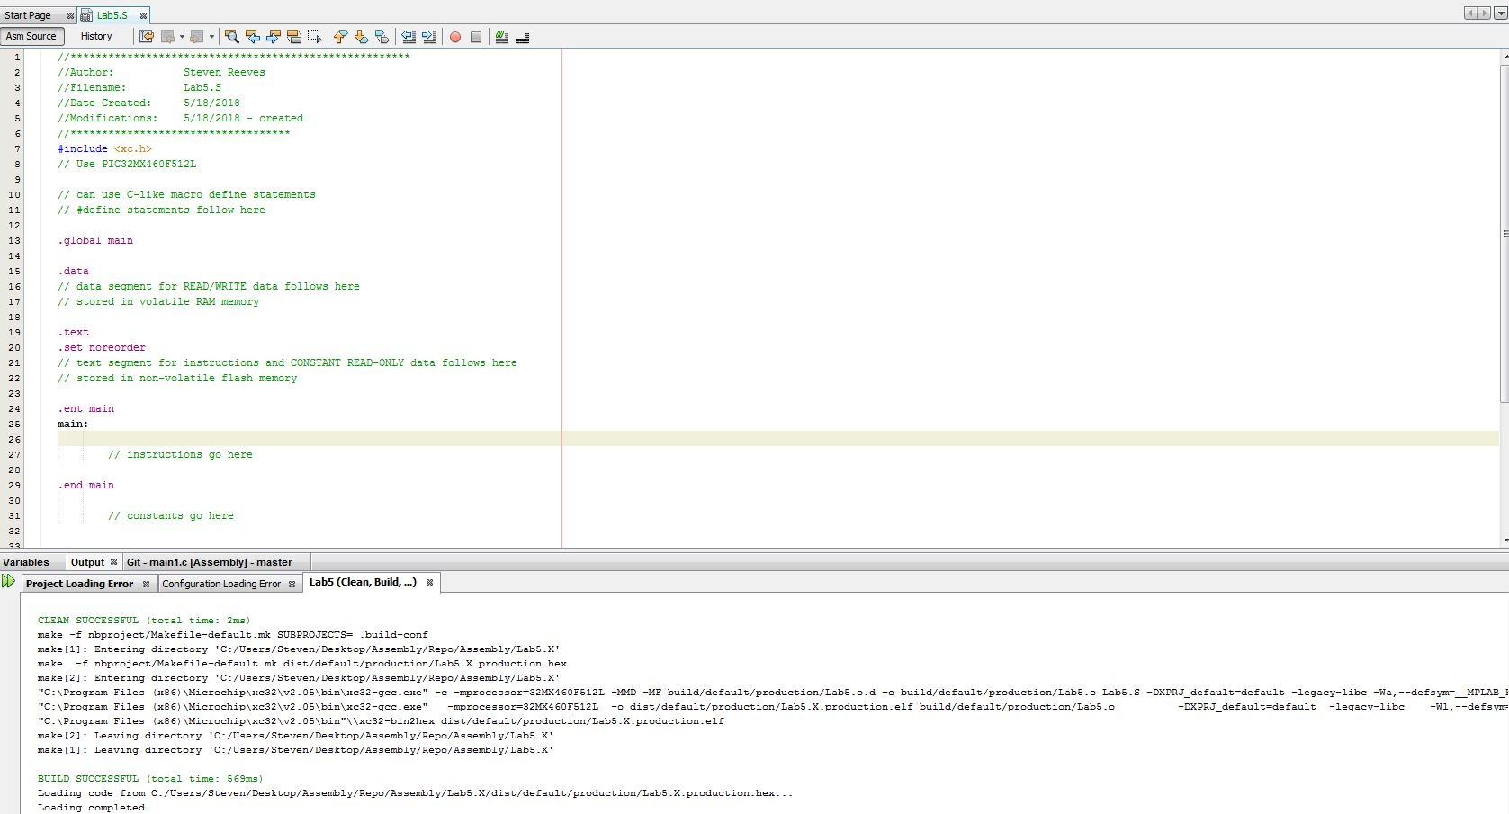

After noting where the string to be parsed would be stored (bottom of the .text section), I followed the steps in the separate lab file to set up the UART output window.

- Open the Project Properties window

- Navigate to Conf:[default] -> Simulator -> Option categories

- Use dropdown menu to choose “Uart1 IO Options”

- Click the box to activate “Enable Uart 1 IO”

- Apply changes and exit window

I then added the verbatim code from the lab document for configuring the UART TX and the output_string function. I also added the labels for is_a_digit and binary_to_asciidec. A clean and build showed that I was good to go thus far.

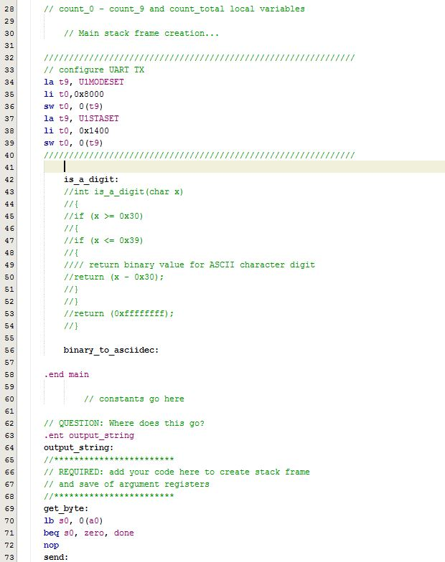

**Part 2:**

The first things I did in this part was setup my push and pop macros. I then made sure I could traverse through the string and send the characters out over UART. After writing some basic traversing logic, I realized I was having a runtime exception in the provided code.

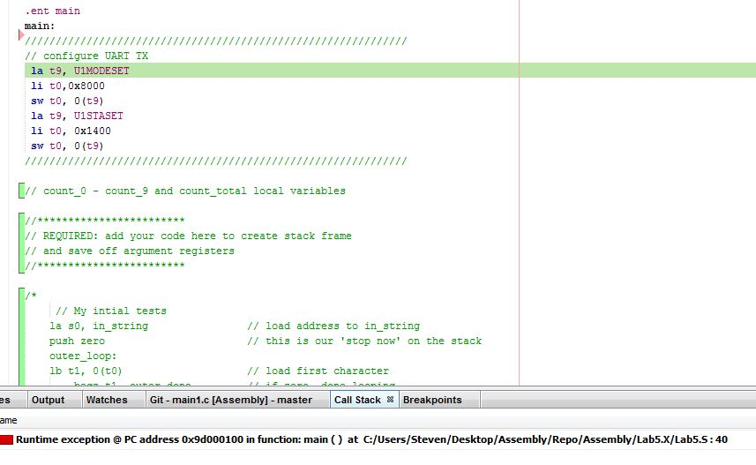

**Part 3:**

**Conclusion:**

- Where do functions go? .ent?

- answered with example

- Runtime exception with UIMODESET

- LAB?