CST 320 – Assignment 2 part 1
Wilsonville, Winter 2018

Top-Down Parsing
- Find the FIRST and FOLLOW sets for the grammar: (Show all work!)

S → ABC
A → a | Cb |ε
B → C | dA | ε
C → e | f

FIRST(S) = FIRST(A) – { ε} + FIRST(B) – { ε} + FIRST(C) – { ε}
FIRST(A) = FIRST(C) – { ε} + {a} + {ε} = {e, f} – { ε} + {a, ε} = {a, ε , e, f}
FIRST(B) = FIRST(C) - { ε }+ {d} + { ε } = {e, f} – { ε} + {d, ε } = {d, ε , e, f}
FIRST(C) = {e, f}
FIRST(S) = {a, ε , e, f} – { ε} + { d, ε , e, f }– { ε} +{ e, f }– { ε} = { a, d, e, f }

FOLLOW(S) = {$}
FOLLOW(A) = FIRST(B) – ε + FIRST(C) – ε + FOLLOW(B) = {d,e,f} + {e,f} + {e,f} = {d,e,f}
FOLLOW(B) = FIRST(C) – ε = {e,f}
FOLLOW(C) = FOLLOW(S) + {b} + FOLLOW(B) = {$}+ {b}+{e,f} = {b,e,f,$}

- Construct a predictive-parser table for the following grammar. Be sure to construct the FIRST and FOLLOW sets first.

E → TP
P → +TP | ε
T → FQ
Q → FQ | ε
F → (E)R | iR
R → *R | ε

FIRST(E) = FIRST(T) – { ε} = { (,i}
FIRST(T) = FIRST(F) – { ε} = { (,i}
FIRST(F) = {(, i}
FIRST(P) = {+, ε}
FIRST(Q) = FIRST(F) – { ε } + { ε } = { (,i, ε }
FIRST(R) = {*, ε}

FOLLOW(E) = {$} + { ) } = { $, )}
FOLLOW(P) = FOLLOW(E) = { $, ) }
FOLLOW(T) = FIRST(P) – {ε} + FOLLOW(P) = FOLLOW (E)
= {+ } + {$,)} = {+,$,)}
FOLLOW(Q) = FOLLOW(T) = {+,$,)}
FOLLOW(F) = FIRST(Q) – { ε} + FOLLOW(T) + FOLLOW(Q)
= {(,i} + {+,$,)} = { (,i,+$,)}
FOLLOW(R) = FOLLOW(F) = { (,i,+$,)}

Predictive Parser Table:
 | i | + | * | ( | ) | $
E | TP |  |  | TP
P |  | +TP |  |  | ε | ε
T | FQ |  |  | FQ
Q | FQ | ε |  | FQ | ε | ε
F | iR |  |  | (E)R
R | ε | ε | *R | ε | ε | ε

- Trace the parse of “(i/i)” using the table below.

 | i | + | - | * | / | ( | ) | $
E | TQ |  |  |  |  | TQ
Q |  | +TQ | -TQ |  |  |  | ε | ε
T | FR |  |  |  |  | FR
R |  | ε | Ε | *FR | /FR |  | ε | ε
F | i |  |  |  |  | (E)

Stack Input Production Derivation
E
$E (i/i)$ E->TQ TQ
$QT (i/i)$ T->FR FRQ
$QRF (i/i)$ F->(E) (E)RQ
$QR)E( (i/i)$ match
$QR)E i/i)$ E->TQ (TQ)RQ
$QR)QT i/i)$ T->FR (FRQ)RQ
$QR)QRF i/i)$ F-> i (iRQ)RQ
$QR)QRi i/i)$ match
$QR)QR /i)$ R-> /FR (i/FRQ)RQ
$QR)QRF/ /i)$ match
$QR)QRF i)$ F-> i (i/iRQ)RQ
$QR)QRi i)$ match
$QR)QR )$ R-> ε (i/iQ)RQ
$QR)Q )$ Q-> ε (i/i)RQ
$QR) )$ match
$QR $ R-> ε (i/i)Q
$Q $ Q-> ε (i/i)
$ $ match!

- Draw the parse tree of “(i/i)” based on the derivation in problem 3.
E
TQ
FRQ
(E)RQ
(TQ)RQ
(FRQ)RQ
(iRQ)RQ
(i/FRQ)RQ
(i/iRQ)RQ
(i/iQ)RQ
(i/i)RQ
(i/i)Q
(i/i)

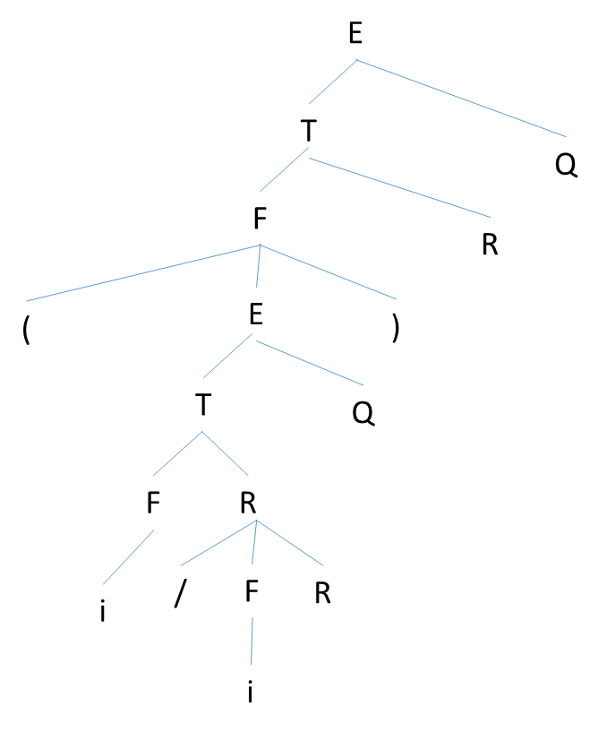
(i/i)

Bottom-Up Parsing
- Using the operator-precedence table below, trace the parse of “(id * id) *id”

E → E + E | E * E | (E) | id

 | + | * | ( | ) | id | $
+ | > | < | < | > | < | >
* | > | > | < | > | < | >
( | < | < | < | = | <
) | > | > |  | > |  | >
id | > | > |  | > |  | >
$ | < | < | < |  | < | acc

Stack Input Production
$ (id * id) *id$
$ <( id * id) *id$
$<(<id * id) *id$
$<(<id> E -> id
$<(E * id) *id$
$<(<E* id) *id$
$<(<E* id) *id$
$<(<E*<id ) *id$
$<(<E*<id> ) *id$ E-> id
$<(<E*E ) *id$
$<(<E*E> ) *id$ E -> E*E
$<(E ) *id$
$<(E) *id$
$<(E)> *id$ E-> (E)
$E *id$
$<E* id$
$<E*<id $
$<E*<id> $ E-> id
$<E*E $
$<E*E> $ E-> E*E
$E $ Accept!

- Draw the parse tree of “(id * id) * id” based on the derivation steps in problem 5.
E
E*E
E*id
(E)*id
(E*E)*id
(E*id)*id
(id * id) * id

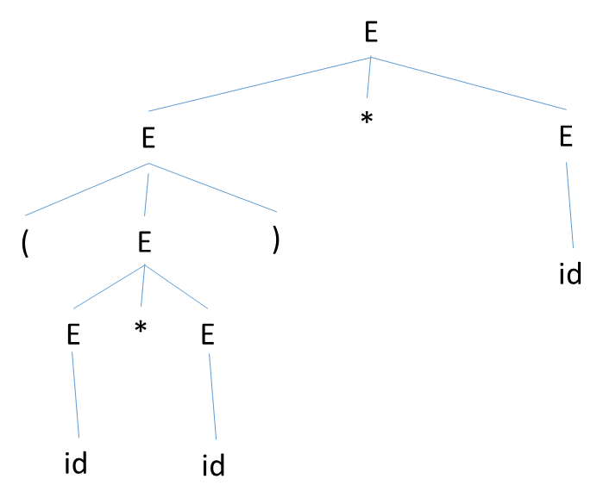
Given the following grammar and LR table, trace the parse of “id / id + id”
(1) E → E + T
(2) E → E – T
(3) E → T
(4) T → T * F
(5) T → T / F
(6) T → F
(7) F → (E)
(8) F → id

State | id | + | - | * | / | ( | ) | $ | E | T | F
0 | S5 |  |  |  |  | S4 |  |  | 1 | 2 | 3
1 |  | S6 | S7 |  |  |  |  | Acc
2 |  | R3 | R3 | S8 | S9 |  | R3 | R3
3 |  | R6 | R6 | R6 | R6 |  | R6 | R6
4 | S5 |  |  |  |  | S4 |  |  | 10 | 2 | 3
5 |  | R8 | R8 | R8 | R8 |  | R8 | R8
6 | S5 |  |  |  |  | S4 |  |  |  | 11 | 3
7 | S5 |  |  |  |  | S4 |  |  |  | 12 | 3
8 | S5 |  |  |  |  | S4 |  |  |  |  | 13
9 | S5 |  |  |  |  | S4 |  |  |  |  | 14
10 |  | S6 | S7 |  |  |  | S15
11 |  | R1 | R1 | S8 | S9 |  | R1 | R1
12 |  | R2 | R2 | S8 | S9 |  | R2 | R2
13 |  | R4 | R4 | R4 | R4 |  | R4 | R4
14 |  | R5 | R5 | R5 | R5 |  | R5 | R5
15 |  | R7 | R7 | R7 | R7 |  | R7 | R7

Stack Input Entry Action/Production
0 id / id + id$ Shift 5 Shift – state 5
0id5 / id + id$ Reduce 8 F-> id
0F3 / id + id$ Reduce 6 T->F
0T2 / id + id$ Shift 9 Shift – state 9
0T2/9 id+id$ Shift 5 Shift – state 5
0T2/9id5 +id$ Reduce 8 F-> id
0T2/9F 14 +id$ Reduce 5 T -> T/F
0T2 +id$ Reduce 3 E->T
0E1 +id$ Shift 6 Shift – state 6
0E1+6 id$ Shift 5 Shift – state 5
0E1+6id5 $ Reduce 8 F -> id
0E1+6F3 $ Reduce 6 T –> F
0E1+6T 11 $ Reduce 1 E -> E+T
0E1 $ Accept!

