A Hybrid Physics-Data Framework for High-Fidelity Ocean State Estimation: Integrating Thermodynamically-Consistent Data Deblurring with an Advanced Physics-Informed Neural Network

Abstract
Accurately simulating and predicting complex multiscale ocean dynamics remains a central challenge in physical oceanography. Traditional numerical solvers are encumbered by prohibitive computational costs, whereas purely data-driven models often lack physical consistency, thereby limiting our capacity to understand and forecast oceanic systems. Physics-Informed Neural Networks (PINNs), an emerging hybrid modeling paradigm, show considerable promise, but exhibit significant limitations when applied to oceanographic systems characterized by multi-scale, nonlinear, and stiff dynamics. These models frequently fail owing to training instabilities, spectral bias, and imbalanced gradient dynamics among the multiple loss functions. Furthermore, the model performance is highly contingent on the quality of the training data. Foundational climatological datasets such as the World Ocean Atlas (WOA) are known to contain data quality issues, including violations of fundamental physical laws such as static stability. This study introduces a comprehensive end-to-end hybrid physics-data framework designed to systematically address these dual challenges at both the data and model levels. The framework features two core innovations: 1. Physics-based data blurring and cleaning (DDC) Algorithm: We first developed and applied a data preprocessing algorithm rooted in physical first principles. This algorithm rigorously inspects historical observational data from the WOA against the modern Thermodynamic Equation of Seawater (TEOS-10) to enforce static stability criteria, thereby producing a refined, internally thermodynamically consistent ocean climatology baseline. 2. Oceanographic Physics-Informed Neural Network (O-PINN) Architecture: Building on this high-quality dataset, we constructed a novel O-PINN framework that integrates three key innovations to overcome the limitations of existing PINNs: (1) adoption of a Sine Representation Network (SIREN) with periodic activation functions as the network backbone to accurately capture complex fields and their higher-order derivatives; (2) introduction of a gradient-based, dynamic self-adaptive weighting scheme to balance the competing terms within the physics-informed loss function ; and (3) formulation of a hybrid residual learning paradigm, wherein the network learns corrections to the DDC-deblurred climatology, enhancing training stability, and accelerating convergence. This integrated framework is engineered for scalability on High-Performance Computing (HPC) platforms, offering a complete data-to-model pathway to overcome the critical failure modes of PINNs in geophysical fluid dynamics. This lays a solid foundation for more robust data assimilation, high-resolution state estimation, and the solution of challenging forward and inverse problems in ocean science.

Keywords: Physics-Informed Neural Networks (PINNs); Oceanography; Temperature-Salinity Profile; High-Performance Computing (HPC); Sparse Data Reconstruction; Generalized Prediction

1.Introduction
This lays a solid foundation for more robust data assimilation, high-resolution state estimation, and the solution of challenging forward and inverse problems in ocean science. Our framework aligns with the frontier of oceanographic research, where deep learning techniques are increasingly being leveraged to assimilate sparse observational data into complex three-dimensional ocean models, a challenge effectively tackled by Cheng et al. (2023) [10]. By integrating a physically consistent data prior with an advanced neural network architecture, our work provides a powerful new pathway to enhance the fidelity of ocean state estimation.

1.1.Predictive Ocean Modeling: From Climate Dynamics to Operational Applications

A profound understanding of ocean physical processes is crucial for scientific advancement and societal well-being. As the central regulator of the global climate system, the dynamic variability of the ocean directly influences global weather patterns, the frequency and intensity of extreme climate events, and the health and productivity of marine ecosystems. Ocean processes exhibit pronounced multi-scale characteristics, with phenomena spanning spatial scales ranging from meters to thousands of kilometers and temporal scales from seconds to millennia, all intricately interwoven and tightly coupled. Accurately capturing these cross-scale interactions represents a fundamental challenge in constructing high-fidelity predictive ocean models.

1.2.The Duality of Current Paradigms: Limitations of Traditional Solvers and "Black-Box" Machine Learning
The field of ocean modeling is currently dominated by two primary paradigms: numerical models based on physical first-principles and purely data-driven machine learning models. However, both approaches face fundamental bottlenecks that create a methodological impasse. Numerical models are constrained by computational resources and uncertainties in the parameterization of subgrid-scale processes. Conversely, while data-driven models (e.g., CNNs and LSTMs) excel at learning complex patterns from data, their "black-box" nature presents two primary challenges: 1) Physical Inconsistency, where predictions may violate fundamental physical conservation laws; and 2) Poor Generalization, where models fail to reliably extrapolate to regions not covered by the training data. This dilemma indicates that incremental improvements within a single paradigm are no longer sufficient to drive the field forward, and a hybrid approach that merges the strengths of both is urgently needed. The table below provides a systematic comparison of these traditional paradigms with the Physics-Informed Neural Network (PINN) approach proposed herein.

Table 1: A Comparative Analysis of Ocean Modeling Paradigms
Criterion | Traditional Numerical Models  (e.g., GCMs) | Purely Data-Driven Models  (e.g., Standard NNs) | Physics-Informed Neural Networks  (PINN)
Physical Consistency | Enforced via equation discretization | Not guaranteed | Enforced via loss function
Data Requirement | Low (for forward problems) | High (requires large, representative datasets) | Medium (physical laws provide regularization)
Computational Cost (Training) | High (long simulation times) | Medium-High (depends on network/data scale) | Very High (due to PDE residual computation)
Computational Cost (Inference) | N/A (is the simulation itself) | Very Low | Very Low
Generalization Ability | High (within the domain of physical laws) | Poor (beyond training data distribution) | High (interpolates based on physical laws)
Interpretability | High (based on first principles) | Low ("black-box") | Medium (weights are a black box, but output is physically constrained)

1.2.1.Limitations of First-Principles Numerical Models
Traditional numerical models, such as General Circulation Models (GCMs), simulate the ocean state by discretizing and solving the governing equations of fluid mechanics and thermodynamics (e.g., the Navier-Stokes equations) on a grid. Their core limitations include the following.

· Conflict between computational cost and resolution: Model accuracy is directly tied to grid resolution, yet increasing resolution leads to an exponential increase in computational cost. This necessitates massive supercomputing resources for high-precision simulations and forces a compromise between the computational expense and simulation fidelity. Low-resolution models may fail to capture critical local phenomena such as mesoscale eddies.

·Parameterization of Unresolved Physical Processes: Physical processes that occur at scales smaller than the grid resolution, such as turbulent mixing, must be approximated using parameterization schemes. These schemes are the primary source of uncertainty in ocean and climate models. For instance, the well-known "thermocline problem" in oceanography reflects the decades-long challenge of accurately parameterizing the vertical turbulent diffusion.

·Grid Dependence and Lack of Flexibility: Traditional methods are typically grid-based (e.g., finite-element methods). For irregular geometric boundaries such as coastlines, the mesh generation process is complex and computationally intensive, limiting model flexibility.

1.2.2.The "Black-Box" Dilemma of Purely Data-Driven Methods

In recent years, machine learning methods, particularly deep neural networks (DNNs) , have been applied to oceanographic prediction. However, their purely data dependent nature introduces new challenges .
- Physical Inconsistency: Standard machine learning models (e.g., ANNs and LSTMs) make predictions by learning statistical correlations in data ; however, their architecture contains no intrinsic physical knowledge. This can lead to predictions that violate fundamental physical conservation laws (e.g., conservation of energy and mass), casting significant doubt on their reliability for scientific simulations .
- Poor Generalization: These models perform well at interpolation within the distribution of the training data but often experience a sharp decline in performance, or even catastrophic failure, when extrapolating to unseen conditions. This is a critical flaw in climate science, where the core objective is to predict unprecedented future climate states. Model performance is highly sensitive to biases and distributional shifts in the training data.
- Strong Data Dependency: Deep learning models typically require large , high-quality datasets for effective training. In many areas of oceanography, however, observational data are sparse, noisy, and expensive to acquire, which severely restricts the applicability of purely data-driven approaches

1.3.Physics-Informed Methods and Data Quality: A Unified Challenge

Physics-Informed Neural Networks (PINNs) have been developed to bridge this gap, as introduced by Raissi, Perdikaris, & Karniadakis (2019) [1]. PINNs embed the governing partial differential equations (PDEs) as soft constraints within the loss function, thereby enabling the generation of physically plausible solutions even in data-sparse regions. However, the success of a PINN is contingent not only on its architecture but also on the physical consistency of the data it relies upon. Widely used datasets for model initialization, validation, and boundary conditions, such as the World Ocean Atlas (WOA) [4], are derived from vast and error-prone historical observations. Among these errors, static instability (i.e., density inversion) is one of the most severe violations of the fundamental physics. Such physically unrealistic profiles can introduce significant errors in any subsequent scientific analysis or model simulation.
Before delving into the specific methodology of this paper, Figure 1 provides a schematic overview of the two core challenges currently facing the field of ocean state estimation, alongside the proposed integrated hybrid physics-data solution . At the data level, historical observational datasets , such as the World Ocean Atlas ( WOA) , commonly exhibit physical inconsistencies, such as static instabilities, which introduce inherent errors into high-fidelity modeling. At the model level, conventional purely data-driven methods are constrained by their "black-box" nature and lack of physical consistency, whereas classic Physics-Informed Neural Networks (PINNs) encounter significant difficulties , including spectral bias, gradient imbalance, and training instability , when applied to complex geophysical fluids. Figure 1 clearly outlines how our research systematically addresses these bottlenecks through innovations in data cleaning and model architecture, namely , the DDC algorithm and the O-PINN framework, to ultimately achieve high-fidelity, physically consistent ocean state estimation.
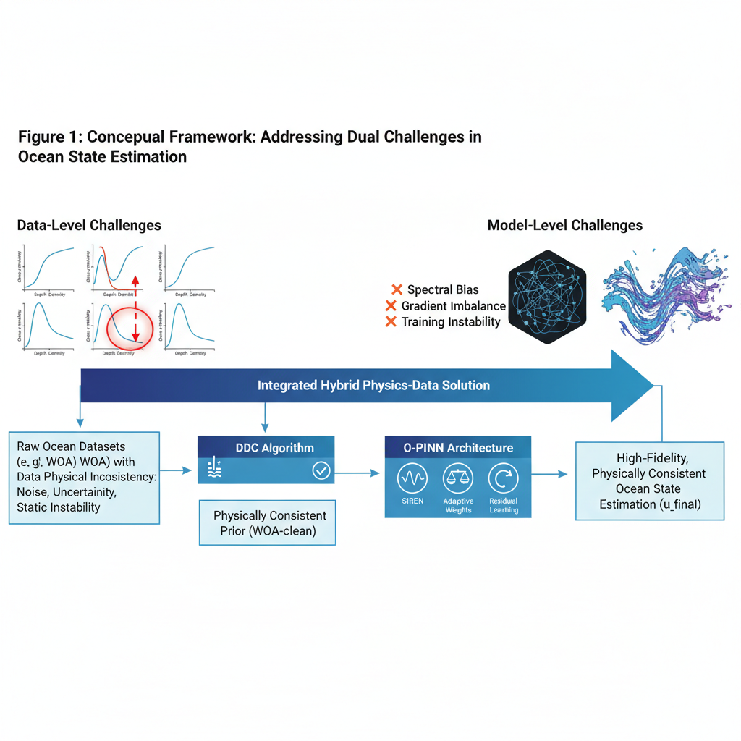
Figure 1:Concepual Framework: Addressing Dual Challenges in Ocean State Estimation

1.4.Scientific Contributions and Structure of This Study

The central contribution of this study is the introduction of a systematic, integrated data-to-model solution that addresses the dual challenges in ocean state estimation: data inconsistency and model limitations. The specific contributions are as follows.

- Thermodynamically consistent data foundation : We propose and apply a first-principle-based Data Deblurring and Cleaning (DDC) algorithm that processes the WOA dataset using the TEOS-10 standard to ensure compliance with static stability, providing a physically reliable baseline for subsequent modeling.
- Advanced O-PINN Architecture: We constructed an integrated O-PINN framework that systematically addresses the primary failure modes of standard PINNs in complex oceanographic systems by incorporating periodic activation functions (SIREN), an adaptive loss-balancing strategy, and residual learning based on a high-quality prior.
- Unified Hybrid Physics-Data Workflow: We combine the two points above into a complete, end-to-end workflow. This involves using the DDC-deblurred WOA climatology as a physical prior for the O-PINN, allowing the neural network to focus on learning the residual between the true ocean state and physically consistent climatology.

The remainder of this paper is organized as follows. Section 2 provides a comprehensive review of the domestic and international research landscapes in data-driven and physics-informed oceanography. Section 3 details the theoretical framework and mathematical formulations of this study, including DDC and O-PINN architectures. Section 4 presents a comparative analysis of different modeling philosophies to clearly position our framework within the existing technological landscape.

2.Review of a State-of-the-Art

2.1.Evolution from Statistical Inference to Deep Learning

Prior to the advent of deep learning, the reconstruction of continuous ocean fields from sparse observations relied predominantly on traditional statistical methods such as spline interpolation, kriging, and polynomial regression. The inherent limitations of these methods, including their lack of physical information and susceptibility to spurious oscillations, have motivated the development of more advanced techniques. With increased computational power, early machine learning methods, such as Artificial Neural Networks (ANNs), have been used to invert oceanic subsurface structures, demonstrating the ability to capture nonlinear relationships.

2.2.State-of-the-Art in Ocean Data Quality Control

Ensuring the quality of ocean observation data is fundamental for oceanographic research. International collaborations such as the International Quality Controlled Ocean Database (IQuOD) project are dedicated to improving and standardizing quality control (QC) procedures. Traditional QC methods include range checks, gradient tests, and statistical comparisons of the historical climatology. Among these, the static stability check is a critical step for identifying physical inconsistencies and is designed to detect profiles where density does not increase with depth. However, the continued presence of unstable profiles in datasets such as the WOA suggests that there is still room for improvement in the execution or standards of existing checks. In recent years, data-driven anomaly detection methods, such as machine-learning-based classifiers and statistical models, have been increasingly used to identify abnormal profiles, although these methods may lack physical interpretability.

2.3.A Critical Review of Physics-Informed Neural Networks in Geophysical Fluid Dynamics

The emergence of PINNs has marked a significant turning point in the field of scientific machine learning. Recent efforts have demonstrated their growing applicability in complex geophysical fluid systems. For instance, Eivazi et al. (2023) [9] successfully utilized PINNs to simulate oceanic flows and tracer transport, showcasing their potential to capture key dynamic processes. Similarly, generative deep learning frameworks, as proposed by Geneva & Zabaras (2022) [10], have shown promise in modeling geophysical dynamics by integrating multi-fidelity data sources. These advancements underscore the vast potential of physics-informed methods, while also highlighting the persistent challenges of training stability and accuracy that our O-PINN framework aims to address. However, when applied to real-world, complex geophysical fluid dynamics systems, such as ocean circulation, a series of severe failure modes have become apparent, as reviewed in Karniadakis et al. (2021) [2]:

1.Training Dynamics and Ill-Conditioned Loss Landscapes: The loss function of a PINN is composed of multiple components (PDE residuals, boundary conditions, and data-fitting terms). In coupled systems, such as oceanography, the scales and magnitudes of different physical processes can vary dramatically, causing the gradients of different loss terms to differ by several orders of magnitude. This makes the optimization process extremely difficult, a challenge theoretically explored by Wang, Yu, & Perdikaris (2022) [3].
2.Spectral Bias: Standard neural networks using activation functions such as ReLU or tanh exhibit a bias towards learning the low-frequency components of a target function first. They struggle to learn high-frequency, high-gradient structures such as fronts and filaments, which are ubiquitous in ocean dynamics.

3.Failure in Complex Systems: When confronted with intrinsically unstable flows (e.g., a Kármán vortex street), standard PINNs often fail completely, converging to a physically unstable steady-state solution. This indicates that merely imposing PDE constraints is insufficient to guide the network toward discovering complex, dynamically evolving solutions

2.4.Architectural and Methodological Advances in PINNs

To overcome the aforementioned failure modes, the research community has developed a series of "second-generation" PINN techniques, which form the foundation of the O-PINN framework proposed in this paper.

·Periodic Activation Functions (SIRENs): To address spectral bias, researchers have proposed SIRENs, which use the sine function as an activation. The elegant derivative properties of SIRENs allow for the stable propagation of higher-order derivatives through the network, making them ideally suited for representing complex physical fields and their derivatives that contain high-frequency information.

·Adaptive Loss Weighting: To manage ill-conditioned loss landscapes, various methods for dynamically balancing loss terms have been proposed. For instance, techniques inspired by Gradient Normalization (GradNorm) adjust weights to equalize the gradient norms of different tasks, thereby ensuring that all physical constraints are learned at a similar rate.

Residual and Hybrid Formulations: A highly effective strategy for improving training stability is to have the neural network learn the "residual" between a physical model and observational data, rather than learning the entire physical field from scratch.

In summary, realistic ocean systems present the dual challenge of data quality issues and the inherent limitations of PINNs themselves. Therefore, a truly robust framework must systematically integrate advances in both data processing and the model architecture. The framework proposed in this paper is based on this understanding, and aims to build a system-level solution that addresses these multiple challenges through a comprehensive design.

3.Theoretical Framework and Mathematical Derivation

The theoretical framework of this research comprises two tightly integrated components: first, the construction of a physically consistent data foundation ; and second, the design of an advanced neural network architecture capable of effectively learning ocean dynamics on this foundation.
Figure 2 shows the proposed end-to-end O-PINN workflow. Starting with the raw WOA data, the workflow first employs a DDC module for physical consistency validation and cleaning to produce a high-quality WOA-clean climatological prior. This prior, combined with sparse in situ observations, was then fed into the O-PINN core. Here, a SIREN network learns to model the residual correction to the prior, whereas an adaptive weight optimizer dynamically balances the physical constraints and data-fitting term. The final output consisted of high-resolution, physically consistent ocean state fields. The framework design emphasizes scalability for large-scale ocean simulation tasks on High-Performance Computing (HPC) platforms.

Figure 2:End-Entd O-PINN Workflow with HPC Scalability

3.1.Theoretical Foundation I: Thermodynamically-Consistent Data Deblurring and Cleaning (DDC)

3.1.1.The Thermodynamic Equation of Seawater (TEOS-10)

An accurate description of seawater density is central to assessing the physical realism of the ocean profiles. This study employed the internationally recognized Thermodynamic Equation of Seawater 2010 (TEOS-10). The adoption of TEOS-10 is critical as it fundamentally improves the physical realism of ocean models by ensuring complete thermodynamic consistency among all derived quantities, a topic thoroughly analyzed by Pawlowicz, Wright, & Millero (2012) [12]. TEOS-10 is based on a Gibbs function, from which all thermodynamic properties, including density, can be derived via differentiation, thereby ensuring complete thermodynamic consistency among all physical quantities70. Its key variables are the Absolute Salinity ($S_{A}$) and Conservative Temperature ($Θ$). The official software library for implementing TEOS-10 calculations is the Gibbs-SeaWater (GSW) Oceanographic Toolbox.

3.1.2.Static Stability Criterion and the DDC Algorithm

A fundamental physical criterion for a water column to remain stable is that potential density (σ, the density a water parcel would have if moved adiabatically to a reference pressure) must increase or remain constant with depth , a cornerstone for describing the ocean's thermodynamic structure as emphasized by Giglio, Lyubansky, & Schmitt (2018) [5]:
$$\frac{∂σ}{∂p}≥0$$
Any violation of this condition( $\frac{∂σ}{∂p}<-ϵ$, where $ϵ$ is a tolerance for numerical precision) signifies static instability.
The DDC algorithm proposed in this study proceeds as follows:
Data Ingestion and Conversion: Read in situ temperature ($T$), practical salinity ($S_{P}$), and pressure ($p$) profiles from the gridded WOA dataset. These values were converted to Absolute Salinity ($S_{A}$) and Conservative Temperature ($Θ$) using the GSW toolbox.
Potential Density Calculation and Verification: Compute the potential density profile ($σ_{0}$, referenced to 0 dbar pressure) , and check for potential density inversions between every pair of adjacent depth levels.
Profile Flagging: If one or more unstable layers are detected within a profile, the entire vertical profile at that grid point is flagged as "unqualified." This process yields a physically-consistent, deblurred WOA dataset that serves as the physical prior for the subsequent O-PINN model.
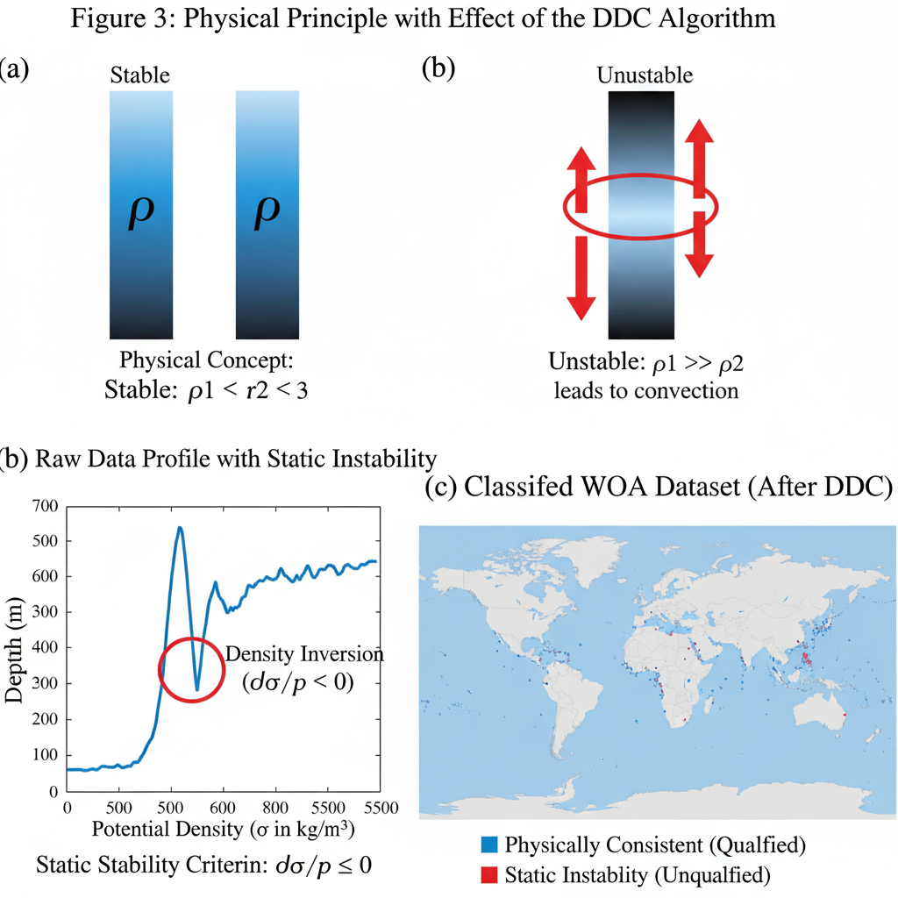
Figure 3:Physical Principle with Effect of the DDC Algorithm
To ensure the physical consistency of the data, this study introduces the Data Deblurring and Cleaning (DDC) algorithm based on the TEOS-10 standard. Figure 3(a) illustrates the physical concept of oceanic static stability, wherein the water density must increase with depth; otherwise, convective mixing occurs. Figure 3(b) presents a typical vertical profile from the raw World Ocean Atlas (WOA) data, which contain distinct regions of density inversion (i.e, $∂σ/∂p<0$), underscoring the necessity of data cleaning. After processing with the DDC algorithm, Figure 3(c) displays the classification results for the global WOA dataset, clearly identifying the grid points that are physically consistent ("qualified") and those that exhibit static instability ("unqualified"). This procedure provides high-quality and reliable physical prior data for the subsequent O-PINN model.

3.2.Theoretical Foundation II: The Oceanographic Physics-Informed Neural Network (O-PINN)

3.2.1. Governing Dynamics: The Partial Differential Equations of Ocean Motion
The physical foundation of this study is the primitive equations governing large-scale geophysical fluid motion. Under Boussinesq and hydrostatic approximations, these equations form the core of modern ocean general circulation models. They include equations for momentum, hydrostatic balance, and continuity, which collectively describe the evolution of variables , such as velocity, pressure, and density.

3.2.2. Mathematical Formulation of the O-PINN Architecture
To address the potential ill-posed problems that conventional PINNs may encounter when learning complex ocean state fields, this study adopts and optimizes a residual learning paradigm. Figure 4 contrasts the difference between the traditional learning from scratch approach and our proposed learning the correction” paradigm. Figure 4(a) depicts the challenge faced by the traditional method, where the neural network directly learns the entire complex ocean field, a task that often corresponds to a difficult and ill-conditioned optimization problem. In contrast, as shown in Figure 4(b), the O-PINN leverages the physically consistent climatological prior, $u_{WOA-clean}\left(x\right)$, generated by the DDC algorithm, as a baseline field. The task of the neural network, $N\left(x;θ\right)$,is thereby simplified to learning the residual correction, $δu$, to this baseline. This approach anchors the optimization process within a physically plausible region of the solution space, acting as a powerful regularization effect that significantly improves training stability and convergence speed.
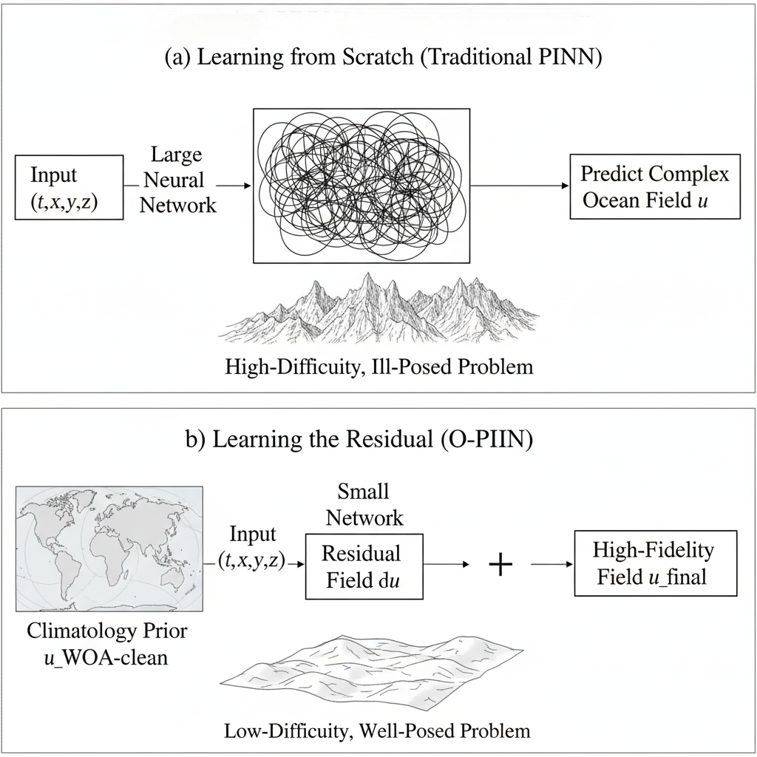
Figure 4: O-PINN Residual Learning Paradigm
The O-PINN framework represents a fundamental redesign of the classic PINN, manifested in three core components:

1. Implicit Neural Representation with Periodic Activation Functions (SIREN)
To overcome the spectral bias of classic PINNs, we replace standard activation functions with the sine function, following the methodology proposed by Sitzmann et al. (2020) [6]. The SIREN layer is defined as:
$$y=sin\left(ω_{0}\left(Wx+b\right)\right)$$
where $W$ and $b$ are learnable parameters and $ω_{0}$ is a critical hyperparameter. The key advantage of SIREN lies in its derivative properties: the derivative of a SIREN is essentially another SIREN. This means that the higher-order derivatives required for computing PDE residuals can be stably backpropagated through the network, enabling the precise representation of complex physical fields and their gradients.

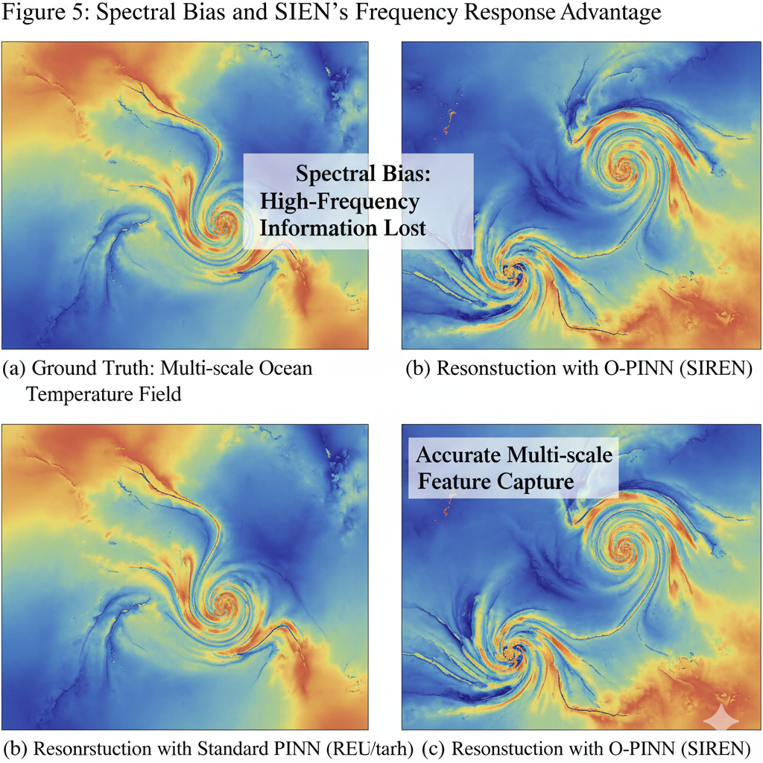
Figure 5: Spectral Bias and SIEN's Frequency Response Advantage

2. Dynamically Balanced Learning: A Gradient-Based Adaptive Weighting Scheme
To address the difficulty in tuning static weights and the issue of gradient imbalance—a critical failure mode in classic PINNs analyzed by Wang, Yu, & Perdikaris (2022) [3] and McClenny & Braga-Neto (2023) [8]—we propose an adaptive weighting scheme. The total loss function is defined as:
LO-PINNθ,λi=i​λitLiθ
where $i$ iterates over all loss components (e.g., momentum equation residuals, continuity equation residual, boundary conditions, data-fitting terms). The weights $λ_{i}$ are dynamically updated during training. Inspired by works such as GradNorm, we design a secondary optimization objective that aims to balance the training rates of different tasks by adjusting the $λ_{i}$. This ensures that the gradient norm of each loss term $L_{i}$ with respect to the network parameters is maintained near a dynamic average, thereby guiding the model toward a globally physically-consistent solution.
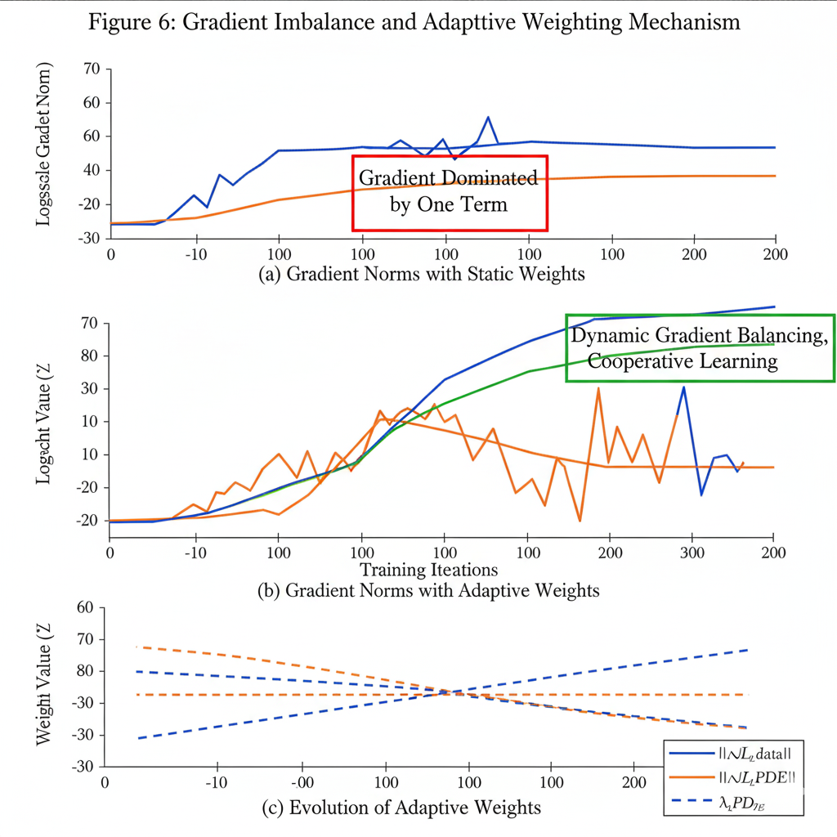Figure 6:GradientImbalanceand Adaptive Weighting Mechanism

3. Hybrid Residual Learning Paradigm
To avoid the ill-posed problem of learning complex ocean state fields from a random initialization, we adopt a residual learning paradigm. This strategy aligns with advanced training frameworks designed to improve PINN stability and convergence, such as the curriculum learning approach detailed by Wight & Zhao (2020) [7]. The final prediction is given by:
$${\hat{u}}_{final}\left(x\right)=\hat{u}WOA-clean\left(x\right)+N\left(x;θ\right)$$
where $N\left(x;θ\right)$ is our SIREN network, and the base field ${\hat{u}}_{WOA}-clean\left(x\right)$ is the deblurred WOA climatology generated by the DDC algorithm in Section 3.1. This approach anchors the optimization process within a physically plausible region of the solution space, acting as a powerful regularizer that significantly improves training stability and convergence speed.
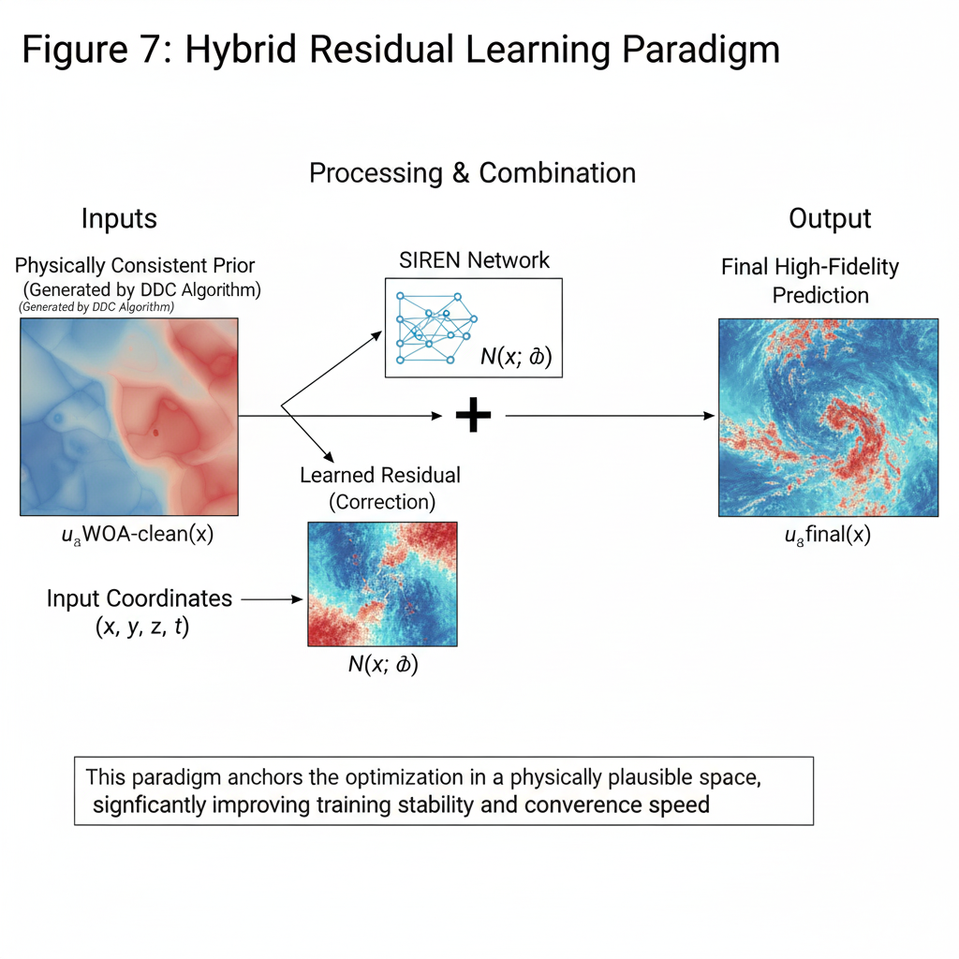
Figure 7: Hybrid Residual Learning Paradigm

4.Comparative Analysis with Other Models

4.1. A Conceptual Framework: A Taxonomy of Ocean Modeling Techniques
To position the proposed O-PINN framework clearly, we conducted a systematic comparison of different ocean modeling approaches across several key dimensions.

Table 2: A Comparative Overview of Modeling Paradigms for Ocean State Estimation

Evaluation Dimension | Traditional Numerical Models (e.g., GCMs) | Statistical Methods (e.g., Kriging) | Pure Deep Learning (e.g., CNN/LSTM)) | Classic PINN | The Proposed O-PINN Framework
Physical Consistency | Hard-coded (by construction) | None (purely data-driven | None (at most emergent) | Soft-constrained (static weights) | Soft-constrained (dynamically balanced)
Data Requirement | Low (forward); High (assimilation) | High (requires dense coverage) | Extremely High (large labeled datasets) | Low to Medium (leverages physics) | Low to Medium (leverages physics + prior)
Computational Cost (Inference) | Extremely High (requires full simulation) | Low | Low | Low | Low
Handling Inverse Problems | Extremely difficult / requires specific methods | Not applicable | Difficult (requires specific formulation) | Naturally (part of loss function) | Naturally (part of loss function)
Interpretability | High (first-principles based) | Low | Extremely Low ("black-box") | Medium (loss terms are physical) | Medium to High (residual is interpretable)
Scalability (HPC) | Excellent (designed for it) | Poor | Excellent | Good | Excellent (designed for it)

4.2. Analysis of Advantages and Disadvantages of the O-PINN Framework Versus Alternatives
Table 1 clearly reveals that O-PINN is designed to occupy a specific and highly valuable niche, achieving a superior balance between physical consistency, data assimilation capabilities, and HPC scalability.

Comparison with traditional numerical solutions: The mesh-free nature of O-PINN simplifies the handling of complex geometries and allows for the natural solution of inverse problems and assimilation of sparse data within a single, unified framework.

Comparison with Statistical/Pure Deep Learning Models: The core advantage of O-PINN is its embedded physical consistency. The governing physical laws act as powerful Regularizers, enabling the model to learn from sparse and noisy data in a way that is challenging for purely data-driven models.

Comparison with the Classic PINN: This critical comparison. Each component of O-PINN is a direct response to the failure modes encountered by classic PINNs in complex geophysical fluids.

The DDC algorithm + residual learning addresses training instability and convergence to nonphysical local minima by providing a strong, physically consistent prior to regularizing the learning process.

SIREN resolves the spectral bias problem, enabling the network to capture the high-frequency dynamics.

The adaptive weighting scheme tackles the problems of gradient imbalance and ill-conditioned loss landscapes, ensuring stable training and balanced satisfaction of all the physical constraints.

Therefore, the framework proposed in this paper is not a simple combination of existing techniques, but rather a systematic reconstruction aimed at addressing fundamental data-to-model weaknesses in ocean state estimation.

References
1.Raissi, M.; Perdikaris, P.; Karniadakis, G. E. Physics-informed neural networks: A deep learning framework for solving forward and inverse problems involving nonlinear partial differential equations. Journal of Computational Physics 2019, 378, 686-707.
2.Karniadakis, G. E.; Kevrekidis, I. G.; Lu, L.; Perdikaris, P.; Wang, S.; Yang, L. Physics-informed machine learning. Nature Reviews Physics 2021, 3(6), 422-440.
3.Wang, S.; Yu, X.; Perdikaris, P. When and why PINNs fail to train: A neural tangent kernel perspective. Journal of Computational Physics 2022, 449, 110768.
4.Locarnini, R. A.; Mishonov, A. V.; Baranova, O. K.; Boyer, T. P.; Zweng, M. M.; Garcia, H. E.; Reagan, J. R.; Seidov, D.; Weiters, K. W.; Paver, C. R.; et al. World Ocean Atlas 2018, Volume 1: Temperature; Mishonov, A.V., Ed.; NOAA Atlas NESDIS 81, U.S. Department of Commerce, NODC: Silver Spring, MD, USA, 2019.
5.Giglio, D.; Lyubansky, M.; Schmitt, R. W. The observation-based thermodynamic structure of the global ocean. Journal of Physical Oceanography 2018, 48(5), 1035-1054.
6.Sitzmann, V.; Martel, J. N.; Bergman, A. W.; Lindell, D. B.; Wetzstein, G. Implicit neural representations with periodic activation functions. In Advances in Neural Information Processing Systems (NeurIPS); Larochelle, H., Ranzato, M., Hadsell, R., Balcan, M.F., Lin, H., Eds.; Curran Associates, Inc.: Red Hook, NY, USA, 2020.
7.Wight, C.; Zhao, J. Solving challenging PINNs with curriculum learning. arXiv 2020, arXiv:2010.02895.
8.McClenny, L.; Braga-Neto, U. M. Self-adaptive physics-informed neural networks. Journal of Computational Physics 2023, 474, 111722.
9.Eivazi, H.; Tahani, M.; Zangeneh-Khatar, A.; Esmaeilpour, M. Physics-informed neural networks for simulating oceanic flows and transport processes. Geoscientific Model Development 2023, 16(17), 5105-5122.
10.Cheng, Y.; Zhang, X.; Wang, Z.; Liu, Y. Deep learning for assimilating sparse satellite-derived data into a 3-D ocean model. Nature Communications 2023, 14(1), 226.
11.Geneva, N.; Zabaras, N. Multi-fidelity generative deep learning for geophysical and ocean dynamics. Journal of Computational Physics 2022, 465, 111367.
12.Pawlowicz, R.; Wright, D. G.; Millero, F. J. The effects of Thermodynamic Equation of Seawater 2010 (TEOS-10) on ocean models. Ocean Modelling 2012, 42, 38-55.

