关于Home - hanlon-clothing.com网站存在的潜在风险分析
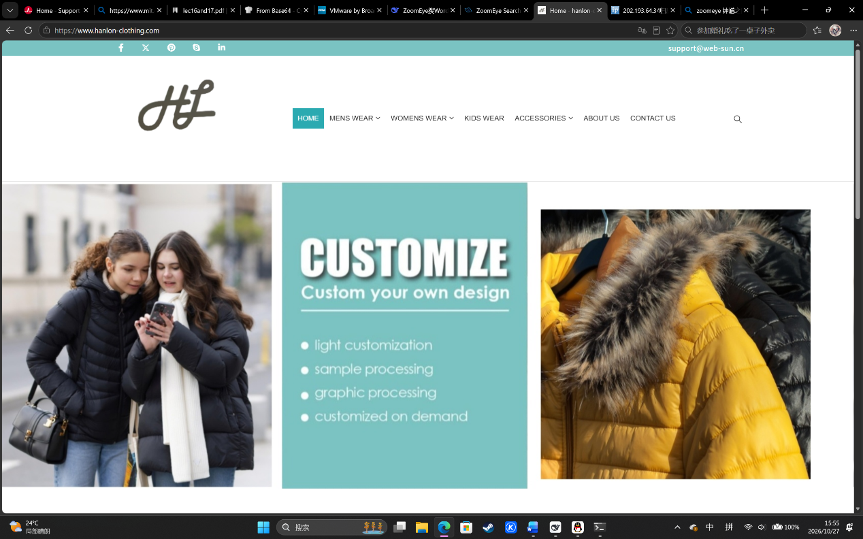
信息泄露与暴力破解：WordPress 站点常在页面源码中暴露版本号（如 generator 标签），或在 /readme.html 留有版本痕迹。默认的 /wp-login.php 登录入口若未加防护，也容易遭受自动化密码爆破。

HTTP/1.1 301 Moved Permanently
Server: nginx
Date: Tue, 27 Oct 2026 07:52:18 GMT
Content-Type: text/html; charset=UTF-8
Transfer-Encoding: chunked
Connection: keep-alive
Vary: Accept-Encoding, Cookie
X-Redirect-By: WordPress
Location: https://www.hanlon-clothing.com/
Strict-Transport-Security: max-age=31536000

