Implement Azure AI Search Service –

Data Chunking Strategy

Portal Implementation Steps

Login to Azure AI Search.
  - Login to Azure Portal – Go to Google Search bar and enter Azure Portal Login.

  - Select Microsoft Azure portal link.
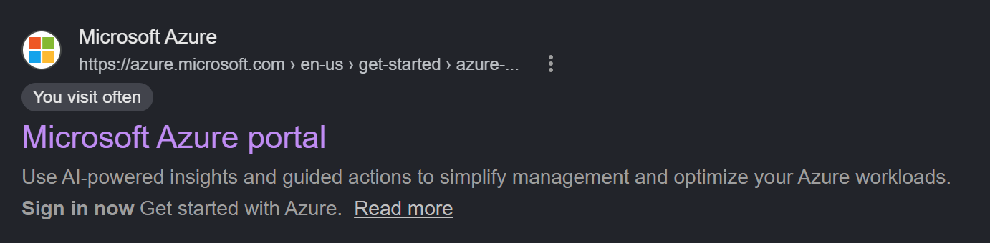
  - Select Sign in now button.


Open the search service: In the Azure portal, open the Azure AI Search service used by the Policy Assistant.
  - Enter AI Search in the Azure Portal Search bar and select AI Search to go to Azure AI Search Service.
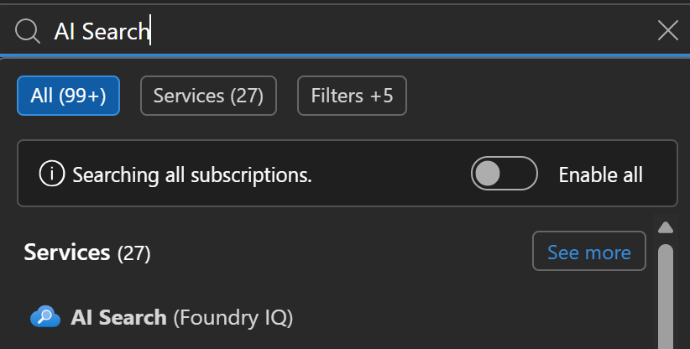

Open the skillset: Select Skillsets, then open the skillset created by the Import and vectorize data workflow.
  - Select the AI Search Service that you wish to make a change on/in.
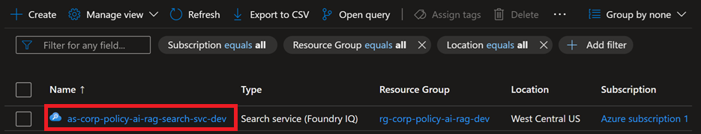
  - Select Search management menu item.
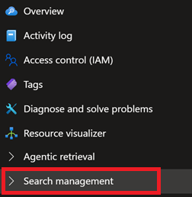

  - Click Skillsets to go to AI Search skillsets.
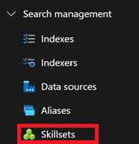
  - Click Add skillset to add a skillset.
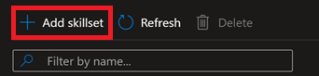
  - Enter the top-level Skill name and description.
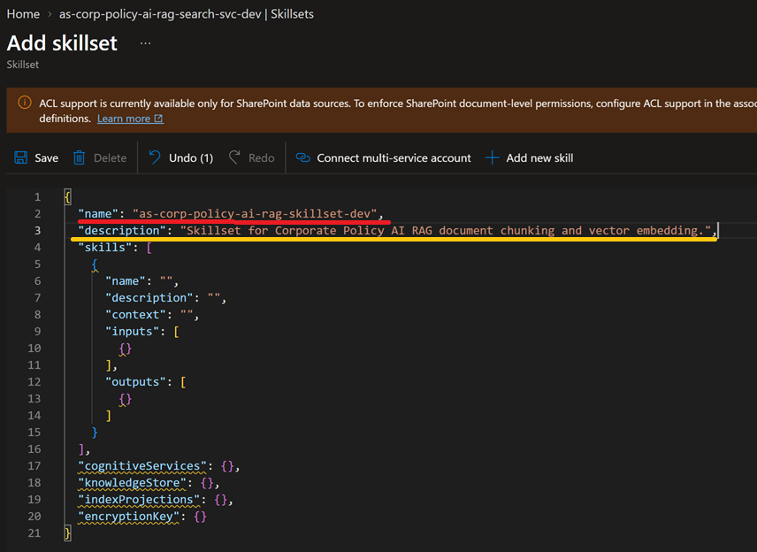

Find the Text Split skill: In the JSON definition, locate the object whose @odata.type is #Microsoft.Skills.Text.SplitSkill.
  - Click Add new skill to add Text Split Skill.
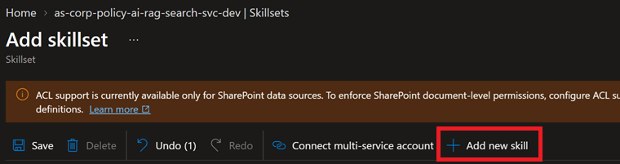
  - Click Templates dropdown menu to select Text Split Skill.
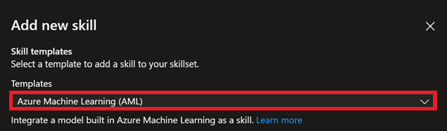
  - Select TextSplit Skill.
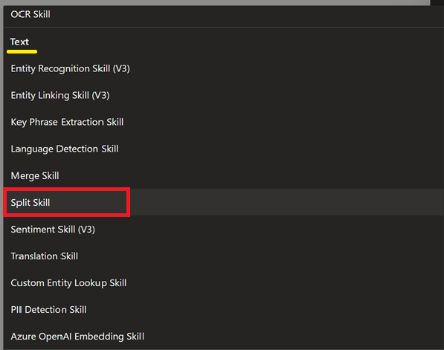

  - Click Add button to add the Text Split Skill.
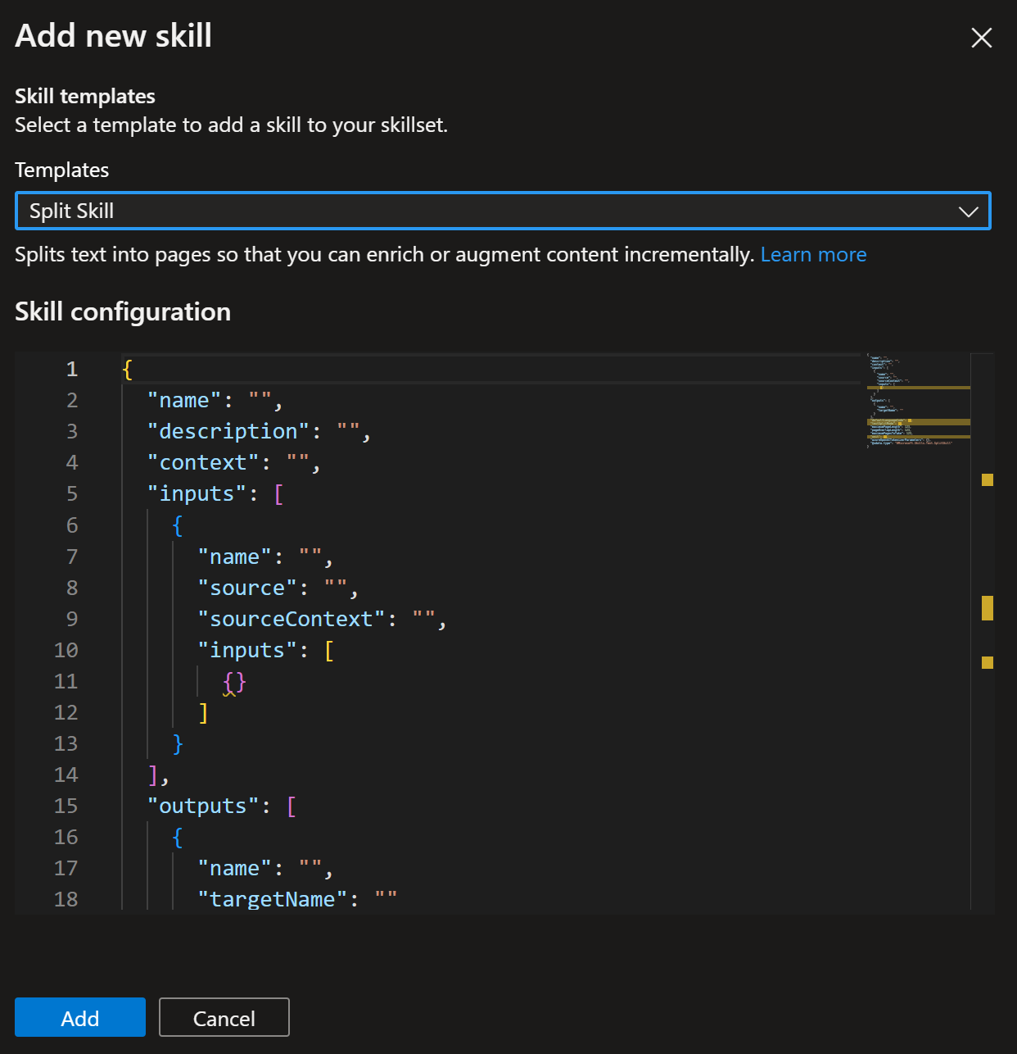
  - Scroll down to the skill that contains the “defaultlanguageCode”, “textSplitMode”, and etc. Enter a name for the Text Split Skillset.
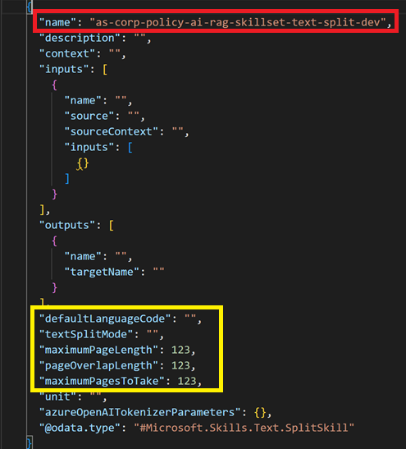

Change the Text Split Settings:
  - Enter the following:
    - Set textSplitMode to pages,
    - Set maximumPageLength to 1000,
    - Set pageOverlapLength to 125, and
    - Set unit to azureOpenAITokens.
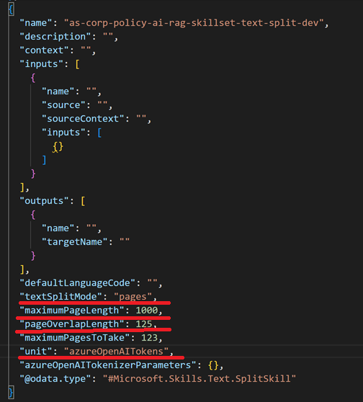
  - Click Save button to save skillset configuration.
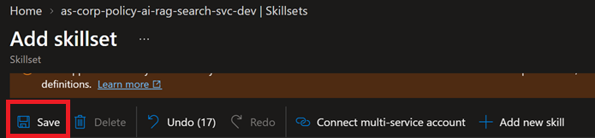

  - Remove the following Text Split configurations:
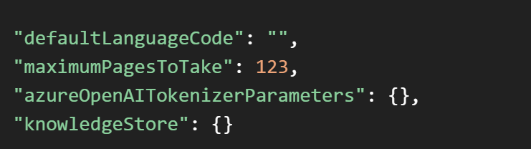
  - Your completed Text Split Skillset configurations should look like the following:
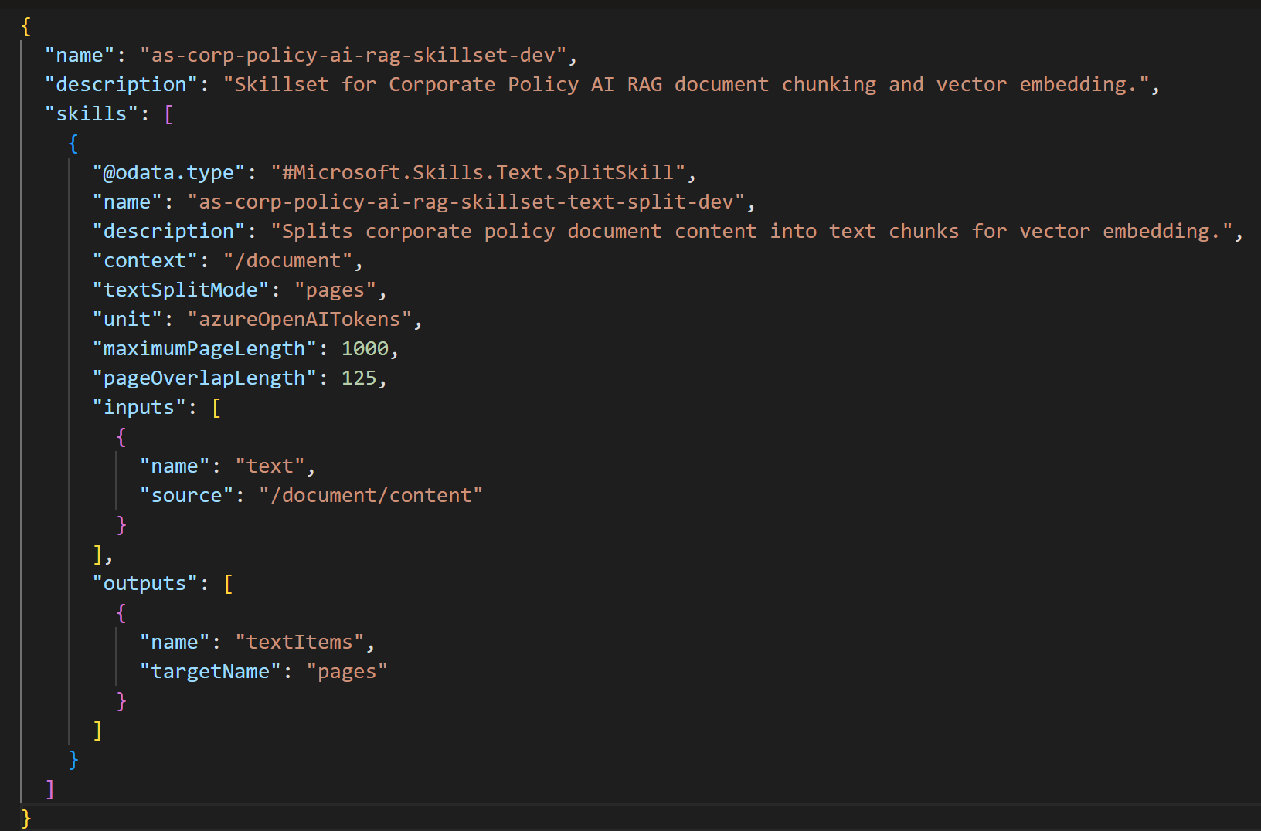

Preserve downstream paths: Keep the output target name, commonly pages, unless every downstream skill and index projection is updated.
  - Ensure target Name is set to pages.
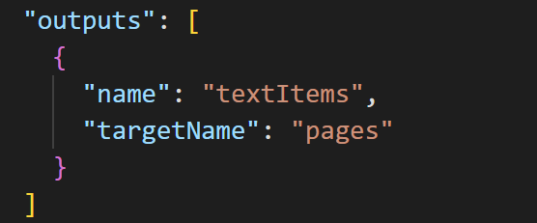

  - Click Save button to save skillset configuration.
  - Click the X to close the Add skillset window.


Test: Use a debug session with one representative policy document before rebuilding the entire index.
  - Click Indexes menu item to see indexes.
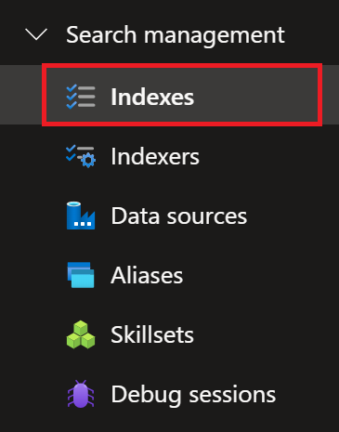
  - Select the Corp Policy Assistant Index.
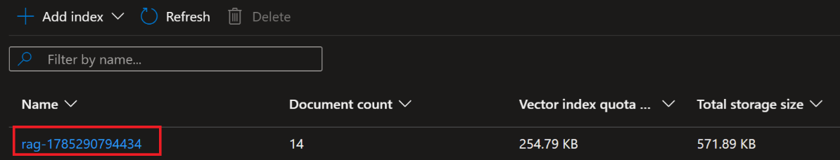
  - Enter a Policy Question and click the Search button to execute a raw Vector Index query.
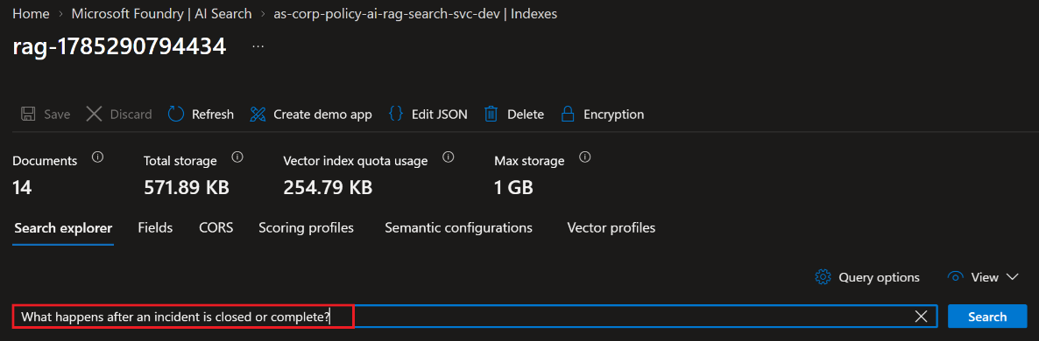
  - Confirm the following:
- The AI Search - Vector Index returned a search response,
- Confirm that the data response is relevant to the query request.
- Note, this is a raw policy query response, and it still needs to be grounded with the LLM; thus, the response may not look exactly like it’s answering the policy question/user prompt however it is a far returning lots of relevant data responses that still need to be refined.
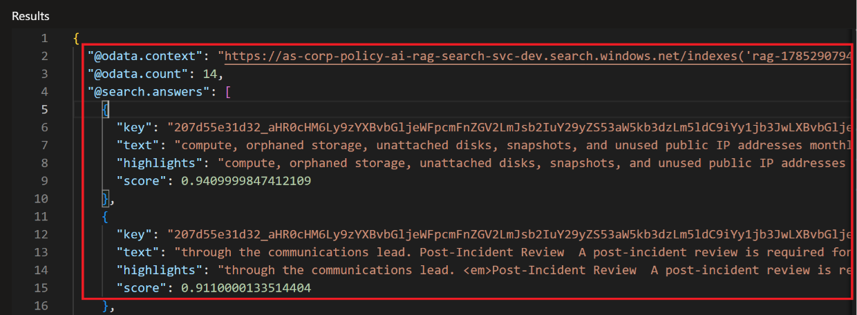
  - Close the AI Search Vector Indexes window.

Update Indexer.
  - Select Indexers menu item to view indexers.
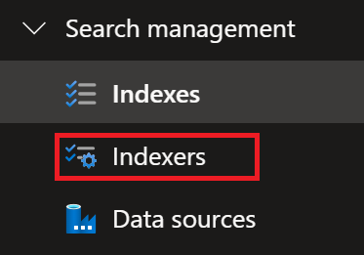
  - Select Indexer.

  - Click Edit JSON menu item.
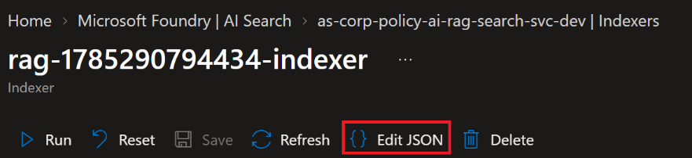

  - Set skillsetName to the name of your top-level skillset name.
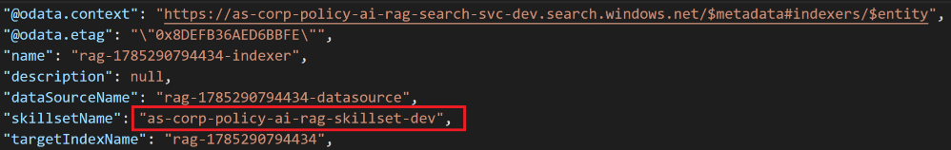
  - Click Save button to save the Skillset configuration.

  - Click Refresh to refresh the indexer.
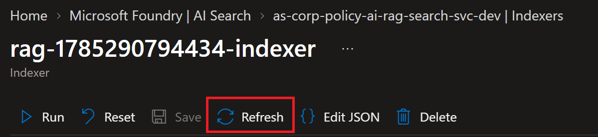
  - Click Run button to run the data ingest process again.
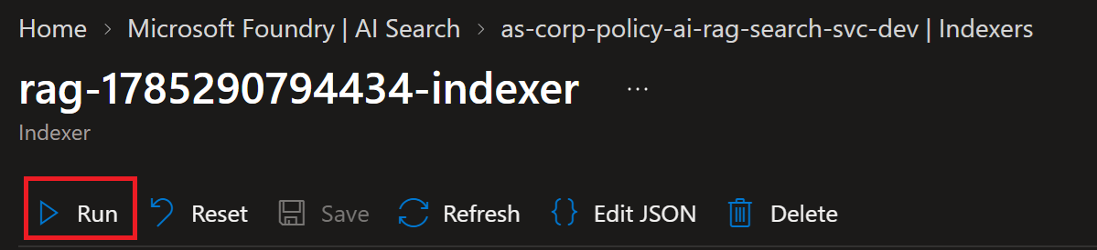
  - Click Yes button to run the indexer.
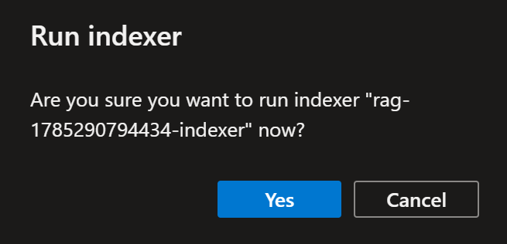

  - Finished.
