Implement Azure AI Search –

Embeddings Skill Strategy

Purpose
This strategy defines how to configure Azure AI Search so that text chunks produced by the existing Text Split skill are converted into vector embeddings and stored in the Corporate Policy Assistant search index.
The target implementation uses Azure AI Search integrated vectorization: the indexer invokes the skillset, the Text Split skill creates chunks, an Azure OpenAI Embedding skill vectorizes each chunk, and index projections write chunk-level records into the vector-enabled search index.
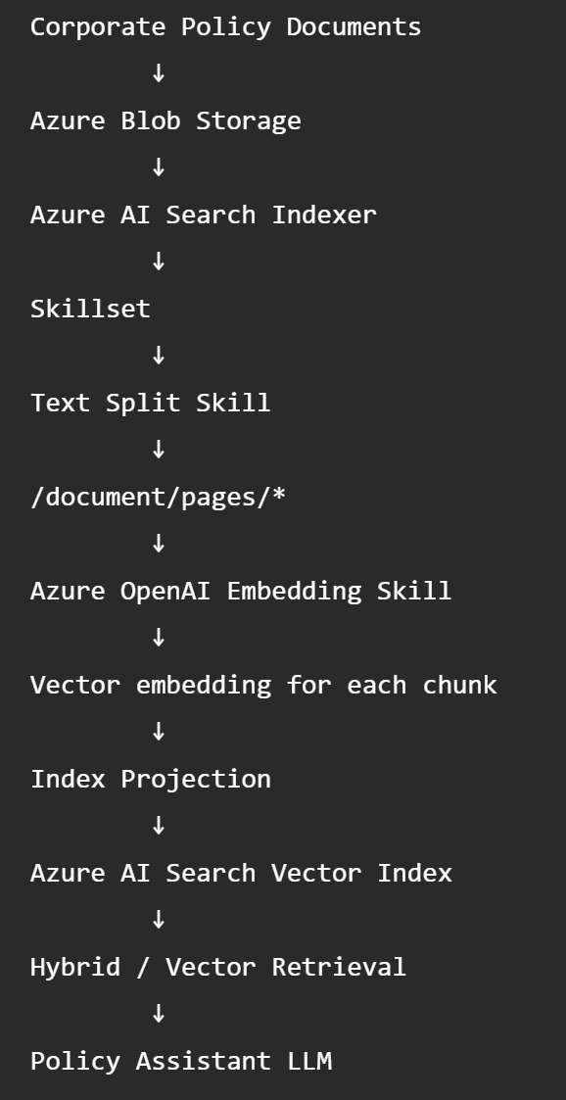

Current State
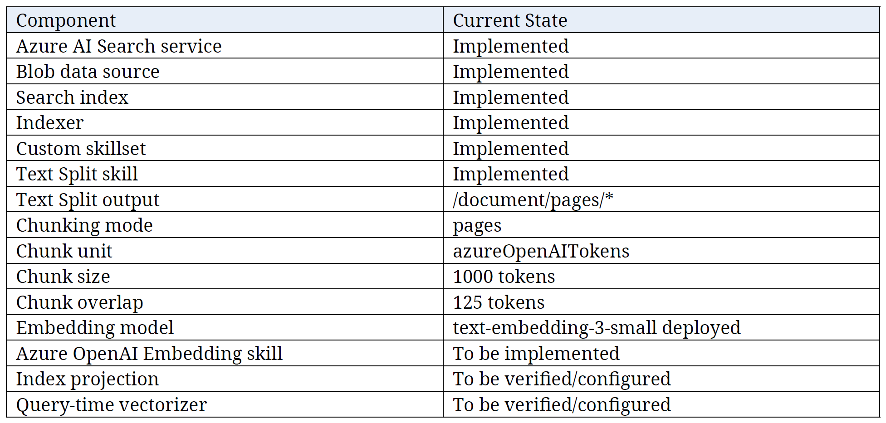

Implementation Objective
Implement an Azure OpenAI Embedding Skill inside:
as-corp-policy-ai-rag-skillset-dev
The embedding skill should:
- Receive each text chunk from /document/pages/*.
- Send each chunk to the deployed text-embedding-3-small model.
- Generate a vector for every chunk.
- Store the resulting embedding in the Azure AI Search enrichment tree.
- Project chunk text, embedding, document identifier, title, and useful metadata into the search index.
- Use the same embedding model at query time so indexed policy chunks and user questions are represented in the same vector space.

Recommended Naming Convention
Artifact | Recommended Name
Skillset | as-corp-policy-ai-rag-skillset-dev
Text Split Skill | as-corp-policy-ai-rag-skillset-text-split-dev
Embedding Skill | as-corp-policy-ai-rag-skillset-embedding-dev

Verify the MS Foundry Embedding Deployment
Before modifying the skillset, verify the deployed embedding model and record:
- Resource URI
- Deployment ID
- Model name
- Embedding dimensions
- Authentication method
Recommended baseline:
- Model Name: text-embedding-3-small
- Dimensions: 1536
- Resource URI:https://<your-foundry-or-azure-openai-resource-endpoint>/
- Deployment ID:<the name you gave your embedding model in foundry>
Note – the Model Name and Model Dimensions should have been verified during the Quota validation phase/process where you verify the embeddings model quota against Azure AI Searches embeddings models supported.
Important: Do not assume that the deployment ID is the same as the model name. Use the deployment name actually configured in Azure.

Login to Microsoft Foundry
Enter Microsoft Foundry into Search bar and select Microsoft Foundry link.
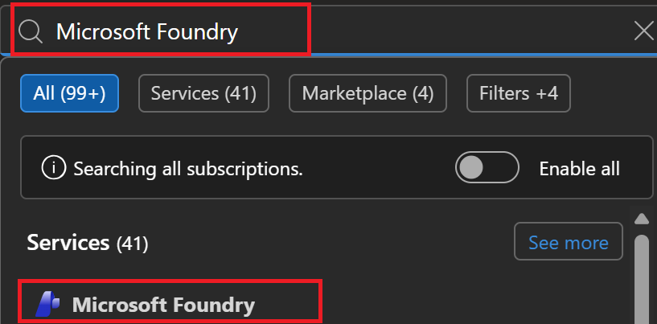
Select All Resources menu item.
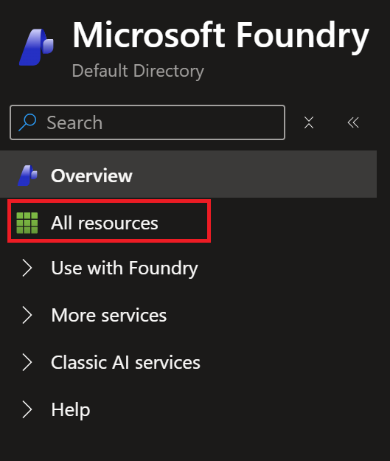
Select the Foundry Resource that contains your Embedding Model.
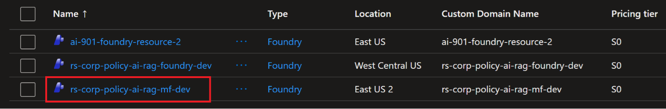
Select Go to Foundry portal button to go Foundry.
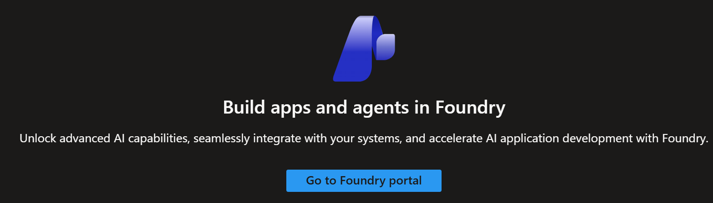

Select deployed Embeddings model
Click the Build button.

Click Deployments menu item.
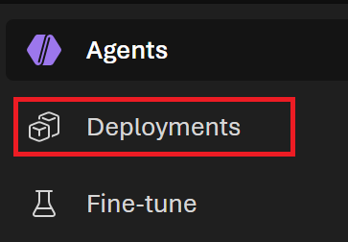
Select your deployed embeddings model.
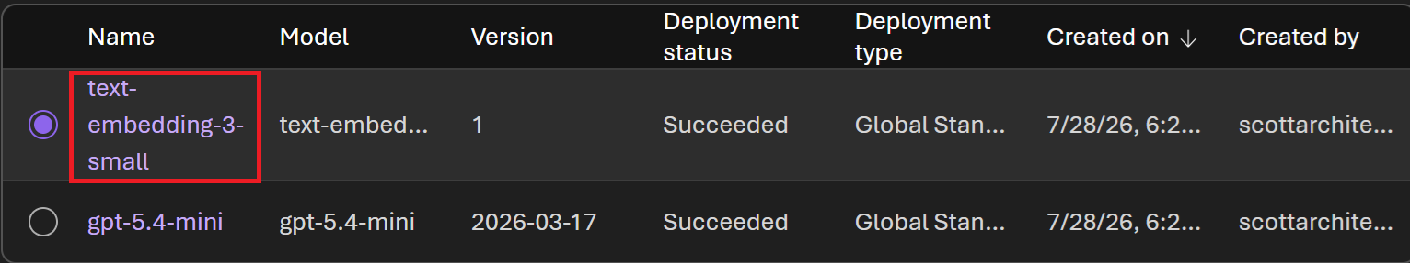

Document the following:
- Resource URI
- Deployment ID
- Model Name:
- Embedding Dimensions
- Authentication Method
Note: Embedding Dimensions may not be listed in Microsoft Foundry, so you’ll need to verify the Embedding Model possible dimensions against the embeddings dimensions supported by Azure AI Search.
Document the Embeddings Model Name and Deployment ID.
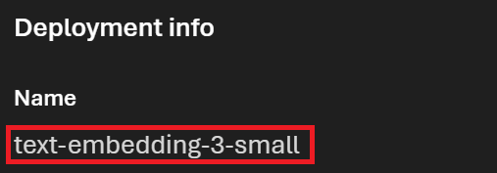
- Model Name: text-embedding-3-small
- Deployment ID: text-embedding-3-small
Note – In this case, the Model Name and Deployment ID are the same. This may not be the case in all situations because the Model Name is the actual name of the model, and Deployment ID is the name that you gave the Embeddings Model when you deployed it to Microsoft Foundry.
Document the Resource URI/Endpoint.
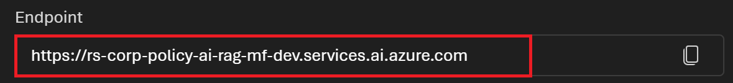
- Resource URI: https://rs-corp-policy-ai-rag-mf-dev.services.ai.azure.com

Configure Azure AI Search Authentication

Login to Azure AI Search Service
Go Azure Portal home page and enter Azure AI Search in the Search bar. Nex, click the AI Search link to go to Azure AI Search.
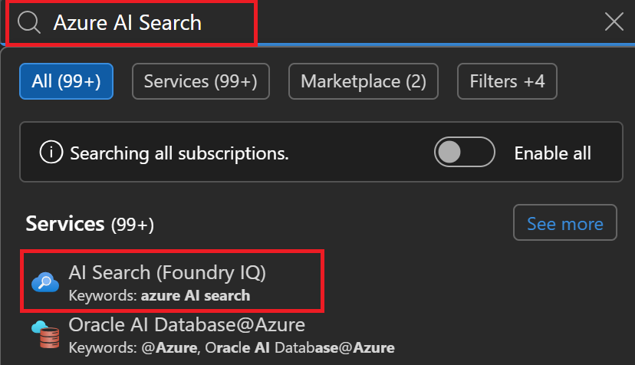
Select Azure AI Search service.
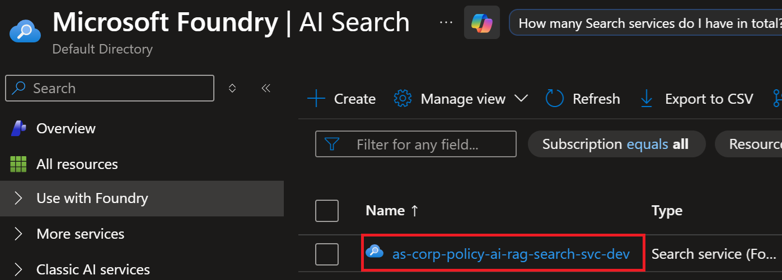

Configure Managed Identities
Select Access control (IAM) menu item.
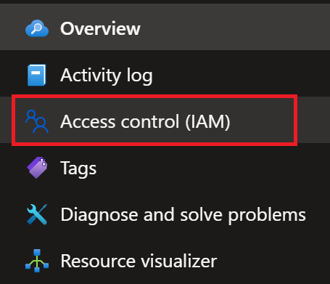
Click View button to view access to this service.
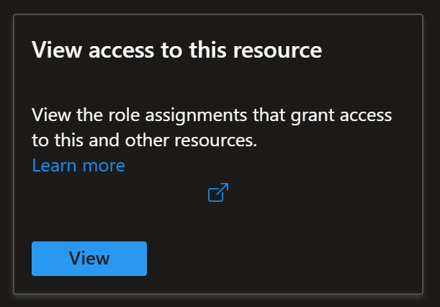
Select Role assignments.


Verify that the Azure AI Search Service - Managed Identity has the Cognitive Services OpenAI User role assigned to it.

Add the Azure OpenAI Embedding Skill

Add New Skill
Select Skills menu item.
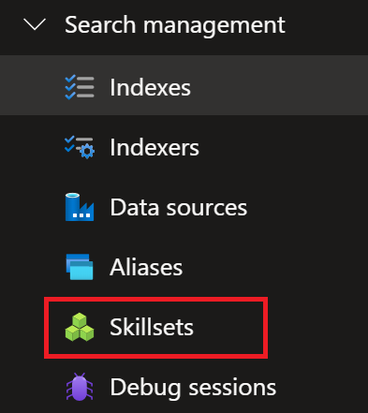
See result
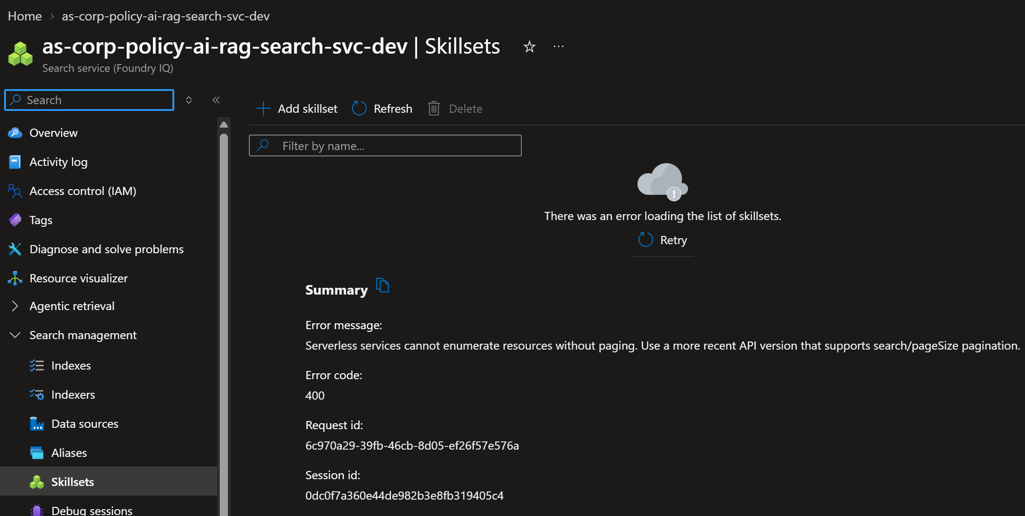

Click Add skillset button.

Click Add new skill.
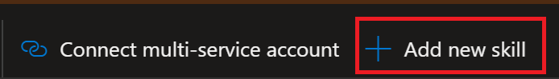
Click the Templates dropdown menu.
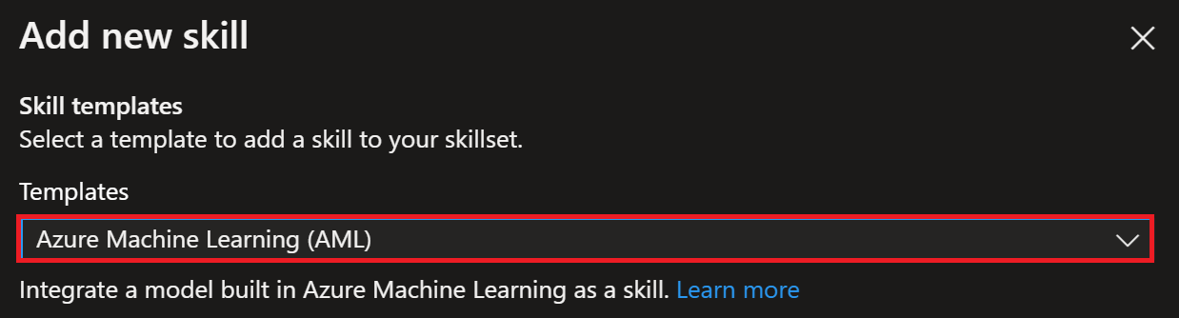
Select Azure OpenAI Embedding Skill.
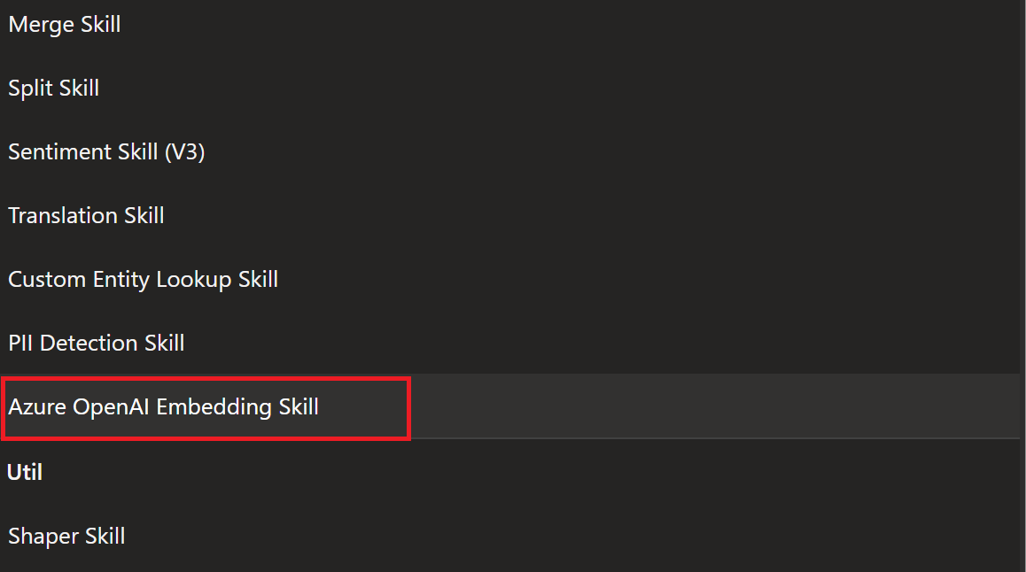

Click Add button to add the OpenAI Embedding Skill.


Configure OpenAI Embedding Skill
Locate the Skill where @data.type is set to #Microsoft.Skills.Text.AzureOpenAIEmbeddingSkill
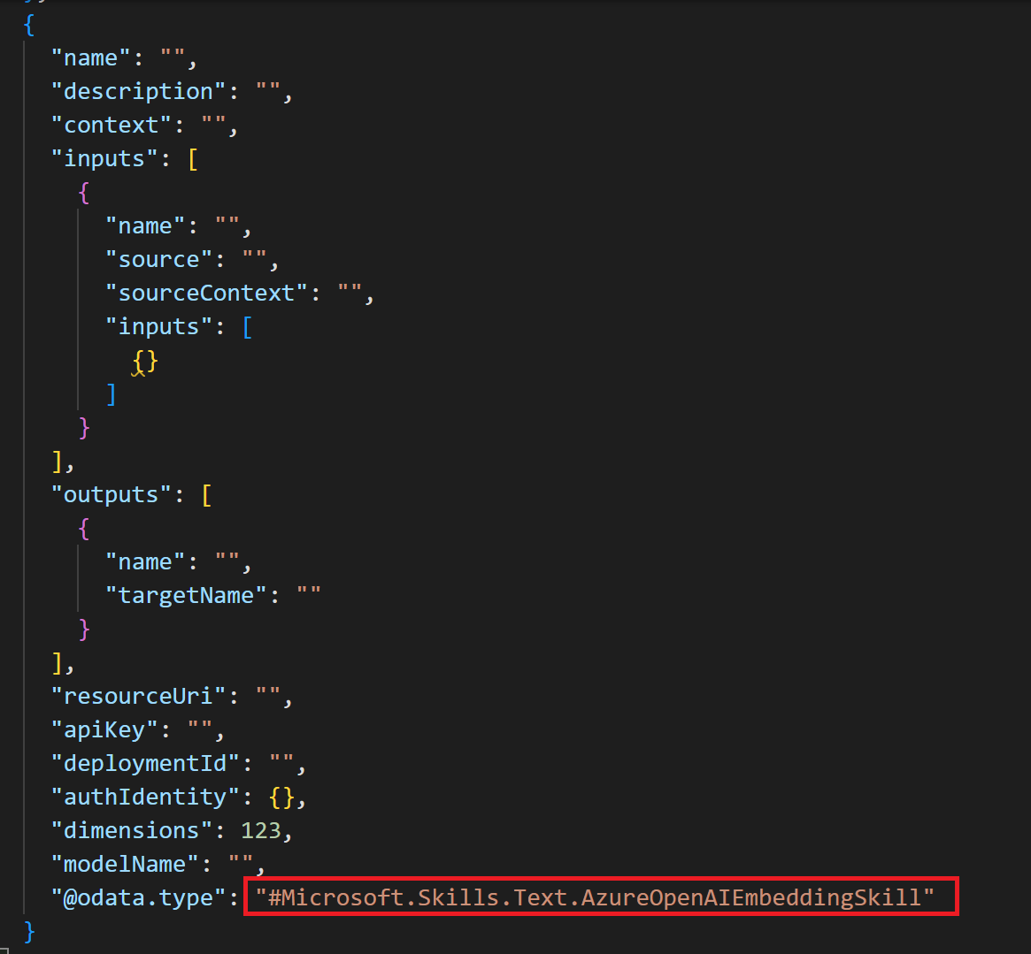
Set the following skill configurations to the same configurations in the screenshot below and remove configuration parameters that do not exist in the screenshot below.
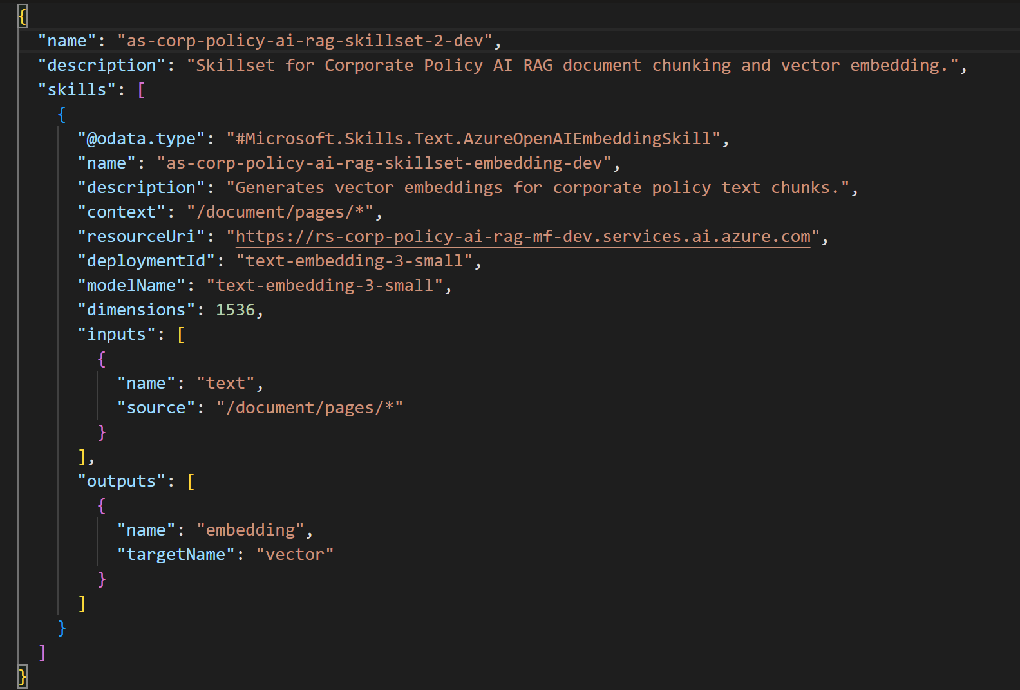
Remove the following Configuration Parameters:
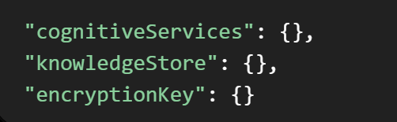
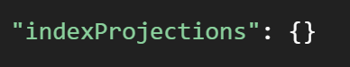

Remove Empty/Blank Skill if one exists.
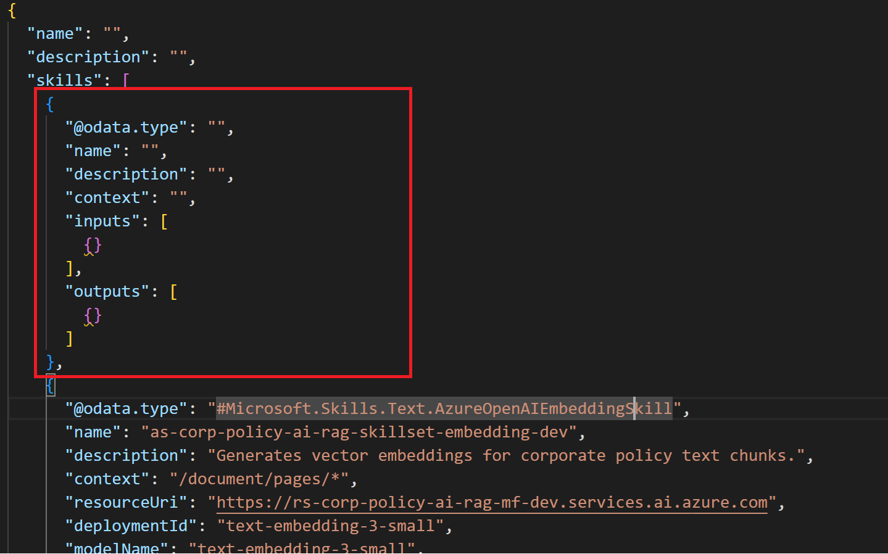
Click Save button.

Finished.

Verify the Search Index Vector Field
Before running the indexer, inspect the target index and verify that it contains a vector field capable of storing the generated embedding.
{
"name": "contentVector",
"type": "Collection(Edm.Single)",
"searchable": true,
"dimensions": 1536,
"vectorSearchProfile": "<vector-profile-name>"
}
** The vector field dimension must match the Embedding skill dimension. **

7.1 Edit the Vector Index field
Go to Search managementIndexes.
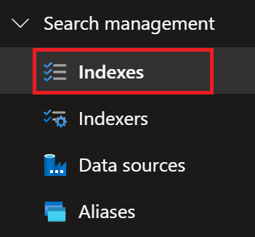
Select the Policy Assistant Index link.
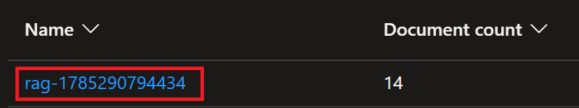
Click the Edit JSON menu item.

Click Ctrl+F to open the Find textbox. Enter Vector in the textbox and click the Arrow keys to search for the text_vector field block below:
Confirm the dimensions field is set to 1536.
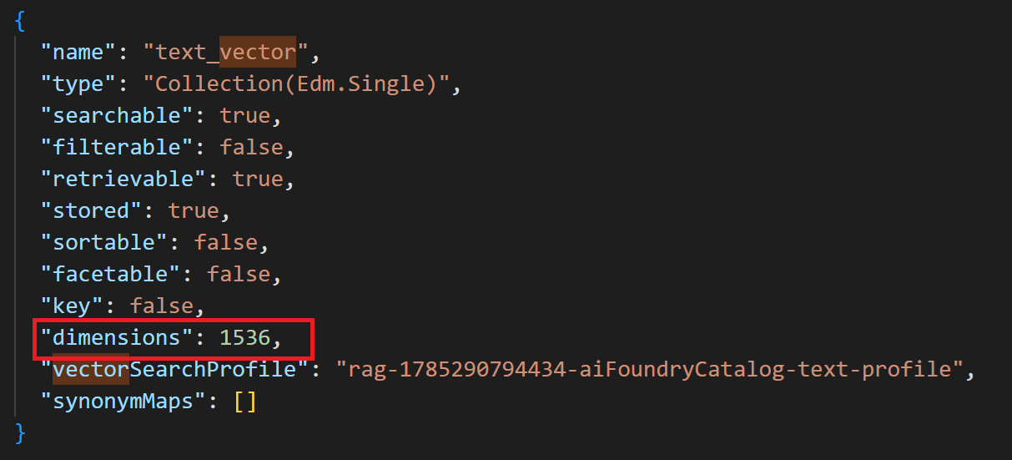
Enter vectorSearch into the Find textbox and search for the vectorSearch field using Arrow buttons.
Verify the vectorSearch algorithm field exists
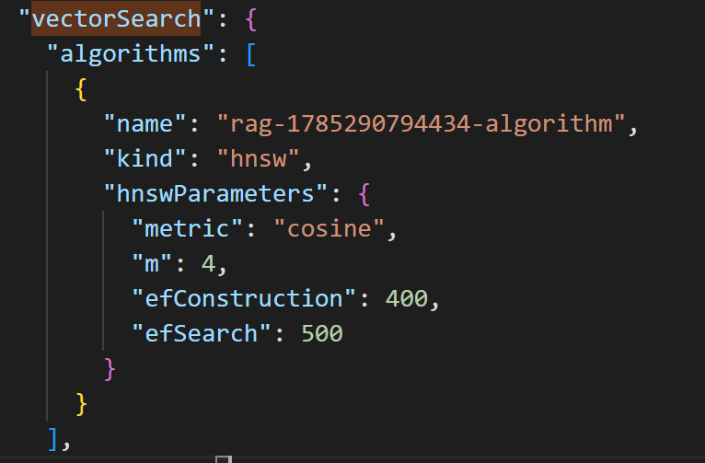
Scroll-down a little to confirm profiles exist.
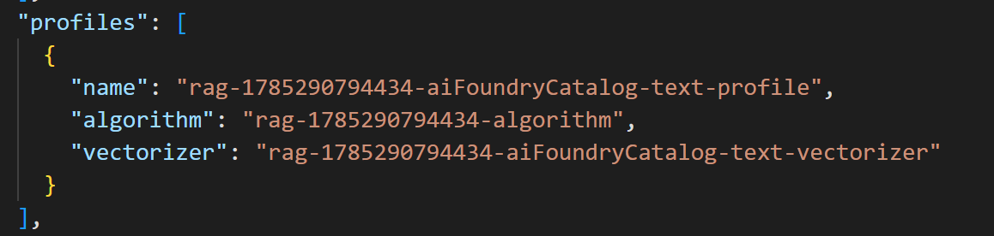
Scroll-down a little to confirm vectorizers exist.
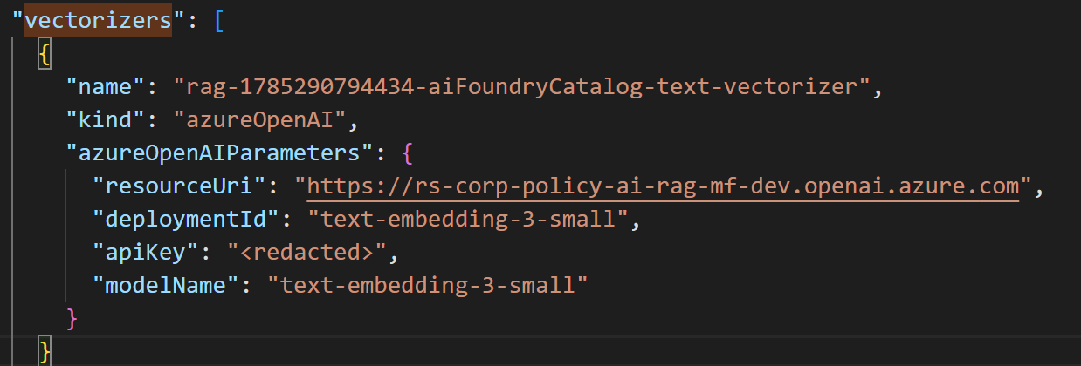
Finished.

Configure Index Projections
For a chunk-based RAG design, index projections should create separate searchable records for each chunk while preserving metadata from the source policy document.
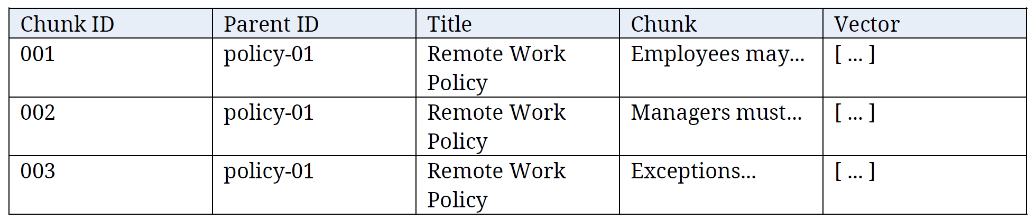

Open your index JSON
Go to Search managementIndexes to go to you Vector Index.
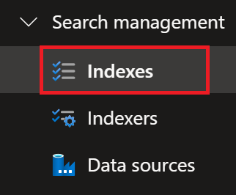
Select you Azure AI Search Vector Index.
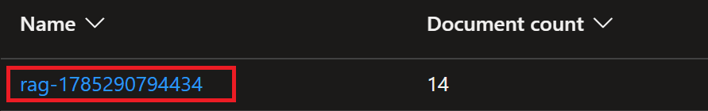
Select Edit JSON menu item to edit the Vector Index.

Using Ctlr+F to bring up the Find textbox, search for chunk_id to verify this field block (key field) exists.
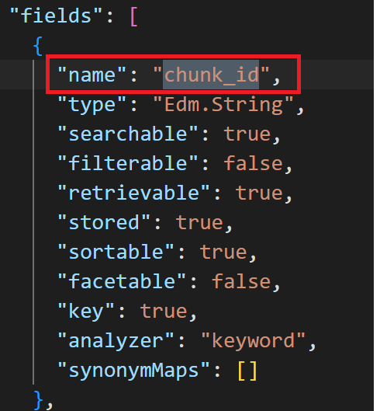
Enter parent_id in Find textbox and click Search Arrows to verify parent_id (filterable parent field) field block exists.
Verify parent_id field block exists.
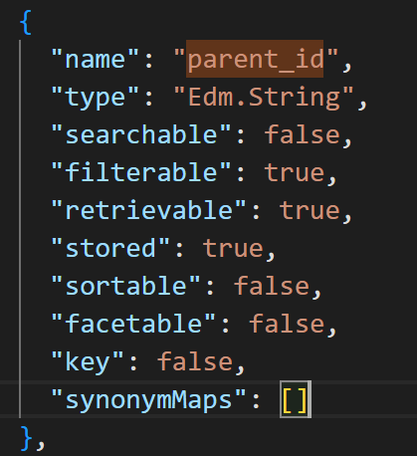
Enter chunk in Find textbox and click Search Arrows to verify chunk (searchable text field) field block exists.
Verify the chunk field block exists.
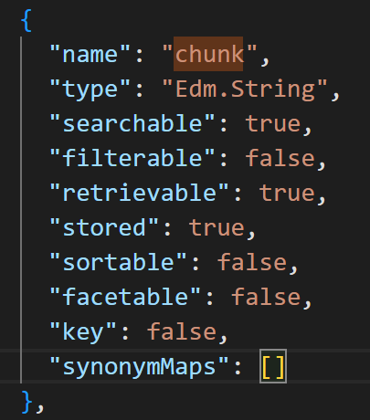
Enter text_vector in Find textbox and click Search Arrows to verify text_vector (1536 -dimension vector field) field block exists.
Verify the text_vector field block exists.
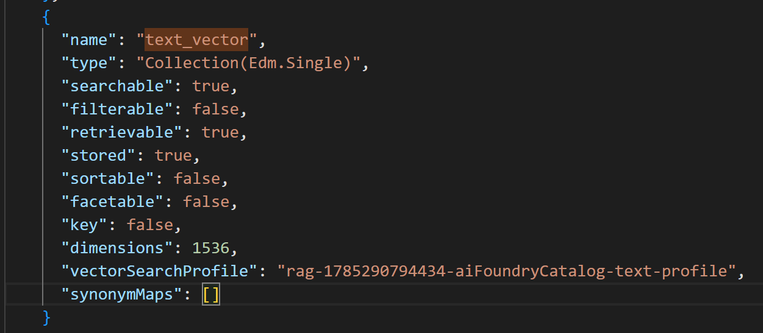
Click Save button if you’ve made a change to the Vector Index JSON.

Click X to close the Vector Index window.
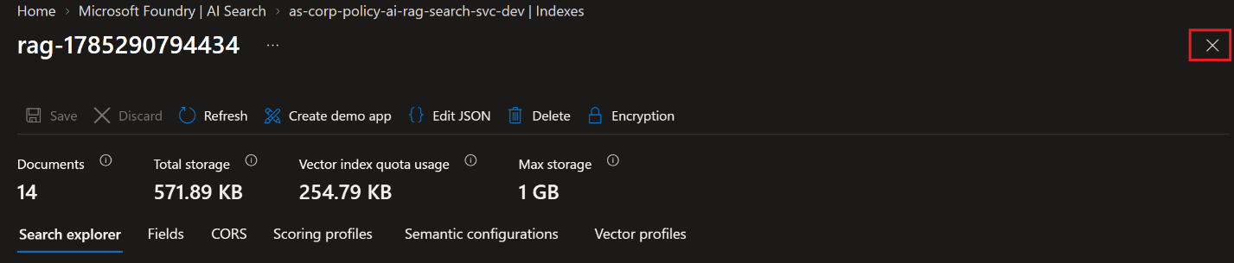

Go to Search managementSkillsets to update/add indexProjections to the Skillset.
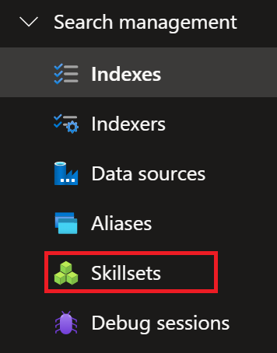
Click Add skillset button to add a new skillset.

Delete the default JSON code in the Skill.
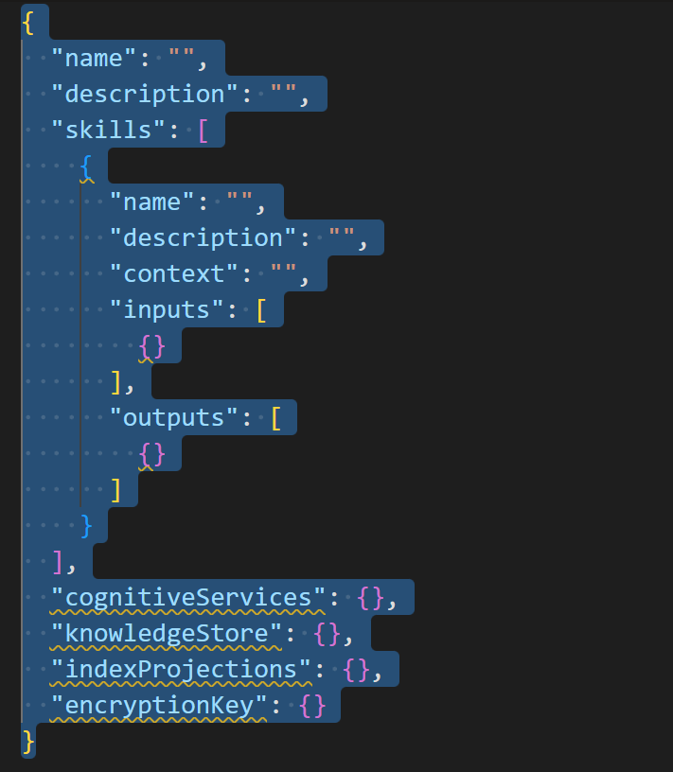
Paste the following JSON code into the Skillset window:
{
"name": "as-corp-policy-ai-rag-skillset-v4-dev",
"description": "Corporate Policy AI RAG skillset for chunking, embeddings, and index projections.",
"skills": [
{
"@odata.type": "#Microsoft.Skills.Text.SplitSkill",
"name": "as-corp-policy-ai-rag-text-split-dev",
"description": "Splits corporate policy document content into overlapping token-based chunks.",
"context": "/document",
"textSplitMode": "pages",
"unit": "azureOpenAITokens",
"maximumPageLength": 1000,
"pageOverlapLength": 125,
"inputs": [
{
"name": "text",
"source": "/document/content"
}
],
"outputs": [
{
"name": "textItems",
"targetName": "pages"
}
]
},
{
"@odata.type": "#Microsoft.Skills.Text.AzureOpenAIEmbeddingSkill",
"name": "as-corp-policy-ai-rag-embedding-dev",
"description": "Generates vector embeddings for corporate policy text chunks.",
"context": "/document/pages/*",
"resourceUri": "https://rs-corp-policy-ai-rag-mf-dev.services.ai.azure.com",
"deploymentId": "text-embedding-3-small",
"modelName": "text-embedding-3-small",
"dimensions": 1536,
"inputs": [
{
"name": "text",
"source": "/document/pages/*"
}
],
"outputs": [
{
"name": "embedding",
"targetName": "vector"
}
]
}
],
"indexProjections": {
"selectors": [
{
"targetIndexName": "rag-1785290794434",
"parentKeyFieldName": "parent_id",
"sourceContext": "/document/pages/*",
"mappings": [
{
"name": "chunk",
"source": "/document/pages/*"
},
{
"name": "text_vector",
"source": "/document/pages/*/vector"
},
{
"name": "title",
"source": "/document/metadata_storage_name"
}
]
}
],
"parameters": {
"projectionMode": "skipIndexingParentDocuments"
}
}
}
Click Save button to save the Skillset.
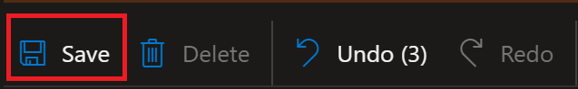
Go to Search managementIndexers to access indexers.
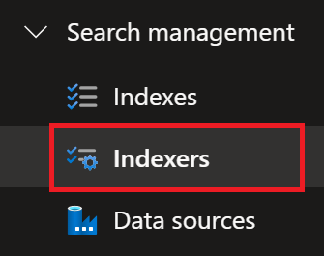
Select your Indexer.

Click Edit JSON button to edit the Indexers configurations.

Click Ctrl+F and enter skillsetName into the Find texbox and click the Arrow keys to search for skillsetName.
Verify the skillsetName is the same top-level skillsetName as you used earlier to create the textSplit and Embedding skillsets.
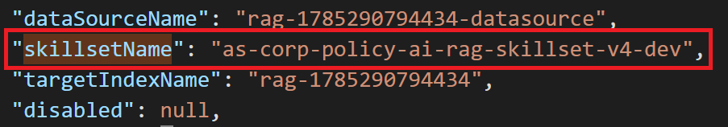
Enter targetIndexName into the Find textbox and click the Arrow keys to search for targetIndexName.
Verify targetIndexName is set to the Vector Index Name.
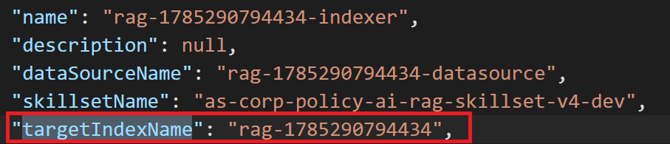
Click Save button.

Finished.

Reset and Run the Indexer
Click Reset button to mark the existing corpus for reprocessing.
Click Yes button to Reset the Indexer.
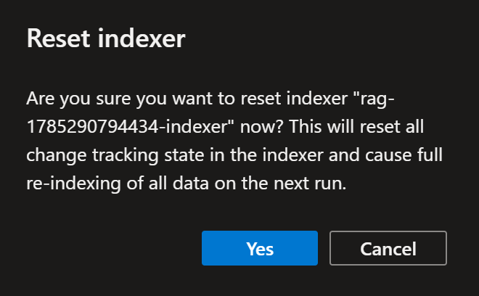

Click Run to execute the indexer.
Click Yes button to Run the indexer.
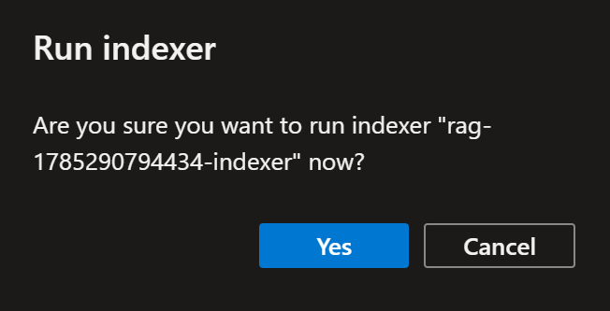
Click Refresh button to update the portal view/status.

Validate Indexed Results
After the indexer succeeds, use the Search Explorer to verify:
- Each source policy produces multiple chunk-level records when appropriate.
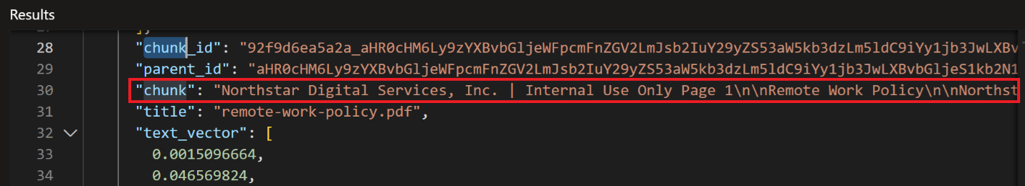
- Each chunk contains the expected chunk text.

- Each chunk includes a populated vector field.
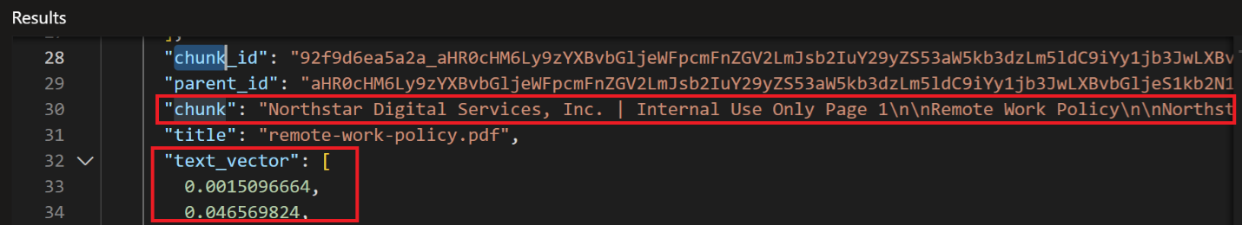
- Parent/source metadata is retained.
- No dimension, authorization, or enrichment errors are reported.

Validate Indexer Execution history
Under IndexerExecution history, verify there is no embedding, authorization, dimension, or enrichment errors/warnings in the Indexer window below.
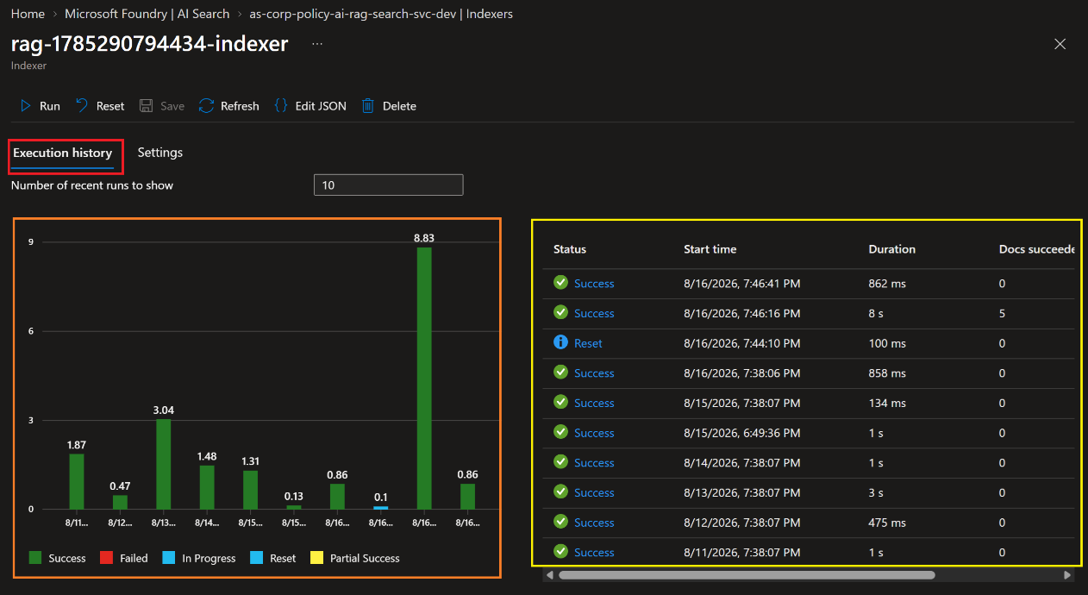
Click X to exit the Indexer window.


Validate Index Execution history
The purpose of this section is to verify the following:
- Each source policy produces multiple chunk-level records when appropriate.
- Each chunk contains the expected chunk text.
- Each chunk includes a populated vector field.
- Parent/source metadata is retained.
- No dimension, authorization, or enrichment errors are reported.
Click the Indexes menu item.
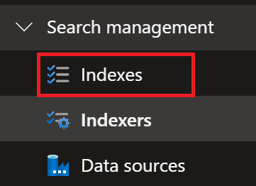
Select the policy assistant Vector Index.
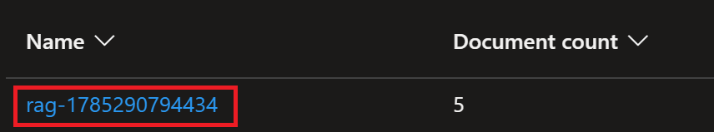
Enter the following question in the Search textbox and click the Search button to execute text+vector search query.
- What is the cloud cost policy?
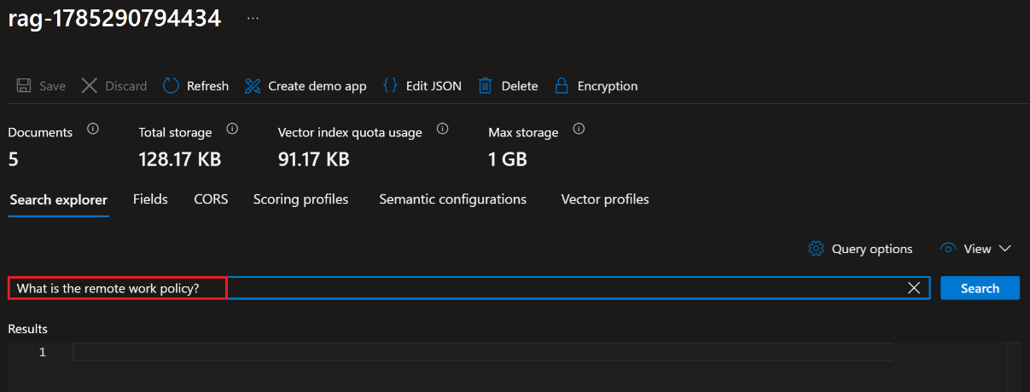
Click Ctrl+F to open the Find search tool. Enter Chunk_id and click the Arrow keys to search for Chunk_id.
Verify the following parameters exist and contain data:
- chunck_id
- parent_id
- chunk
- title
- text_vector
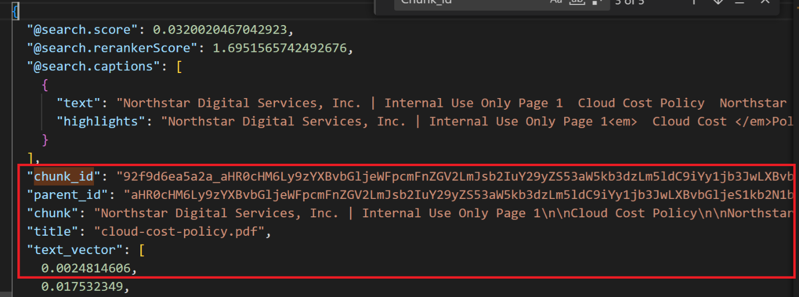

Test Vector and Hybrid Retrieval

Pre-Test Validation
- Open - Azure Portal -> Azure AI Search service -> Indexes -> select the RAG index -> Search Explorer.
- Enter - What is the corporate remote work policy? in the Search textbox and click the Send button.
- Switch - Search Explorer to JSON view.
- Verify - "top": 5 exists in the JSON query editor query request
- Verify the Index Results contains the fields used by these tests:
  - title,
  - chunk,
  - parent_id, and
  - text_vector.
- Verify - text_vector field is populated for indexed chunks.
- Verify the expected policy documents are present in the index.

Test Policy Questions
Here are some test policy questions:
- What is the corporate remote work policy?
- How frequently do employees need to change passwords?
- What is the incident escalation procedure?
- What policies apply to cloud costs?

Vector Index query process
Here is the Vector Index query process:
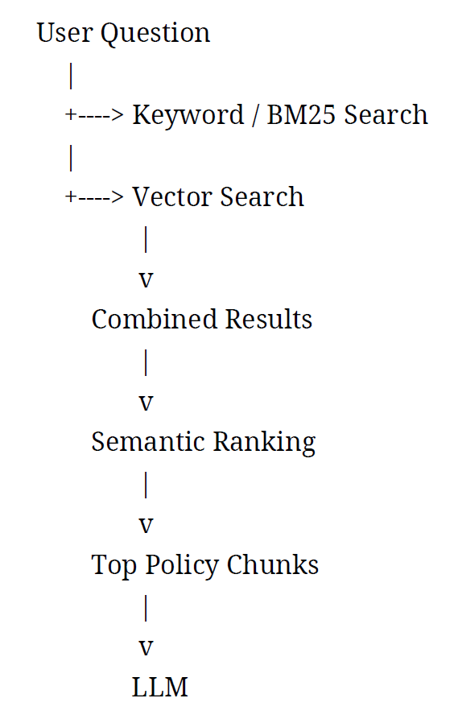
Note;: Microsoft specifically supports running vector and hybrid queries through Search Explorer.

Test 1 - Validate Keyword / BM25 Retrieval
Enter the Search query in “search” and “text” query fields then click the Search button to run this query:
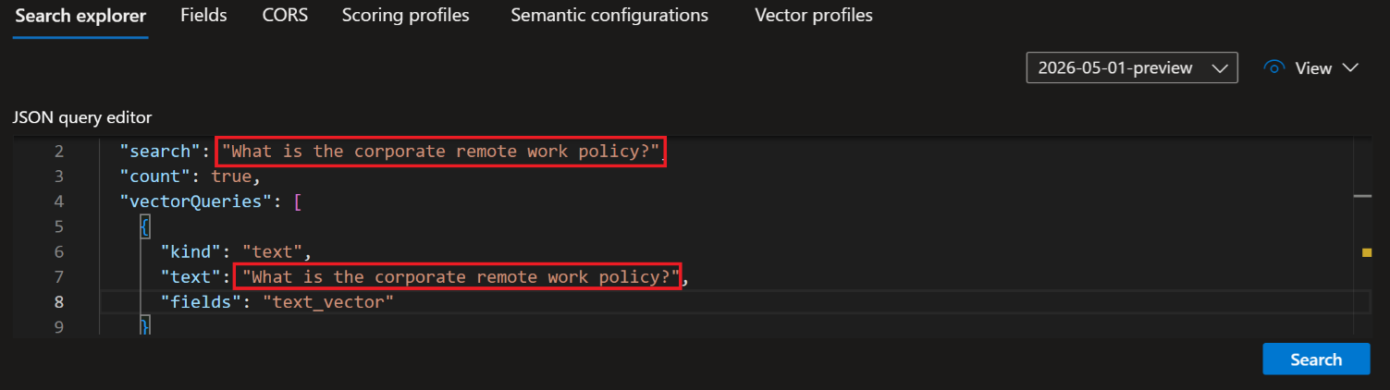

- Verify - the search field exists. It should contain the user question: "What is the corporate remote work policy?"
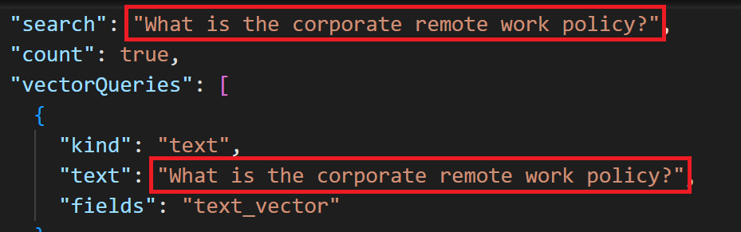
- Verify - the search field contains the exact user question. This confirms the request will perform lexical/BM25 retrieval against searchable text fields.
- Verify - select includes title, chunk, and parent_id. These fields let you identify the source document and inspect the retrieved content.
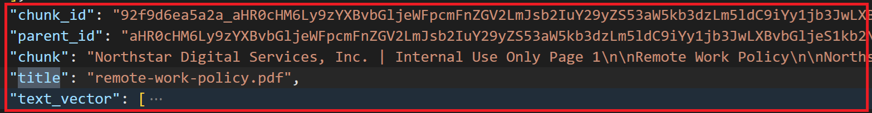
- Verify - top is set to 5. This limits the final result set to the five highest-ranked keyword matches.
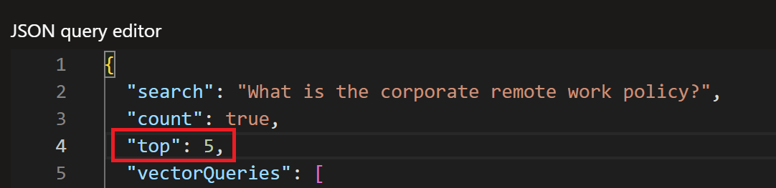
- Verify - the query and inspect the returned titles. remote-work-policy.pdf should rank at or near the top.
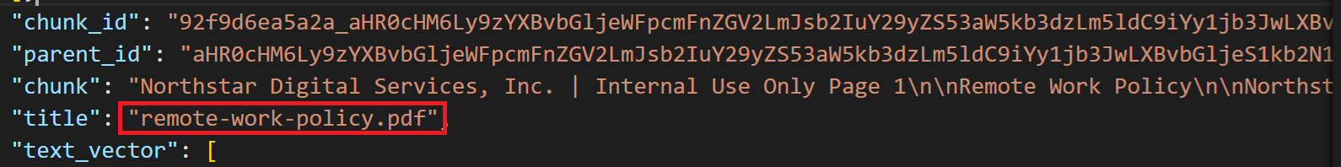

- Inspect - the returned chunk. It should contain substantive remote-work policy content, not only the title or metadata.
PASS when: the expected remote-work document appears near the top and the chunk contains relevant policy content.
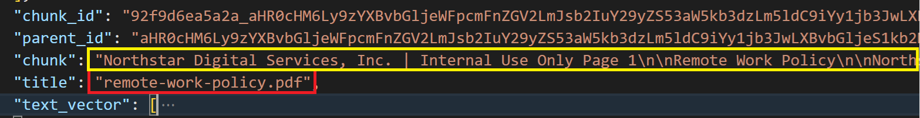

Test 2 - Validate Vector Retrieval
In the JSON query editor, enter the Search Query below and click the Send button.
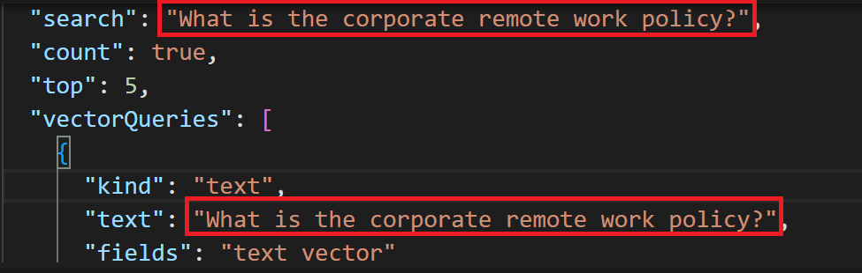
- Verify - vectorQueries exists. This confirms vector retrieval is included in the request.
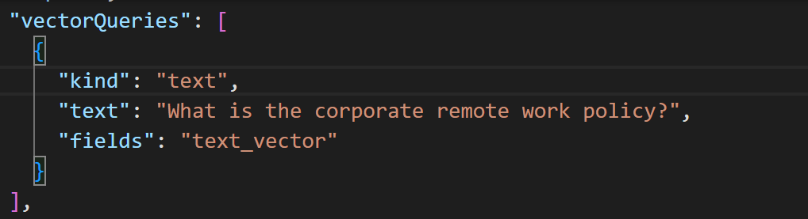
- Verify - kind is set to text. This tells Azure AI Search to vectorize the natural-language query at query time, assuming an index vectorizer is configured.
- Verify – vectorQueriestext contains the user question. This is the text that will be converted into a query embedding.

- Verify - fields is set to text_vector. This points the vector query at the indexed embedding field.

- Verify - k is set. For this isolated vector test, k = 5 requests the five nearest vector matches.

- Verify - select includes title, chunk, and parent_id. This lets you evaluate the source and content returned by vector similarity.
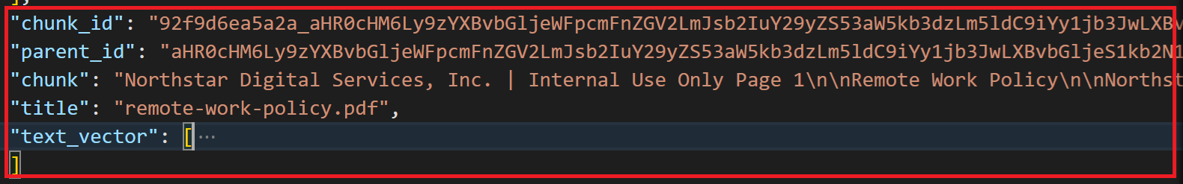
- Verify - top is set to 5. This returns the five final results for inspection.
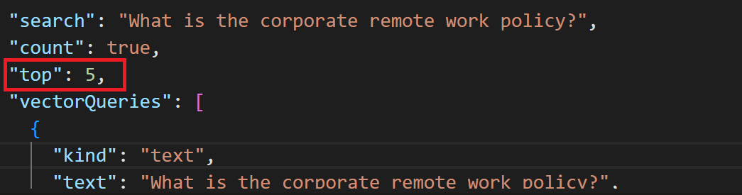
- Verify - the query and inspect the returned titles and chunks. remote-work-policy.pdf should rank highly even when wording differs from the source text.
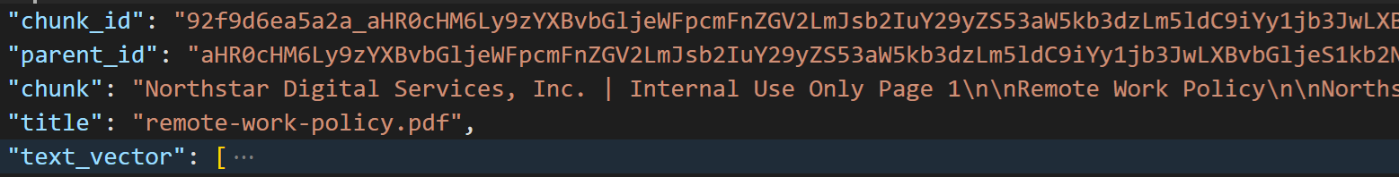
PASS when: the vector query returns semantically relevant remote-work content such as chunk and the expected policy ranks near the top of returned results list.

Test 3 - Validate Hybrid Retrieval
Run the following query:
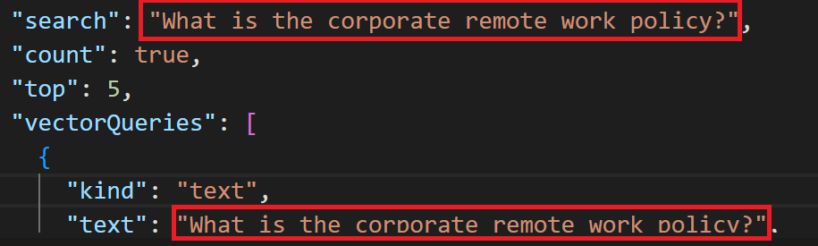

Execute the following test procedures:
- Verify - the search field exists and contains the user question. This confirms the request includes keyword/BM25 retrieval.
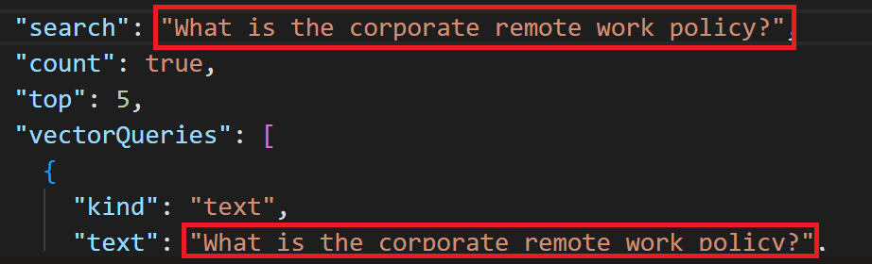
- Verify - vectorQueries exists. This confirms vector retrieval is included in the same request.
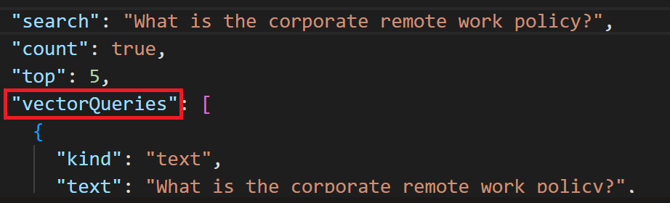
- Verify – vectorQueriestext contains the same user question. This confirms the user question will also be vectorized for semantic similarity retrieval.
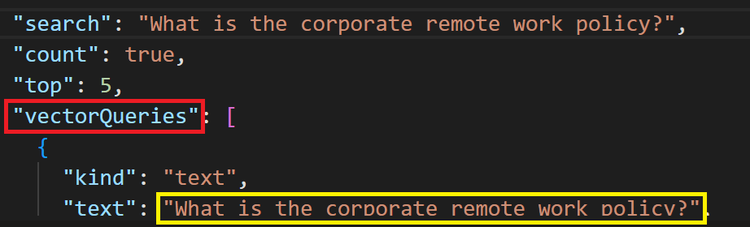
- Verify - kind is set to text. This enables query-time text vectorization when the configured vectorizer supports it.
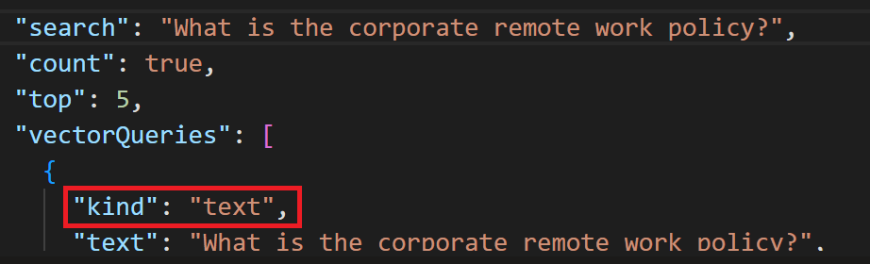

- Verify - fields is set to text_vector. This identifies the indexed vector field used for similarity matching.
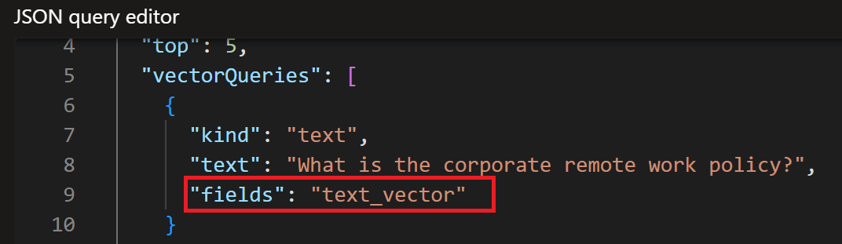
- Verify - k is set to 50. This provides a broader vector candidate set before the hybrid ranking is combined.

- Verify - select includes title, chunk, and parent_id. These fields allow you to validate which source and chunk were selected.
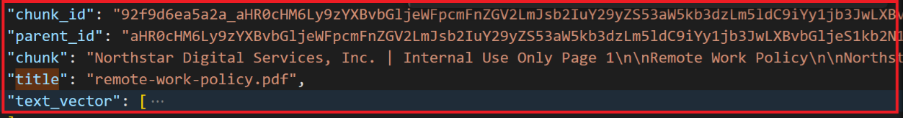
- Verify - top is set to 5. This returns the five highest-ranked final hybrid results.
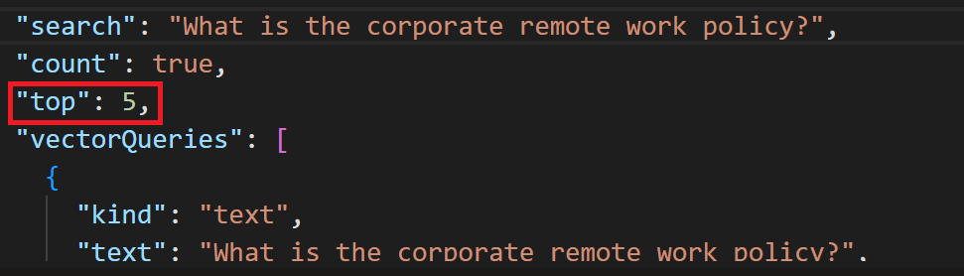
- Run - the query and compare the ranking with the keyword-only and vector-only tests. The expected policy should remain at or improve toward the top.
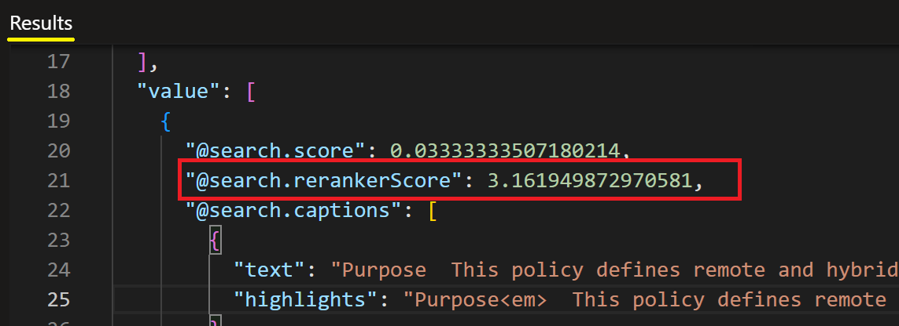

- Run the following query:
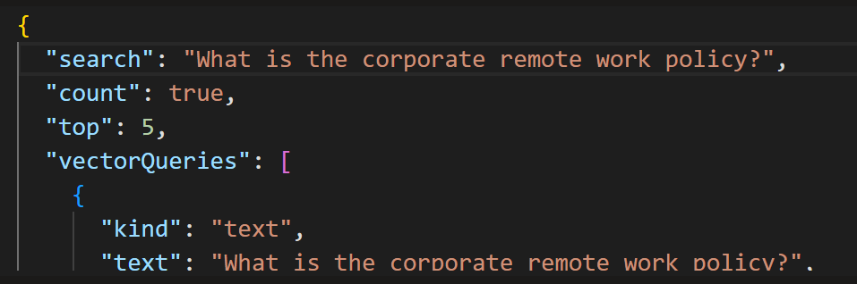
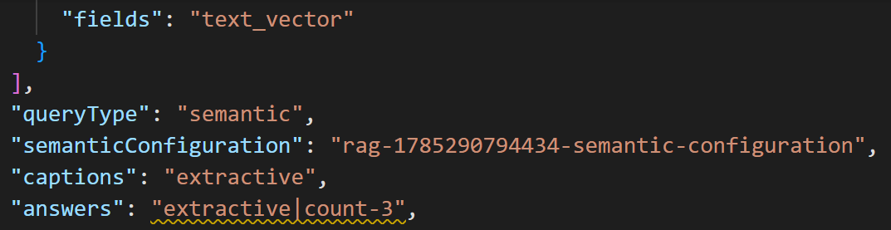
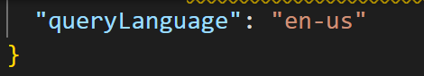
Execute the following Hybrid Retrieval test cases:
- Verify - search and vectorQueries are both present. This confirms the request remains hybrid.
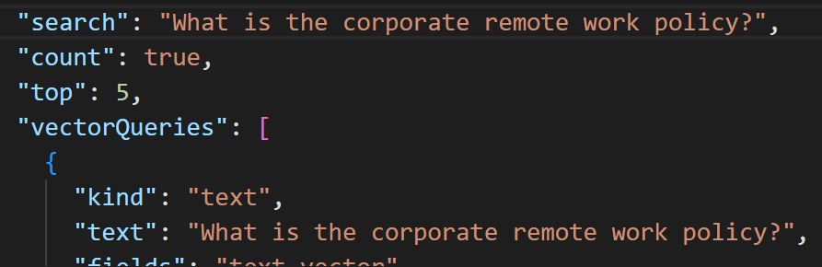
- Verify – vectorQueriestext contains the user question. This confirms the same question is used for vectorization.
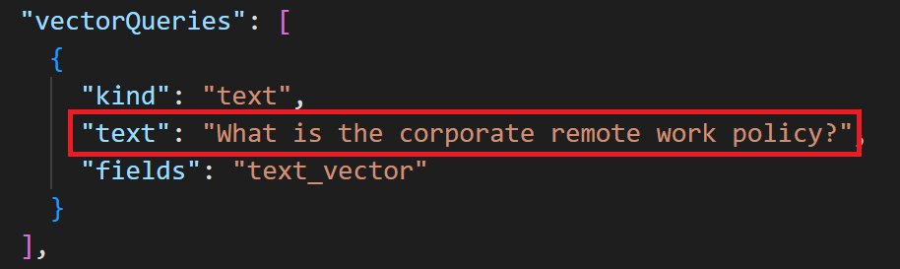
- Verify - fields is set to text_vector and k is set. This confirms the vector search target and candidate count.
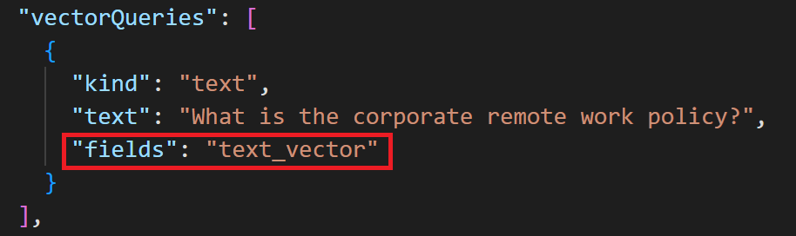
- Verify - queryType is set to semantic. This enables semantic ranking for the retrieved candidates.
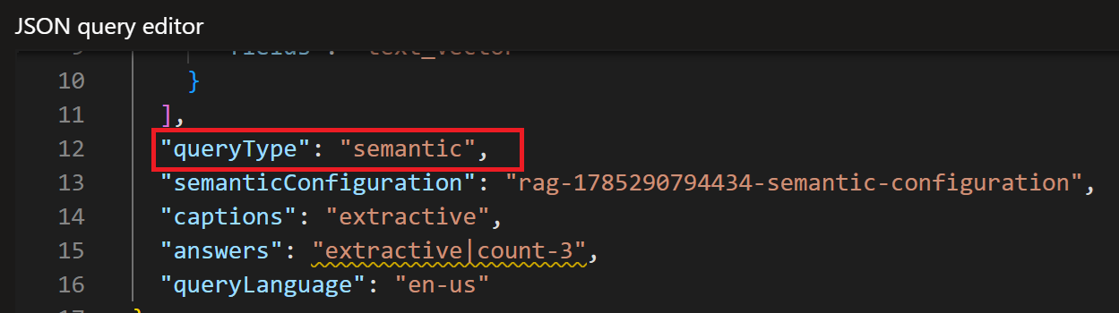
- Verify - semanticConfiguration is set to the actual configuration name for the index. Do not leave the placeholder value in the final test.
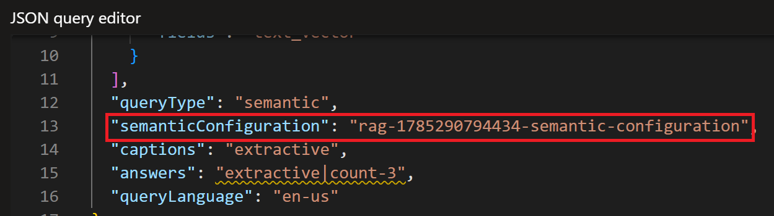

- Verify - captions is set to extractive. This requests a concise passage that helps you judge why a result is relevant.
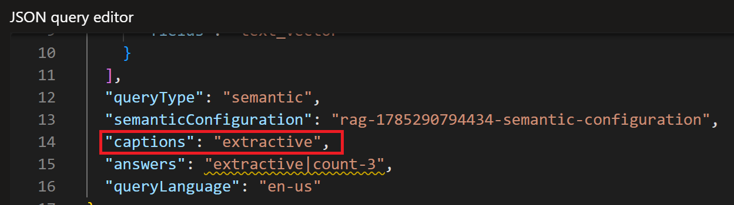
- Verify - answers is set to extractive. This requests an extractive answer when the query and semantic configuration support one.
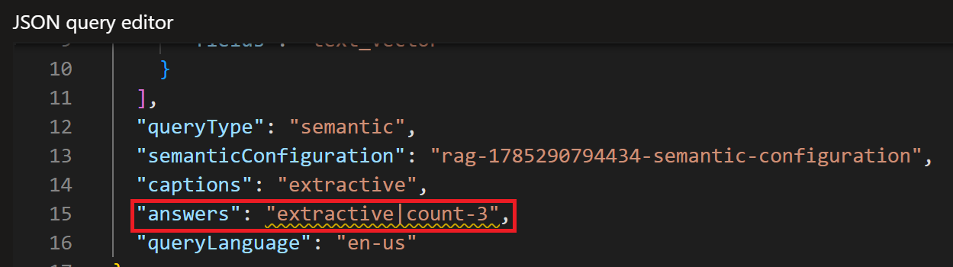
- Verify - top is set to 5. This limits the final result set to five results.
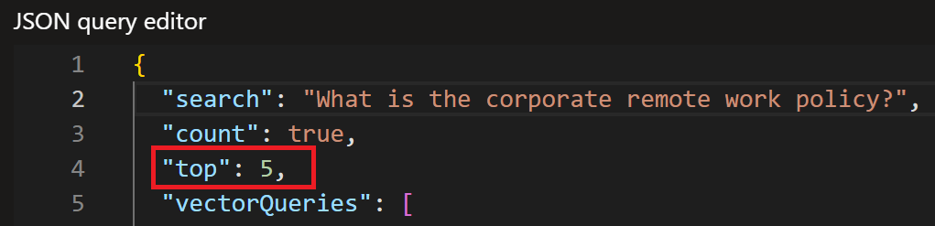
- Inspect - @searchrerankerScore, captions, answers, titles, and chunks. Use these together to judge relevance; do not evaluate success from @search.score alone.
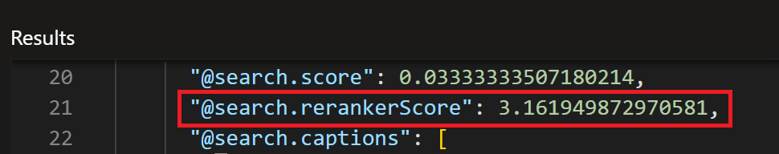
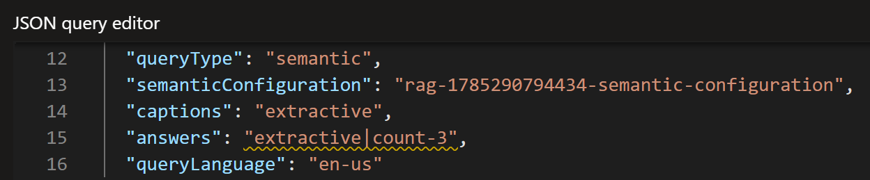
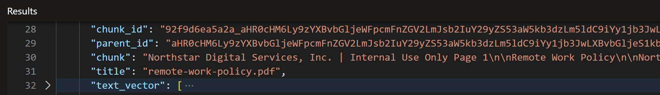
PASS when: the correct policy is highly ranked and semantic reranking/captions improve the usefulness of the returned context.

Test 4 - Validate Hybrid + Semantic Ranker
Run the following query in Foundry AI SearchIndexJSON view:
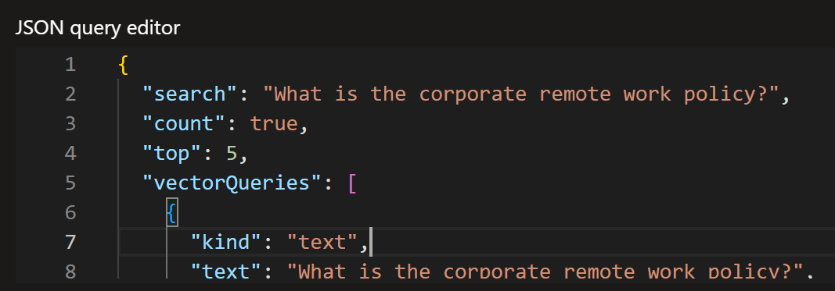
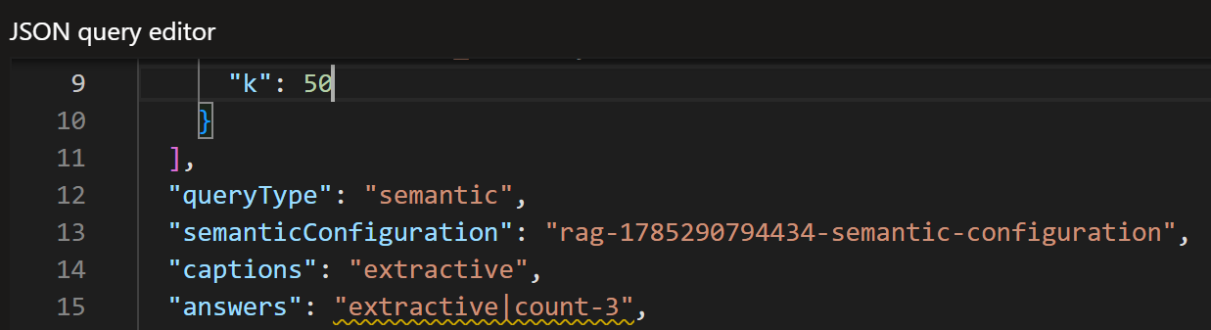

- Verify - search and vectorQueries are both present. This confirms the request remains hybrid.
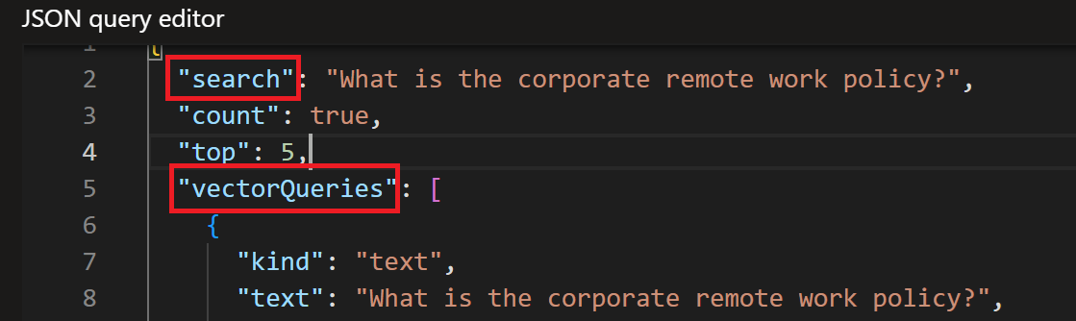

- Verify – vectorQueriestext contains the user question. This confirms the same question is used for vectorization.
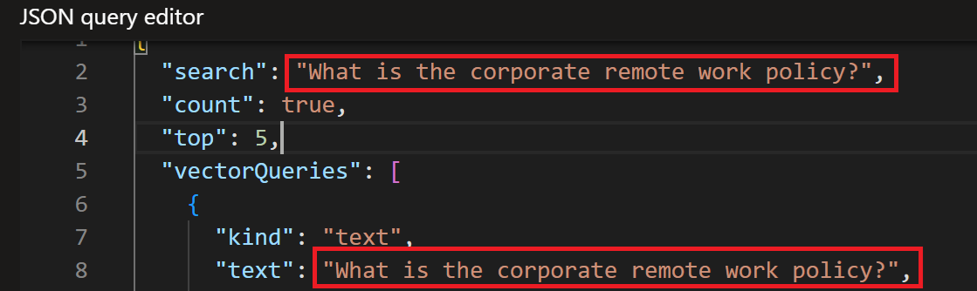
- Verify - fields is set to text_vector and k is set. This confirms the vector search target and candidate count.
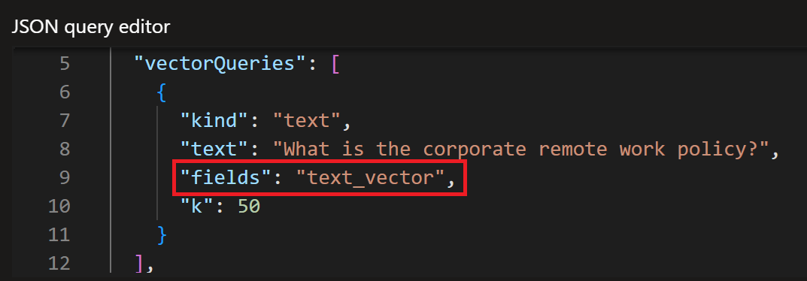

- Verify - queryType is set to semantic. This enables semantic ranking for the retrieved candidates.
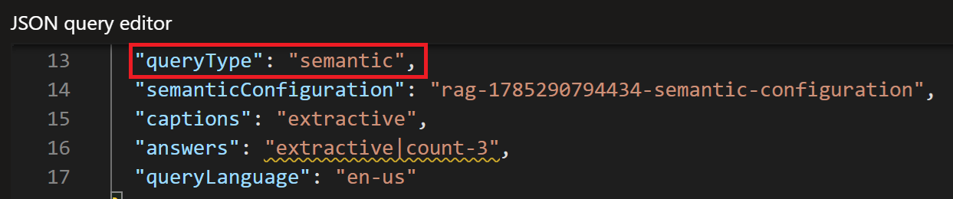
- Verify - semanticConfiguration is set to the actual configuration name for the index. Do not leave the placeholder value in the final test.
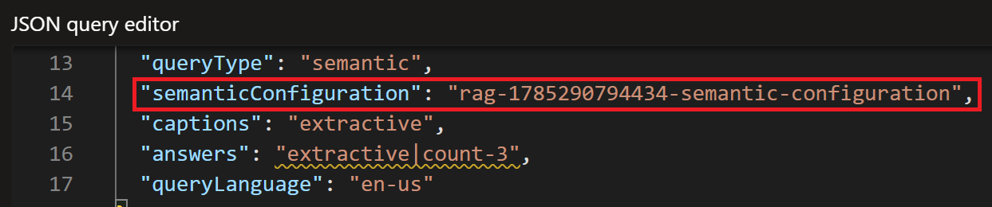
- Verify - captions is set to extractive. This requests a concise passage that helps you judge why a result is relevant.
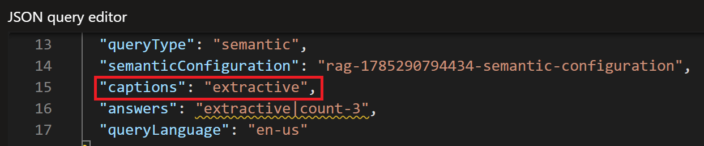
- Verify - answers is set to extractive. This requests an extractive answer when the query and semantic configuration support one.
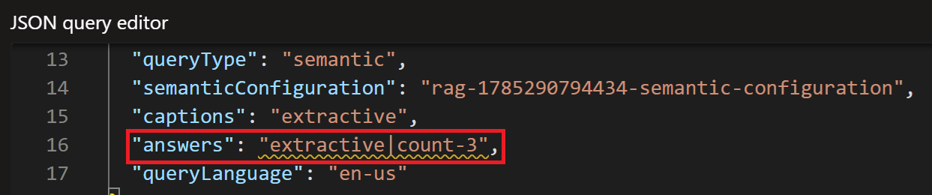

- Verify - top is set to 5. This limits the final result set to five results.
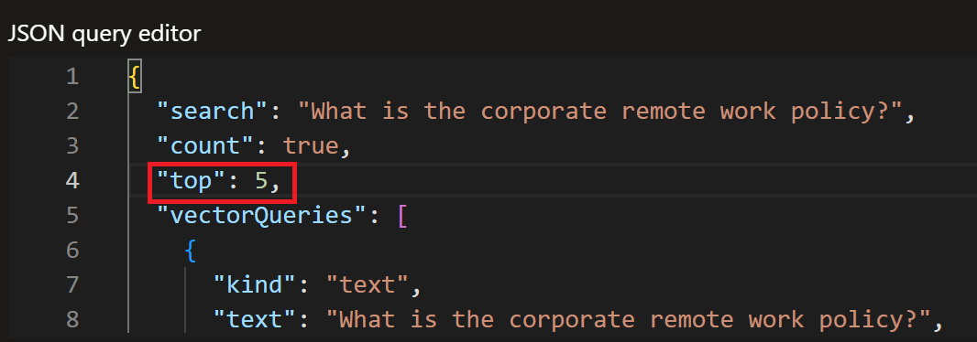
- Inspect - @searchrerankerScore, captions, answers, titles, and chunks. Use these together to judge relevance; do not evaluate success from @search.score alone.
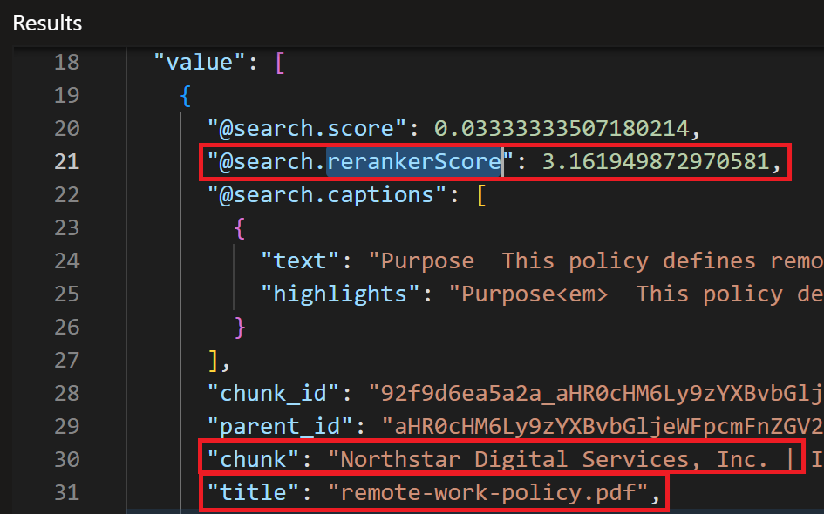
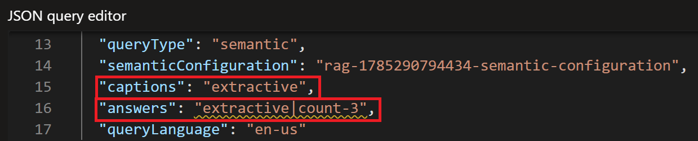

Validate the Four Representative Policy Questions

Remote work
- Run: What is the corporate remote work policy?

- Expected primary source: remote-work-policy.pdf

- Verify: Verify the expected source ranks near the top and the chunk contains eligibility/security/work-environment guidance.

- Record: the source rank (#1, #2, #3, or Not found) for Keyword, Vector, Hybrid, and Hybrid + Semantic.

Password changes
- Run: How frequently do employees need to change passwords?

- Expected primary source: password-reset-guide.txt

- Verify: Verify the source is retrieved, but do not treat a missing fixed rotation interval as a failure. The supplied guide discusses expiration, prompted changes, and immediate changes after suspected exposure.

- Record: the source rank (#1, #2, #3, or Not found) for Keyword, Vector, Hybrid, and Hybrid + Semantic.

13.3. Incident escalation
- Run: What is the incident escalation procedure?

- Expected primary source: incident-management-process

- Verify: Verify the incident-management source ranks highly and the returned chunk contains actual escalation procedure details.

- Record: the source rank (#1, #2, #3, or Not found) for Keyword, Vector, Hybrid, and Hybrid + Semantic.

Cloud costs
- Run: What policies apply to cloud costs?

- Expected primary source: cloud-cost-policy.pdf

- Verify: Verify the cloud-cost policy ranks at or near the top and the chunk contains cost governance requirements such as ownership, tags, budgets, alerts, optimization, or enforcement.

- Record: the source rank (#1, #2, #3, or Not found) for Keyword, Vector, Hybrid, and Hybrid + Semantic.

Validate Paraphrased Questions
Run paraphrased versions to confirm semantic retrieval is working beyond exact title/keyword matches.
- Run: Can I work from home and what security rules do I have to follow?
  - Verify expected source: remote-work-policy.pdf

- Run: Who should I contact when a serious production issue gets worse?
  - Verify expected source: incident-management-process

- Run: What are the rules for controlling Azure and cloud spending?
  - Verify expected source: cloud-cost-policy.pdf
PASS when: hybrid/vector retrieval still finds the correct policy even when the query uses different wording.

Record Retrieval Rankings
Query | Keyword | Vector | Hybrid | Hybrid + Semantic
Remote work | Rank: | Rank: | Rank: | Rank:
Password Frequency | Rank: | Rank: | Rank: | Rank:
Incident Escalation | Rank: | Rank: | Rank: | Rank:
Cloud Costs | Rank: | Rank: | Rank: | Rank:
Paraphrase Tests | Rank: | Rank: | Rank: | Rank:
Note - Record values such as #1, #2, #3, or Not found.

Final Validation Checklist
- Keyword/BM25 query returns relevant policy documents.

- Vector query uses vectorQueries and the text_vector field.

- Hybrid query contains both search and vectorQueries.

- Hybrid vectorQueries.text contains the user's natural-language question.

- Hybrid query has an appropriate k value and top is explicitly set.

- Hybrid + Semantic query uses the correct semantic configuration.

- Expected source documents rank near the top for representative questions.

- Returned chunks contain enough relevant content for the LLM to answer.

- Paraphrased questions still retrieve the correct policy.

- The system does not invent policy details that are absent from the source content.

Completion Criteria
Mark the Vector and Hybrid Retrieval testing phase complete when the expected source consistently ranks near the top for exact and paraphrased questions, the returned chunks contain useful policy context, and the Hybrid + Semantic configuration produces stable, relevant results suitable for the RAG application.

