Microsoft Entra ID Single Tenant Implementation
Step 2 — Direct implementation instructions
1. OPEN the Microsoft Entra admin center
In a browser, open the Microsoft Entra admin center and sign in with the Azure account you are using for the Policy Assistant.
In the left navigation, go to:
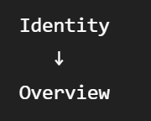
You should see information including:
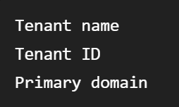
2. COPY your Tenant ID
Find:
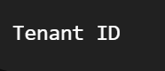
It will look similar to:

COPY this value.
This Tenant ID identifies the Entra directory that will be allowed to authenticate Policy Assistant users.
Do not post the value publicly, but it is not treated like a password or client secret.

3. RECORD the Tenant ID for the Policy Assistant
Create a configuration/design value called:
ENTRA_TENANT_ID
For now, record it in your Policy Assistant architecture/security documentation as:
ENTRA_TENANT_ID = <your actual tenant ID>
Later, when we implement I-07, this value will also be placed in the appropriate React/backend configuration.
4. DEFINE the tenant rule
Record this IAM rule:
- Policy Assistant Tenant Rule

- Only access tokens issued by the approved corporate
- Microsoft Entra ID tenant are accepted.

- Approved Tenant ID:
- <ENTRA_TENANT_ID>
Correct corporate tenant
↓
Potentially allowed

Different Entra tenant
↓
DENY

Personal Microsoft account
↓
DENY

5. DO NOT create the Entra applications yet if you are still completing I-06
I-06 is defining the security design.
You do not have to create the React or backend API app registrations during this step.
That happens during I-07.
Eventually you will create two application registrations:
Microsoft Entra ID
│
├── Policy Assistant React Client
│
│ Public/browser client
│
└── Policy Assistant API
Backend API / Orchestrator
Both will belong to the same corporate Entra tenant.

