人脸识别综述
2018 5 21 myf

数据库：
Purdue AR | contains 70 male and 56 female young adult faces. All images were taken in two sessions with 14 days interval under strictly controlled conditions.

标题 | Blessing of Dimensionality: High-dimensional Feature and Its Efficient  Compression for Face Verification
发表机构 | Microsoft Research Asia
期刊|年份 | 2013
技术路线 | 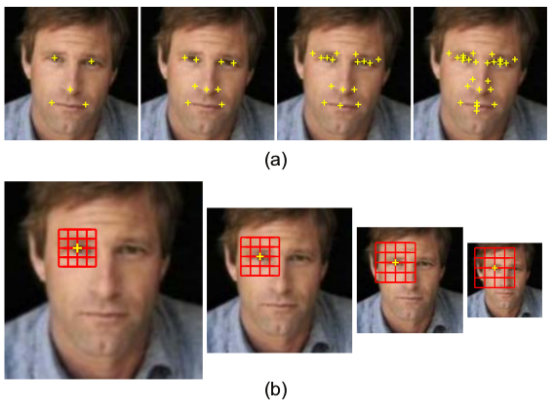  1. 在landmark[7]（27个）周围开窗，多尺度(5)图像变化，提取（LE [8], LBP [1], SIFT [29], HOG [13] and Gabor [27].）特征。  2. Rotated sparse regression
评价
索引论文 | [7] X. Cao, Y. Wei, F. Wen, and J. Sun. Face alignment by explicit shape regression. In Computer Vision and Pattern Recognition, pages 2887 –2894, June 2012. 1, 2
其他 | []LFW. There are a total of 5749 subjects but only 95 persons have more than 15 images. For 4069 identities, just one image is available.  [10]WDRef. contains 99,773 images of 2,995 subjects  [17]Multi-PIE. contains images of 337 subjects. These images are captured under controlled pose, expression and light conditions

标题 | Local Gabor Binary Pattern Histogram Sequence (LGBPHS):  A Novel Non-Statistical Model for Face Representation and Recognition
发表机构 | School of Computer Science and Technology, Harbin Institute of Technology, Harbin, China
期刊|年份 | 2005
技术路线 | 2.3  a. 用(u,v)=(0,0)~(7,4)一共40组参数处理图像得到LGBP map。  b. 将每个分割LGBP成m(8,8)块，计算直方图: 统计强度为i的个数得到h1,h2,…,hi,…,hL。串起来得到一张图的直方图。将m个直方图串起来得到特征。  3 距离测量  对两个hist sequence,算距离。  a. 直方图相交部分，即min  b. 基于Fisher separation criterion[16]加权算距离(使用FERET trainingdata算)。图像80*88（子窗格4*8）  4 局部遮挡  在AR数据集上与[21]对比
评价e | AR[18] The AR Face Database  http://www2.ce.ohio-state.edu/~aleix/ARdatabase.html 同济邮箱查收  FERET[3]  https://www.nist.gov/itl/iad/image-group/color-feret-database steven1633307@gmail.com 查收
索引论文
其他

标题 | Gabor Surface Feature for Face Recognition
发表机构 | Graduate School at Shenzhen Tsinghua University Shenzhen, China
期刊|年份 | 2011
技术路线 | 1. 提取gsf特征：  a. gabor magnitude + 一阶导数 + 二阶导数  b. 二值化  c. 直方图  2.fda 分类器[8]
评价 | lbp的本质是梯度，  gsf改进了lbp特征编码方式的缺陷  gsf保留了梯度和灰度信息
索引论文 | [10]  [11]  是两种利用gabor magnitude提取中层特征的文章
其他

