## The project

# Pyctures

During the training of ES technicians in application development, the first project consists of creating an application for a user using Picasa.

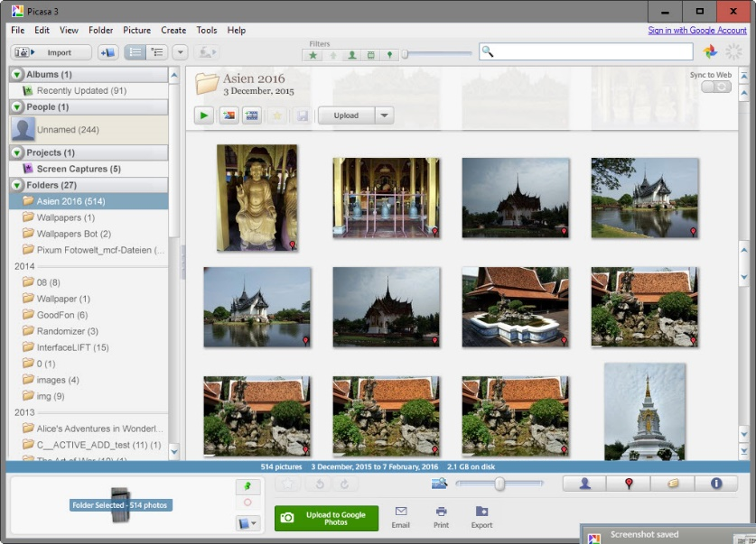

Google having stopped maintenance of Picasa, the goal is to create an application that can do the same tasks.

The application must be able to rename photos according to their shooting date but also to modify the metadatas.

Interesting metadatas are tags, people, location, commentary and favorite.

## Technologies

|  |  |
| --- | --- |
| http://programmingislife.com/wp-content/uploads/2013/06/python-logo-master.png | https://sunlightmedia.org/wp-content/uploads/2017/02/github-bb449e0ffbacbcb7f9c703db85b1cf0b.png |
| **Python 2.7**  Use to code | **GitHub**  Use for versioning |
| Résultat de recherche d'images pour "python tkinter logo" | https://d3nmt5vlzunoa1.cloudfront.net/pycharm/files/2015/12/PyCharm_400x400_Twitter_logo_white.png |
| **TKinter for Python**  Use for GUI | **Pycharm**  IDE for Python |
| https://dl2.pushbulletusercontent.com/Lt8qd6mA9vpyyQ7iNxIpdOyxioMsZ7hV/pyexiv2-big-192x192.png | https://upload.wikimedia.org/wikipedia/commons/thumb/4/48/Markdown-mark.svg/2000px-Markdown-mark.svg.png |
| **Python exiv2**  Use to handle metadatas | **Markdown**  Use for documentation |
| https://i0.wp.com/mydevgeek.com/wp-content/uploads/2017/09/json.png?resize=256%2C256 | http://i.imgur.com/CZx0dgG.jpg?1 |
| **JSON**  Use for better research | **RegEx**  Use to check file names |

## The result

The application works, it displays photos of the user.

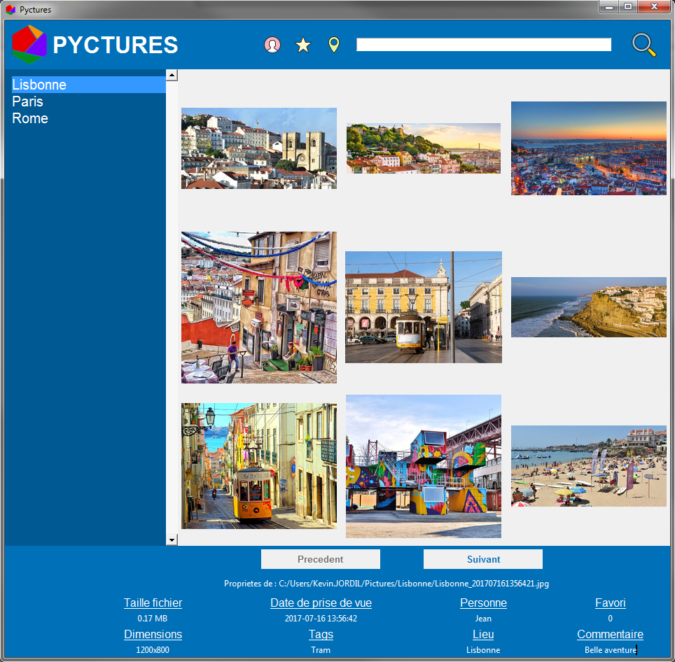

The left menu allows the user to change the photo folder at any time.



By clicking on an image, the user can edit the metadatas of the image.



A search is also available. It allows searching in metadatas. The function uses three filters: Person, Favorite, Location. By default, filters are disabled but the user can activate them.

