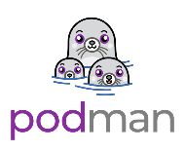
Podman Setup

Podman network setup
To prevent access directly into the database, the podman containers are for front and back-end are separated like seen in the image below.
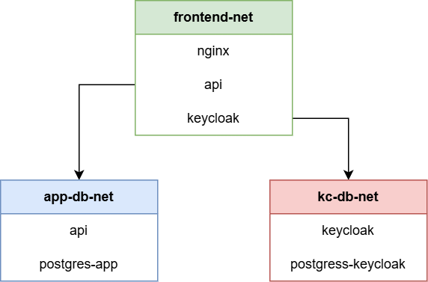

Create networks
1 podman network create public-net
2 podman network create app-db-net
3 podman network create kc-db-net

Check if networks exist
1 podman network ls
Should return something similar to;
NETWORK ID NAME
abc123 public-net
def456 app-db-net
ghi789 kc-db-net

Run the docker containers
Running the database containers;
podman run -d \
--name postgres-app \
--network app-db-net \
-e POSTGRES_DB=myapp \
-e POSTGRES_USER=myappuser \
-e POSTGRES_PASSWORD=secret \
postgres:16

podman run -d \
--name postgres-keycloak \
--network kc-db-net \
-e POSTGRES_DB=keycloak \
-e POSTGRES_USER=keycloak \
-e POSTGRES_PASSWORD=secret \
postgres:16

Running Keycloak
podman run -d \
--name keycloak \
--network public-net \
quay.io/keycloak/keycloak:latest start
podman network connect kc-db-net keycloak

Running the app API
podman run -d \
--name api \
--network public-net \
myapi:latest
podman network connect app-db-net api

Running the nginx webserver
podman run -d \
--name nginx \
--network public-net \
-p 80:80 \
-p 443:443 \
nginx:latest

