Material decomposition

Beer-Lambert equation

|  |
| --- |
|  |
|  |

where and are intensities after and before traverse the sample, is the thickness of the sample, is the energy of the X-ray beam, and is the attenuation coefficient. For a breast tissue with micro-calcifications, the integral term can be written as:

With , as the attenuation coefficients of two types of micro-calcifications, and as the attenuation coefficient of the breast tissue. The energy-independent integrals, , correspond to the projected thickness of each material. If is the total projected thickness of the sample, then the Beer-Lambert equation is

images at different energies, *,* are taken to retrieve and using matricial methods as:

And inverting the matrix equation for as

**Verification**

Images were acquired for two types of micro-calcifications—alumina and hydroxyapatite (HA)—at five different radii, embedded in a standard breast tissue with a thickness of 5 cm. The corresponding imaging energies were 20 keV, 24 keV and 28 keV (Figure 1), forming a matrix for . The objective is to retrieve the projected thickness of alumina and HA, using their attenuation coefficients at these energies to construct the matrix .

|  |  |  |
| --- | --- | --- |
|  |  |  |
| keV | keV | keV |

Figure 1.

|  |  |
| --- | --- |
| Alumina | HA |
| Theoretical | |
|  |  |
| Material Decomposition | |
|  |  |
|  |  |

Figure 2.

The results are presented in Figure 2, where the algorithm successfully retrieves the projected thickness of both materials. A comparison between the expected and retrieved projected thickness profiles—obtained by projecting the projected thickness images along the horizontal axis—is shown for both materials.

**Characterization of the Timepix3 detector**

**ToT vs. E. Using Timepix3 in Pixel mode.**

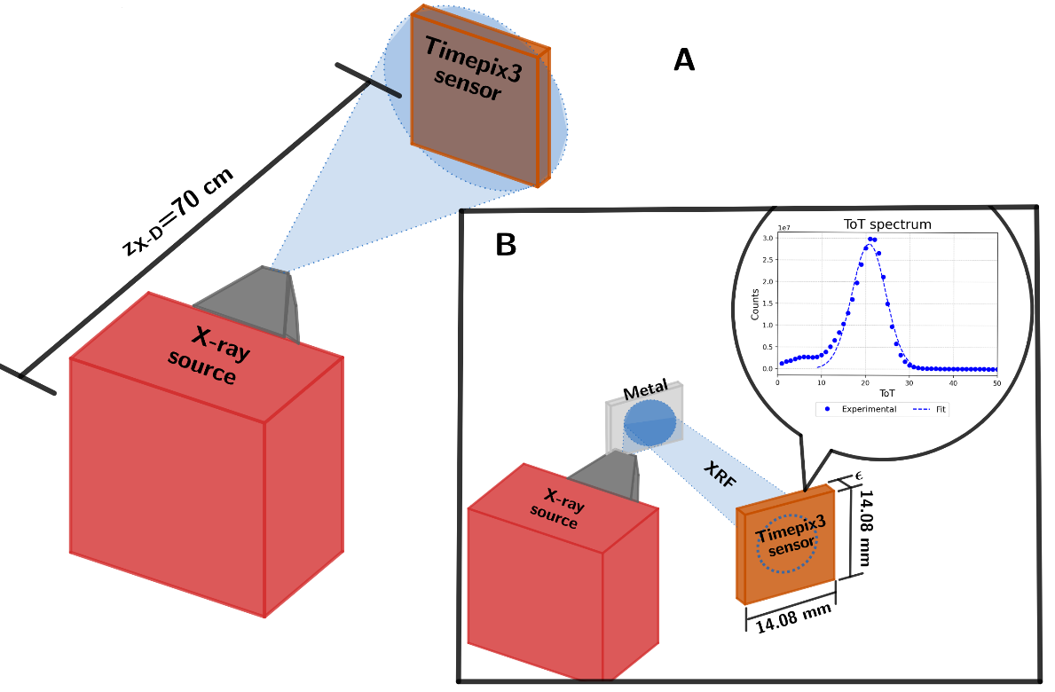

Figure 3. A: General diagram of dose measurement, illustrating the X-ray source and detector. B: General diagram used for characterization of the Timepix3 detector, to convert ToT to energy values. The detector is arranged so that a metal can read the fluorescence photons generated by it. The ToT distribution obtained for comparison.

Use 4 metals: Emission lines sufficiently separated, such that they cover a wide range of energies.

* Zr keV kVp
* Rh keV kVp
* Sn keV kVp
* Gd keV kVp

|  |  |
| --- | --- |
| C:\Users\drago\Documents\Libros y Trabajos\Tesis\PresentacionesSeminario202419\CaracterizaciónTimePix3\ToT-Energy\ToT-Energia\Images\ToTS4M.png | C:\Users\drago\Documents\Libros y Trabajos\Tesis\PresentacionesSeminario202419\CaracterizaciónTimePix3\ToT-Energy\ToT-Energia\Images\Fit.png |

Figure 4. Left. ToT spectrum of four materials. Right. Dependence of ToT with energy.

**Spectrum of the X-ray source using the Timepix3.**

* : Energy spectrum measured by the detector
* : Spectrum of the X-ray source
* : Detector response function

Obtaining , is determined by the energy resolution of the detector. This resolution is determined by the fluorescence spectra of four materials: Zr ( keV), Sn ( keV), Gd ( keV), ( keV).

* Perform a Gaussian fit around the peaks of the spectrum
* Obtain and from each fit to obtain the energy resolution from each material.
* Graph of vs E

|  |  |
| --- | --- |
| C:\Users\drago\Documents\Libros y Trabajos\Tesis\PresentacionesSeminario202419\CaracterizaciónTimePix3\ToT-Energy\ToT-Energia\Images\ESp.png | C:\Users\drago\Documents\Libros y Trabajos\Tesis\PresentacionesSeminario202419\CaracterizaciónTimePix3\ToT-Energy\ToT-Energia\Images\R.png |

Figure 5. Left. Energy spectrum of four materials, with Gaussian fits. Right. Energy resolution.

From the energy resolution, it is possible to construct each element of , as illustrated in Figure 6.

|  |
| --- |
| C:\Users\drago\Documents\Libros y Trabajos\Tesis\PresentacionesSeminario202419\CaracterizaciónTimePix3\ToT-Energy\Espectros-Dosis\Images\MFR.png |

Figure 6. Left. for E=8 keV (Black), E=17 keV (Blue) and E=27 keV (Red).

Consequently, is obtained for each given spectrum using the Bayesian deconvolution method, as illustrated in Figure 7 for Rh and Al at 28 kVp.

|  |  |
| --- | --- |
| C:\Users\drago\Documents\Libros y Trabajos\Tesis\PresentacionesSeminario202419\CaracterizaciónTimePix3\ToT-Energy\Espectros-Dosis\Images\ME.png | C:\Users\drago\Documents\Libros y Trabajos\Tesis\PresentacionesSeminario202419\CaracterizaciónTimePix3\ToT-Energy\Espectros-Dosis\Images\MEA.png |
| C:\Users\drago\Documents\Libros y Trabajos\Tesis\PresentacionesSeminario202419\CaracterizaciónTimePix3\ToT-Energy\Espectros-Dosis\Images\SE.png | C:\Users\drago\Documents\Libros y Trabajos\Tesis\PresentacionesSeminario202419\CaracterizaciónTimePix3\ToT-Energy\Espectros-Dosis\Images\SEA.png |

Figure 7. Top. measured for Rh and Al at 28 kVp. Bottom, retrieved for Rh and Al at 28 kVp.