**The poem we write as a group:**

**“We Are the Voice / Ko Mātou te Reo”**

I see tides rising, but so do we,  
I feel the **hau** (wind) and the **rā** (sun) with me.  
I carry **mana** (strength), not just fear,

I plant with hope our **āpōpō** (tomorrow) is near.   
I learn, I speak, I act with pride,  
Globally, we stand side by side.  
I dream of **ahua** (change) we build today,  
I am youth and I’ll lead the way.

Young people in Aotearoa are employing a range of civic engagement strategies to address the issue of unemployment. These efforts often involve a mix of direct action, advocacy, and collaboration with various organizations. Key strategies include:

**1. Advocacy and Policy Influence:**

* **Lobbying and Direct Engagement:** Young people, often through youth-led organizations, directly engage with government bodies and politicians. They advocate for policy changes, such as improvements to the careers system in schools, more effective and culturally responsive education, and the development of pathways into sustainable work, particularly for rangatahi Māori and Pacific young people.
* **Youth-focused Reports and Submissions:** Organizations and individuals contribute to reports and submissions on youth employment to government inquiries and ministries, such as the Ministry of Social Development. These reports highlight barriers to employment and propose solutions.
* **Public Campaigns:** Youth-led initiatives utilize public campaigns to raise awareness about the issues and pressure for change. For example, groups like Youth Employability Aotearoa (YEA) have a call to action for the government to ensure all New Zealand youth are work-ready.

**2. Community-Based and Grassroots Initiatives:**

* **Peer-to-Peer Support:** The Young Workers Resource Centre (YWRC) is a prominent example of a youth-led organization providing employment education, support, and advocacy for young workers. Their services are designed by and for young people, helping them understand their rights and navigate workplace issues.
* **Skills and Employability Programs:** Young people are involved in and are the beneficiaries of programs that focus on developing "soft skills" and practical experience. Initiatives like the Youth Employability Programme (YEP) offer workshops and work experience to help young people transition into the workforce.
* **Place-Based Partnerships:** In various communities across Aotearoa, local initiatives bring together schools, iwi, regional employers, and community groups to create specific pathways to employment. These partnerships, often supported by foundations and local government, focus on connecting young people with local job opportunities.

**3. Digital and Social Media Activism:**

* **Online Platforms:** While the search results don't explicitly detail specific digital campaigns, the use of social media and online platforms is a common and effective tool for young people. The YWRC, for example, uses platforms like Facebook and Instagram to share tips and resources and to connect with young people directly.
* **Creating a "United Voice":** Advocacy organizations work to unify the voices of young people and their supporters, using online and in-person networks to build a collective movement for change. This is a crucial part of civic engagement, as it amplifies individual concerns into a shared agenda.

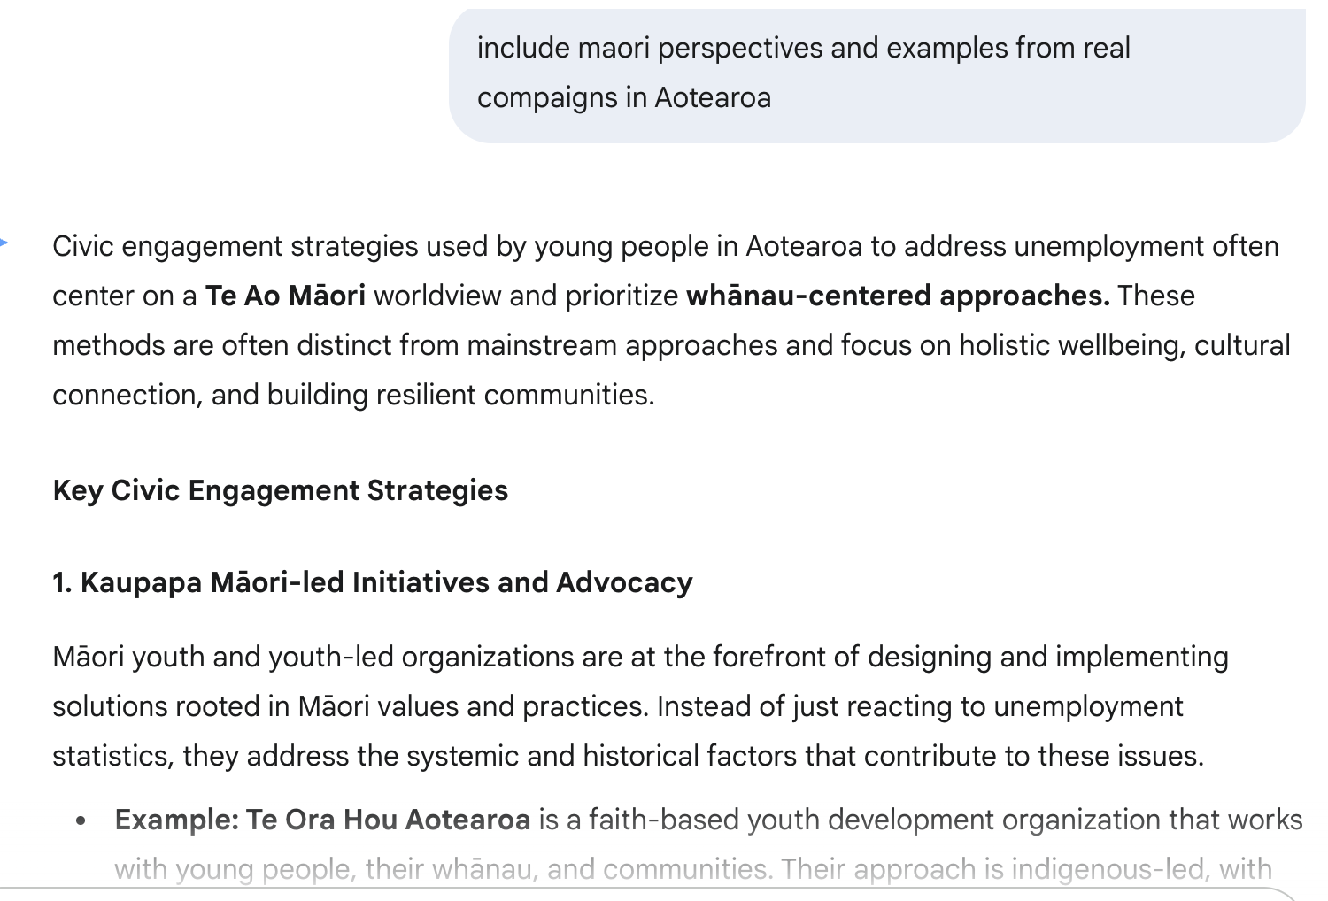

Civic engagement strategies used by young people in Aotearoa to address unemployment often center on a **Te Ao Māori** worldview and prioritize **whānau-centered approaches.** These methods are often distinct from mainstream approaches and focus on holistic wellbeing, cultural connection, and building resilient communities.

**Key Civic Engagement Strategies**

**1. Kaupapa Māori-led Initiatives and Advocacy**

Māori youth and youth-led organizations are at the forefront of designing and implementing solutions rooted in Māori values and practices. Instead of just reacting to unemployment statistics, they address the systemic and historical factors that contribute to these issues.

* **Example: Te Ora Hou Aotearoa** is a faith-based youth development organization that works with young people, their whānau, and communities. Their approach is indigenous-led, with Māori leadership as a priority. Their mission is to empower young people to reach their full potential and become positive contributors to society by building strong relationships and providing support. They offer mentoring, coaching, and educational programs that help young people build confidence and life skills to succeed in education, employment, and life.

**2. Community-Based and Whānau-Centered Programs**

Many young Māori address unemployment through programs that focus on community and family (whānau) support rather than individualistic solutions. They recognize that a person's wellbeing and employment are deeply connected to the health of their wider support network.

* **Example: Te Puni Kōkiri's Pae Aronui initiative** sought innovative approaches to improve education, training, and employment outcomes for rangatahi Māori (ages 15-24) who are not in education, employment, or training (NEET). This initiative recognized the need for targeted support to help rangatahi and their whānau navigate their options and pursue their aspirations. This type of program emphasizes a **collective approach**, where success is measured not just by individual employment but by the overall wellbeing of the whānau.

**3. Targeted Advocacy and Policy Submissions**

Young people and their advocates actively engage with government agencies and policy-making processes. They submit reports and directly lobby for changes that address the unique challenges Māori face in the labor market, such as institutional racism and disproportionate underemployment.

* **Example: Te Puni Kōkiri's Māori Employment Action Plan** was established to address the disproportionately high unemployment rates for Māori. The development of this plan involved extensive engagement with key stakeholders, including young people and their communities, to ensure their voices and lived experiences were at the center of the solutions being proposed. The plan aimed to ensure that Māori were offered opportunities that would emerge during economic recoveries, a crucial point after events like the COVID-19 pandemic.

**4. Creative and Arts-based Activism**

Some organizations use creative and arts-based platforms to re-engage young people who have fallen through the cracks of the mainstream education system. These methods help rangatahi develop confidence, reconnect with their purpose, and imagine a positive future for themselves.

* **Example: Ngā Rangatahi Toa** uses creative arts and wellbeing programs to help young people re-engage with education and employment. Their intensive wānanga (workshops) and end-of-year theatre performance, "Manawa Ora," provide a lifeline for rangatahi at risk of dropping out of school. The programs focus on rebuilding confidence and trust, fostering a love for lifelong learning, and helping young people develop a sense of purpose that extends beyond traditional employment.

**My response:**

What the response got right was identifying key strategies. It correctly highlighted that many youth-led initiatives, especially those for rangatahi Māori, are rooted in **Kaupapa Māori**, prioritizing whānau and community wellbeing over just a pay check. It also use reliable real-world sources like Young Workers Resource Centre (YWRC) and Youth Employability Programme (YEP). Examples like **Te Ora Hou Aotearoa** and **Ngā Rangatahi Toa** are spot-on; they show how young people are building their own solutions based on cultural values. It also correctly mentioned that youth are engaging with official channels, like making submissions to **Te Puni Kōkiri**, to influence policy.

However, the response simplified a lot. It didn’t dig deep into the messy political context. It missed how funding for these youth initiatives can swing dramatically with a change in government. It also failed to reflect the full intersectionality of the issue. The struggles of **Pasifika, disabled, or LGBTQIA+** youth with unemployment often get overlooked, and their engagement strategies might be very different. The role of **digital activism** was also understated; my peers and I use TikTok and Instagram daily to expose bad employers and build online communities of support.

To challenge and expand on this, I'd bring a more critical lens. I’d question whether these initiatives are truly sustainable when they often rely on the unpaid labour of young people. I'd also expand our understanding of "civic identity" beyond formal political acts. For us, it’s about a deep connection to our whānau and whenua (land). Civic action isn't just a separate activity; it's an extension of our identity. I would also emphasize the power of **direct action and protests**, like the school strikes for climate, which show that we’re not just asking for a seat at the table—we’re building our own and demanding change on issues that are fundamentally linked to our future livelihoods.