PERSONAL INFORMATION | Ilinca Ștefan Claudiu
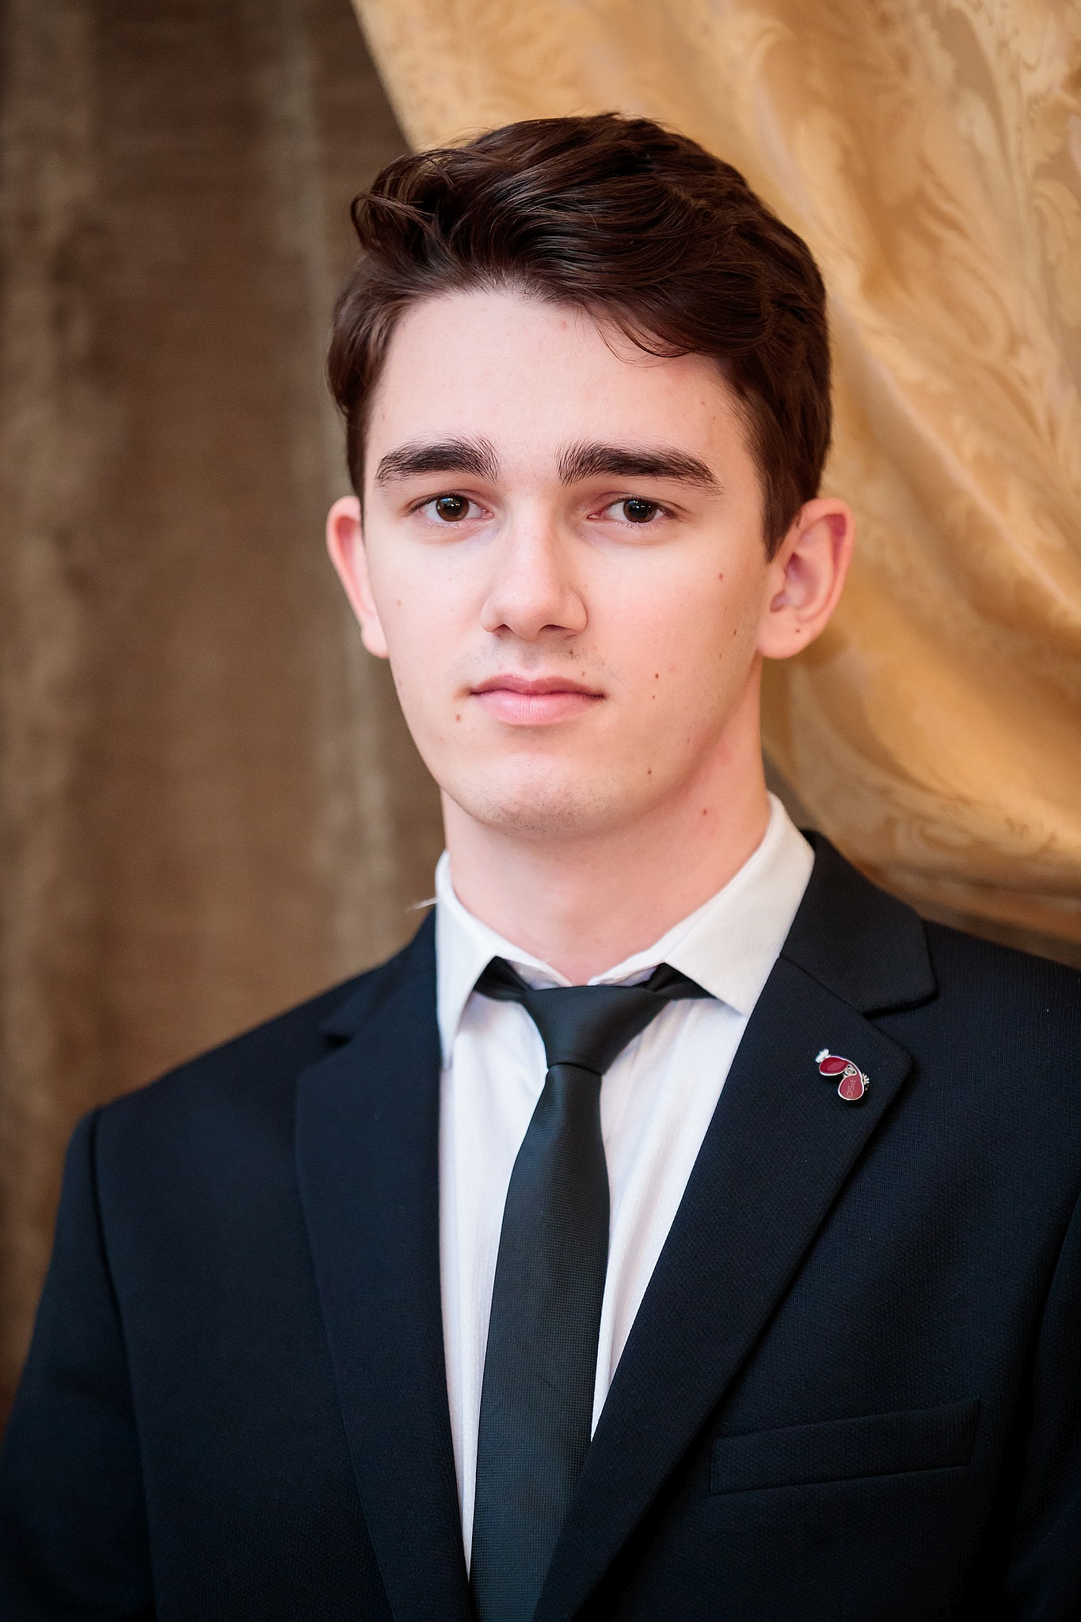 |   Sat. Lespezi (Com. Lespezi), Jud. Iași
 | +40 745953424

ilinca.stefan99@gmail.com
 | Sex Male | Date of birth 10/12/1999 | Nationality Romanian

JOB APPLIED FOR  POSITION  PREFERRED JOB  STUDIES APPLIED FOR  personal statement | Internship

EDUCATION AND TRAINING

Iulie 2021 – Septembrie 2021 Continental Automotive Romania
Summer Practice 2021
2018 - Present Universitatea Tehnică ”Gheorghe Asachi”” Iași
Facultatea de Electronică, Telecomunicații și Tehnologia Informației
Specializarea : EA (Electronica Aplicata)

2014 -2018 Diplomă de Bacalaureat
Colegiul Național “Emil Racoviță” Iași
Profil Real Matematică-Informatică, Intensiv Engleză

PERSONAL SKILLS

Mother tongue(s) | Romanian
Other language(s) | UNDERSTANDING |  | SPEAKING |  | WRITING
Other language(s) | Listening | Reading | Spoken interaction | Spoken production
English | B2 | B2 | B1 | B1 | B2
French | A1 | A2 | A1 | A1 | A2
Levels: A1/A2: Basic user - B1/B2: Independent user - C1/C2 Proficient user
Common European Framework of Reference for Languages

-team spirit: I have team work experience ever since highschool, when I participated in various activities and team projects
Communication skills
-acquired experience in a team during my summer practice program
-good written and verbal communication skills
-empathic listener

Digital skills | - good command of Microsoft Office: Word, Excel, PowerPoint, Access  - good command of programming languages: C, C++, HTML, CSS  - good command of assembly language,worked with MPLAB  - experience with programs such as Matlab and Mathcad
Other skills | - basic knowledge of electrical components  - simulated circuits in Proteus and made the physical circuit on breadboard  - electrical design: OrCad,Pyxis Schematics(Mentor Graphics)  - microcontrollers programming: Arduino  - embedded systems basic  - ability to use measuring instruments(oscilloscope,multimeter)  - the capacity to work under under pressure,analytical thinking,adaptability and flexibility

