Connector

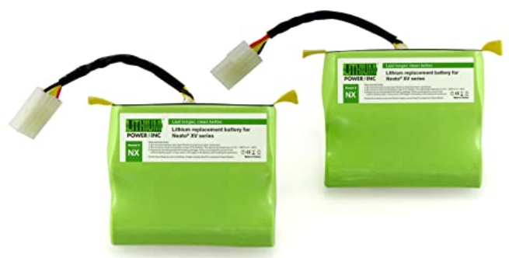

Batteries GND

Batteries +14.4V

**7.2V Battery**

**7.2V Battery**

Battery V+

Battery GND

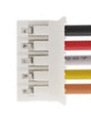

Motor Shield M4

Motor Shield M3

Pin 17 3v3

Pin 25 GND

GPIO 24

**Left Motor**



Motor Shield M2

Motor Shield M1

Pin 17 3v3

Pin 25 GND

GPIO 23

**Right Motor**

1

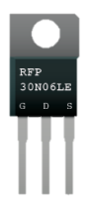

GPIO 16

Battery GND

JST2 black -

**MOSFET**

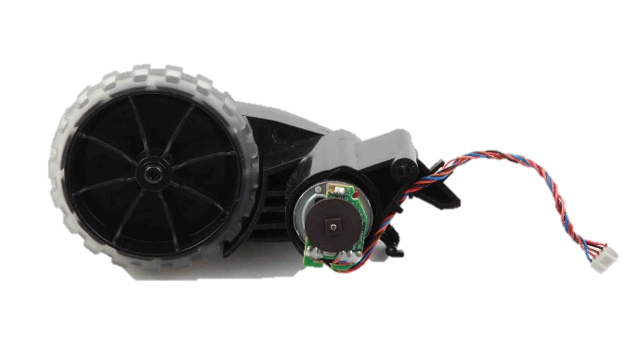

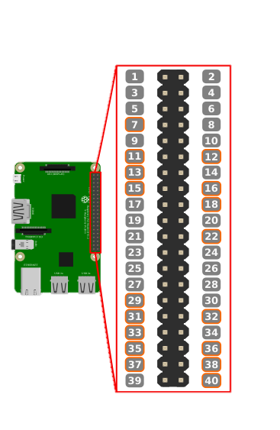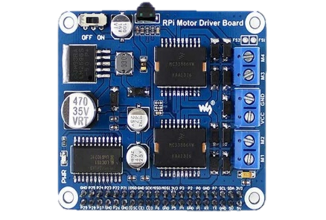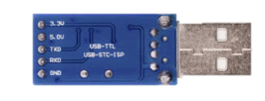

Receiver CH1

Receiver CH3

Receiver CH2

Receiver 5V

Receiver GND

Left encoder input

Right encoder input

Right M red +

Right M black -

Left M red +

Left M black -

Battery V+

Battery GND

Encoders hall 3v3

Encoders hall GND

Lidar motor PWM

JST4 black GND

JST4 orange SIG

JST4 red 3v3

**USB Converter**

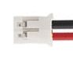

Battery V+

MOSFET drain

**JST2**

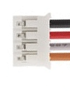

USB converter GND

USB converter Rx

USB converter 3v3

**JST4**

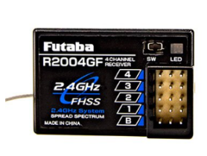

**RC Receiver**

GPIO 14

GPIO 18

GPIO 15

Pin 4 5V

Pin 6 GND

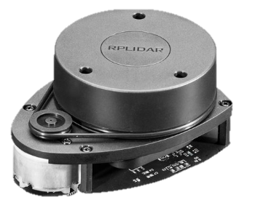

Motor assembly connections:

Red and black belong to the motors.

For encoders, brown is GND, orange is +5V, blue is output.

The output needs to be pulled up to 3.3V (tested fine with 10K and Rpi INPUT_PULLUP).

The sensor itself can only drive it low, or be floating. So when its low you get 0, and when it floats you get the 3v3 pullup.

Taking the gearbox into account, there are about 550 encoder steps per wheel turn.

LIDAR assembly connections:

The lidar has 2 braids coming out of it:

* Black and red 2-wire connector, going straight to the motor.

This actually makes it a completely separated system and thus is controlled by the code accordingly.

I drove the motor using 1 power MOSFET since it should only rotate in one direction.

* 4-wire connector which powers up and communicates with the rotating lidar electronics.

Black and red power up the device (3.3V), orange is the Rx read by the Rpi, and brown is probably Tx but we don’t use.