***Game Design Document***

Designers: Steven Coverdale & Lenneal Pennant

Flame Runners

***Objective***:

The game is going to be on an upward right angle were you have your character who is on fire running up a large cylindrical object and dodging obstacles and going through a wall of water before they're time limit completely burns out or they get hit by an obstacle.

***Power ups:***

Slow gauge: Basically slowing down your gauge so you don't burn out as quickly.

Speed up: Making you faster so you can reach your checkpoint quicker

Shield: Giving you the ability to take ONE hit and not get a game over. Once the hit is received the shield drops.

Obstacles: Platforms that need to be jumped over and walls and other debris that need to be dodge.

Bombs are another obstacle that needs to be dodged or the player will explode and receive a game over.

***Characters:***

Currently Designing 3 playable characters for game play. Along the next up of the gdd I’ll share it with you my designs and one 3d model work in progress.

***Ads-sense:*** Using google ads sense to help market ads for this game not to mention we will sell more power ups and costume designs for micro transactions as well. If Flame runners turns out to be selling well we can do further character designs.

**Next Milestone**: In the next mile stone I’ll show finished character designs and a finish model of the course we just have to make the course run endlessly.

Well also need to think of a name for our

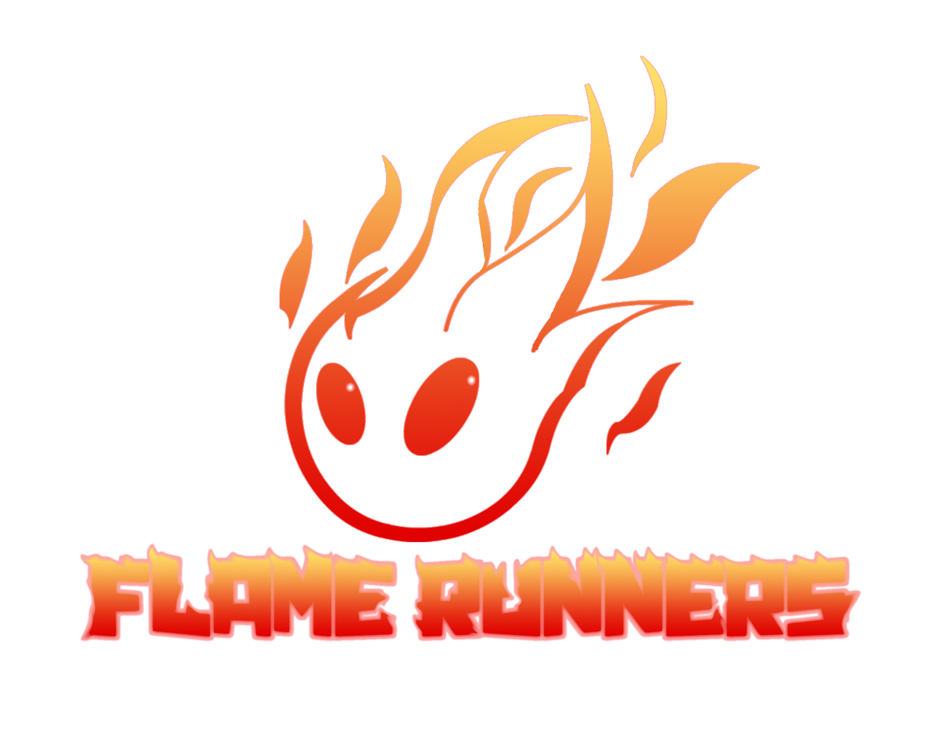

Logo design for the game. Give me your opinion and feel free to make an adjustments.

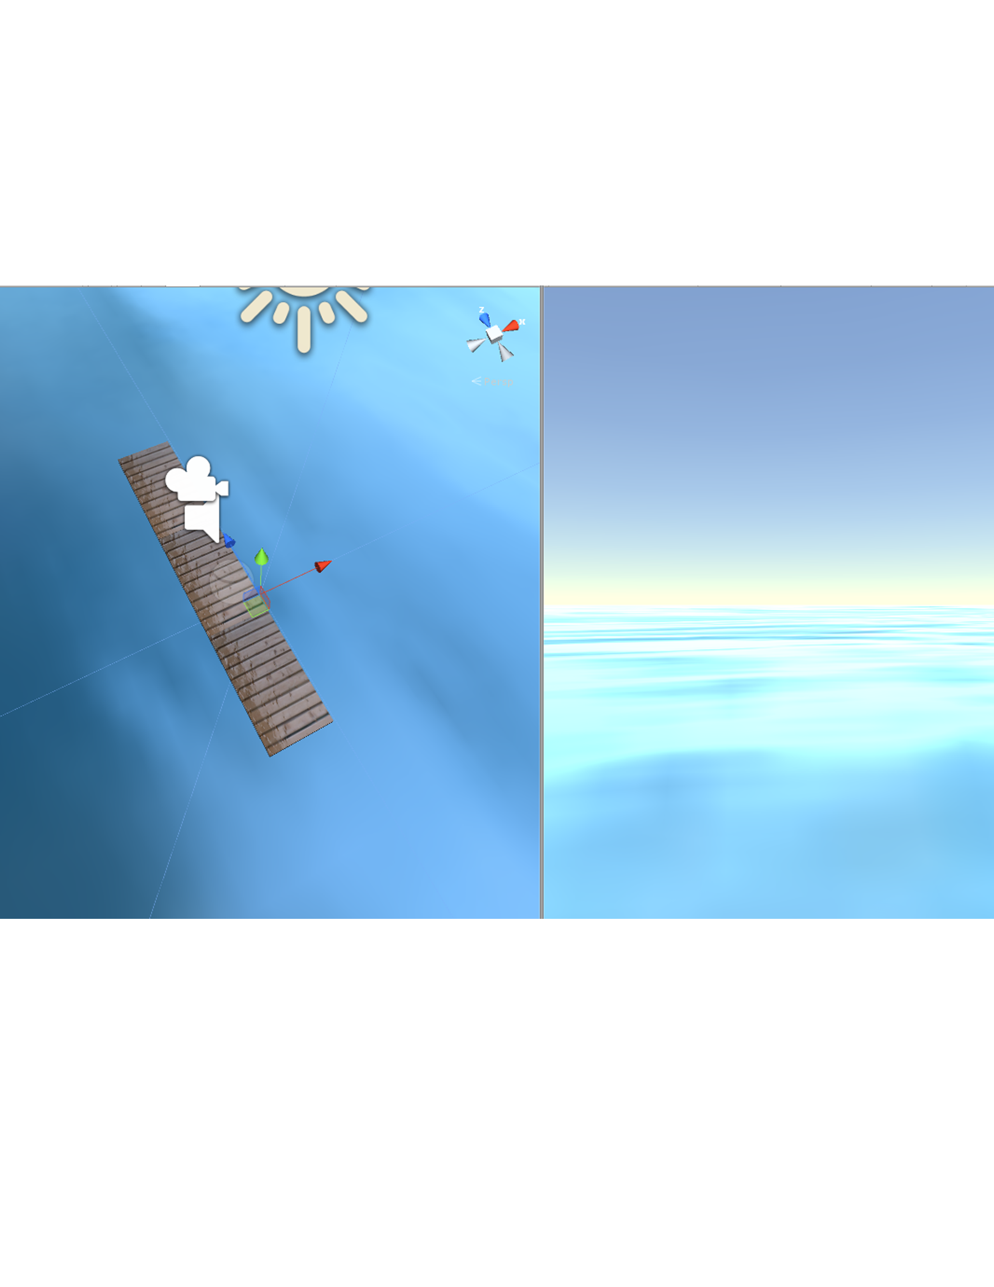

Playing with lighting for the game and oceans as one of the backdrops as the characters runs up large cylindrical object. Also please let me know what you thing of the game overall. I’ll update this further in the next coming week.