**Function Requirements Required**

1. Website must connect with the WAMP server as soon as the user opens up the page
2. Insert, delete, and view tasks must be able to connect and work with the server properly
3. The total tasks and status requests from the user must update and be displayed properly on the web page when prompted.

**Function Requirements Desired**

1. Instead of each task providing the user with its status, due date, etc. It is important to have other factors to consider, for example, a task name, task description, task plan, etc.
2. The web page must be easy to view, use, and navigate throughout.
3. All buttons must be working properly.

**Non-Functional Requirements**

1. Web page should be able to work with different types of web browser and mobile devices.
2. Clear and precise easy-of-use for the user. A good ToDo App must be so good that the user actually wants to use it again.

**System Architecture Diagram**

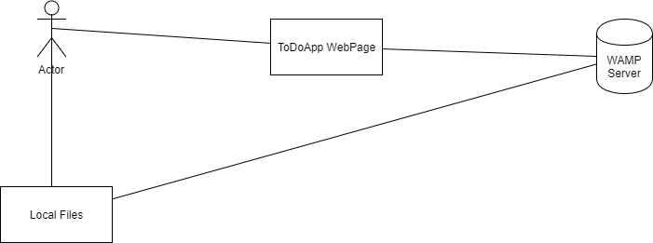

**Data Flow Diagram**

**Use case**

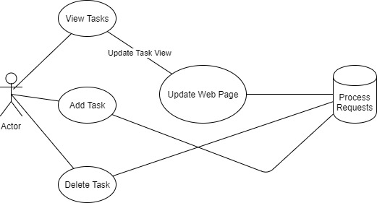

**Sequence Diagram**

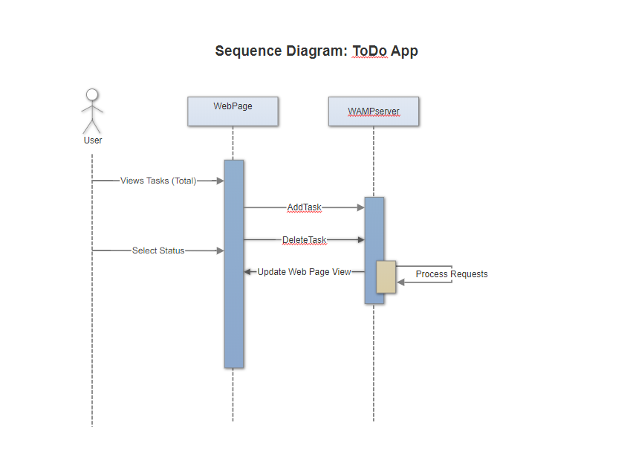

**Database Design/Diagram**

**Class Diagram**

**Test Case**

1. Upon opening the Web Page, it should be able to properly connect to the WAMP Server and create the DB. There should not be any errors.

**ToDo App Work Breakdown**

**Name of the task:** Create github repository and make first commit

**Estimated No of hours:** .2 hrs

**Actual time spent:** <.2hrs

**Notes:** Getting the first commit was interesting because I have not used github before.

**Issues:** Figuring out if the [4996WSU@gmail.com](mailto:4996WSU@gmail.com) was the correct email for adding to the repository. They have not verified it as of 1/13/2018.

**Name of the task:** Download and install Wamp Server

**Estimated No of hours:** .5 hrs

**Actual time spent:** .5 hrs

**Notes:** I am a novice at using WAMP server, but luckily it is easy to learn

**Issues:** Had to uninstall and reinstall one time because it would connect properly with local host

**Name of the task:**  Installing bash to incorporate github commits

**Estimated No of hours:** 10mins

**Actual time spent:** <10 mins

**Notes:** I have never used bash before

**Issues:**  I had to update my knowledge about git commands and how the basic commands work

**Name of the task:** Installing PHPStorm

**Estimated No of hours:** 20 mins

**Actual time spent:** <10 mins

**Notes:** First time using this program. I works very nicely with editing code

**Issues:** Figuring out PhpStorm was a viable program.

**Name of the task:** Start designing a basic skeleton for HTML/CSS/ website to be used for the ToDoApp.

**Estimated No of hours:** 1.5 hrs

**Actual time spent:** 2-3hrs

**Notes:** Getting the skeleton ready to be incorporated with php and the Wamp server was relatively straight forward

**Issues:** getting the website primed to look good was a hassle because HTML is somewhat annoying to work with

**Name of the task:** Connecting the database server with the Html script

**Estimated No of hours:** <1hr

**Actual time spent:** 2 hrs writing and figuring out how to connect

**Notes:** Had a lot of reading how to do this

**Issues:** I had very little knowledge about how to connect the database to the website. It was very stressful. Handling the stress was the worst part.

**Name of the task:** Building forms and tables getting ready for the commands for the ToDoApp

**Estimated No of hours:** 1.5hrs

**Actual time spent:** 1hr

**Notes:** this was the easy part

**Issues:** none

**Name of the task:** Creating the db tables

**Estimated No of hours:** 1hr

**Actual time spent:** .5 hrs

**Notes:** had to brush up on this documentation as well

**Issues:** I have very little knowledge about what and how databases work. I am still learning. I need to find better sources or help to learn how to do this.

**Name of the task:** Creating and learning how to do the insertion function for php

**Estimated No of hours:** 1hr

**Actual time spent:** 3hrs and counting

**Notes:** This insertion part of the application took much time and reading

**Issues:** I still cannot figure out how to get this part done as of 1/13/2018…

**Name of the task:** Creating the Delete Task for php

**Estimated No of hours:** 1hr

**Actual time spent:**

**Notes:** After learning insertion basics, delete should be relatively straightforward

**Issues:** I am unaware of how to do this. Steadily learning how is the biggest problem.

**Name of the task:**

**Estimated No of hours:**

**Actual time spent:**

**Notes:**

**Issues:**

**Name of the task:**

**Estimated No of hours:**

**Actual time spent:**

**Notes:**

**Issues:**

**Name of the task:**

**Estimated No of hours:**

**Actual time spent:**

**Notes:**

**Issues:**