Advanced Lambda Streams Applied Practice

Candidate Instructions:
- Create a Java Maven project in IntelliJ.
- Code each scenario as one method
- Create a class with a main method to run all scenarios
- Upload your project to your SharePoint folder
- Create a folder “Labs” with a sub-folder “1.Lambdas_and_Streams_API” as below:
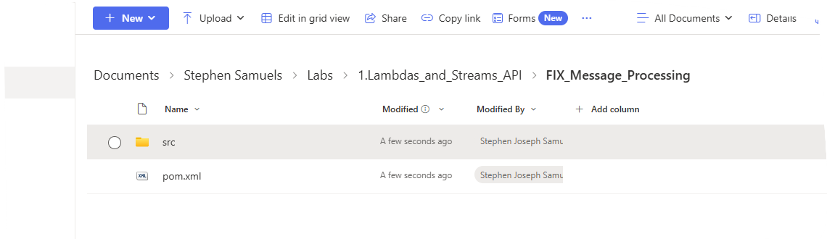
- Only upload the src folder and pom.xml
- Do not zip and upload the project.
- Test that your uploaded project can be downloaded, imported into IntelliJ and run.
======================================================================
This is an applied topic that combines your understanding of Java Streams with real-world investment banking FIX message processing (Financial Information eXchange protocol).
Below are five coding questions that mimic live trade data stream processing scenarios used in trading or exchange gateways. Each question includes:
- Scenario / Context
- Sample Input Stream (List of FIX-like Strings)
- Expected Output
- Hints on the Stream operations involved

Question 1: Filter Executed Trades
Scenario
You are receiving a continuous stream of FIX messages from an exchange.
Each message represents an order update with tags:
- 35=8 → Execution Report
- 150=0 → New
- 150=1 → Partial Fill
- 150=2 → Full Fill
- 55=Ticker, 31=Price, 32=Qty
You must filter only fully executed trades (150=2) and print the ticker, price, and quantity.
Sample Input Stream
List<String> fixMessages = List.of(
"35=8|150=0|55=INFY|31=0|32=0",
"35=8|150=2|55=TCS|31=3721.45|32=100",
"35=8|150=1|55=HDFC|31=1623.75|32=50",
"35=8|150=2|55=RELIANCE|31=2440.00|32=200"
);
Expected Output
TCS - 3721.45 x 100
RELIANCE - 2440.00 x 200
Hint
Use filter() on messages containing 150=2, then map() to extract fields, and forEach() to print.

Question 2: Compute Total Executed Quantity per Symbol
Scenario
You want to aggregate the total executed quantity of each symbol from the same stream.
Sample Input Stream
List<String> fixMessages = List.of(
"35=8|150=2|55=TCS|32=100",
"35=8|150=2|55=TCS|32=50",
"35=8|150=2|55=INFY|32=200",
"35=8|150=2|55=INFY|32=100"
);
Expected Output
TCS -> 150
INFY -> 300
Hint
- Filter for 150=2
- Use Collectors.groupingBy(symbol, summingInt(quantity))

Question 3: Average Execution Price per Symbol
Scenario
Risk systems need to know the average trade price per symbol.
Sample Input Stream
List<String> fixMessages = List.of(
"35=8|150=2|55=SBIN|31=570.50|32=100",
"35=8|150=2|55=SBIN|31=571.00|32=200",
"35=8|150=2|55=AXISBANK|31=910.25|32=150",
"35=8|150=2|55=AXISBANK|31=909.75|32=50"
);
Expected Output
SBIN -> 570.83
AXISBANK -> 910.06
(Average price = Weighted average based on quantity)
Hint
Use a custom collector or reduce operation:
(price * qty sum) / (qty sum)

Question 4: Identify Top N Active Symbols by Volume
Scenario
You must find the top 2 most actively traded stocks by total executed volume for the day.
Sample Input Stream
List<String> fixMessages = List.of(
"35=8|150=2|55=TCS|32=100",
"35=8|150=2|55=INFY|32=300",
"35=8|150=2|55=RELIANCE|32=250",
"35=8|150=2|55=TCS|32=200"
);
Expected Output
1. INFY -> 300
2. TCS -> 300
(If same volume, order alphabetically)
Hint
Group by symbol → sum quantities → sort by value (descending) → limit(2).

Question 5: Identify Trade Anomalies (Outliers)
Scenario
Some trade executions have prices that deviate too far from the average market price.
Mark trades as “Anomaly” if price deviation > 5%.
Sample Input Stream
List<String> fixMessages = List.of(
"35=8|150=2|55=INFY|31=1500|32=100",
"35=8|150=2|55=INFY|31=1510|32=50",
"35=8|150=2|55=INFY|31=1600|32=200", // anomaly
"35=8|150=2|55=TCS|31=3700|32=100",
"35=8|150=2|55=TCS|31=3720|32=100"
);
Expected Output
INFY trade @1600 flagged as Anomaly (avg=1506.6)
Hint
- Group by symbol.
- Compute average price per symbol.
- Then compare each message’s price against average using map/filter.

Concepts Covered
Stream Operation | Where Used
filter() | Filtering by execution type (150=2)
map() | Extracting fields like symbol, price, qty
collect() | Grouping & aggregating
sorted() | Sorting by volume
reduce() | Weighted average
peek() | Debug intermediate results

