下发日期: week 4, 2023.03.19

提交日期: 23:59 pm, week 7, 2023.04.09

总分值: 10

提交邮箱：data_visualization@yeah.net

数据集说明：鸢尾花数据集（Iris dataset）含有150个花朵样本，共属于3类花（Setosa, Virginica and Versicolor），每一类50个样本。每个样本包含四种花朵属性：sepal（花萼）的长度和宽度，petal（花瓣）的长度和宽度。数据集已经提供。

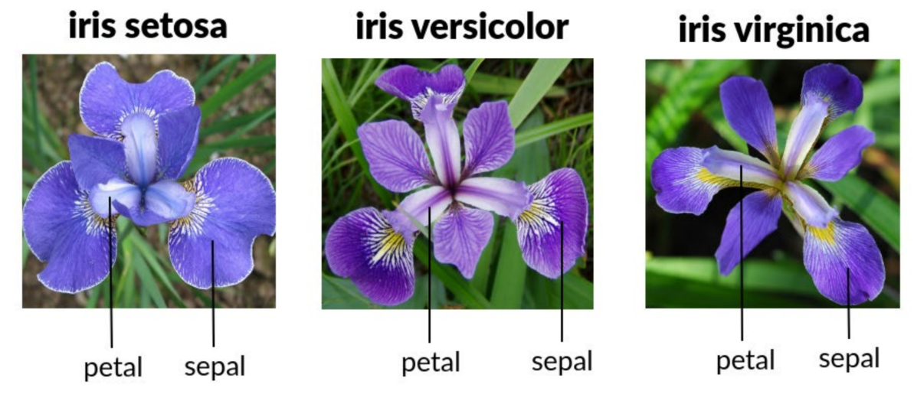

作业要求：推荐使用D3开源可视化工具（<https://d3js.org/）生成5>种不同的可视化图片。每一种可视化方法都能够做清晰区分这三种类型的花。如下例子展示了平行坐标方法的可视化结果图。

提交内容：提交代码和可视化结果图或视频。如不使用D3，也可以使用Python等其他编程工具或平台，不能使用Excel。

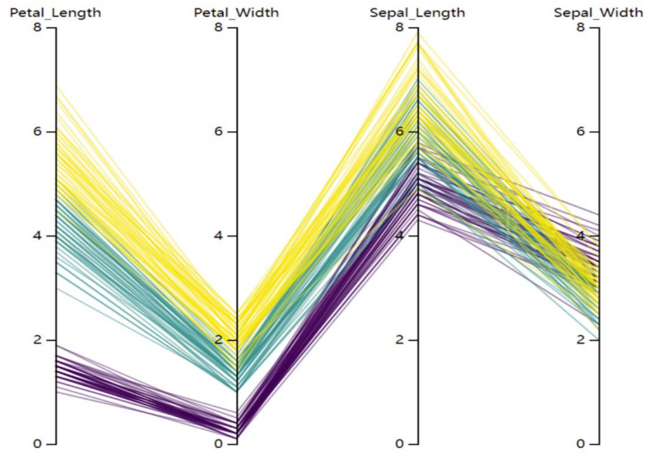

(English)

**Handout**: week 4, 2023.03.19

**Due**: 23:59 pm, week 7, 2023.04.09

**Total points**: 10

**Send to Email**: data_visualization@yeah.net

**Dataset**: The Iris dataset included in this project consists of 150 flower samples, with 50 from each of three species of Iris - Setosa, Virginica, and Versicolor. Each sample was measured for four attributes - the length and width of the sepals and petals, all in centimeters.

**Task**: Your task is to use D3 (https://d3js.org/) or Python toolbox to create five different visualizations for this Iris dataset, with the objective of visually differentiating the three types of Iris flowers. A parallel coordinate result is shown below, which highlights the variations between the three types of Iris.

**Submission**: Please submit your D3/Python source code, along with representative visualization results in the form of screenshot images or videos. Additionally, include instructions for running your D3/Python programs. No Excel!

