h (2016) revealed that Akaike Information Criteria (AIC) is a well-known information criterion, for evaluating the data-fitting performance of a model. The model with the smallest AIC is the best as describing the greatest amount of information with the smallest amount of variables (Bevans, 2021). It is necessary for checking the model assumption, to guarantee that model can be applied. The assumptions were examined by all four plots in **figure 3.7**, the explanation and examination of assumption plots were written below.

According to the plot, Residuals vs Fitted Values in **figure 3.7**, the pattern of residuals is not obvious, suggesting that the assumption of linear or curvilinear is acceptable. The residuals spread equally around the zero line, proved that the error terms have the same variance. Outliers, additionally do not exist as no residual standing away from the pattern (Department of Statistics Online Programs, 2018); Although having a light tail, Normal Q-Q plot suggested that the dependent variables, inside the model, are normally distributed (Ford, 2015). In the Scale-Location plot, Since the red line is approximately horizontal across the plot, with no clear pattern. In this way, the spreading of the residuals is random, as well as in the neighborhood of equal for all fitted values. (Zach, 2020). Observing Residuals Vs Leverage, the last plot in **figure 3.7**, there is no points affecting the trend much. In this way, there are no outliers. Based on the graphs in **figure 3.7**, the polynomial linear regression model, demonstrated in the summary, was applied for studying the relations between Pokémon Go and the amount of physical activity. The detailed final model was demonstrated in **formula 3.8**.

*PhysicalActivity* = β0+β1\**age* + β2\**education* + β3\**Gender* + β4\**Attitude* + β5\**PokemonGo_AppUsage* + β6\**PokemonGo_Relate.Behaviour* + α1\**Attitude*^2 + α2\**PokemonGo_Relate.Behaviour*^2 + α3\**age*\**education* + α4\**education*\**Attitude* + ϵ

* β0 is the intercept of the model
* β1 represents the estimate of variable *age*
* β2 represents the estimate of variable *education*
* β3 represents the estimate of variable *Gender*
* β4 represents the estimate of variable *Attitude*
* β5 represents the estimates of variable *PokemonGo_AppUsage*
* β6 represents the estimates of variable *PokemonGo_Relate.Behaviour*
* α1 represents the estimates of interaction term of the *Attitude* itself
* α2 represents the estimates of interaction term of the variable *PokemonGo_Relate.Behaviour* itself
* α3 represents the estimates of interaction term of variables *age* and *education*
* α4 represents the estimates of interaction term of variables *education* and *Attitude*
* ϵ represented the error terms of the model, with an assumption of normal distribution

*PhysicalActivity* = β0+β1\**age* + β2\**education* + β3\**Gender* + β4\**Attitude* + β5\**PokemonGo_AppUsage* + α1\**Attitude*^2 + α2\**age*\**education* + α3\**education*\**Attitude* + ϵ

* β0 is the intercept of the model
* β1 represents the estimate of variable *age*
* β2 represents the estimate of variable *education*
* β3 represents the estimate of variable *Gender*
* β4 represents the estimate of variable *Attitude*
* β5 represents the estimates of variable *PokemonGo_AppUsage*
* α1 represents the estimates of interaction term of the *Attitude* itself
* α2 represents the estimates of interaction term of variables *age* and *education*
* α3 represents the estimates of interaction term of variables *education* and *Attitude*
* ϵ represented the error terms of the model, with an assumption of normal distribution

|  |  |  |  |  |
| --- | --- | --- | --- | --- |
| Coefficients | Estimate | Std. Error | t value | Pr(>|t|) |
| (Intercept) | 6.136942 | 3.010388 | 2.039 | 0.04176 |
| age | 0.012821 | 0.015683 | 0.818 | 0.41382 |
| education | -0.279905 | 0.284092 | -0.985 | 0.32474 |
| Gender | 0.278323 | 0.084595 | 3.290 | 0.00104 |
| Attitude | -1.761775 | 1.013901 | -1.738 | 0.08260 |
| PokemonGo_AppUsage | -0.198716 | 0.035205 | -5.645 | 2.17e-08 |
| PokemonGo_Relate.Behaviour | 0.973577 | 0.207318 | 4.696 | 3.03e-06 |
| I(Attitude^2) | 0.155076 | 0.097228 | 1.595 | 0.11104 |
| I(PokemonGo_Relate.Behaviour^2) | -0.046845 | 0.029368 | -1.595 | 0.11101 |
| age*education | -0.003554 | 0.002289 | -1.553 | 0.12079 |
| education*Attitude | 0.085761 | 0.051815 | 1.655 | 0.09822 |

Table 3.6: Summary of Final Model

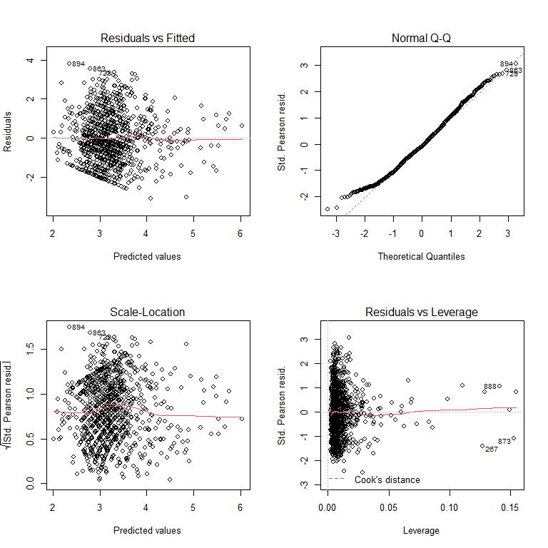

Figure 3.7: model assumption plots

# 4. Analysis Results

With the polynomial regression model constructed before, we answered the questions mentioned in the “research objectives” session. In accordance with the summary (**Table 3.6)**, the estimate for the number of app usage is -0.198716, with a variation of approximately 0.0002460, meaning that 1% increase of App usage lower -0.198716 amount of general physical activity. In contrast with the expectation, playing Pokémon Go frequently negatively affects the amount of physical activity. This phenomenon can be related to the variable ***PokemonGo_Relate.Behaviour***. Unlike ***PokemonGo_AppUsage***, **Table 3.6** showed that the estimates ***PokemonGo_Relate.Behaviour*** is 0.973577, possibly meaning activities related to Pokémon Go increase amount of Physical activities, instead of playing Pokémon Go. For explaining and examining this phenomenon, variable ***PokemonGo_Relate.Behaviour*** was removed from the model, and the result was showed in **Table 3.6.** According to **Table 3.6**,thevalues of ***PokemonGo_AppUsage*** became positive after the elimination of the variable ***PokemonGo_Relate.Behaviour***. Meaning that if other factors were fixed, the PokemonGo_Relate.Behaviour acted as a suppressor of the amount of physical activity. It, thus, is obvious that the positive effects of Pokémon Go app usage on physical activity restricted by Pokémon Go related activity rather than general physical activity like walking or cycling. Despites the variables mentioned before, there are more variables related to the amount of physical activity.

**Table 3.6** manifested that age and genderof a playerincrease the amount of physical activity, while education level and attitude towards sports negatively affects the physical behavior. there is correlation; additionally, between age and education level (labelled as ***education***), forming a new variable representing the interaction between age and education level. Education level and gender, in reality, is related to the attitude of participants towards physical activity***.*** In accordance with **figure 4.3**, the average attitude score of participants, with first three education level, are lower than the participants accepting higher education level. This represented that participant with higher education held a more active attitude towards physical activity. Moreover, the formation of new interaction variable, ***education*Attitude*** presented in Table 4.1, proved the correlation between education level and attitude towards physical activity. Besides education level, **Figure 4.3** represented that female have more positive attitude towards physical activity, comparing with male. (Note: in variable Gender, female was labelled as “1”, while male was represented by “2”.) In this way, both Gender and education have relationships with the amount of physical activity, proving that attitude towards physical activity is a key factor. In contrast to the above situation, male have higher amount of physical activity (represented by the positive estimates in **table 3.6**), being plausible that the attitude towards physical activity is not positive. In fact, **table 3.6** showed that the estimated value of variable representing the attitude of participants towards sport was negative (-1.761775). Although seemed unreasonable, a positive attitude towards physical activity reduced the amount of physical activity. Considering the interaction between education level and Attitude towards sports, we saw positive relations with the amount of physical activity.

|  |  |  |  |  |
| --- | --- | --- | --- | --- |
| **Formula** | | | | |
| PhysicalActivity = age + education + Gender + Attitude + PokemonGo_AppUsage + Attitude* Attitude + age*education + education*Attitude | | | | |
| Coefficients | Estimate | Std. Error | t value | Pr(>|t|) |
| (Intercept) | 7.070780 | 3.010388 | 3.164619 | 0.0257 |
| age | -0.001712 | 0.016454 | -0.104 | 0.9171 |
| education | -0.016170 | 0.298011 | -0.054 | 0.9567 |
| Gender | 0.392655 | 0.088170 | 4.453 | 9.43e-06 |
| Attitude | -2.156115 | 1.060194 | -2.034 | 0.0423 |
| PokemonGo_AppUsage | 0.051826 | 0.021254 | 2.438 | 0.0149 |
| I(Attitude^2) | 0.230975 | 0.101574 | 2.274 | 0.0232 |
| age*education | -0.001736 | 0.002289 | -1.553 | 0.12079 |
| education*Attitude | 0.085761 | 0.051815 | 1.655 | 0.09822 |

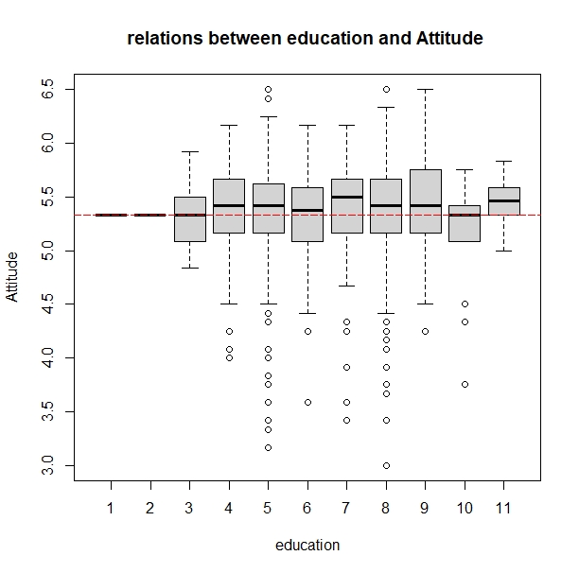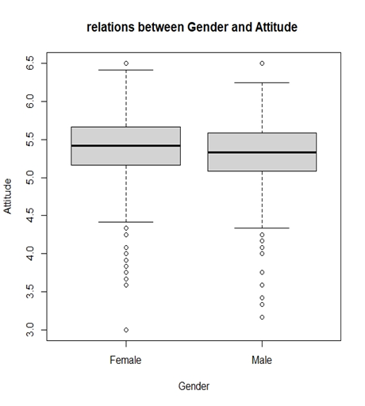

*Table 4.1: Formula and Summary of Model without “****PokemonGo_Relate.Behaviour***”

Figure 4.3: boxplot for relations between Gender and Attitude

Figure 4.2: boxplot for relations between education and Attitude

# 5. Discussion

Pokémon Go is a popular AR mobile game, causing the revolution of mobile game by combing AR technology with mobile game (Lopez German 2016). Players of this game can catch and hatch Pokémon, a virtual creature. Those activities requiring walking for a certain distance, or arriving to a specific location. With this characteristic, some researchers like Kamboj and Krishna (2016) claimed that Pokémon Go is an effective mobile game for rising the walking time, following the improvement of public health, including obesity. However, Gabbiadini & Greitemeyer (2018) declared that the effects caused by Pokémon Go is restricted to the activities related to the application, similar to my opinion mentioned before. As mentioned in the “Analysis Results” session, the amount of app usage (with estimate -1.761775) reduced the amount of general physical activity. The interpretation is Pokémon Go did not lead players more favor in physical activity, echoed with Baranowski and all the others (2012) that there are no obvious relationships between frequency of playing video game and amount of general physical health. There are several possible reasons of this phenomenon. The first one is the game design. For instance, some players hatched the Pokémon eggs when driving (with a speed lower than 10km per hour.) (Ayers et al., 2016), or took public transport for catching a Pokémon. In this way, walking can be unnecessary. Another reason is the preference of participants. Unfortunately, “analysis results” suggested that players more willing to join app related activity, instead of general physical activity. Comparing **table 3.6**with **table 4.1**, we have discovered that the estimated values of amount of app usage became positive if removing the factor of Pokémon Go related activity, demonstrated that app related activity cause huge effects on the amount of physical activity. We surmise with confidence that players were willing to join application related activity, instead of general physical activity. In this way, we discovered that Pokémon Go cannot increase the amount of physical activity directly as the effects is limited. The effects will disappear due to the altering of playing method, as well as the reducing of players.

The effects of Pokémon Go on the amount of physical activity, however, is unstable and inconsistent. The format of activity, to begin with, can be altered with accidents. Due to the COVID-19 pandemic, the entire game was changed for indoor playing (Maher 2020). For example, players were not required hatching Pokémon through walking. Players, indeed, bought tools-in-game for hatching Pokémon automatically. Players, additionally, used “Incense”, a tools for attracting Pokémon, to catch Pokémon without travelling. Last but not least, players can join Raid Battle (activity for catching rare Pokémon) without reaching a Gym. Those changes lowered the requirements walking outside. Despite the company’s policy, it is commonly known that most mobile game cannot attract large amount of users forever. Bratuskins (2018) also claimed that the lifespan of mobile game became shorter. With the above reasons, it is unstable and unsustainable using mobile games for public health enhancement. Others, including Attitude, age, education level and gender are in consideration for discovering solutions optimizing public health.

Besides app usage and app related behavior, both attitude, education level, gender and age are factors related to the amount of physical activity. Attitude, in reality, is a key factor, but not in a way expected previously. As written in the session “Analysis Results”, we had proved that female have a more positive attitude towards physical activity, this can be related to the education (according to **figure 3.4**, the average education level of female is higher than that of male). In accordance with **table 4.6**, the age was also interacted with the education level, demonstrating that education level is correlated with age of participants, as visualized in **figure 3.5.** The appearance of the above trend is related to free education policy in most of the first-world countries. Despite Gender, education level is also correlated with Attitude, proved by the positive trend presented in **figure 4.2**, as well as the interaction term showed in **table 3.6**. However, the relationship between attitude towards physical activity and the amount doing exercise was negative. We conclude that attitude towards physical activity is not related to the amount of physical activity, unlike the opinions from Araújo and Dosil (2015). This phenomenon cannot be explained clearly. Nevertheless, most people know the benefits of sports. They, however, did not exercise due to several reasons, including long working hour, pandemic, or even lazy in exercising. Although attitude is not related to the amount of physical activity. In accordance with **table 3.6**, we can find that the variable representing the interaction term between education level and attitude towards sport is positively correlated. It is possible that merely the increase of both education level and attitude can increase the amount of public health. In my suggestion, the government can not only increase the funding of tertiary education, but also instill a positive attitude towards sports in students.

There are several limitations during the study, being improved in future. To begin with, the population of dataset was from America. The statistics from Clement (2021), however, showed that there are consider number of players in Great Britain, Japan, Sweden and Canada. It is well known that there are many difference between countries, including culture and education system. Biases possibly exist if only observing data from players in America. The study should also have hosted in other countries in future. 999 records were used in this study. However, there are more than eight-hundred thousands of active users in America, not to say the whole world. For the future study, increase the population was recommended. This dataset only contained values from questions inside the survey. There is a risk that participants forget the number of times playing Pokémon, or lie on the survey due to shame. The future study is suggested including participants’ data inside the application. Last but not lease, **figure 3.7** demonstrated that there was a hidden pattern in the fitted values versus residual plot. We can apply more kinds of model, including Poisson, negative-binomial or neural network model.

**6. Conclusion**

Sport is essential for public health. However, proportion having exercise regularly in United Kingdom was limited. Pokémon Go is a well-known AR mobile game, with huge number of players. I believed that Pokémon Go is serviceable for public health due to the claims from multiple pieces of researches, whereas some researchers argued that the effects caused by Pokémon Go were indirect and unsustainable. Discovering methods for public health improvement, we studied the relationships between Pokémon Go and amount of general physical activity. The entire study was processed in four aspects: The relations between amount of app usage and the amount of physical activity; the preference of Pokémon Go players; other variables related to the amount of physical activity, as well as the relationships between the attitude and two variables, gender and education level. Constructing required variables, we grouped some series of variables together by mean of each instance, applying Cronbach's alpha as internal correlation observation method, as well as evidence for the variables-grouping process. After variables grouping, polynomial linear model, a linear model allows interactions between variables, was applied for discovering relations between variables. Stepwise selection method using AIC as selection criteria was used for model selection. The final model was written in **table 3.6**. With this model, we found some interesting facts.

To begin with, Pokémon Go cannot directly increase the amount of physical activity because participants focused on the app-related activities. In this way, Pokémon Go is not a good method improving public health due to the instability and unsustainability of mobile games. Attitude towards physical activity was a key factor as both education level and gender were related to the amount of physical activity, with a high correlation between education level and age. The positive attitude towards sports, nevertheless, could not increase the amount of physical activity. Focusing on the interaction between education level and attitude towards sport, we suggested instilling a positive attitude towards sports in students, and reducing education fee for public health improvement. In fact, there are lots of limitations in our project, including the population size and the surveying countries. We can host the survey with larger size in various countries in future. To solve the model assumption problems, we could apply other models or modelling methods.

# 7. Reference

# Agrawal Raghav. (2021). All you need to know about Polynomial Regression. Analytics Vidhya. https://www.analyticsvidhya.com/blog/2021/07/all-you-need-to-know-about-polynomial-regression/

# Araújo, A. T., & Dosil, J. (2015). The influence of attitudes toward physical activity and sports. Motriz: Revista de Educação Física, 21, 344-351.

# Ayers, J. W., Leas, E. C., Dredze, M., Allem, J. P., Grabowski, J. G., & Hill, L. (2016). Pokémon GO—a new distraction for drivers and pedestrians. JAMA internal medicine, 176(12), 1865-1866.

# Baranowski, T., Abdelsamad, D., Baranowski, J., O’Connor, T. M., Thompson, D., Barnett, A., ... & Chen, T. A. (2012). Impact of an active video game on healthy children’s physical activity. Pediatrics, 129(3), e636-e642.

# Bradfield & Underhill. (2004). IntroSTAT. 2nd. Department of Statistical Sciences, University of Cape Town. p.181-183

# Bratuskins Martins. (2018). Mobile game lifespan is shortening, but there’s a way to extend it.. Medium. https://medium.com/monetizr/mobile-game-lifespan-is-shortening-but-theres-a-way-to-extend-it-d7e96561b008

# Buraimo Babatunde, Jones Helen & Millward Peter. (2011). "Adult participation in sport: Analysis of the Taking Part Survey". department for culture, media, and sport. https://assets.publishing.service.gov.uk/government/uploads/system/uploads/attachment_data/file/137986/tp-adult-participation-sport-analysis.pdf

# Clement J.. (2021). Number of daily active users (DAU) of Pokémon Go via iPhone in selected countries in January 2021. https://www.statista.com/statistics/604551/pokemon-go-daily-active-users-in-europe/

# Cortina Jose. (1992). What Is Coefficient Alpha? An Examination of Theory and Applications. American Psychological Association, Inc. p.101

# Cronbach, Lee J. (1951). Coefficient alpha and the internal structure of tests. Psychometrika. Springer Science and Business Media LLC. 16 (3): 297-334

# Department of Statistics Online Programs. (2018). “4.2 - Residuals vs. Fits Plot”. The Pennsylvania State University. https://online.stat.psu.edu/stat462/node/117/

# Eysenbach Gunther. (2016). Influence of Pokémon Go on Physical Activity: Study and Implications". Journal of Medical Internet Research. https://www.ncbi.nlm.nih.gov/pmc/articles/PMC5174727/

# Fisher Tim. (2021). What Is Augmented Reality?. Lifewire. https://www.lifewire.com/augmented-reality-ar-definition-4155104

# Ford Clay. (2015). Understanding Q-Q Plots. The University of Virginia. https://data.library.virginia.edu/understanding-q-q-plots/

# Gabbiadini, A., Sagioglou, C., & Greitemeyer, T. (2018). Does Pokémon Go lead to a more physically active life style?. Computers in Human Behavior, 84, 258-263.

# Ganti Akhilesh. (2021). "Median". Investopedia. https://www.investopedia.com/terms/m/median.asp

# Glen Stephanie. (2021). Cronbachâ’s Alpha: Simple Definition, Use and Interpretation. Statistics How to. https://www.statisticshowto.com/probability-and-statistics/statistics-definitions/cronbachs-alpha-spss/

# Goforth Chelsea. (2015). Using and Interpreting Cronbachâ’s Alpha. The University of Virginia Library. https://data.library.virginia.edu/using-and-interpreting-cronbachs-alpha/

# Hayes Adam. (2021). Stepwise Regression. Investopedia. https://www.investopedia.com/terms/s/stepwise-regression.asp

# Hocking, R. R. (1976). A Biometrics Invited Paper. The Analysis and Selection of Variables in Linear Regression. Biometrics, 32(1), 1â“49. https://doi.org/10.2307/2529336

# Jacquet Jennifer. (2011). The pros & cons of Amazon Mechanical Turk for scientific surveys. Scientific American. https://blogs.scientificamerican.com/guilty-planet/httpblogsscientificamericancomguilty-planet20110707the-pros-cons-of-amazon-mechanical-turk-for-scientific-surveys/

# Kamboj, A. K., & Krishna, S. G. (2017). Pokémon GO: An innovative smartphone gaming application with health benefits. Primary care diabetes, 11(4), 397-399.

# Kostoulas Achilleas. (2013). On Likert scales, ordinal data and mean values. Achilleas Kostoulas. https://achilleaskostoulas.com/2013/02/13/on-likert-scales-ordinal-data-and-mean-values/

* Lopez German. (2016). Pokémon Go, explained. Vox. https://www.vox.com/2016/7/11/12129162/pokemon-go-android-ios-game
* Maher, C. (2020). How COVID-19 transformed Pokémon GO into “Pokémon stay-at-home”. ArsTechnica. Last modified July, 13.
* McElreath Richard. (2016). Statistical Rethinking: A Bayesian Course with Examples in R and Stan. CRC Press. p.189
* McNeish, D., & Wolf, M. G. (2020). Thinking twice about sum scores. Behavior research methods, 52(6), 2287-2305.
* Reilly Luke. (2017). Pokémon GO Coming to Smartphones. IGN Entertainment. https://www.ign.com/articles/2015/09/10/pokemon-go-coming-to-smartphones
* Seippel, Ø. (2006). The meanings of sport: fun, health, beauty or community?. Sport in Society, 9(1), 51-70.
* Sengupta Somak. (2020). Gamma Distribution Explained | What is Gamma Distribution? . Great Learning. https://www.mygreatlearning.com/blog/gamma-distribution/
* Smith, C. (2017). 80 amazing Pokemon Go statistics. RetrievedNovember 17, 2017, from https://expandedramblings.com/index.php/pokemon-go-statistics/.
* Stacy, E. W. (1962). A generalization of the gamma distribution. The Annals of mathematical statistics, 1187-1192.
* Webster Andrew. (2015). "With Pokémon Go, Nintendo is showing that it takes mobile seriously". The Verge. https://www.theverge.com/2015/9/10/9300101/pokemon-go-nintendo-mobile-games
* Zach. (2020). How to Interpret a Scale-Location Plot (With Examples). Scatology. https://www.statology.org/scale-location-plot/