Report on Assignment 1
Data Mining Course

Africa Soil Property Prediction Challenge

Lecture: |  |  | Prof. Xiaoli Li
Students: |  |  | Matriculation No.:
 |  | Steven Du |  | G1300007H
 |  | Ho Thi Nga |  | G1402725D
 |  | Nguyen Tan Thong |  | G1402865J

Abstract

Predicting physical and chemical properties of soils based on reflectance spectroscopy[1] is an important mission for planning sustainable agricultural intensification and natural resources management. In this report, we investigate machine learning techniques for predicting the properties from the diffuse reflectance infrared spectroscopy which is shown potential applications for less time consuming and low cost in many studies. We joined a Kaggle competition, named Africa Soil Property Prediction Challenge, this is where we get the data set for training purpose and the error score for testing purpose. For the bird's eyes view, below is list of what we have done:
- Data pre-processing the data set: categorical data converting, outlier detection, dimension reduction.
- Applying several of machine learning techniques on the problem without spending much time in detail problem’s characteristics.
- A simple schema for combining the results from different approaches for better result.
- A problem-specific cross-validation for model evaluation.
- Experiments and the comparison of different techniques.

We successfully beat the benchmark on both public leader-board (only 13% of the whole evaluation data set) and private leader-board (ranked by the rest 87% of data).

I. Problem description

1. Motivation
Knowing soil functional properties, i.e. soil's capacity in supporting ecosystem services, is an important analysis for planning and management of agricultural and natural resources. However, it is impossible to collect all samples and then do manually analysis on them, especially in the sparse area such as Africa. Therefore, digital mapping of soil functional properties, which using infrared spectroscopy and geo-referencing of soil samples instead of real samples, is becoming a potential approach. The approach, with the available of earth remote sensing data, is also advanced in more rapid and lower cost compare to traditional approach.

The real demand of analyzing soil functional properties has made it became a challenge on Kaggle website. Kaggle is a host of several competitions, which come from real life problems, asking the data scientists to submit their solution and win a prize. The soil functional properties prediction challenge was published on Kaggle named: “Africa solid property prediction challenge”[7]. By enrolling this competition, we first would like to give a try for our knowledge in data mining methodologies and algorithms in a real world problem. More importantly, we would have a chance to discuss and learn a lot from the senior scientists, who are also interested in solving the problem. Then lastly, we hope to get experience as well as boost up our rank in Kaggle community.

2. Data description
The given data is divided into two sets: 1158 samples for training and 728 samples for testing. Both training and testing set contains the information of each sample as follows:
- PIDN: unique soil sample identifier
- SOC: Soil organic carbon
- pH: pH values
- Ca: Mehlich-3 extractable Calcium
- P: Mehlich-3 extractable Phosphorus
- Sand: Sand content
- m7497.96 - m599.76: There are 3,578 mid-infrared absorbance measurements. For example, the "m7497.96" column is the absorbance at wavenumber 7497.96 cm-1.
- The CO2 bands in absorbance measurements is in the region m2379 to m2352.76 is considered as noise data and recommended to remove.
- Depth: Depth of the soil sample (2 categories: "Topsoil", "Subsoil")
Besides, some potential spatial predictors from remote sensing data sources have been included:
- BSA: Average long-term Black Sky Albedo measurements from MODIS satellite images (BSAN = near-infrared, BSAS = shortwave, BSAV = visible)
- CTI: Compound topographic index calculated from Shuttle Radar Topography Mission elevation data
- ELEV: Shuttle Radar Topography Mission elevation data
- EVI: Average long-term Enhanced Vegetation Index from MODIS satellite images.
- LST: average long-term Land Surface Temperatures from MODIS satellite images (LSTD = day time temperature, LSTN = night time temperature)
- Ref: average long-term Reflectance measurements from MODIS satellite images (Ref1 = blue, Ref2 = red, Ref3 = near-infrared, Ref7 = mid-infrared)
- Ref_i: topographic Relief calculated from Shuttle Radar Topography mission elevation data
- TMAP & TMFI: average long-term Tropical Rainfall Monitoring Mission data (TMAP = mean annual precipitation, TMFI = modified Fournier index)
SOC, pH, Ca, P, Sand are the five target variables for predictions.

Data have been monotonously transformed and mean centered and scaled.

Additionally, according to organizer, samples have been collected area by area, each area is 10 x 10 km sized, named as “Sentinel Landscapes”, there were 60 “Sentinel Landscapes” have been sampling. In each area then was divided into 16 sampling clusters, 1 km2. Each cluster then also was divided into 10 sampling plots, sized 1000 m2. In each plot, there were two samples have been collected according to depth measurement, one is in topsoil (0 – 20 cm) and another is in subsoil (20 – 50 cm). After collected, only 10 percent of data were analyzed and then used for this competition. The testing and training data have been separated along Sentinel Landscape levels, as the organizer expect to be able to predict soil properties of new Sentinel Landscape in the future.

3. The competition evaluation
The predicted results once submitted will be evaluated by following evaluation methods:
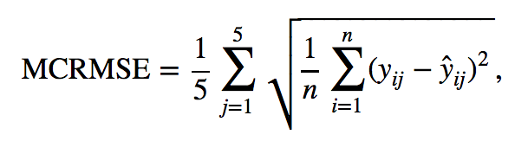
where:
y: is actual value
ŷ : is predicted value

During the competition period (27 Aug 2014 to 21 Oct 2014), the competitor could submit their results up to three time a day. The submission score will appear shortly after submitted. However, this score is for reference as it is only calculated using 13% of testing data. The rest of 87% testing data is used in final evaluation and processed one time after the completion end. The winner decision is made base on the score tested on 87% testing data.

4. Problem definition
The task of predicting SOC, pH, Ca, P, Sand of soil samples could be solved by regression methodologies. However, to predict the results accurately, we defined that we will have to deal with several minor problems of given data set such as: small training data set (only 1158 sample records are given), high dimensional data (each sample contains about 3800 features) and the development set was not given.
To fully explore the accuracy of several regression methodologies and algorithms, we decided to develop several individual systems, each using different algorithms and deal with different features of data. Then finally, individual systems were combined together to maximize the accuracy. In next sections, we will present detail about how we analyze the given data, which methodologies, algorithms have been selected and how our system combination worked.

II. Approach
Our approach includes four main parts which are data analysis, machine learning models, combination schema, and cross-validation.

1. Data analysis

a. Categorical attribute
The last attribute of the data is topsoil or subsoil. Often such data can be efficiently coded as integers for instance [0, 1] or [1, -1]. Many regression estimators expect the input attributes to be continuous and will treat these data as being ordered, which is often not desired. One possibility is to convert categorical feature to a one-of-K manner where k possible values into k binary features, with only one active, e.g. Top-soil value becomes two attributes [1, 0] and Sub-soil becomes [0, 1].

Outliers
To detect the outliers in the data set, we plotted all spectral training data in a single figure to have an overview of the distribution of the input data, which is showed in following figure:
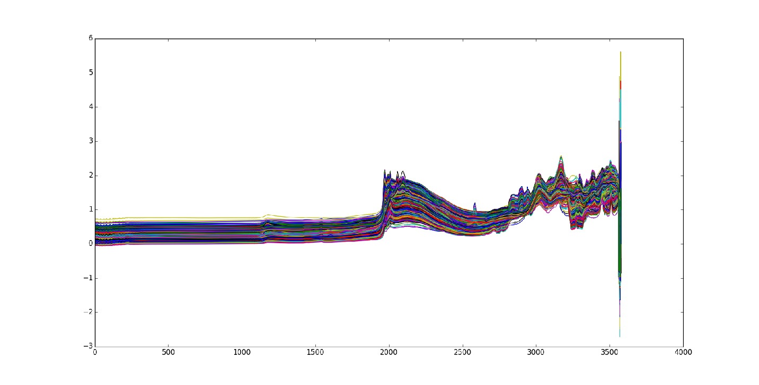
Figure 1: The distribution of feature space

As we can see, the distribution is quite smooth and we do not really detect any outlier over the input data space.

After that, we also want to detect outliers from the output variables which are Ca, P, pH, SOC, Sand, to do that, we plotted the histogram for each variable, the results show us interesting clues.
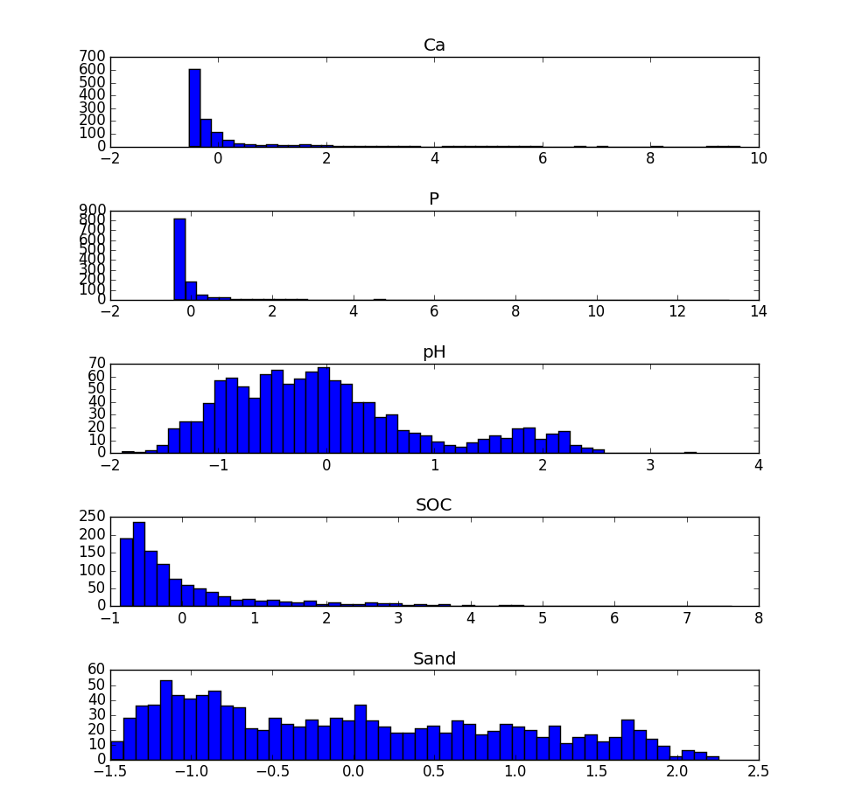
Figure 2: Histogram of output variable Ca, P, pH, SOC, Sand.

Based on above figures, we choose thresholds separately for output variables and the search through the whole data set for removal outliers data points whose value is greater than the threshold.

Feature selection
CO2 band removal: As recommended from host of the competition, we remove features in the band of CO2 gas, and the decision really improved our result.

When deal with spectrum and sequential data, first and second derivative is normally applied [5].

PCA dimension reduction: We also try to reduce the large number of features from original data set, to do that, we use PCA to transform the feature space into a lower dimension space, but the result after transformation is worse than the result on the original data.

Restricted Boltzmann Machine (RBM) is a popular tool for extracting features from data in an unsupervised setting. They can be easily stacked to construct Deep Belief Networks (DNN), which are able to discover high level structure in data[6]. However our DNN per-training with RBM on this task does not work. We find that stacking the RBM features with SVR slightly improved the result.

Machine learning models
It is easy to realize that our problem is a regression problem, which we want to predict some continuous value properties (Ca, P, pH, SOC, Sand) that we have chosen. In the situation that we do not have prior-knowledge about this research field, a list of possible regression models in our toolbox of machine learning models: Decision Tree, Bayesian regression, Bayesian ARD regression, Random Forest, Stochastic Gradient Descent, KNN,SVR, DNN, DNN+SVR, RBM, SVR+RBM. The only advantage of having small data set is that one can quick find a suitable approach without spending days on training a huge model. We quickly found that the SVR performance was the best among all the regression approaches through cross validation. Selected models will be discussed in the experiment section.

3. System combination
Since we had built several individual systems to investigate the advantage of some regression approaches to deal with this challenge. We then had idea of combining all the good system which worked well on different features, the expectation this combination is to get a better score for final result. However, we did not spend much time on this task, instead, we only use the mean method to get final predicted value by mean method. The different results were also weighted by it general accuracy.

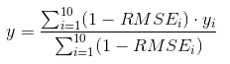

4. Cross-validation
As given data set is only for training and testing, but the number of submission per day is limited to 3 per account and the leader board is only showing the result of 13% test data, which is not used in final evaluation (as description in section 1). We believe that developing a cross validation method is a necessary step to validate our experiments.

We implement a modified version of K-fold cross-validation. Because the competition rules indicated that the training data and the testing data come from separated location of samples, so we divided the training data set into 37 subsets based on given sentinel location of samples, each subset for a location. We then do cross-validation by repeatedly picking a subset for testing purpose and the rest 36 subsets for training purpose. The score of model is computed:
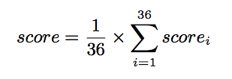

III. Experimental results and Analysis
In this session we first present the baseline system, then we introduce our approach and finally we discuss about our struggle with over-fitting.

1. Baseline system
Baseline system is based on Bayesian Additive Regression Tree (BART). It is a system running on R using a BayesTree package which has been removed from R package distribution due to memory access errors were not corrected. Yet we manage to found that package in the archive. The benchmark system gives 0.5 and ranked 810 on the public leader board, on the private leader board it gives 0.56551 and ranked 793. In both cases we beat the baseline system, we ranked 82nd on the public leader-board and 512nd on the private leader-board.

2. Our approach
Several methods we have tried including Decision Tree, Bayesian regression, Bayesian ARD regression, Random Forest, Stochastic Gradient Descent, KNN,SVR, DNN, DNN+SVR, RBM, SVR+RBM, not all give reasonable results. Notice that does not mean the approach is bad, indeed it is just a problem for this “strange” data set.

Here we only present few selected models. In most of our approaches we build a model and predict the output one by one.

System  ID | Removed features | Ca | P | pH | SOC | Sand | Avg RMSE | 13% (Public LB) | 13%  Rank | 87%  (FinalLB) | 87%  Rank
1 | None | 0.397 | 1.002 | 0.5439 | 0.4895 | 0.5641 | 0.5993 | 0.4136 | 297 | 0.5133 | 505
2 | Co2 | 0.397 | 1 | 0.5456 | 0.4914 | 0.5665 | 0.6 | 0.4117 | 262 | 0.5126 | 478
3 | Land | 0.3574 | 0.9904 | 0.4645 | 0.5329 | 0.5212 | 0.5733 | 0.4419 | 620 | 0.5083 | 413
4 | Depth | 0.391 | 0.993 | 0.5443 | 0.494 | 0.5649 | 0.597 | 0.4104 | 216 | 0.5081 | 390
5 | Co2  Depth | 0.3911 | 0.9944 | 0.5477 | 0.4949 | 0.5665 | 0.598 | 0.4086 | 179 | 0.5081 | 374
6 | CO2  Landscape | 0.3584 | 0.9913 | 0.4683 | 0.5327 | 0.5201 | 0.5741 | 0.4381 | 605 | 0.5075 | 362
7 | Depth  Landscape | 0.3559 | 0.9859 | 0.4658 | 0.5215 | 0.5234 | 0.5705 | 0.4362 | 504 | 0.5055 | 285
8 | Co2  Depth  Landscape | 0.3557 | 0.9868 | 0.4680 | 0.5199 | 0.5223 | 0.5704 | 0.4342 | 448 | 0.5059 | 317

Table 1: SVR (support vector machine) approach with different feature selection, such as with/without CO2, with/without Depth, with/without landscape information

The best system according to private leader board is system 7 where the depth and landscape information is removed. On public leader board the best system is system 5 where CO2 and depth are removed. System 3 and 4 show that if look at cross validation result alone, lower RMSE may not result in good result in both public and private.

We can also discovery that the 87% data which used as the final scoring is not strongly related with 13% of data, one can argue that organizer did not make a good job. They change a meaningful regression task to a “not to over-fit” problem. After competition is finished many people expressed their concerns about this in the discussion forum. The 1st in the public leader board drops to 520th in the final leader board. In contrast the 2nd in final leader board comes from 880th position in public leader board. The following session will give a brief discussion about how to fight over-fitting.

3. Fight the over-fitting
Averaging output is one way to fight over-fitting. We repeat such process for multiple times and average the all its prediction to make a final submission. It is inspired by the 24th on the final leader board who average 100 predictions from baseline BART model.

First testing on the baseline, it proves that averaging does work for this task. (Private LB standards for RMSE value on the private leader board)

System  ID | Removed features | 1 models Private LB | 5 models Private LB | 20 models  Private LB | 35 models  Private LB | 50 models  Private LB
1 | Depth  Landscape | 0.56526 | 0.51492 | 0.51113 | 0.50940 | 0.50882

Table 2: Private leader board score on averaging

The table 2 shows significant improvement by averaging out 50 BART model. We did not try out till 100 models as training BART model is time consuming. We running four threads on a laptop and manage to get 50 models over weekend.

Then we test such approach on DNN as it is one part of the prediction who bring us from 100th to 82nd place on the public leader board. The DNN has two layers only, we keep them same size and running 50 epochs for each target for all 3 setups, to overcome the over-fitting problem we randomly leave few sample out during training. We choose 50 epochs because we observe the over-fitting problem during 10-fold cross validation. Same random seed is used for different DNN setups, so the results are comparable.

Sys.  ID | Removed features | DNN setup | 1 model  RMSE | 1 model (Private LB) | 5 models RMSE | 5 models (Private LB) | 20 models RMSE | 20 models (Private LB) | 35 models RMSE | 35 models  (Private LB) | 50 models RMSE | 50 models  (Private LB)
1 | Depth  Landscape | 400 400 | 0.3864 | 0.63693 | 0.4782 | 0.58720 | 0.4317 | 0.5751 | 0.4294 | 0.5754 | 0.419 | 0.5756
2 | Depth  Landscape | 200 200 | 0.3615 | 0.63092 | 0.6194 | 0.59022 | 0.4578 | 0.5842 | 0.4233 | 0.5828 | 0.417 | 0.5826
3 | Depth  Landscape | 100 100 | 0.5184 | 0.6337 | 0.4304 | 0.59543 | 0.4427 | 0.5863 | 0.4461 | 0.5845 | 0.449 | 0.5847

Table 3: MRSE score and private LD score on average outputs
With increasing number of averaging models, the Avg RMSE measured from cross validation (our own result) are more stable, the performance become better for all three DNN setups and finally saturated due to too few data we have.

Compare the system 2 and 3, it shows that more nodes in each layer gives constant improvement in this competition. The best performance is obtained with a two hidden layer (400,400) DNN.

Next we further evaluate the performance of DNN on its multitask regression. The final output layers of DNN, we use all five target attributes (System 2 in the following table) instead of predicting the target one by one.

System  ID | Removed features | DNN setup | 1 models (Private LB) | 5 models (Private LB) | 20 models (Private LB) | 35 models  (Private LB) | 50 models  (Private LB)
1 | Depth  Landscape | 400 400 | 0.63693 | 0.58720 | 0.5751 | 0.57537 | 0.5756
2 | Depth  Landscape | 400  400  5 tasks | 0.6482 | 0.59401 | 0.5833 | 0.5829 | 0.5823
3 | None | 400  400 | 0.619 | 0.5785 | 0.57205 | 0.5734 | 0.5733

Table 4: Performance of DNN on its multitask regression

The result table shows that for this competition system 2 is not as good as system 1. It is better predict the value one by one. It may indicate that the five targets are independent. It again proofs that the averaging method is one approach for over-fitting problem.

4. Some investigations on system combination
Below table shows results of k-NN and SVR approaches running individually. We then use these results to build a combined system.

Approach | Features | Result
Approach | Features | Public LB | Private LB
5-NN | Spectra | 0.81305 | 0.75376
5-NN | Spectra without CO2 | 0.78916 | 0.76018
15-NN | Spectra | 0.69149 | 0.68371
15-NN | Spectra without CO2 | 0.66956 | 0.66384
SVR | Spectra | 0.40863 | 0.50810
SVR | Spectra - CO2 | 0.43624 | 0.50557
 | 1st derivate + Spectra - CO2 | 0.57745 | 0.56917
Table 5: The individual systems

Combined system | Features | Result
Combined system | Features | Public | Private
15NN+SVR | Spectra without CO2 | 0.47023 | 0.52877
15NN+SVR | Spectra without CO2  1stDerivate | 0.46415 | 0.50879

Table 6: Combined systems

We built the combination system during the competition, which using SVR and DNN results; however, the final result is not as good as expected. Here we combined SVR, kNN after the competition finished. Recently, we have just received good news that our second combination system has beaten our final official result: it ranked 422nd in the private leader board. Though this result has not been good as expected, we are excited to find that the approach of combination several systems could be a promising direction for our future development.

IV. Conclusion
In this Africa Soil Property Prediction Challenge, using varies tools in varies programming language (R, Python, Matlab) our group successfully beating the Bayesian Additive Regression Tree baseline, we get the 82nd position on the public leader board and 512nd on the private leader-board across the 1233 teams. A meaningful, yet painful lesson learned. Many techniques we had tried did not work for this particular competition.

Despite that this data set with thousands samples cannot be called as big data. The training for BART and DNN with multiple interactions take quite much of time. To tackle this problem, we use multitasking approaching, and running on distributed computers. To reduce the DNN running time, we modify the code to make it able to use the power of GPU. Using DNN and GPU is the current trends in many research areas.

We also learn from other competitors who shared their thoughts through discussion board. The best shared approach is to find optimal model parameter, model combination, data pre-processing technique for each individual target. This is different from our approach, in which we used same data prepossessing for all targets, and combined the final results. Such approach is a hard task for newbies. By discussion with the top players in the competition we found that effective feature selection, grid search for parameter estimation, model selection and ensemble are fields need to explore, perhaps in our next attempt on Kaggle competition.

A. References
[1] Srivastava, Hinton, Krizhevsky, Sutskever, Dropout: A Simple Way to Prevent Neural Networks from Overfitting.
[2] Li, Daoliang, Soil Classification Via Mid-infrared Spectroscopy, http://dx.doi.org/10.1007/978-0-387-77253-0_48, Springer US, 2008-01-01.
[3] Mulbry Walter, Reeves James, Liu Yan, Ruan Zhenhua, Liao Wei, Near- and mid-infrared spectroscopic determination of algal composition, 2012-10-01.
[4] I. Bogrekci, W. S. Lee, Improving phosphorus sensing by eliminating soil particle size effect in spectral measurement.
[5] Anthony J. Owen, Uses of Derivative Spectroscop http://www.chem.agilent.com/Library/applications/59633940.pdf
[6] Derk Mus, Audio Feature Extraction with Restricted Boltzmann Machines
[7] https://www.kaggle.com/c/afsis-soil-properties

B. Appendixes

Data set
The data set can be easy access at kaggle website: https://www.kaggle.com/c/afsis-soil-properties/data

Source code and instructions
We put our source code (README file included) repository at address: https://bitbucket.org/xcodevn/soilchal

