VIETNAM NATIONAL UNIVERSITY OF HOCHIMINH CITY

THE INTERNATIONAL UNIVERSITY

SCHOOL OF COMPUTER SCIENCE AND ENGINEERING



**A WEB-BASED SYSTEM FOR ARTICLES MANAGEMENT**

By

KHUU KHON LAM

Student ID: ITITIU18303

A Thesis submitted to the School of Computer Science and Engineering

in partial fulfillment of the requirements for the degree of   
Bachelor of Information Technology

Ho Chi Minh City, Vietnam  
2023

APPROVED BY: ________________________________ ,

Nguyen Van Sinh, Assoc. Prof., Chair  
*(*Type Committee names beneath lines*)

________________________________   
(*Typed Committee name here*)

________________________________   
(*Typed Committee name here*)

________________________________   
(*Typed Committee name here*)

________________________________   
(*Typed Committee name here*)

THESIS COMMITTEE   
(Whichever applies)

# ACKNOWLEGMENTS

It is with deep gratitude and appreciation that I acknowledge the professional guidance of Dr. Nguyen Van Sinh. His constant encouragement and support helped me to achieve my goal.

I am grateful to the faculty of the School of Computer Science of the International University, especially Assoc. Prof., Nguyen Van Sinh for his support since the beginning of my studies. Gratitude is also expressed to the members of my reading and examination committee.

*Note: Paper A4, Top: 2.5cm; Bottom: 2cm; Left: 3cm; Right: 2cm*

TABLE OF CONTENTS

ACKNOWLEGMENTS 3

LIST OF TABLES 5

ABSTRACT 6

CHAPTER 1 7

INTRODUCTION 7

1.1. Background: 7

1.2. Problem Statement: 7

1.3. Scope and Objectives: 9

1.4. Assumption and Solution: 10

1.5. Structure of Thesis: 10

CHAPTER 2 11

LITERATURE REVIEW 11

2.1. Similar sites to the WAM system application: 11

2.2. Techinical components of the article management system application: 15

CHAPTER 3 19

METHODOLOGY 19

3.1. Overview: 19

3.2. User requirement analysis 20

3.2.1. User functional requirement analysis 20

3.2.2. User non-functional requirement analysis 20

3.3 System design 21

3.3.1. Use Case Diagram 21

3.3.2. Use Case Description 22

3.3.3. Datadase design 27

3.4. User Interface design: 34

CHAPTER 4 34

IMPLEMENT AND RESULTS 34

4.1. Implement database 34

4.2. Result: 37

CHAPTER 5 42

DISCUSSION AND EVALUATION 42

5.1. Discussion 42

5.1.1. Website SCIMAN 42

5.1.2. Website Academic Journals 43

5.2. Comparison 43

5.3. Evaluation 44

CHAPTER 6 44

CONCLUSION AND FUTURE WORK 44

6.1. Conclusion 44

6.2. Future work 45

CHAPTER 7 46

REFERENCES 46

**LIST OF TABLES**

Table 1. Use case 1 – Sign up. 22

Table 2. Use case 2 – Login. 22

Table 3. Use case 3 – View Article. 23

Table 4. Use case 4 – Search for article. 23

Table 5. Use case 5 – Generate reference of article automatically. 23

Table 6. Use case 6 – Manage article. 24

Table 7. Use case 7 – Manage Account. 24

Table 8. Use case 8 – Submit Article 25

Table 9. View inspection status of article. 25

Table 10. Use case 10 – Appraise Article. 26

Table 11. Use case 11 – Select Reviewer. 26

Table 12. Use case 12 – Review Article. 26

Table 13. Detail information of approvedArticle table. 31

Table 14. Detail information of Article table. 31

Table 15. Detail information of publishArticle table. 32

Table 16. Detail information of rejectedArticle table. 33

Table 17. Detail information of resetPassword table. 33

Table 18. Detail information of Users table. 34

# ABSTRACT

With the speed of growth in the number of articles today. The creation of a management system for articles is a necessity. Create a system to help manage articles more effectively, giving it a more organized way. Articles are always compiled with a lot of information, so citing where the sources come from also helps the article to have more credibility and quality. In this thesis, I propose The Web-based Article Management System (AMS) helps to manage and categorize with many types of articles. The method includes the following steps, there are 3 markable functionalities for this website: Manage article, progress of publishing article, and generate references automatically for article.

The system will include all the basic functions of a management website. In addition, the system also has the function of searching articles by filter, in addition, a special feature is auto-generating automatically creating references. In order to improve efficiency in managing articles, that is why this thesis will research the related aspects and build the AMS to better understand this system.

# CHAPTER 1

# INTRODUCTION

The first chapter is to introduce about the Web-based Article Management about the background motivation of the the system, about the problem of the system could happened in the future, about the scope and objectives with all the activities should be done to develop and deliver the software product, and about the assumption and solution of the system explain the major of the system as well as the explaination to solve problems which should be done by system, support the tasks instead of completing task manually.

## **Background:**

The article management system (AMS) is a web application that allows to manage the types of articles from many different authors, where they can log in using a member account to submit, review and publish the articles. When they log up, member accounts can also view other articles, and admin can also manage all the articles and all the accounts of the website.

A remarkable function in this website is the function of creating reference of articles automatically without the need for users to do it manually. After the article has published on the system, the user only needs to click on the generate reference button, the next screen would show all the form that has all the needed fields to generate a reference with standard of APA 7th, the final result would show the user a model APA 7th reference of that article.

## **Problem Statement:**

Scientific research articles are the premise for the development and innovation in all areas of life. With the current era of 4.0 era, it is extremely necessary to replace manual methods of storing and managing scientific articles. If with manual methods of storing and managing articles, there will be many problems that can affect the quality of management. Firstly, it can be mentioned that it is lost about the articles: imagine that if store and manage scientific articles in paper form, there is a high probability of loss and damage, harm. Those problems can come from people, such as the manager lost it somewhere but when needed, can't find it, there is also the possibility that if it exists and is stored in paper form, scientific articles can be burned by flames, or get wet, the paper is torn without a copy of that article. Such capabilities may justify the need to archive and manage articles that need to be digitized and managed with IT applications. Secondly, with manual management, it will take a lot of time. Currently, according to subjective statistics from many websites, each year, about two million scientific articles with many different classifications are published. With such a large number, manual management will of course take a lot of time. Imagine, if someone needs to find a scientific article for reference but there are few sources about it, they don't know where exactly to look for it, it takes a lot of time to find it. sword. Since then, the time to research the scientific problem becomes another matter, there will be less time for research because more time is spent on searching and finding for scientific articles. Third, manual management of scientific articles consumes a lot of storage space. As mentioned earlier, the number of scientific articles per year is so much that it would be inconvenient to store and manage manually with such a large number. Manual archiving will require storage places, so why not use IT applications to digitize the articles instead? With the storage capacity of computers, after being digitized, the articles will be stored and managed in a more efficient and organized manner, of course, will save more storage space. because computer memory can store tens of billions of archives of scientific articles through storage applications such as servers and cloud-platform storage systems being developed in the current era of big data applications. Finally, globalization will be an advantage when using software to manage scientific articles. Imagine, with the manual method of managing and storing it in the form of paper, it would be difficult to disseminate scientific articles to different audiences around the world, who can find scientific articles. study it in scientific journals. However, not everyone can easily access those journals because geographical distance is a big barrier. Systems for managing and storing scientific articles make it easier to access information to everyone through networked services around the world. Therefore, the AMS is an essential application for solving the above problems.

## **Scope and Objectives:**

In today's era of data development, the development of systems for managing and storing data has also become extremely important. In the modern 4.0 era, where people have been gradually converting manual things into computer digitization, this is to promote improved processes to deliver results and products. more effective and useful products. The AMS is a system for managing and storing scientific articles. The system allows users to view, manage and publish public scientific articles, besides with the automatic creation of references, it is useful for users. For the purpose of the system: Firstly, is to optimize the management with this system, the management of articles becomes easier and more optimal. With the computerization of information data, records from articles, from authors, administrators can manage all more conveniently. Secondly, the AMS helps management of article more cost savings, with manual management of articles, it will be costly for different employees to take on different tasks. With the computerization of the management system, only a few administrators, even one, are needed to manage all the activities of the management system in this article. Thirdly, the system helps management of article more time saving, with manual article management, it takes more time to separate different processes to handle different tasks than with a computerized system. Updating data, information, or records of articles, personal information of authors or members will save a lot of time compared to manual manipulation. Finally, with the use of computer software to store and manage articles, it will improve the convenience of finding and extracting reference sources, with this online article management system, users can more conveniently find and extracting citations of articles, which not only helps to clarify the transparency of the article but also saves time. for making citations.

With the AMS, users can view and publish published scientific articles and automatically create references. Firstly, with the authentication function, users can create their account through the steps of declaring some personal information such as full name, email, phone number, address, then they can use their account and password to log in to their account to perform other functions such as viewing specific and detailed scientific articles, publishing scientific articles. Secondly, about the function of publishing scientific articles. The first condition to publish is that the user must log in to his account, then the system will allow the user to submit the article. Regarding the format of articles if users want to upload, they will have to upload pdf file format to make it easier to view those articles, avoiding problems like font errors which are a common mistake. In addition, before posting, users must fill in all information in the declaration, including what the topic is, what field it belongs to, and the author's personal information. or author group such as name, email, .. this is to verify the origin of the scientific article that the user wants to upload. Once they have filled out the form, there will be a button for them to upload the file of the article and send it reviewer, if article is approved by reviewer, then board editor will appraise it and if board editor approve, the article would be publish onto the website. Thirdly, about the website's filter, there will be different filters to create convenience for users such as filtering a specific detail of the article to find or filtering a combination of many information details of the article: firstly, filter by duration, the user can enter the date of the published article; Secondly, the user can enter the filter data by entering the field of the published article, there are currently 2 fields, or the user can default to "All fields". Finally, with filters: Keywords include the title or ID of the article, name of authors. Authors include the author of the article or the name of the journal. Users can easily search for the desired elements of the article to find their desired articles.

## **Assumption and Solution:**

* + 1. **Assumption:**

This article management system application is for converting manual application to online web application. The article management system's custom database is accessible in real time.

* + 1. **Solution:**

Solution for provides better and efficient service and management website. Solution for reduces workload of employees: When managing articles, for jobs that are divided manually, this causes a lot of human resources, and it takes a lot of staff to take care of the jobs. The computerization of the system helps to reduce the number of employees in the article management, in addition to being more efficient. Solution for extracting citations: With this system, users can easily extract citation sources of articles displayed on the website system. Solution for satisfaction of user experience: With this online system, it allows users to directly view articles, edit and create new articles on topics that interest them, providing a more enjoyable experience.

## **Structure of Thesis:**

*Figure 1. Structure of Thesis.*

# CHAPTER 2

# LITERATURE REVIEW

## **Similar sites to the WAM system application:**

With the development of Internet technology today. Accessing websites for users to manage and publish articles is not difficult, here are a few websites that are intended to be used to manage and publish articles:

* + 1. **SCIMAN Website:**

*\*Overview:*

SCIMAN [1] is a website that manages publications scientific articles of International University - Vietnam National University, Ho Chi Minh City. The target user of this website includes faculty lecturers of the university and students and graduate students from various faculties of the university, such as School of Business, school of Electrical Engineering, School of Biotechnology, School of Computer Science and Engineering, School of Industrial Engineering and Management, Department of Civil Engineering, Department of English, Department of Physics, Department of Mathematics, Department of Environmental Engineering and so on .This website allows users to publish their scientific research articles through various categories, such as SCI-E journal papers, SSCI journal papers, non-ISI journal papers, ESCI journal papers, AHCI journal papers, Scopus journal papers, Domestic journal papers, International conference papers, Domestic conference papers, Proceedings, Books, Book Chapters, Projects and so on. Displayed from the initial interface of the website, users can view each article's classification, the titles of the articles are placed next to the author's name or group of authors along with the name of the scientific conference. or the scientific forum where the articles are published and presented by the authors, and finally is the publication month and year of the paper. If user want to view the details of those articles, users are required to have a login account of the SCIMAN website system.

*Figure 2. SCIMAN website.*

When starting to look at the website, users can easily see the top right corner of the website including 3 functions: the first is the link to the ORD website - the main website of the Research Office Research and Development of the International University, the second is the link to the topic registration website to help lecturers, students or graduate students register the topic, the third is the link to log in to the account users of the SCIMAN website.

The site has a very detailed and complete article filter. The first is to filter by duration, the user can enter the period including the month and year of the published article. Secondly, the user can enter the filter data by entering the field of the published article, there are currently 2 fields: “Natural sciences and engineering”, and “Social sciences and humanities”, or the user can default to "All fields". Thirdly, users can search through the "Divisions" filter, here the Division filter includes all the faculties and departemnts and taught at the International University, including: School of Business, school of Electrical Engineering, School of Biotechnology, School of Computer Science and Engineering, School of Industrial Engineering and Management, Department of Civil Engineering, Department of English, Department of Physisc, Department of Mathematics, Department of Environmental Engineering and so on, or the user can default to "All devisions". This is a useful filter for students doing their own research papers because topics related to school or department are the starting point for students. Fourthly, users can search through the "Type" filter, here the Type filter allows user to find the type of their desire’s punlished articles, includes SCI-E journal papers, SSCI journal papers, non-ISI journal papers, ESCI journal papers, AHCI journal papers, Scopus journal papers, Domestic journal papers, International conference papers, Domestic conference papers, Proceedings, Books, Book Chapters, Projects and so on, or the user can default to "All fields". Finally, with filters: Keywords include the title or ID of the article, Authors include the author of the article or the name of the journal. Users can easily search for the desired elements of the article to find their desired articals.

Furthermore, with the “Clear the search history”, users are able to clear all the filter has filled with. Each category of articles has a counter displayed next to the category name to make it easier to count the number of each type of article.

*\*Advantages:*

This is the website for managing scientific articles of the International University, which is an indispensable aspect for scientific research. It was created for the purpose of managing articles by faculty, students, and graduate students. The SCIMAN system is extremely necessary, without it, it would be difficult to manage the articles in an organized manner, making it easy to find articles as well as reference for users. With the modern development of the 4.0 era, the use of computer systems, digitizing data and information for storage and sharing has replaced time-consuming, inefficient and manual methods. limited storage capacity and easy loss of articles. The system was created to serve the subjects of the International University well, contributing to promoting the development of the university's scientific research management more and more easily, improving the storage efficiency and management efficiency, saving many aspects such as labor, time and storage space.

*\*Disadvantages:*

As can be seen, the SCIMAN website has a very simple interface design, which can enhance the look and feel of the website by using front-end frameworks and a good design. In addition, the site's search speed can be slow at times, which happens when searching through filters that allow users to type in such as "keywords", "author", "article title" filter. ". This has a slight impact on site speed, but the user experience is not really negatively affected.

* + 1. **Academic Journals website:**

*Figure 3. Athen Academic Journals website.*

*\*Overview:*

Academic Journals is the website of Athens Institute for Education & Research (A World Association of Academics and Researchers) also known as the AITNER website [2] is an Open Access quarterly double-blind peer reviewed journal and considers papers from all topics of Arts and Humanities, Social Sciences, Business and Law, Urban Planning, Architecture and Environmental Sciences. The Journal encourages the submission of policy papers and small case or country studies. Many of the papers published in this journal have been presented at the various conferences sponsored by the Center for European & Mediterranean Affairs (CEMA) of the Athens Institute for Education and Research (ATINER). All papers are subject to ATINER’s Publication Ethical Policy and Statement. A journal publication might take from a minimum of six months up to one year to appear. According from the introduction of the website: “All ATINER’s publications, including the e-journals, are open access, without any costs related to publication charged to the author or to the reader which includes their host institutions as well” [3] However, in order to submit a paper to the AITNER website, there are also conditions that need to be satisfactorily met.

Firstly, the article must be written in English, and author need to follow the Journal’s guidelines of the webstie to satisfying the required condition. The information are shown as the paper submission form to verify author’s purpose, susch as profile information (Name, Postion, Affiliation, Country, Email, Title of Paper) and some question to ensure purpose of author as well as the acception of the author about the terms and condiotns ‘s of the website. After completing these tasks, author are able to submit their paper to the system. Secondly, the format of the file need to be in Microsoft World only, alongs with it is the author's declaration. The length of the article should be between 5000 and 10000 words. The abstract of the article must be included, and the length of the abstract should not exceed 200 words. All articles must follow different reference systems or styles. Special note in the case that, if the article has been published elsewhere, it is definitely not allowed to be submitted to this ATINER system. This system uses Unicheck (unicheck.com) which is a cloud-based plagiarism detection software to check for similarities, check citations, check article references to get percentages of the truthful and original content of the article, in order to add evidence that the article is a non-fraudulent scientific research. All submissions must be checked before being sent to reviewers, and then, if the organization's honesty conditions are met, then the article will be published and uploaded to the website system. The reiview process time for an article might take long time, average of half to a year to complete checked and accepted. Papers are not followed the requirements will be desk rejected. Thirdly, the AITNER website is a massive library that covers many areas such as: Arichitecture, Bussiness and Economics, Education, Healt, History, Humanities and Art, Law, Mas Media and Comunication, Mediaterranean Studies, Philogy, Philosophy, Social Sciences, Sprots, Technology and Engineering, Tourism, and Publication Ethics and so on, they are easily view at the landing home page. Besides it, there are the tab to direct go to the link of Submission Form, List of Editors, List of Reviewers, List of Universities, Contact, Publication Status and Papers Under Review.

## **2.2. Techinical components of the article management system application:**

**2.2.1. Front end:**

* *HTML5:[3]*
* Definition:

- HTML is Hyper Text Markup Language.

- HTML is INDISPENSABLE when develop web application. - HTML structs web page by using series of elements.

* Advantages:[4]

- Simplicity, Basic Design: There is no doubt HTML is extremely easy for beginner, the fundamental of HTML is friendly to learn, easy learning curve.

- Browser friendly: every browser supports HTML.

- Free Open-source and Huge Community Support: HTML is the indispensable language for web development, easy to connect with HTML user at everywhere.

* Disadvantages [4]:

- Static Language: HTML is static language, cannot produce dynamic web page with plain HTML. Develop dynamic web page needs to combine HTML with others web development programming language.

- Security: HTML’s security is inefficient. It is certain is that HTML needs security that comes from services or other components or languages embedded in it.

* *CSS: [5]*
* Definition:

*- CSS is Cascading Style Sheets.*

*- CSS shows how HTML elements are to be displayed on a web page.*

*- CSS controls the layout of multiple web pages all at once.*

*- CSS files are able to store external stylesheets.*

* Advantages:

- Must-have for Web Development: CSS and HTML is the duo component that every web page needs to have. CSS plays an important role, make front- end of web page more attractive, repeated one element multiple times.

- Consistency: The consistency of CSS is that its styles are applied consistently from a directive that can control multiple changes of tags and elements without affecting each of them.

* Disadvantages:

- Different layout display: the same CSS data may be interpreted different when browsers are outdated.

- Vulnerability: CSS is open text-based system give easily accessible. A small change to the final file will definitely disrupt the entire display of the website.

* *Boostrap: [6]*
* *Definition:*

Bootstrap is the most well-known CSS framework or building responsive, mobile-first sites, with jsDelivr and a template starter page.

* *Advantages:*

- Save Time, Lightweight: Bootstrap is framework for CSS which have great documentation on every component makes developer no need to coding much that give save time. Easy to use and maintain.

- Excellent Grid System: Bootstrap definitely gives the best responsive grid system thanks to usage of predefined classes that makes grid easier to use and faster to get a grasp on.

- Free Open-source, Easy to Learn and Huge Community Support: Bootstrap is free to use software, vast documentation. The fundamental of it is easy for beginner to catch with. The widen community user of Bootstrap is also good point to boost up quality of Bootstrap, give better teamwork.

* *Disadvantages:* Could be Heavy: Some verbose styles affect the unnecessary redundancy of output of HTML. Bootstrap makes easier to build responsive we page, however, size of files generated might huge.

**2.2.2. Back End:**

* JavaScript: [7]
* Definition:

- JavaScript is a dynamic cross-platform programming language used for Web application.

- JavaScript is the most popular and the most used for Web application. It is used for both back-end and front-end in web application.

* Advantages:

- Speed: JavaScript is a client-side script which means web browser processes the code, not the web server. For that reason, JS is fast running language. Furthermore, JS is the interpreted language so that it reduces the time required by the programing language.

- Simplicity: JS has easy learning curve, make it easier for both of users and developers.

- Interoperability: The ability to work with others language of JS is awesome. They could run well together to develop application. JS is easy to be embedded into the code script of another programming language.

- Various of interfaces: JS provides rich resources of interfaces. This greatly improves the user interface interactivity of the website.

- Versatility: JS is a language that works and builds well for both back-end and front-end. A great language that has a lot of libraries, frameworks, and runtime environments, popular examples nowadays like NodeJS supporting JS to build back-end, AngularJs, VuejS and ReactJS are frameworks and libraries support JS to build front-end.

* Disadvantages:

- Client-side Security: Client-side is the paradox of JS. It speeds up the time, however JS executed on client-side is viewable, so the security is not good. Bugs and oversights possible to exploited for malicious purposes.

- Browser Support: The output of JS scripts produced by server-side are probably the same. However, different browser interpretations would give different results, this affects the JS program. Fortunately, this has been fixed in many browsers. It is important to test the JS program using all popular browsers today.

* PHP:
* Definition:

PHP is a server side scripting language that is embedded in HTML. It is used to manage dynamic content, databases, session tracking, even build entire e-commerce sites.

* Advantages: *:* Opensource, free cost, independence platform, stable, and so on.
* Disadvantages: Poor framework, Not suitable for giant web application.
* MySQL: [8]
* Definition:

MySQL is relational database management system (RDBMS) based on structured query language (SQL), it is a free database server.

* Advantages:

- Fast, Reliable, Scalable, Easy to Approach: MySQL requirement for running on applications is very little or even none. MySQL is also easy to configure and adjust give better efficient for memory, CPU power, also I/O capacity available. MySQL server is the first choice for many large database management and highly efficient accessing databases on the Internet.

- Open-source: Freely to use to modify software.

- Flexibility: MySQL Server is a client/server system with multithreaded SQL server supports different back ends, numerous of different client program also libraries, administrative tools, as well as several APIs.

* Disadvantages: Because MySQL is free open-source software, the debugging tool of MySQL is not efficient compared to others paid databases server.

# CHAPTER 3

# METHODOLOGY

## **Overview:**

Coming to this chapter 3 will present the system design. There are two major goals: user requirements analysis and AMS design diagrams. Firstly, the user requirements analysis includes two main analyzes: non-functional requirements analysis and functional requirements analysis for the system. A functional requirement is a description of the service that the software must provide, it describes a software system or its component, for example, all user could login, sign up for new account to the system, search for the article via filter, for some specific functions for particular actor such as submit article, review article, appraise article, manage account and manage article. About the non-functional requirement is a specification that tells the user about the operating capabilities to be achieved by the system or the constraints required by the system for the purpose of improving the system's functionality. Unlike the functional requirements of the system including the software or its components, the non-system function will focus on specifying the quality attributes of the software. Aspects that fall within the area of ​​non-functional requirements include security issues, maintainability issues, performance, reliability and so on. Finally, the system design would include all needed diagrams to illustrate the process of funtions of the sytem, such as: use case diagrams to describe the functions that each type of user can use on the site; sequence diagrams which are interactive diagrams describing the organizational evolution of the system's functions; architectural diagram

## **User requirement analysis**

User requirement analysis includes two parts: User functional requirement analysis which is all requirements system must offer to provide functionalities for user, it can be user interactions, business processes, data operations between users and the system, computations, and so on. Non-functional requirements represent the quality attributes of the system, the criteria used to evaluate the user's perception of the specific operation of the system.

### **User functional requirement analysis**

User functional requirenment

- User is allowed to authentication to the system.

- User is allowed to search field of the article via filter.

- User is allowed to submit the article.

- User is allowed to review, appraise, approve, reject, publish, and comment the article.

- User is allowed to select reviewer.

- User is allowed to view status of inspecting article.

- User is allowed to get reference of article by reference generator.

- User is allowed to manage article, manage account.

### **User non-functional requirement analysis**

*Security: The security for the website is important includes safety for the articles, the contents of the website and user data. Password of account must be hashed.

* User Interface: The UI of website should be well designed that give better experience for the user.

*Maintainability: System maintenance with maintain and expand changes will be modified without harming the running application.

## **3.3 System design**

### **3.3.1. Use Case Diagram**

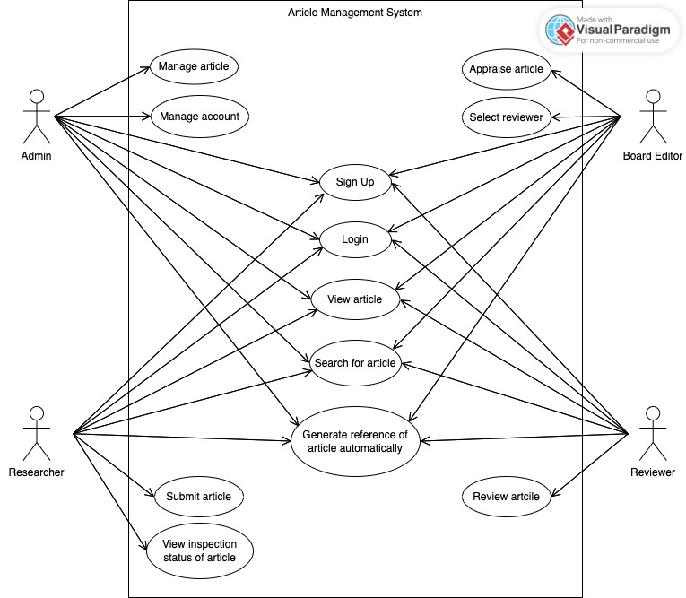

Figure 4. Use Case Diagram for Article Management System.

The Use Case Diagram illustrate all the actors and all the functional requirements of the Article Management System (AMS). There are 4 actors: Admin, Researcher, Reviewer, and Board Editor.

### **3.3.2. Use Case Description**

**Use case 1: Sign Up:**

|  |  |
| --- | --- |
| **Name** | **UC1 – Sign Up** |
| Description | Use case Sign up is an account registration feature for a new member, there are 3 options for the user's role: Researcher, Board Editor and Reviewer. |
| Rationale | An important step to get the website's user data for system development. |
| Actors | All |
| Pre-conditions | * Sign up:   - The user must access the website domain name.  - Email and username for sign up have not been already existed in the system. |
| Basic course of events | * Sign up:  1. User clicks on the "Sign up" button to perform the first step of registering an account. 2. The website will display an account sign up form for the user. 3. After that, the user has to fill all required information . 4. User clicks “Sign up” button. |

Table 1. Use case 1 – Sign up.

**Use case 2: Login:**

|  |  |
| --- | --- |
| **Name** | **UC2 - Login** |
| Description | Use case Login is let users log in with the account and password they have registered with. After successful login, the user can then use the unique features specific to each role the user has registered with. |
| Rationale | An important step to get the website's user data for system development. |
| Actors | All |
| Pre-conditions | * Login:   - The user has registered an account on the website with the registered username and password. |
| Basic course of events | * Login:  1. User clicks on the "Login" button to perform the first step of logging in an account. 2. User enters email, or username and password have registered before. 3. User clicks “Login” button. 4. If user entered wrong information, the system would require entering email and password again. |

Table 2. Use case 2 – Login.

**Use case 3: View article:**

|  |  |
| --- | --- |
| **Name** | **UC 3 – View Article** |
| Description | Use case View article is a feature that help user to view all articles that has been categories shown at homepage. |
| Rationale | Help improve the user experience, enhance the interaction of the system. |
| Actors | All |
| Pre-conditions | Access to the website domain link. |
| Basic course of events | 1. View all article has been categories at homepage. 2. Click on the title of the article to view detail of it. |

Table 3. Use case 3 – View Article.

**Use case 4: Search for aticle:**

|  |  |
| --- | --- |
| **Name** | **UC 6 – Search for article** |
| Description | Use case Search for article is a feature that help user to search for the desire article by using the filter. |
| Rationale | Help improve the user experience, enhance the interaction of the system. The purpose is to increase convenience and save time searching for articles as desired by users. |
| Actors | All. |
| Pre-conditions | Access to the website domain link. |
| Basic course of events | 1. Select desired filter such as name of the article, field of the article, keywords of the article, and authors of the article. 2. Click “Search” button to search. |

Table 4. Use case 4 – Search for article.

**Use case 5: Generate reference of article automatically**

|  |  |
| --- | --- |
| **Name** | **UC 6 – Generate reference of article automatically** |
| Description | Use case Generate reference of article automatically is a feature that let user to generate reference of the article they want to get. |
| Rationale | Help improve the user experience, enhance the interaction of the system. The purpose is to increase convenience and save time searching for articles as desired by users. |
| Actors | All. |
| Pre-conditions | Access to the website domain link. |
| Basic course of events | 1. Click to the button “Generate reference” of the article list. 2. Edit information of article as user’s desire. 3. Click “Generate” to get the reference. |

Table 5. Use case 5 – Generate reference of article automatically.

**Use case 6: Manage article**

|  |  |
| --- | --- |
| **Name** | **UC 6 – Manage article** |
| Description | Use case Manage article is a feature that manage the all of article of the system. |
| Rationale | Help improve the user experience, enhance the interaction of the system. The purpose is to increase convenience and save time searching for articles as desired by users. |
| Actors | Admin. |
| Pre-conditions | Access to the website domain link. |
| Basic course of events | 1. Log in by using admin account. 2. Perform administrative functions. |

Table 6. Use case 6 – Manage article.

**Use case 7: Manage Account**

|  |  |
| --- | --- |
| **Name** | **UC 7 – Manage Account** |
| Description | Use case Manage Account is a feature that manage the account of member of the system. |
| Rationale | Help administrators perform better user management of the site. |
| Actors | Admin |
| Pre-conditions | Log in into admin account. |
| Basic course of events | 1. Log in by using admin account. 2. Perform administrative functions. |

Table 7. Use case 7 – Manage Account.

**Use case 8: Submit Article:**

|  |  |
| --- | --- |
| **Name** | **UC 8 – Submit Article** |
| Description | Use case Submit article is a feature that allow user to submit the article into system. |
| Rationale | Allow users to be allowed to publish public articles, help maintain the number of articles on the system, develop the richness of content for the system. |
| Actors | Researcher. |
| Pre-conditions | Log in into researcher account. |
| Basic course of events | 1. Login to the system with Reseracher account. 2. Click on “My Article”. 3. Click on “My Submisson” tab. 4. Click on “Submit new article” button. The web direct user to new page. 5. Fill in the information form includes Author information, article information:  * Author information: user need to fill in required information form. * Article information: user need to fill in title, abstract, field, and keywords of the articles.  1. Drag or browse file into “Choose file” button. Format file must be Microsoft Word. 2. Click on “Submit” button. |

Table 8. Use case 8 – Submit Article

**Use case 9: View inspection status of article.**

|  |  |
| --- | --- |
| **Name** | **UC 9 – View inspection status of article.** |
| Description | Use case View inspection status of article let user view the inspection status of article. |
| Rationale | Help administrators perform better user management of the site. |
| Actors | Researcher. |
| Pre-conditions | Log in into admin account. |
| Basic course of events | 1. Login by using Researcher account. 2. Click to tab “My article”. 3. View the status of inspection. |

Table 9. Use case 9 - View inspection status of article.

**Use case 10: Apparaise Article:**

|  |  |
| --- | --- |
| **Name** | **UC 10 – Appraise Article** |
| Description | Use case Appraise Article is a feature that help user to appraise of the article as a general assessment of the summary information of the article, such as the format of the article, the criteria of the article, and so on. If the articles comply with the requirements of the board editor, Board Editor click approve for that article. Conversely, if the article violates one of the regulations, the editorial board will reject the article. |
| Rationale | Help improve the user experience, enhance the interaction of the system. The purpose is to appraise of articles easier for editors, thereby improving the quality of articles. |
| Actors | Board Editor. |
| Pre-conditions | Login to the system as the Board Editor account. |
| Basic course of events | 1. Login to the system with Board Editor account. 2. Click on “My Appraisal” tab. 3. View list of waiting article. 4. Click on title of article that need to appraise. 5. View summary of needed information of the article to appraise.    1. Click “Approve” if agree the article, the article would send to reviewer.    2. Click “Reject” if rejected the article to send it back to author(s). |

Table 10. Use case 10 – Appraise Article.

**Use case 11: Select Reviewer:**

|  |  |
| --- | --- |
| **Name** | **UC 11 – Select Reviewer** |
| Description | Use case Select Reviewer is a feature that help Board Editor to select reviewer after approved the article of researcher. |
| Rationale | Help improve the user experience, enhance the interaction of the system. The purpose is to complete the review cycle of a paper. |
| Actors | Board Editor. |
| Pre-conditions | Login to the system as the Board Editor account, the board editor approved the article. |
| Basic course of events | After appraised the article, the Board Editor will:   1. Click “Approve” button, the system would direct to select reviewer page. 2. Search filed of the article. The page would show table of reviewer about that field. 3. Select reviewer by ticking into their name’s box. 4. Click “Send”. |

Table 11. Use case 11 – Select Reviewer.

**Use case 12: Review Article:**

|  |  |
| --- | --- |
| **Name** | **UC 12 – Review Article.** |
| Description | Use case Review Article is a feature that help Reviewer to review the approved article. The reviewer can view the specific content of the article and also the information of the paper such as the names of the authors, the sources of the references and so on. After the article content, there will be a comment box for that article, the reviewer can comment in the review box. Finally, if the reviewer agrees to the article, they would public the article, otherwise, the reject button will be pressed and the article will be sent back to the author. |
| Rationale | Help improve the user experience, enhance the interaction of the system. The purpose is to complete the review cycle of a paper. |
| Actors | Reviewer. |
| Pre-conditions | Login to the system as the Reviewer account. |
| Basic course of events | 1. Login to the system by Reviewer account. 2. Click “My Review of Article” tab. 3. Click to the title of article. 4. View the content and detail information of the article. |

Table 12. Use case 12 – Review Article.

### **Datadase design**

* + - 1. **– Entity Relational Diagram**

Figure 5. Entity Relational Schema

**\**Article* article:** has attribute “id” for identifying id for article; attributes “title”, “abstract”, “field”, “author”, “journal”, “volume”, “pubDate”, for identifying which information of article.

**3.3.2.2 – Entity Relational Schema:**

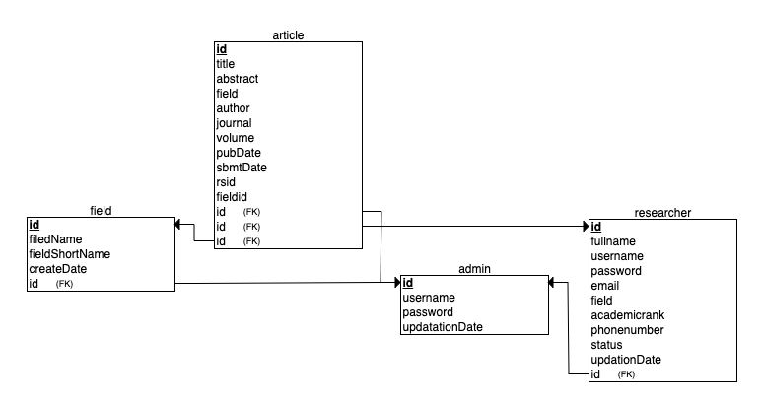

## **User Interface design:**

# CHAPTER 4

# IMPLEMENT AND RESULTS

## **Implement database**

* + 1. **Check for MySQL database management system**

This step is to ensure that the MySQL is installed on the device and set the password for the root user.

Figure 7. Database configuration terminal command

Open the app “MySQL Woorkbench”. Then open the Manage Server Connections window to configure the setting of the project’s database.

Figure 8. Set up Database.

Then click “Test Connection” to check if the connection is successful or not. If it successed, there is the alert window to announce:

Figure 9. Succeed announcement database set up.

Then, the home page of MySQL Workbench shows the “buildThesis” database tab.

Figure 10. Select database.

Click into the “buildThesis” tab. There is a UI to shows the function of MySQL Workbench. Next step is to typing queries and run it to create table in the database. Click to “create a new scheme” icon to create new database, then fill to the name box:

Figure 11. Create new scheme.

Then click “Apply” to create “buildThesis” database:

Figure 12. Create database.

Next, typing queries to create table for the database:

Figure 13. Querying database

* 1. **Result:**
     1. **Login:**

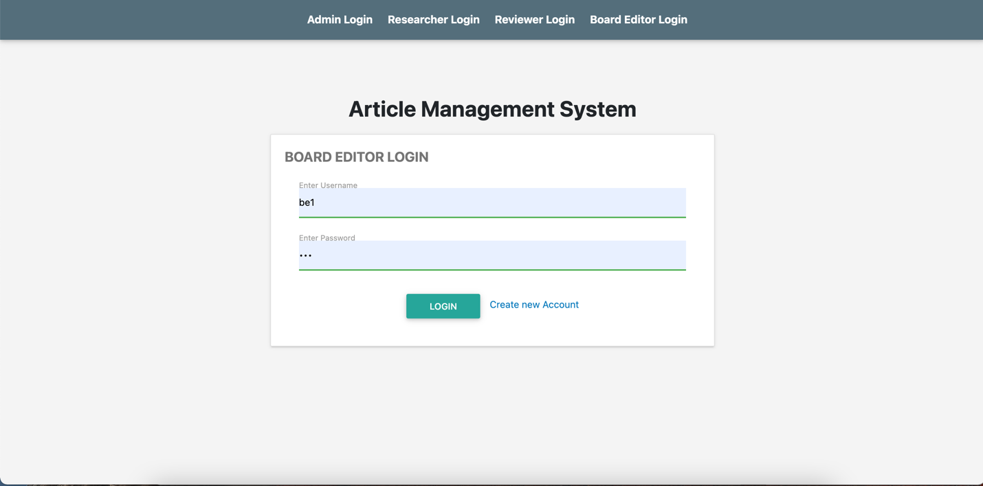

Figure 14. UI Login.

**\*Description:** Login page with roles of Admin, Research, Reviewer, and Board Editor.

* + 1. **Register account:**

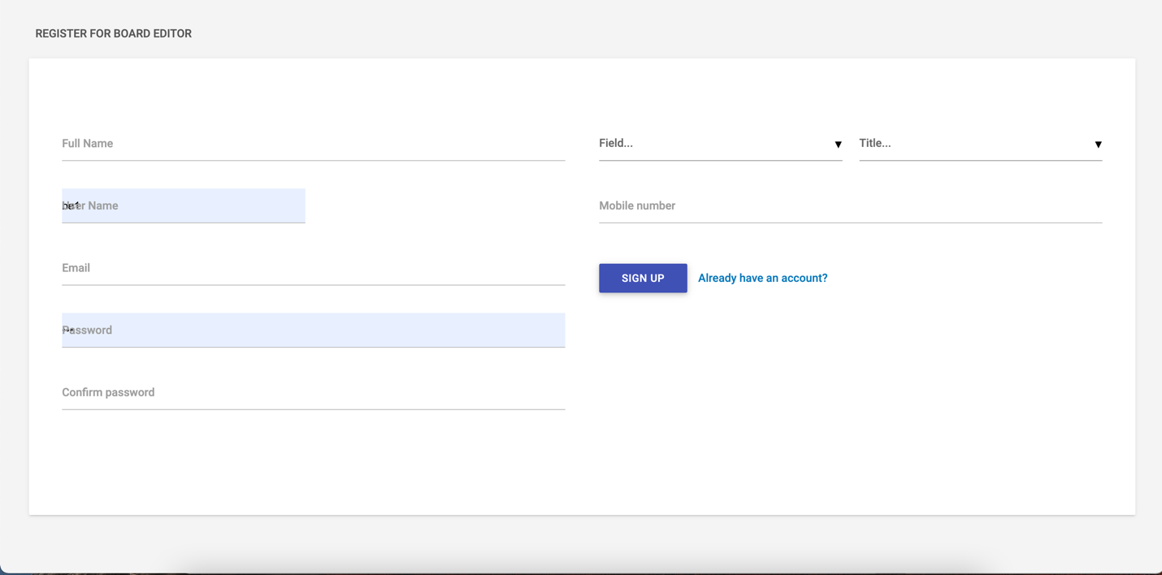

Figure 15. UI Register account.

**\*Description:** Sign up for new account, system allows user register new account with possible roles: Board Editor, Researcher, Reviewer.

* + 1. **Module Manage User’s Accounts/ Article:**

Figure 16. UI Manage User’s Accounts and Article*.*

**\*Description:** For Admin account, user can create new account for Researcher, Board Editor, Reviewer.

Figure 17. UI Manage User’s Account.

**\*Description:** For Admin account, user can remove or edit profile of Researcher, Board Editor, Reviewer. This function belongs to Module of Mange User’s account.

* + 1. **Module Submit Article:**

Figure 18. UI Submit Article.

**\*Description:** For Researcher account, user can submit new article.

* + 1. **Module Manage Article:**

Figure 19. UI View List of All Article.

**\*Description:** User can view list of all article.

Figure 20. UI View Information of Article.

**\*Description:** User can view information of article.

Figure 21. UI Appraise Article.

**\*Description:** User can view information of article

# CHAPTER 5

# DISCUSSION AND EVALUATION

## Discussion

With the above features, it has met almost all the necessary needs in managing the publication of articles. However, the system still has some points that are not yet optimal. The points that are not optimized will be discussed in the next evaluation step below.

With the completed functions of the "Web-base Article Management” system application (WAM), which have been described in detail in the previous sections of this project document. In this section, the purpose is to discuss the advantages and disadvantages of WAM with the applications listed in Chapter 2.

* + 1. Website SCIMAN

Compare with SCIMAN website. The first point of comparison is the article classification, the article classification of the SCIMAN system is more extensive than that of the WAM system here. SCIMAN system includes types of articles such as: SCI-E journal papers, SSCI journal papers, non-ISI journal papers, ESCI journal papers, Scopus journal papers, Domestic journal papers and so on. The second point so compare is that the searching engine, the WAM filter engine is still on develop, about SCIMAN filter engine is much richer variety with more specific filtering objectives such as filtering by time, filtering by divisions, filtering by article types, filtering by author name, filtering by keywords. The third comparison point is the interface design of the system, in the SCIMAN system, the interface is designed more eye-catching with more beautiful harmonious colors, more user-friendly. The user interface design of the SCIMAN website is analyzed and designed with the article categories, the user can more easily see how much each type of newspaper has.

* + 1. Website Academic Journals

Compared with the Academic Journals (AJ) website, the AJ system shows more information about submitting articles to wait for approval, along with detailed information about the conditions for those who want to submit articles. All must be agreed, such as the information to be submitted in the article must be in English, the review period is about six months to a year and there is no charge.

## Comparison

The following statistical table will provide an overview of the respective functionalities by both WAM and the other listed applications in chapter 2.

|  |  |  |  |
| --- | --- | --- | --- |
| Feature | SCIMAN | Academic Journal | WAM system |
| Submit article | Yes | yes | yes |
| Manage article | yes | yes | Yes |
| Search article using filter | yes | no | Yes |
| Auto generate reference of article | no | no | Yes |
| Download article | yes | yes | no |

## Evaluation

Coming to the evaluation of the WAM system, we must first evaluate the advantages of the system. The WAM system has achieved almost all the functions required by the user such as: The system ensures that the user can log in and create a new account, all passwords are encrypted. The system allows users with accounts to manage their own articles, easily add new ones, or edit and delete their existing articles. Additionally, the system includes a filter to help users easily find articles. A special feature of the system is that for each article, the reference information will be automatically generated.

Come to evaluate the limitations limitation of the system is that the user interface design is not modern and smooth, if compared with the interface of the two websites SCIMAN and Academic Journals, the interface of those websites shows the User-friendly is higher. The final limitation of the system is that the system still does not have the feature to download published articles, which needs to be developed at the earliest in future work.

# CHAPTER 6

# CONCLUSION AND FUTURE WORK

## Conclusion

In conclusion, the Web-based Article Management (WAM) system is a powerful and efficient web application designed to revolutionize the way articles are managed and accessed. Throughout this thesis project, we have explored the various features and functionalities of the WAM system and examined their benefits and advantages.

The WAM system offers a comprehensive set of features that greatly enhance the management of articles and users. Firstly, the system allows users to easily manage articles by providing functions such as creating, editing, and deleting articles. This streamlines the article management process, ensuring that information remains up-to-date and organized.

Furthermore, the WAM system incorporates a user management component, enabling administrators to control user access and permissions. By assigning roles and permissions, administrators can ensure that the right individuals have the appropriate level of access to the system's resources. This enhances security and promotes collaboration within the platform.

One of the standout features of the WAM system is its advanced search and filtering capabilities. Users can easily locate articles by employing various search parameters, such as author, title, keywords, or publication date. This functionality greatly reduces the time and effort required to find specific articles, increasing productivity and efficiency.

Additionally, the WAM system offers a special function that automatically generates article references. With a simple click on the article title, the system generates the appropriate reference format, saving users valuable time and eliminating the risk of citation errors. This feature proves to be immensely beneficial for researchers, students, and academics who heavily rely on accurate referencing.

Overall, the WAM system proves to be a highly beneficial and indispensable tool for article management. Its features, including comprehensive article and user management, advanced search and filtering capabilities, and the automatic reference generation function, significantly streamline and enhance the article management process. By utilizing the WAM system, organizations, researchers, and academic institutions can optimize their workflows, improve productivity, and ensure the accuracy and accessibility of their article collections.

As the digital landscape continues to evolve, the WAM system serves as a vital asset for efficient article management in today's fast-paced world. Its user-friendly interface and robust functionalities make it an invaluable tool for anyone involved in the curation and organization of articles. The WAM system stands at the forefront of technological advancements in article management, empowering users to focus on their research and knowledge dissemination with ease and confidence.

## Future work

First, it is necessary to complete the filter function by specific criteria such as filtering by publication year, filter by author name, filter by article type, filter by keyword, filter by reference source. survey. The second thing to do, develop the download feature of published articles on the website to make it more convenient to view and evaluate articles. The last thing is to develop a more user-friendly interface, a more modern design, making users more excited when using the website.

# CHAPTER 7

# REFERENCES

**REFERENCES**

|  |  |
| --- | --- |
| [1] | "SCIMAN," 10th April 2022. [Online]. Available: https://ord.hcmiu.edu.vn/rm/sciman. |
| [2] | "Athens Institute for Education & Research(A World Association of Academics and Researchers)," 10th April 2022. [Online]. Available: https://www.athensjournals.gr/. |
| [3] | "MDN Web Docs," 12th April 2022. [Online]. Available: https://developer.mozilla.org/en-US/docs/Learn/Getting_started_with_the_web/HTML_basics. |
| [4] | "A+ Topper," 12th April 2022. [Online]. Available: https://www.aplustopper.com/advantages-and-disadvantages-of-html/. |
| [5] | "MOTOCMS," 12th April 2022. [Online]. Available: https://www.motocms.com/blog/en/advantages-and-disadvantages-of-css/. |
| [6] | "UPLERS," 12th April 2022. [Online]. Available: https://www.uplers.com/blog/what-are-the-pros-cons-of-foundation-and-bootstrap/. |
| [7] | "tutorialspoint," 12th April 2022. [Online]. Available: https://www.tutorialspoint.com/advantages-and-disadvantages-of-javascript#:~:text=Advantages%20of%20JavaScript,simple%20to%20learn%20and%20implement.. |
| [8] | "techstrikers," 13th April 2022. [Online]. Available: <https://www.techstrikers.com/MySQL/advantages-and-disadvantages-of-mysql.php>. |
|  | **LIST OF FIGURES**  *Figure 1. Structure of Thesis.* 10  *Figure 2. SCIMAN website.* 12  *Figure 3. Athen Academic Journals website.* 14  Figure 4. Use Case Diagram for Article Management System. 21  Figure 5. Entity Relational Schema 27  Figure 6. Entity Relational Schema 30  Figure 7. Database configuration terminal command 35  Figure 8. Set up Database. 35  Figure 9. Succeed announcement database set up. 35  Figure 10. Select database. 36  Figure 11. Create new scheme. 36  Figure 12. Create database. 37  Figure 13. Querying database 37  Figure 14. UI Login. 38  Figure 15. UI Register account. 38  Figure 16. UI Manage User’s Accounts and Article*.* 39  Figure 17. UI Manage User’s Account. 39  Figure 18. UI Submit Article. 40  Figure 19. UI View List of All Article. 40  Figure 20. UI View Information of Article. 41  Figure 21. UI Appraise Article. 41 |