Hey Don/Kashif,

I think it's been thoroughly tested.  The following are some changes to the form:

In General:  When starting to type in a field, it immediately comes up red (in a mandatory field) and an error message comes up.  From a user standpoint when I was filling it out, I stopped and read the error message.  Shouldn't the error message come up after I'm done typing and attempt to move on into another box?  That's at least my experience with these online forms.  I could be wrong, but if it is a choice I think it would be preferred to have an error message display after I'm done typing and/or after I've made a mistake.

A field should no longer come up red if it is a mandatory field before you actually enter the field, however the field will turn red if you are entering data and the current state of the data is invalid. (ie. If you start entering phone numbers, the field will be red until 7 digits are entered. Similarly if you enter characters in a numeric field.)

As well, the telephone number section turns red with an error when I start typing, but it accepts it in green after I've typed 6 digits.  Not sure why 6 digits was chosen as the acceptable amount.  But the phone numbers should be accepted after 7 digits.  Any less an error message comes up (can accept hyphens and non-hyphens).

Not sure what happened here but the validation has been altered. The field was also limited to 20 characters in total which accounts for what appeared to be a limit on the number of digits in the extension. In reality, you were trying to enter more than 20 characters.

One other general problem came up when we copied and pasted a field, it didn't recognize characters written in the field.  For example location manager and on set contact, if they are the same person with the same contact information, the user may just want to copy and paste the information in.  When we did that, it didn't recognize anything in the box where we pasted it.

I have to see this in action. I could not replicate this and standard cutting and pasting appear to work.

Also when I finished entering the information I pressed enter, and seemed to have lost everything.  I understand it's a test page so it's not exactly how it will be displayed, but I just wanted to confirm what is going to happen when it is active and the user presses enter.

When you press enter, you should see

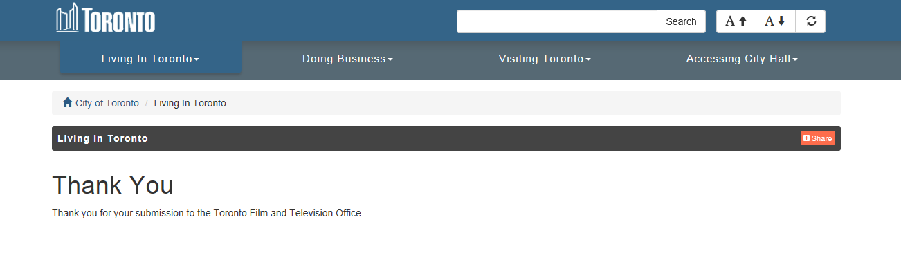

There is "certificate" errors in the QA environment that may be preventing this but I can demonstrate this.

This is not working in my temporary environment but should be in the final product..

**Production Information:**

* The order of fields:  Project title, then Production Type, followed by Broadcast Platform, Content Provider, then Network.  This would essentially only be moving up "production type" to the second field.

I believe this was done due to the extra fields that appear when Broadcast platform is Other and depending on the production type where additional fields are required for series, reality etc.

I've rearranged the screen but an additional line is added:

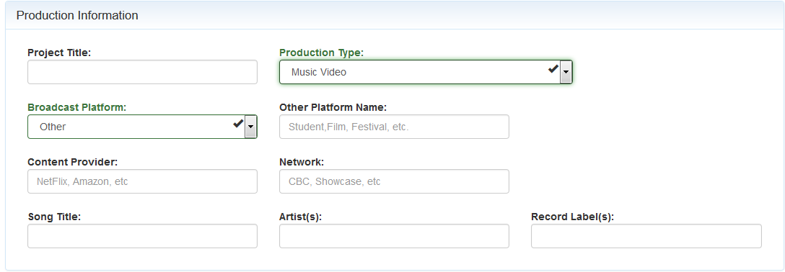

* Broadcast Platform when Other is chosen: We need to provide some examples of what "other" would be.  So either in the red error message or in grey "i.e. Student, Film Festival, etc…"

I added "Placeholder" comments (ie. Text in the grey)

* When certain Production Types are chosen please add mandatory fields for content provider OR Network.  Meaning when they choose a certain production type, only one of the fields content provider or network is mandatory.  Once they type something in one of those two fields, then both would turn green and accept.  The production types that would require this would be: Series, Reality, TV Movie.

This was added. The validation occurs when you hit the submit button. If the user chooses to enter BOTH fields there is nothing to prevent it.

* Production Type "Special" – Is missing the description.  Should be "Special (short film, documentary, variety)".

fixed

* Schools:  Please delete the following schools from the pre-populated list:  Canadian Film Centre, Sheridan College.

fixed

* Schools.  When a student is clicked, and the list of schools come up and one of them is chosen, would it be possible to automatically insert their address information for the school.  We have this information and it doesn't change so if it could be automatically entered.  If possible, I've attached the addresses for the schools we have listed, and the field titles that would correspond with the info.
* Could a submitter update/change the school address? Does the address even need to show up on the screen? Perhaps it only need to show up in the back-end and as such we can add it as we are putting the data into domino.

I'm not sure if some Domino application will ultimately be built using the back-end data, but if so, then adding the school address as a "reference table" in the back-end would make more sense.

* Seeing the new email chain.. I will default school into production company name

**Business Contact Info:**

* Please take out the word "optional".  When they see that word they will not fill it out.

In general [OPTIONAL] was removed from all placeholders

* Street Address: A format for this needs to be written somewhere, either in grey or in the red error message.   Street number, street name, city, country, postal code.

Placeholder (grey text) was added.

* Telephone numbers: the extensions seem to be limited to 3 numbers only.  Should be expanded as there are extensions that are longer than 3 digits.

(see above, this was really a limitation of 20 characters 416-xxx-xxxx ext 123 is actually 20 characters)

* On set Contact Name – Please change "On set Contact Name" to "Production Manager Name"….please change these 3 fields to non-mandatory fields. Make this "if applicable." in grey.

Fixed: but I wonder "if applicable" is necessary. This is similar to the "Optional" concept

**Management and Cast Info:**

The word Optional should be deleted from all the fields in grey.

Fixed

**Production Dates:**

* Total number of shooting days in studio: Please change the grey "optional" to "if applicable".

Fixed

**Budget Information:**

* Budget:  When entering numbers, can the commas and decimals automatically appear as they type it in?  I see that once it is submitted in the backend, there is no standard for the budget as it's all different.  Some looking like 26000, and others 26,000.00, 26000.00.  There needs to be a standard and all of them the same.

Numbers are now formatted with commas and decimals

* "If Toronto, Indicate Post House", please take optional (in grey) and put in "if applicable".

Fixed: but is If Applicable neccessary

* Production Country of Origin: If I pick Canadian co-venture, it has to give me another box to type in what that other country is along with Canada.  That box should be open, 50 characters.

New field added

* "Toronto Playing as": please include in grey "city or not applicable" in grey.

Fixed

**Domino Interface:**

I'm not sure what is supposed to occur within domino but currently Domino is configured to accept 3 fields: date created, subject and a formatted text of the contents of the form.

I don't see an email being produced. I'm not sure what the back-end design is supposed to be. Perhaps it was intended for the back-end to send the email once it was accepted.

I will need to check into this

So I take it there needs to be work done on this now, as it's just raw data in no particular order.  When we spoke we spoke about being able to manipulate it, search specific titles or words in certain fields, export it to an excel document, and have it directly put into FOPS.  Right now its just a large list of what was inputted.  We would need the ability to manipulate the data as well, change words that they typed in, search by project title, or production company, etc…  We would also like the system to email [filmtoronto@toronto.ca](mailto:filmtoronto@toronto.ca) once it is completed with the project title so we can identify what has come in.

We would need to talk about the next step.

But other than these above changes, the form looks great and we are excited to see this change implemented.

Thanks,