# Google Spread Sheets

## 1) Load spreadsheet into google

<https://drive.google.com/drive/my-drive>

(log in with the google user id). 15 Gig is free.

## 2) New --> Google Sheets

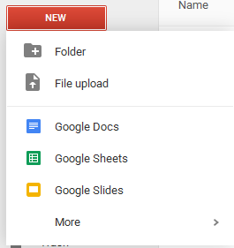

## 3) in the google sheets:

**File --> Import**

Select Upload

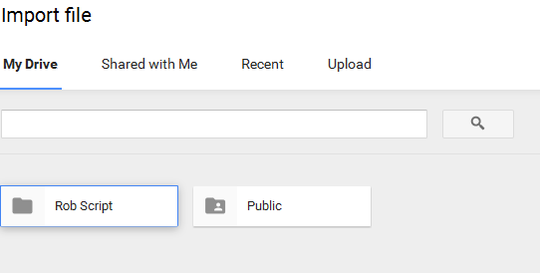

## 4) Select "upload"

Then "select file from computer". Search and find the .xlsx. I loaded: Pickup Schedule 2016.xlsx

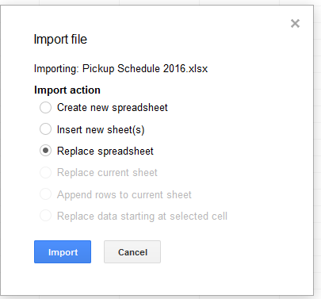

Make sure "replace" is selected and click import

* This takes a few seconds. After the import I got an empty sheet and to me didn't seem to be working.. be patient.

## 5) Title the spreadsheet (if desired)

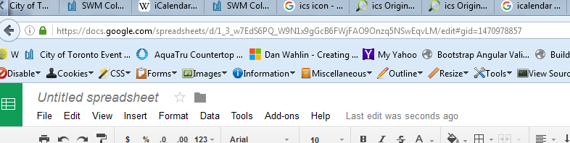

Notice all tabs were uploaded:

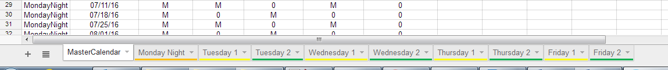

## 6) Rename spreadsheet to something notable.

Back in "My Drive", you'll see a file called spreadsheet. (the uploaded spreadsheet would have be auto saved).



**Right click --> Rename** and put in an appropriate name. (ex: SWM Pickup Schedule)

**Right Click --> Share** --> and make sure "anyone with link can view"

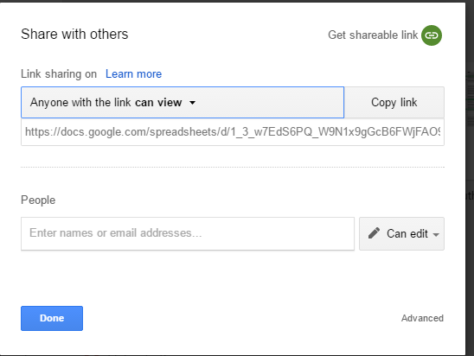

## 7) Verify formatting in spreadsheet is correct

The MasterCalender tab is really the only tab that is used in the application.

a) Select column B (Weekly Startting).

Format --> Number --> more Format --> Customer Number Format

And make sure the format is "YYYY/MM/DD"

b) Make sure the column headers do not have any leading spaces. In the latest spreadsheets in open data, the ChrismasTree column header have a leading space. This must be removed.

[why? Because column headers become JSON property names and a leading space caused problems]

## 8) Publish spreadsheet.

Click on the file and go back into the google sheet editor. (Verify the spreedsheet still looks and seems ok)

**File --> Publish to the web**

Make sure "entire document" is selected

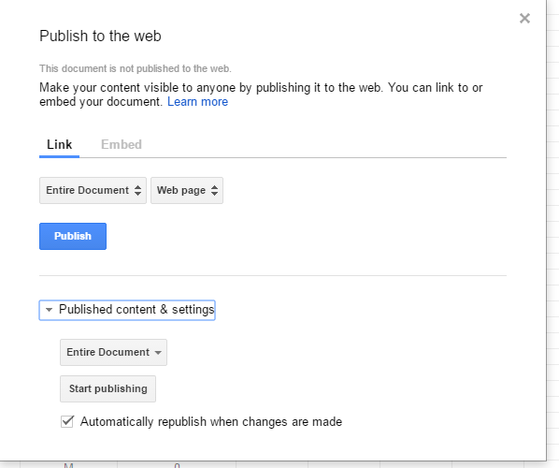

Click publish

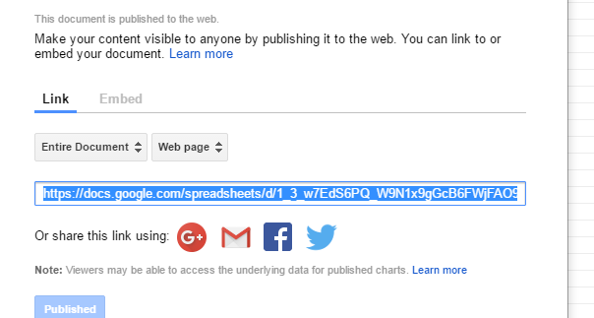

I need to know the link: copy and paste this and send it back to me. This is hard coded in the application code.

Notes:

**If you are in editing the spreadsheet, the related JSON feed used in the application will fail and the application will fail.**

**So any updates to the spreadsheet done manually should be done quickly (ie. A quick cut and paste)**