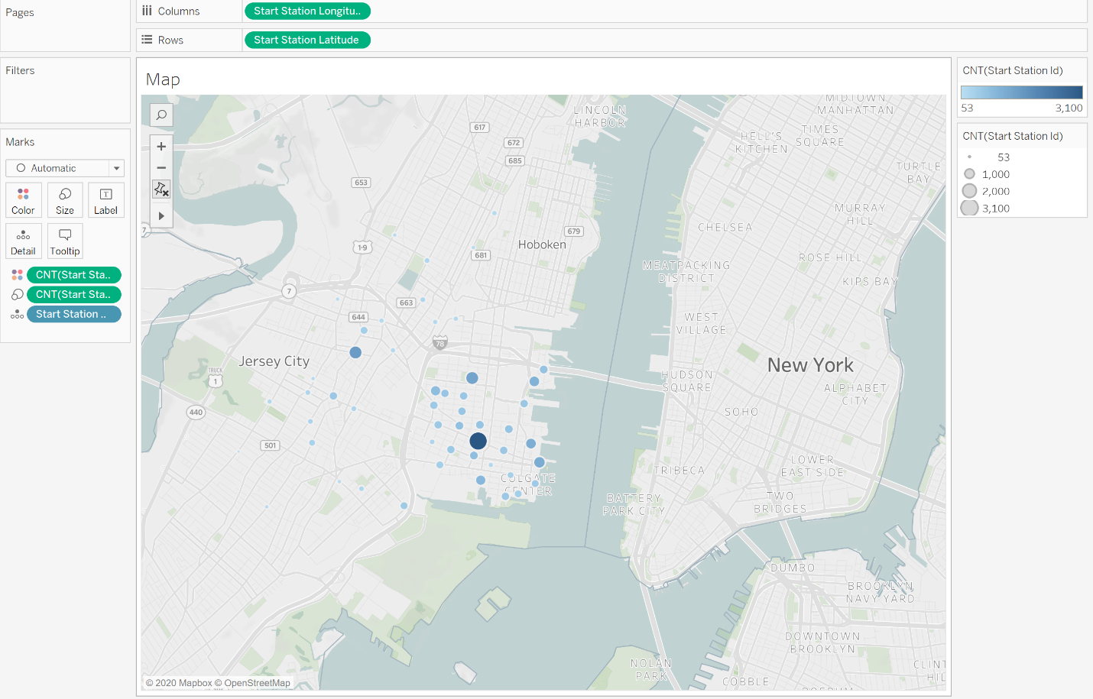Map

This map indicates the frequency of trips by bike station.

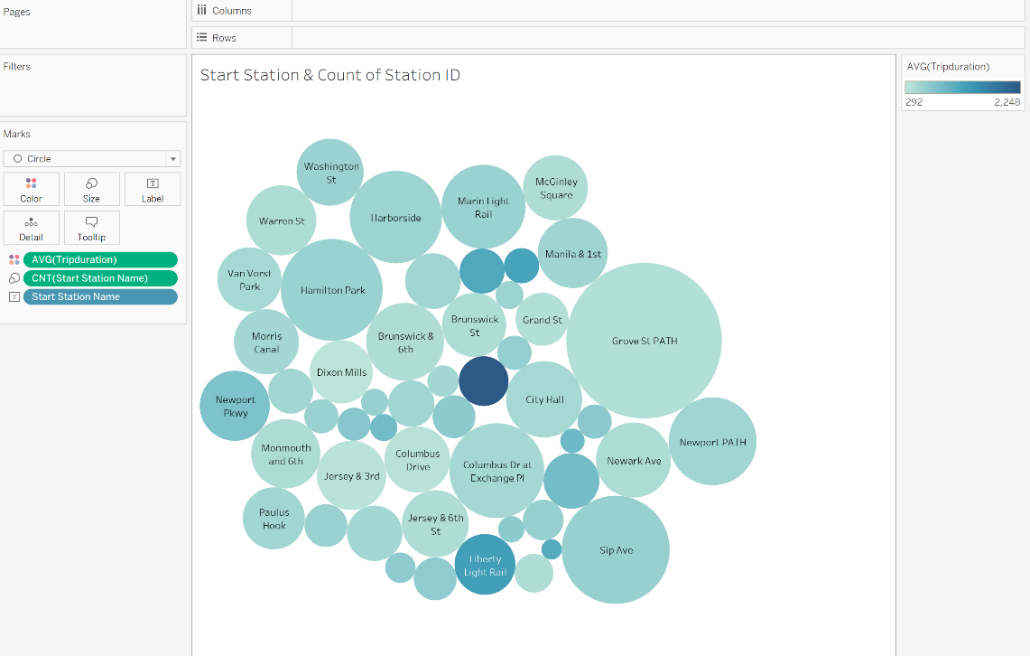Chart 1: Count of starting locations by Average Trip Duration

This chart indicated that the higher frequency locations actually have shorter trip durations. In other words, the less frequency locations result in longer duration trips. This may due to the low frequency locations not being in popular areas and the customers are using these locations to go to the stations in higher demand (aka more popular areas)

Chart 2: Count of Start Locations by Average Trip Distance

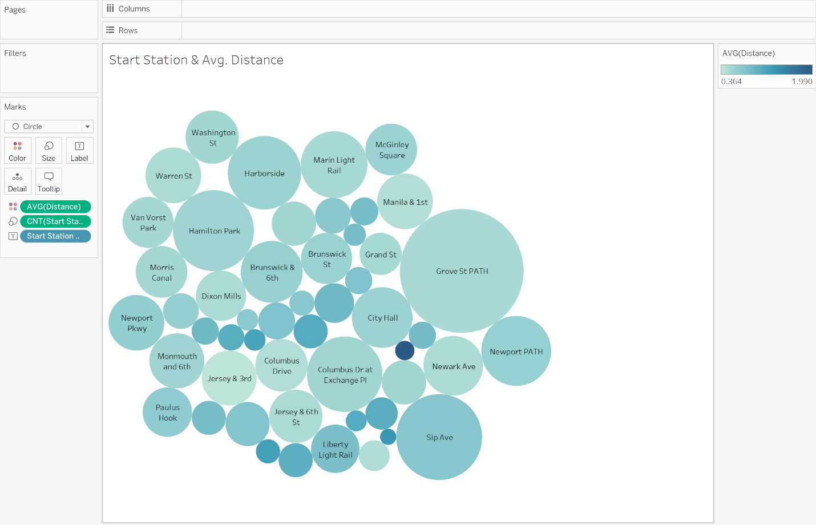This chart further indicates that the lower frequency stations may be further away from areas in higher demand. Thus, individuals taking rides from low frequency stations need to ride further to the areas in demand.

Chart 3: Age by Speed 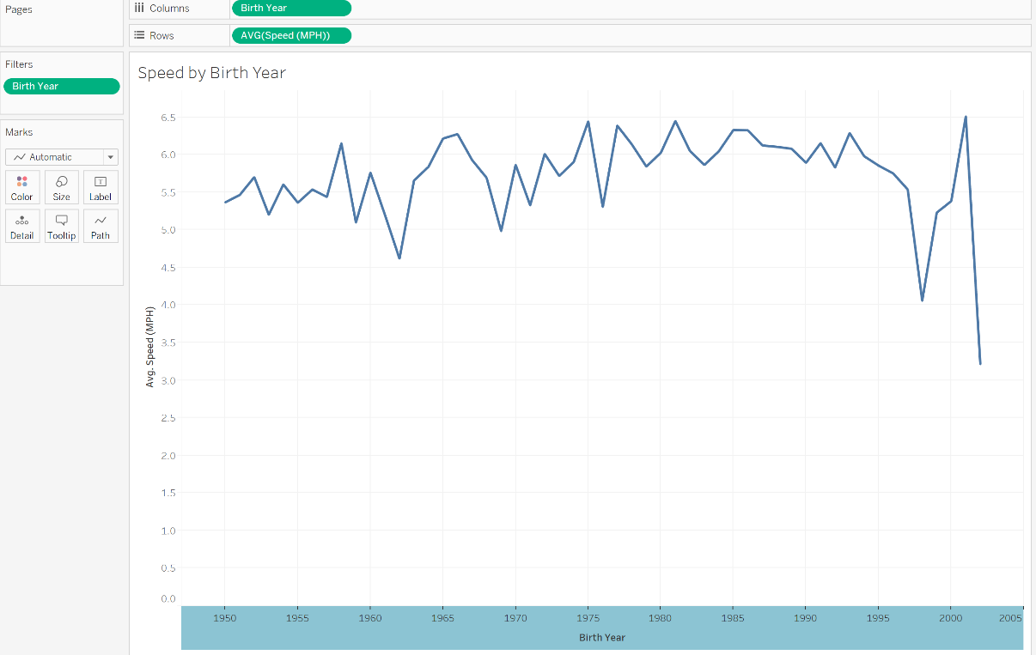

This chart shows that there is a slight upward trend in the speed of users by age. In other words, younger individuals ride slightly faster than older individuals.

Chart 4: Customer Type by Avg Speed, Avg Distance and Number of Trips

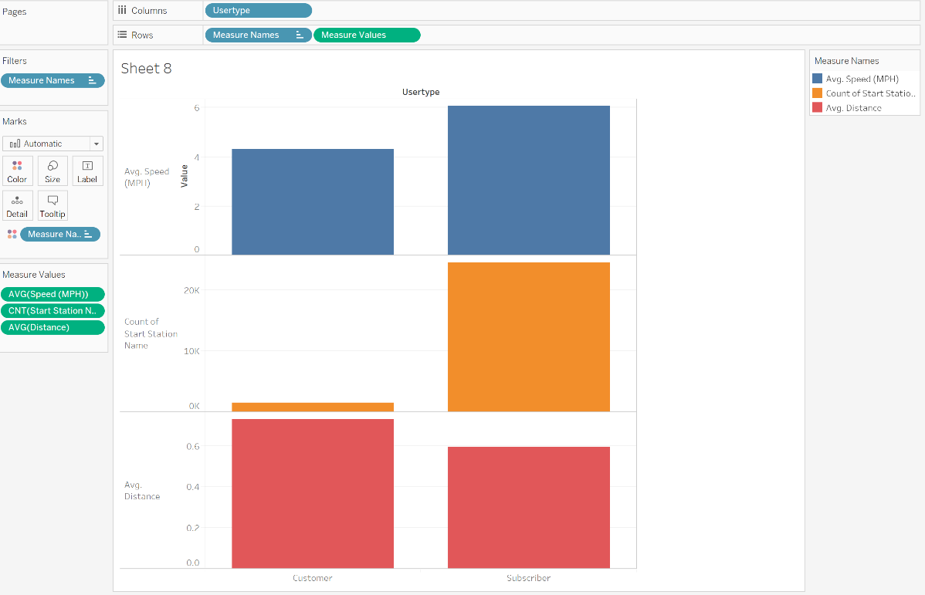

This chart indicates that subscribers to city bike share typically use the services more and ride at a slightly faster pace. However, it appears that subscribers typically take shorter trips than non-subscribers (customers)

Dashboard 1:

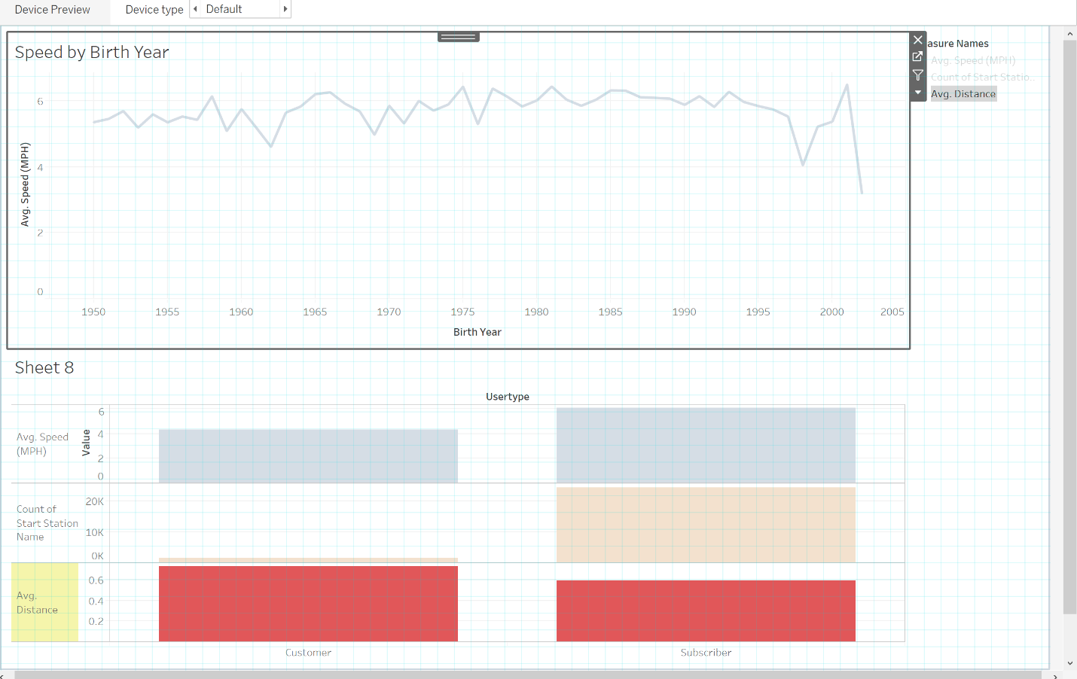

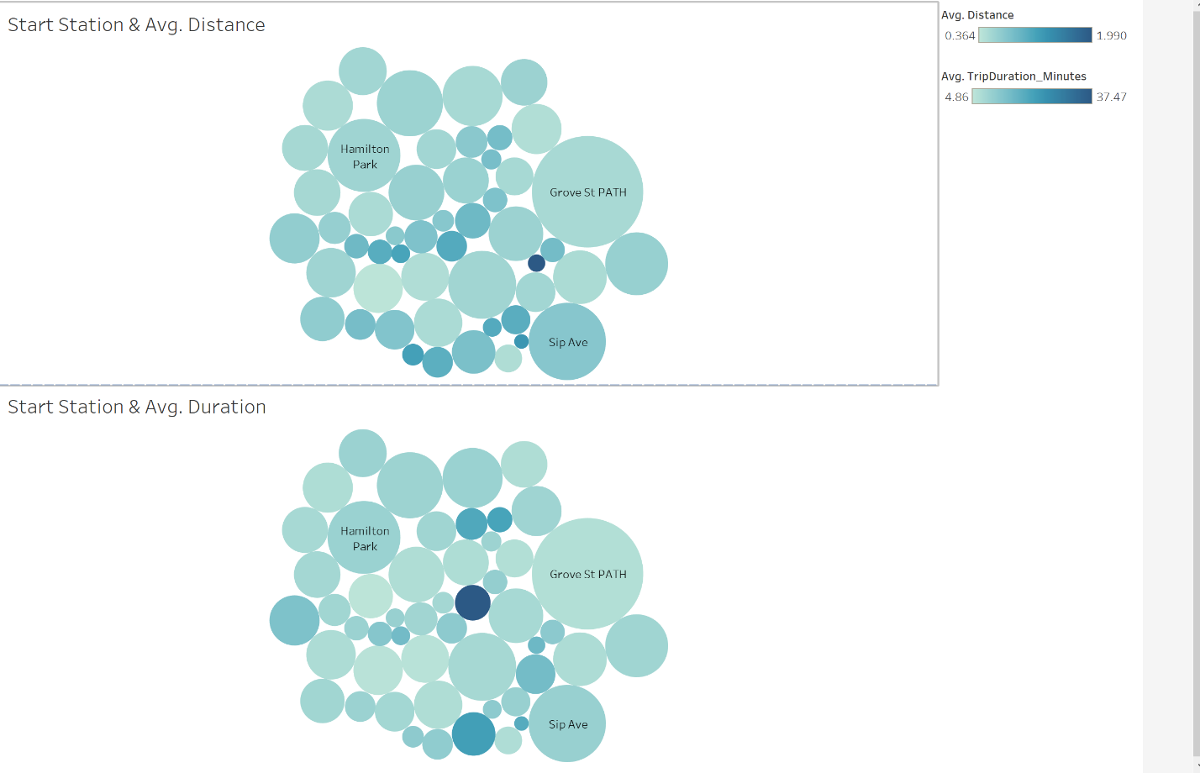Dashboard 2:

Story:

