**Review - MCQ**

**Review 1**

**Binary & decimal & octal & hexadecimal**

1. C 1、A

**Print method & String literal**

1. A 3、D

**Operator**

1. C

**Casting & Operator procedure**

1. D 9、E

**Data type**

6、C

**Double-round-off error**

1. B

**Review 2**

**Boolean expressions**

1、C

**Boolean expressions &Logical operator**

1. C 3、E

**Different between if-else if-else and if-if-else**

4.A

**Iteration -while**

5.D

**Iteration -nested for loop**

1. C

**FRQ**

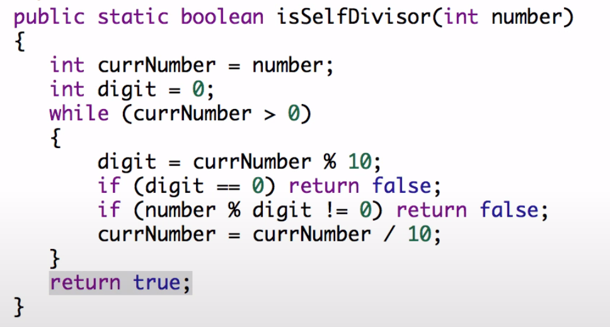

**Review 3**

**Objects & classes**

1、C

**Calling method**

2、D 3、E

**Overload method**

4、D

**Aliases**

C

**Review-4**

**String class method**

1、B 2、E

**equals() & ==**

D

**Wrapper class**

2、A

**Math class**

1、D 2、E

**Review 5**

**Local variable**

1、A 2、D

**Static**

1. B 2、B

**Override methods**

C

**Super keyword**

1. **D 3、E**

**Creating references using inheritance hierarchies**

1.B

**Polymorphism**

1. D 3、D

**Object subclass （toString() & equals()）**

1. C 2、A

**Review 6**

**Array**

1. E 2、C

**Array-For loop & for each loop**

1. D

**Reverse array**

1. A

**Found maximum value**

1. B

**ArrayList method**

1. D 2、A 3、C

**2D array**

1. C 2、D 3、A

**Review 7**

**Searching & Sorting**

**Recursion**

0123456

D D

**Binary search**

Quiz1 A

Quiz2 B

**Binary search recursion**

6 2 4

**insertion sort**

1、C

**Selection sort**

1. C

**Merge sort**

A E D