This document describes the instruction for RPSLS game Steven Li developed.

When you run ‘npm start’, you can see the game interface on <http://localhost:3000>.

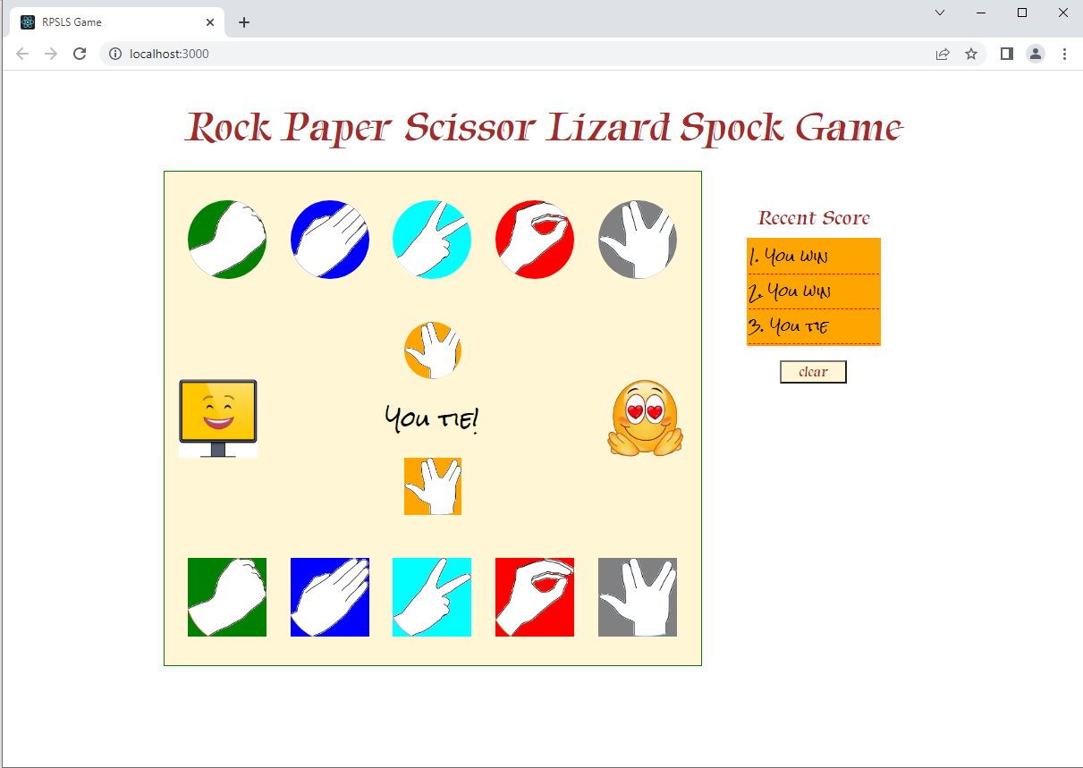

Computer’s choice

Game result

Clear button

Score board

User’s choice

User side

Computer icon for game result

User icon for game result

Computer

Main game screen

The game flow is as below.

After a user selects one of the 5 pictures in the bottom part, the computer selects the random picture.

The image selected by the user is shown as the “User’s choice” icon, and the image selected by the computer is shown as the “Computer’s choice” icon.

By comparing the computer’s choice and the user’s choice, the winner of the game is decided.

The recent score shows recent 10 game results and it is reset when the user clicks the “clear” button.

The description of icons

|  |  |  |
| --- | --- | --- |
| Game result | User Icon | Computer Icon |
| User wins |  |  |
| User loses |  |  |
| Ties |  |  |
| On-progressing |  |  |

Enjoy it!