Final project report
Outdoor environment rendering
- 功能展示
- Blinn-Phong shading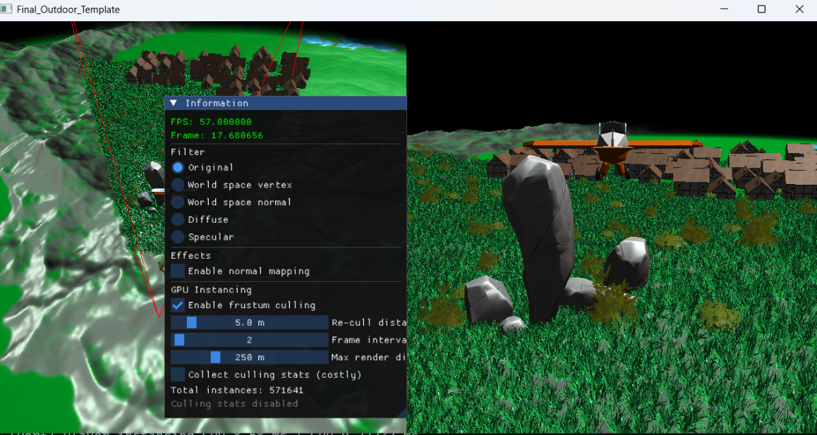
- Deferred shading
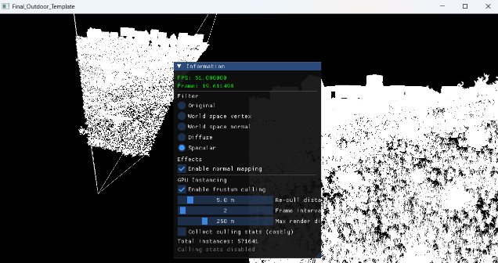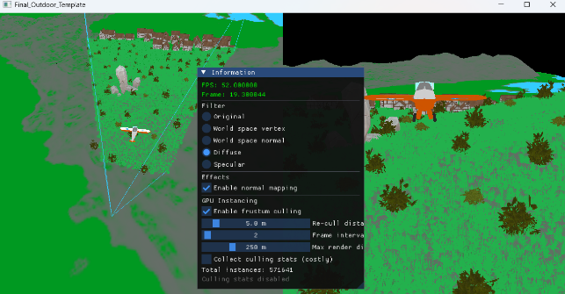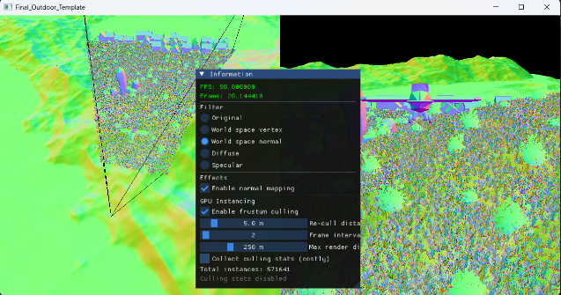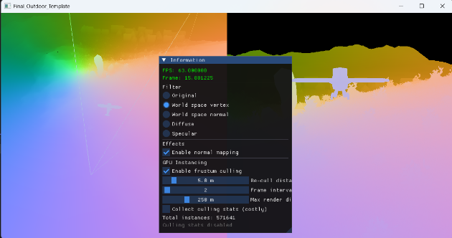

- Normal mapping
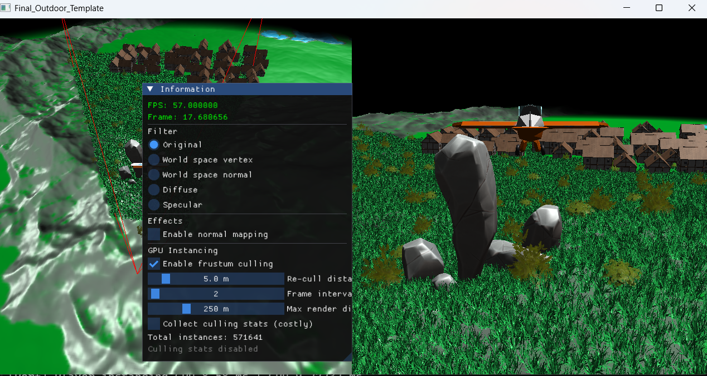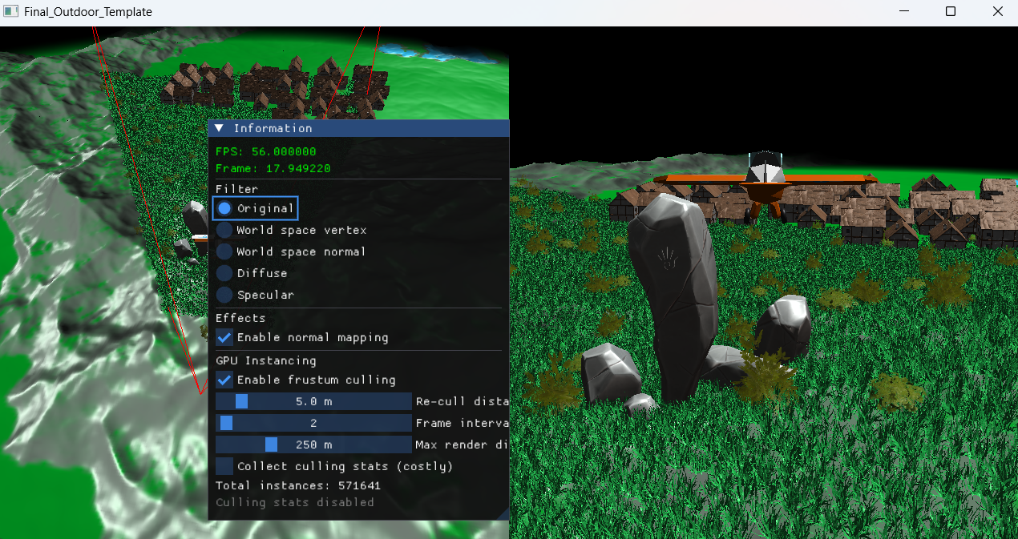

- Rendering & Culling
- When the re-cull distance and frame interval are too large, there can be a noticeable delay in updating the visibility of instances.
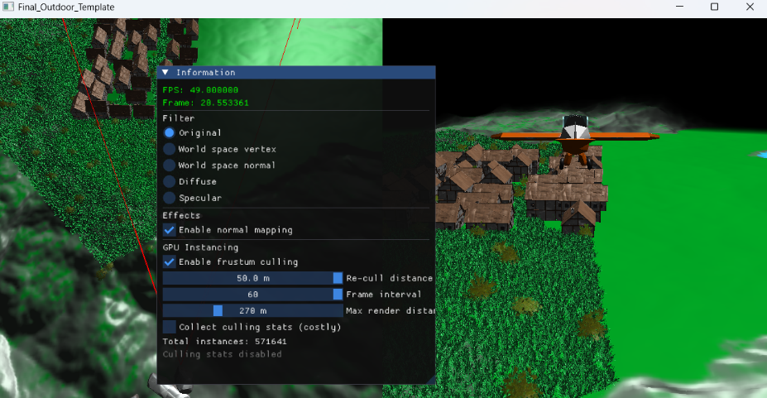
- Render distance
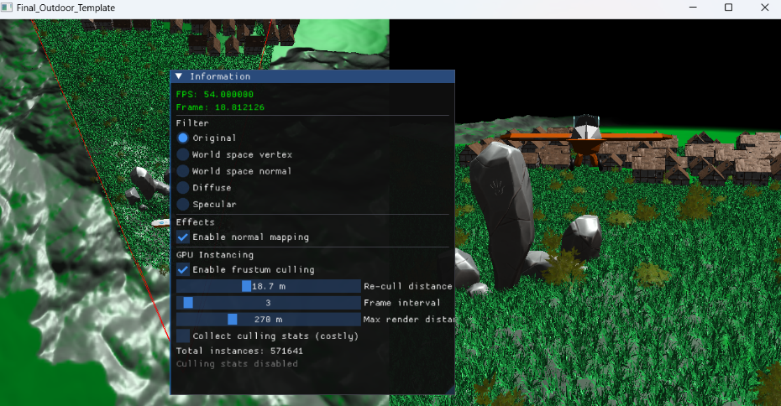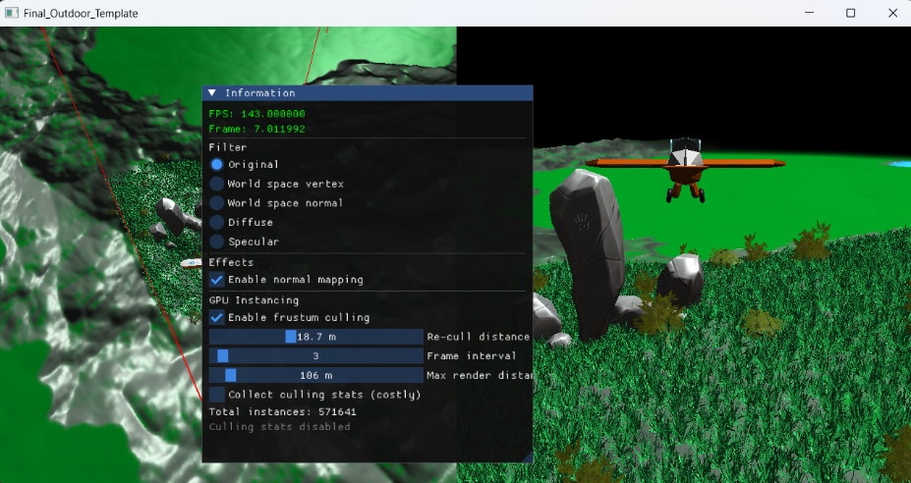
- 分工表
鄧智祥 | Render scene correctly  Blinn-Phong shading
李岱凌 | Deferred shading  Normal mapping
周伯穎 | Foliage and buildings indirect instancing rendering  GPU-driven view-frustum culling with bounding sphere

