Student Answer — Automated Testing & TDD

Name : Steven Lie
NIM : 2501001234
Course: COMP6100001 - Software Engineering

Question:
Explain what Test-Driven Development (TDD) is, describe its Red-Green-Refactor cycle, and explain the benefits and challenges of adopting automated testing in a software project.

Answer:
1. Automated Testing — Definition
Automated testing is the process of using scripts or tools to execute pre-designed tests on software to validate its functionality, performance, and other attributes automatically without human intervention. For example, a script can automatically test login functionality each time the codebase is updated, ensuring no regression occurs. In modern Agile software projects with frequent releases, automated testing is essential to accelerate validation cycles and maintain consistency across test runs.


Figure 1: Why Automated Testing Matters

2. Types of Automated Tests
There are three main types of automated tests: (1) Unit Tests — validate individual functions or methods in isolation; (2) Integration Tests — verify interactions and data flow between components; (3) End-to-End (E2E) Tests — test complete user workflows across the entire system, simulating real user interactions from start to finish.

3. Test-Driven Development (TDD)
TDD is a development approach where tests are written BEFORE the actual production code. Instead of writing code first and testing later, developers define expected behavior through a test, then implement only the minimum code needed to satisfy that test. This approach guides code design from the perspective of requirements and desired behavior.

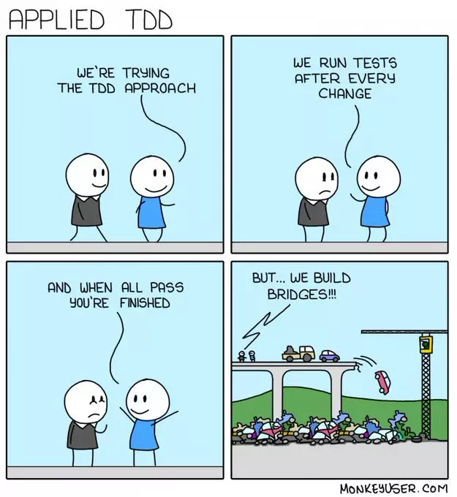
Figure 2: Test-Driven Development Overview

4. The TDD Cycle: Red-Green-Refactor
The TDD cycle consists of three repeating phases:
RED — Write a failing test that describes a small new feature or improvement. The test must fail initially because no code exists yet to satisfy it.
GREEN — Write the minimum amount of code required to make the failing test pass. Focus on simplicity: just enough to meet the test, nothing more.
REFACTOR — Clean up the code by improving structure, readability, and efficiency without changing external behavior. All tests must continue to pass after refactoring.
Example: For a factorial function — write a failing test for f(5)=120, implement the basic recursive function to pass it, then refactor to handle edge cases like f(0)=1 cleanly.

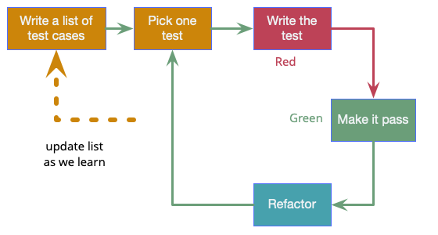
Figure 3: The Red-Green-Refactor TDD Cycle

5. Benefits and Challenges of Test Automation
Key benefits of test automation: (1) Increased Testing Speed — automated tests execute far faster than manual testing; (2) Improved Test Coverage — enables repetitive testing across many scenarios; (3) Early Defect Detection — tests run on every commit, catching bugs before they escalate; (4) Consistency and Reliability — eliminates human error from repetitive tasks.
Challenges: (1) Initial Setup Costs — significant investment in scripts, tools, and frameworks; (2) False Positives/Negatives — poorly designed tests produce misleading results; (3) Maintenance Overhead — tests must evolve as the codebase changes; (4) Not Suitable for All Tests — manual exploratory testing remains essential for usability, UX, and edge case discovery.

Conclusion:
TDD and automated testing are complementary practices in modern software engineering. By writing tests before code and automating validation, teams detect defects earlier, maintain higher code quality, and release with greater confidence — especially in Agile environments with frequent iterative releases. The Red-Green-Refactor cycle ensures code is always driven by clear, verifiable requirements.

